The relationship between True Crime Streaming and Needs for Closure and Cognition.

Ruth Byrne
N00200720



Dissertation submitted as a requirement for the degree of BSc (Hons) in Applied Psychology, Dun Laoghaire Institute of Art, Design & Technology, 2024.

Declaration
I declare that this submission is my own work. Where I have read, consulted, and used the work of others I have acknowledged this in the text.

Word Count: 5000


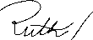

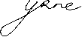
Signed

Date: 20/04/2024

Acknowledgements
I would like to thank my supervisor, Dr. Grainne Kirwan, for her more than generous support throughout each component and stage of this research. This study would not have been possible without your ongoing support, I am truly so grateful. I would like to thank my statistics lecturer Dr Chritine Horn for helping to answer all my questions about my design and ease my worries about statistics. I would also like to extend my thanks to my lecturers Dr. Olivia Hurley, and Ms. Sinead Meade who marked my 3rd year research proposal, which the current research has blossomed from. I would also like to thank my mum for her support, from our proofreading phone calls to post-laundry phone calls, I always know I can count on you to pick up. I would also like to thank my friends; Jamie Lee, Niamhí, Laoise, Amy and Leah. Our infrequent study sessions aren’t the most productive, and we normally always spend more time going for overpriced coffee, but we somehow got each other through the year. I am so lucky to have friends like you, you guys slay. Lastly, I would like to thank everyone who took time out of their day to fill out the survey, which without their participation would not have been possible.

Contents

Abstract 1
Introduction 2
An overview of: True Crime Media 2
The Nature of True Crime Media 2
Need for Closure 3
Media, Crime and Need for Closure 3
Need for Cognition 4
Media, Crime, and Need for Cognition 4
Theoretical Explanations 5
The Current Study 6
Research Question 6
Hypotheses in relation to Need for Cognition 6
Hypotheses in relation to Need for Closure 6
Method 8
Design 8
Participants 8
Exclusion Criteria 9
Materials 9
Need for Closure scale (NFCC) 10
Need for Cognition scale (NFC) 10
True Crime Streaming 11
Software 11
Procedure 11
Results 13
Descriptive statistics 13
Pre analysis 14
Hypotheses Testing 14
Post Hoc Tests 16
Discussion 17
Strengths 18
Limitations 18
Theoretical Implications 19
Practical Implications 19
Generalizability 19
Future research 20
Conclusion 20
References 22
Appendix A 28
Results of Demographic Questions 28
Appendix B 29
Information Sheet 29
Appendix C 32
Consent Forms pre and post survey 32
Appendix D 33
Debrief 33
Appendix E 34
Demographic Questionnaire 34
Appendix F 35
Need For Closure Scale 35
Appendix G 39
Need for Cognition Scale, 39
Appendix H 40
True Crime Documentary and Docuseries list 40
Appendix I 64
Cronbach’s Alpha for each Subscale of the Need For Closure 64
Appendix J 66
Cronbach’s alpha for Need for Cognition 66
Appendix K 67
G*Power output for required statistical power. 67
Appendix L 68
Box Plots after extreme outlier was removed. 68
Appendix M 71
Skewness and Kurtosis for Dependent Variables 71
Appendix N 72
Correlations for Dependent Variables 72
Appendix O 73
Box’s M Statistic 73
Appendix P 74
MANOVA result 74
Appendix Q 75
Tukey Post Hoc test 75

Abstract
In the last decade, True Crime documentary-style content has become increasingly popular across multiple streaming platforms, despite this popularity, there appears to be little research in documentary and docuseries consumption. The research question aimed to investigate the relationship between the consumption of True Crime docuseries and documentaries, Need for Cognition and the six facets of the Need for Closure. To investigate this, participants completed an online survey (N=59, Mean age= 27.95, SD= 12.185) which included Need for Closure scales as well as a list of True Crime series which allowed for the division of the True Crime viewing groups by quantity of series consumed (Low, Medium, and High). A significant MANOVA with a large effect (Partial n²= .219) indicated that Decisiveness differs for individuals with high (p<.001) and low levels (p<.001) of True Crime viewing. Individuals with higher True Crime streaming scored lower on Decisiveness. There were no other significant results for the other facets of the Need for Closure or Cognition scales. Results were discussed based on how high consumption of True Crime may have adverse implications on legal proceedings and jury decision making, though this may only be applicable to an Irish population tested in the study.

Introduction

An overview of: True Crime Media
Punnett defines True Crime as “nonfiction narratives of criminal events that actually happened” (2018, p28). In the 1980s, True Crime saw a peak in popularity in television programming, quietly becoming less popular, until the mid-2010s, remerging as a revamped style of documentary factual-based programming (Walters, 2021). Far removed from the past of scheduled tv, the availability and accessibility of streaming services means individuals have access to a wealth of series and movies on demand, with algorithmic suggestions tailoring each individual’s landing page (Shattuc, 2020). Netflix with its popular docuseries ‘Making a Murder’ is cited as an inciting event, to catapult the streaming service into a main player in the True Crime genre and is responsible for the subsequent paradigm shift towards True Crime docuseries as the mainstay across streaming services (Maher & Cake, 2023). In recent years, the litany of True Crime media on streaming services has continued to spread, with countless titles spanning across a myriad of platforms (Wiest, 2021). Given its proliferation, this leads to the question; why would individuals be drawn to such programming, which so often show sobering visual ‘depictions’ of real-world violence?

The Nature of True Crime Media
The prestige of True Crime being conceptualised in the medium of documentary allows for the highlight of punishment or the display the collapse of justice in a way that boasts credibility whist maintaining entertainment value (Walters, 2021). The True Crime documentary in presenting as fact-based, serves a dual purpose, educating the viewer on criminality and the legal systems attempts to curb social deviances (Larke-Walsh, 2020). The genre centres around its conventionality, adhering to narratives where closure is gained, criminals are captured, and order is reestablished (Larke-Walsh, 2020; Seltzer, 2013) The appeal for audiences is often rooted in the of the genre’s formulaic nature (McCabe, 2021). Bruzzi describes the True Crime documentary audience positioned similar to that of a jury in a real criminal trial, overlooking the evidence, the suspect, and the verdict, describing the audience as ‘jurified’ (2016).
Despite these justice narratives, the genre appears to stimulate the opposite effect. Individuals who consume more True Crime have been found to be more questioning and mistrusting of the criminal justice system and call for more punitory consequences for crimes (Kort‐Butler & Hartshorn, 2011; Pâquet, 2020). Entwined with the entertainment value of True Crime, dramatic techniques like cliffhangers and reenactments bolster engagement (Wiest, 2021). Surette and Otto (2002) developed an infotainment measure evaluated perceptions of the criminal justice system in the media. Falling in the middle of this scale, True Crime appeared to be a blend of both fact and entertainment media. However, the authors stipulated with the proliferation of the genre, it may skew towards more entertainment purposes. As this study was conducted in 2002, before the expansion of such media across the internet. Morton (2021) conversely cites the modern True Crime documentary as becoming increasingly influential on criminal justice as the genre becomes more prolific.

Need for Closure
The Need for Closure (NFCC) is the degree to which individuals are incentivised to achieve complete resolution in judgments, choices, and decisions despite the risk of a possible premature and misinformed conclusion (Webster & Kruglanski, 1994). Whilst NFCC exists on a continuum, it also exists as an inducible state dependent on situational factors. Individuals high in NFCC are motivated to ‘freeze’ on the information as soon as possible, whilst those with a low need are motivated to prolong this uncertainty and ambiguity (Roets & Van Hiel, 2007). Gendi et al. (2023) found that paradoxically the Need for closure is negatively correlated with ability to achieve closure.

Media, Crime and Need for Closure
A recent study by Veggi and Zara (2023), found that a higher Need for Closure was linked to stronger desire for more punitory consequences for crime. Conversely, Giacomantonio et al. (2017) found that it was associated with a more utilitarian desire for punishment. Therefore, one could posit that individuals may be drawn towards solved True Crime narratives to satiate this desire for what they individualistically would consider fair consequence(s) to criminal acts.
The medium for viewing may also be a component in this motivation for closure. Shi and Wang (2019) investigated the drama genre, the Need for Closure and influence of advertisements. The authors found that a both a liking for and Need to find resolution in the series would motivate individuals to continue watching, the interruption of advertisements were reported as frustrating. Some streaming platforms like Netflix, currently have no advertisements, the viewer is able to watch without interruption, possibly allowing those to seek gratification in this form of media consumption.

Need for Cognition
The Need for Cognition (NFC) conceptualised by Cacioppo and Petty (1982) is the extent to which individuals are incentivised to seek out and like cognitively effortful activities. Whist Needs for Closure and Cognition share similar traits; in that they are both driven to seek out and use information, the distinction lies in the steps to the process. Need for Cognition finds gratification in the process whilst Need for Closure is end-goal directed (Fortier & Burkell, 2014). Individuals ranking low or high on their Need for Cognition seek to find meaning and judgements about the world, however they undertake this through different means. Those high in NFC would be predisposed to seek out, make enquires, think, and subsequently reflect on multiple sources of information, to determine events and stimuli in their reality, having a positive attitude towards events or issues related to problem solving or reasoning, but show proportionate attitudes towards non-intellectual stimuli. Antithetically those who score low would be driven to cognitive heuristics and social comparisons and rely on other second-hand information to feed this knowledge (Fortier & Burkell, 2014).

Media, Crime, and Need for Cognition
Shim and Kim (2018) found that binge watching fictional tv dramas has been linked to high Need for cognition, as a result of parasocial relationships and engaging in fandom behaviours. This could possibly link to the ‘True Crime Fandom’, with individuals reportedly viewing certain serial killers as celebrities (Fathallah, 2022). However, Shim and Kim (2018) stipulate that the effects of the Need for Cognition was not linked to all binge-watching behaviours, and it may be only some facets of the construct that factor into the behavioural motivation, which were not tested in the study.
Similar to the motivation through the Need for Closure, Sargent (2004) found that high Need for Cognition had a negative correlation to punitiveness to crime, suggesting desire for more complex thinking prompts utilitarian responses to punishment.

Theoretical Explanations
Historically through the lens of cultivation theory scholars proposed that engagement with crime shows heightens a viewer’s fear of crime (Gerbner & Gross, 1976), with studies by Dolliver et al. (2018) and Boda and Szabó (2011) supporting these claims. However, there have been conflicting studies reporting this due to the varied characteristics of individuals and individual narrative plot points and resolutions of series (Callanan & Rosenberger, 2015; Potter, 1993). Eschholz, et al. (2003) found that realism and proximity in crime news programming were linked to higher reported levels of fear. However a just resolution was not seen to negate fear of crime when shown in reality television formats. Therefore proposed explanations of watching True Crime for justice seeking furthermore comes into question.
Uses and Gratifications (U&G) theory is the assumption that individuals actively seek specific media to satiate a specific Need (Katz et al., 1974). In a study conducted by Brown et al. (2012) on crime drama viewership motivations centred around the U&G framework reported curiosity and information as key motivators.
Scrivner (2021) proposed morbid curiosity as a predictor in viewing distressing or otherwise negatively arousing events like homicide. The study found that is not the resulting event that is where the interest lies, but the inciting events that led up to it, for example, how one was driven to kill, which the author describes as a possible predictor for watching True Crime. This could possibly link to Need for Cognition and U&G and Cultivation theories. Scrivner found that Animal – Reminder Disgust was a predictor of morbid curiosity, where certain phenomena blur the lines between animal society and that of humans, reminding an individual of mortality. The author proposes that a cost benefit analysis of sorts inhibits an individual to view this content in order to gather information despite the grotesque nature of the content they are viewing, and the second-hand dissemination of this knowledge provides enough of a gap in the dangerous situation to allow for it to be consumed.

The Current Study
Despite its popularity, there appears to be little research in the area of streaming documentary-style True Crime content with most studies focusing on podcasting. The popularity of the genre of True Crime documentaries showcase an audiovisual depiction of a blended fact-entertainment depiction of often dramatized yet disturbing content. Both Need for Closure, Cognition and True Crime have been suggested to influence perceptions of the legal system and negate a desired outcome for the legal systems response to crime. The Need for Closure and Cognition have also been linked to increased consumption of tv dramas. Furthermore, models of U&G and cultivation theories, propose emotion fuelled responses increase a desire to consume crime content despite the subject matter. Given this, it may be fruitful to view True Crime in terms of motivational behaviours for information seeking on crime cases and their real life resolutions. There appears to be no research investigating True Crime streaming on the Need for Closure or Cognition, this study hopes to address this gap.

Research Question
Do the Need for closure and Need for cognition differ amongst individuals who stream different amounts of True Crime shows? To address these variables current study will investigate the following hypotheses:

Hypotheses in relation to Need for Cognition
H₁: There will be a difference for the participants’ Need for cognition based on their True Crime consumption (Low, Medium, High).

Hypotheses in relation to Need for Closure
H₂: There will be a difference for the participants’ Need for Order based on their True Crime consumption (Low, Medium, High).

H₃: There will be a difference for the participants’ Need for predictability based on their True Crime consumption (Low, Medium, High).

H₄: There will be a difference for the participants’ Decisiveness based on their True Crime consumption (Low, Medium, High).

H₅: There will be a difference for the participants’ Avoidance of Ambiguity based on their True Crime consumption (Low, Medium, High).

H₆: There will be a difference for the participants Closed-Mindedness based on their True Crime consumption (Low, Medium, High)

Method

Design
The study employed a k=3 factorial independent measures survey design to answer the research question. The independent variable of True Crime streaming with three levels (High, Medium, and Low) was tested on the dependent variables: the facets of the Need for closure scale (Kruglanski et al., 1993; Roets & Van Hiel, 2007) and the Need for Cognition total scores (Coelho et al., 2018). Participants answered two scales which were then reverse scored where indicated in the original scales. To get each subscale score for the Need for closure, the relevant questions were summed as delineated on the scale.
To determine series watching, participants were given a list of streaming platforms available in Ireland. This list employed branching (therefore, docuseries and documentaries were displayed only for platforms each individual indicated using), where participants were asked to tick the names of series watched. To assign participants to groups for analysis, these total counts of series/documentaries were compiled from each platform to form a total watching score, based on this score, individuals were placed using percentile splits in the data to divide them into three roughly equal groups (Low, Medium, and High).

Participants
There was a total of N= 84 respondents to the online survey which was ‘live’ from the 23rd of January to the 14th of February 2024. After data cleaning, a total of N= 59 participants were included in the analysis.
Participants were recruited voluntarily through convenience sampling via social media, through a data collection fair in the college and via a post on the learning platform’ Blackboard’. There was an almost even split in gender, with slightly more males (50.8%, n=30) than females (49.2%, n=29) Age of respondents ranged from 19 to 69 (Mean= 27.95, SD= 12.185) with the highest percentages falling between the ages of 20 to 23.
Demographic questions included the age, gender, and clarifying questions about True Crime streaming, for example, “Do you prefer True Crime series/documentaries to shows with fictionalised or inspired stories?” and “Do you specifically choose to only watch series that are about…” (Appendix A)
The treatment of participants was in accordance with the ethical standards of the Psychological Society of Ireland and The British Psychological Research Ethics due to the survey being hosted online. The Psychology Ethics Committee (PEC) at the Institute of Art Design and Technology approved the study.

Exclusion Criteria
The data of participants who had not ticked any True Crime shows or failed to complete scale items were deleted due to the irrelevance to the research question and analysis, one outlier was also deleted (n=25).

Materials
The survey included an information sheet (Appendix B), consent forms (Appendix C), debrief (Appendix D), demographic questionnaire (Appendix E), two Likert scales totalling 47 items (Appendix F and G) and lists of True Crime docuseries/documentaries available on each of the major streaming platforms in Ireland using branching (Totalling 420) (Appendix H)
Before dissemination of the questionnaire, two pilot studies were conducted. The first was to check the general running of the survey and the phrasing of the questions. Based on the feedback from both pilot studies the Need for Cognition scale changed from the 18 item to the shorter 6 item revised scale. Reliability for this shorter scale was checked before implementation. Reliability for UK population (Cronbach’s Alpha= .86) for the 6 item scale was acceptable and similar to the 18 item measure (α = .91). Therefore, changes were implemented in the second pilot study, and the current study. The Need for Closure scale was not reduced due to revised scales compromising the subscales. To reduce overwhelm from all True Crime Docuseries and Documentaries being displayed at once, branching logic was also implemented. To prevent the repeat of series viewed that may be in commonality across platforms, participants were asked if they did not remember which platform they had viewed the media on, to choose one only. Streaming services are constantly updating their catalogue of items. The original list was compiled around three months before the questionnaire was open for participants, thus, participants were given the opportunity to input any series that were not displayed on the list.

Need for Closure scale (NFCC)
Developed by Kruglanski et al. (1993) the current study employed the revised scale which altered the Decisiveness subscale as proposed by Roets and Van Hiel (2007), which fixed the facet to measure Decisiveness as a need rather than the ability construct it was mistakenly measuring in the original design. Comprised of 41 items, NFCC is designed to measure an individual’s desire for any given answer to avoid ambiguity whilst making a judgement or decision, which can range from a high Need for Closure to no desire to attain Closure. The measure consists of 5 subscales which comprise a facet Need for Closure, which were employed to measure NFC in this study. These subscales were implemented in the current study and used to measure: the Need for Order (α=.77) Predictability (α=.78), and Decisiveness (α=.85), Avoidance of Ambiguity (α=.81), and Closed-Mindedness (α=.48) (Appendix I). Sample questions include: “I enjoy the uncertainty of going into a new situation without knowing what might happen.” “When I am confused about an important issue, I feel very upset”. Individuals ranked their answers on a Likert scale of 1 to 6 (1= Strongly Disagree, 6= Strongly Agree). Questions marked for reverse score were computed and the total score for each subscale were calculated using these new values and the remaining scores. Alphas were comparable to the original scale except for Closed-Mindedness which will be discussed further in the limitations. Alpha for Decisiveness taken from the revised scale from Roets and Van Hiel (2007) was similar (a=.87).

Need for Cognition scale (NFC)
Originally conceptualised by Cacioppo and Petty (1982), the present study employed the abridged 6 item version developed by Coelho et al. (2018). This scale measures the degree to which an individual seeks out cognitive tasks. Sample questions included: “I like to have the responsibility of handling a situation that requires a lot of thinking.” “I would prefer a task that is intellectual, difficult, and important to one that is somewhat important but does not require much thought.” Individuals ranked their answers on a Likert scale of 1 to 5 (1= extremely uncharacteristic of me, 5 = extremely characteristic of me). Questions marked for reverse score were computed and the total score was calculated using these new values and the remaining scores. Cronbach’s alpha was acceptable (α=.79) and comparable to the original scale (α=.86). (Appendix J)

True Crime Streaming
The total list of True Crime shows were gathered by the researcher by looking through the online catalogues of each streaming service under tags such as ‘True Crime’ and ‘Crime Documentary’ for each of the following the streaming services; Netflix, Heyu, Paramount+, Disney+, NowTV, Channel4, RTE Player and Prime.

Software
Microsoft Forms was used to host the survey. Microsoft Excel was used for transferring data from forms and recoding the data. SPSS (Version 29) was used for statistical analysis. To determine the required sample size for statistical power for the MANOVA, G*Power (3.1.9.7) was used.

Procedure
QR codes and data recruitment were posted online and in person. The study was hosted on ‘Microsoft Forms’, participants scanned the QR code, and the page opened with the information sheet, which outlined the implications of participation, and possible sensitive topic of True Crime. Once clear, the participant had the option to participate, and informed consent was obtained through a tick box. The demographic questions followed, wherein the individual also created their unique identifier. This was followed by the two scales and then the True Crime list. To gauge how much True Crime was watched, the participant was asked to tick if they watched the content on each of the previously listed platforms, they were provided with an open ended question to list any shows or platforms that may have been left out. The average time to complete the survey was 16 minutes. After this the participant was debriefed and had the option to have their data deleted. The participant was thanked for their participation and provided with further supports and contact information of the researcher and their supervisor after submission.

Results
Data analysis was comprised of three parts, descriptive statistics, tests of assumptions, and the subsequent MANOVA and post hoc test.

Descriptive statistics
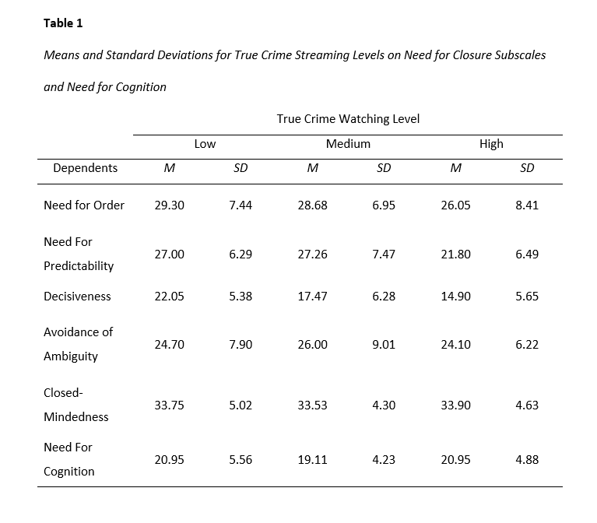
Means and standard deviations for Need for Order, Predictability, Decisiveness, Avoidance of Ambiguity, Close- Mindedness and Need for Cognition, for Low (n=20) Medium (n=19) and High (n=20) True Crime watching groups are shown in Table 1 below.

Pre analysis
The design of the survey allowed for the assumption of independence of observations to be met and original sample size was enough to factor in the subsequent screening of data for individuals who watched True Crime, whist maintaining a satisfactory sample size for statistical analysis as given by the A priori G*power output (α=.25, 80% power) (Appendix K). Preliminary analyses were conducted to check the other assumptions of the test. Box plots were run, and extreme outliers were removed from the data set (Appendix L). Z scores were used to check for the assumption for univariate outliers, which was met. There were no multivariate outliers as assessed by a Mahalanobis distance (p >.001). Kurtosis for Closed-Mindedness was significantly higher than the other variables (-.911) (Appendix M) but it was assumed that the test was robust enough to account for this violation. A bivariate Pearson correlation was conducted to test for multicollinearity. There was no multicollinearity between the constructs (Appendix N).

Hypotheses Testing
Hypotheses were tested by employing a one-way (k=3) between subjects analysis of variance (MANOVA) with level of streaming of True Crime (Low, Medium, High) as independent variables and the Need for cognition, the Need for Order, the Need for predictability, Decisiveness, Avoidance of Ambiguity and Closed-Mindedness as dependent variables.
The assumption of Boxes M for homogeneity of the equality of variances- covariance was met (p=.238) (Appendix O). A statistically significant MANOVA was obtained (F (6,104) = 2.83, p= .002; Pillai’s trace = .49). The effect size was large (Partial n²=.246) (Appendix P)
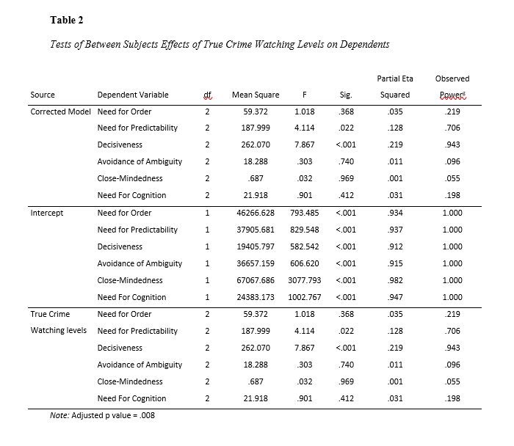
Table 2 below shows a series of follow up one-way ANOVAs with a Bonferroni correction of .008 to test each of the six hypotheses. It shows a statically significant main effect of the grouping variable of True Crime viewing on the subscale Decieveness, (F (2,56) = 7.87, p < .001) The effect size was large (Partial n²= .219).

Post Hoc Tests

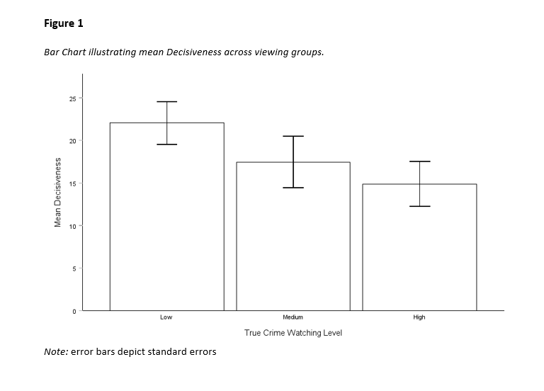
Figure 1 below depicts results of a Tukey HSD post hoc analysis, which showed a statically significant mean decrease (-7.15, 95% CI [-11., -2.4] ) for Decisiveness from the high level of watching group (p<.001) to the low level of watching group (p<.001). There was no significant mean difference in Decisiveness between the medium level of watching group and low (p=.043) or high level (p=.35) of watching groups (Appendix Q)

Discussion
The aim of this study was to investigate True Crime streaming levels on the Need for Closure subscales and Need for Cognition. No significant results were found for level of True Crime streaming on the Need for Cognition (H₁). Indicating participants were not motivated to consume stream True Crime as a cognitive activity, and that the process in viewing True Crime may not be a motivation for streaming, and which possibly challenges the theory of morbid curiosity (Scrivner, 2021). The facets of the Need for Closure scale: Order, Predictability, Avoidance of Ambiguity or Close-Mindedness were not significant (H₂, H₃, H₅, H₆).
The Hypothesis that there would be a mean difference on Decisiveness based on True Crime watching levels was confirmed by the results (H4), indicating that participants who were placed in the high True Crime streaming level had lower scores of Decisiveness than that of the low level of True Crime streaming. This could suggest those who watch more True Crime put less importance on decision making than those who watch fewer series. This is a surprising result, when compared to previous studies findings, that high Need for Closure and more True Crime consumption is a predictor for punitiveness (Kort‐Butler & Hartshorn, 2011; Veggi & Zara, 2023). This assertiveness in punitiveness would suggest this would be mirrored in high True Crime watchers Decisiveness. However the result of the current study shows opposite, this brings this punishment motivation into question.
found that, paradoxically, The Need for Closure is negatively correlated with the Ability to Achieve Closure, furthermore, Decisiveness is crucial foundation in this relationship (Gendi et al., 2023). Therefore, applying this to the current study, those who watch more True Crime compared to less True Crime may have a higher ability to be decisive. This brings into question if watching True Crime satiates a Need for Decisiveness or mediates an ability to be decisive. Relating back to studies on True Crime and the legal system, this result is surprising, and will be discussed in regard to future research. Interestingly, the non-significant result of the medium watching level may show some support for this.

Strengths
Arguably the main strength of the current study is in its novel research and possible addition to the area of both Need for closure and True Crime. There appears to be little research into True Crime documentaries and docuseries despite their popularity. Although the topic seems to be an emerging area of study, most studies conducted have focused more on True Crime podcasts. Secondly, to account for the various rising costs associated with subscriptions and the growing number of platforms available in Ireland, both free and paid services were used. This allowed for a possibly more representative sample that may not have been seen from one streaming site alone. Similarly, due to this growing number of platforms and the nature of streaming sites, an inclusion of an open-ended question allowed for additional shows to be listed.

Limitations
Artificial categorization of the independent variable was used, there is debate around this (see DeCoster et al., 2011 for more details). However, this was implemented due to the difficulty in determining True Crime watching figures, as there may be a wide variation on the subjective nature of what each individual would determine as high watching. Indeed, determining the best way to collect self-reported data on TV watching has been contentious across studies on media consumption (Tóth‐Király et al., 2017). It should be noted that the researcher acknowledges that the responses do not capture to what extent the series was watched, nor the engagement with the series which may affect the construct measured. Some participants noted not remembering all of the shows they had watched. Similarly, the narrative end of each varies widely which could motivate a precognitive desire to consume certain shows. Some data collected as part of the demographic questionnaire was not used due to the word count and time constraints.
After data cleaning, the data set was reduced from 84 to 59 participants, reducing the sample size and possible power. Whilst an extreme outlier was removed, the box plots for the current study depict outliers, however these were interpreted as deemed as low scoring outliers and were therefore kept in. The present study found a few issues for Closed-Mindedness and the other subscale items. However, it should be noted this is in line with reports from previous studies which investigate the model fit (Paliwal & Kumar, 2022; Roets & Van Hiel, 2011). This only supports these authors’ calls for a revision of this facet. Pearsons’s correlations were weak for the NFC and the subscales; however, a separate ANOVA was not conducted due to the positive correlation between NFC and Closed-Mindedness.

Theoretical Implications
Revision of the Need for Closure scale due to the poor factor loading of Closed-Mindedness should be considered. Whilst Need and Ability for Closure are negatively correlated, these variables should be investigated to determine if a causal relationship exists between them. This may help aid in the understanding of the Need for closure as being subject to situational changes.

Practical Implications
The large effect of true crime viewing on Decisiveness prompts further studies to investigate the relationship further. Based on the significant result of the Decisiveness and True Crime streaming, coupled with the previously established links to the legal system and crime, it may suggest an impact of high of True Crime consumption on jurors. Where influences from such content and the relationship to Decisiveness (as both a Need and ability) may pose a threat to verdict and result in the possibility of hung juries. With the proliferation of such content online where ‘live’ updates are occurring pre-trial brings into question a multitude of legal and ethical dilemmas in relation to this Decisiveness. Therefore, possibly having practical implications reaching into real life cases and environments in criminal prosecution and the possible effects of consuming such content online.

Generalizability
It should be stressed that the current study was focused on an Irish population, with content available in Ireland. Whilst streaming is accessible worldwide, certain platforms, series and documentaries can be country specific, therefore the list created for the current study would not be transferrable to different populations. Similarly, if the proposed links to justice narratives are a component of this Decisiveness, it may be mediated by cultural differences. The sampling method relied mostly on convenience sampling and was mostly through means by which younger people would be more likely to be recruited (college and social media). Similarly, this is reflected in the mean respondents age group, who may also spend more time using streaming services. It also should be noted that some respondents may overall stream more content online and may not just be interested in True Crime series alone. The amount of the participants in the current study was relatively conservative, a larger sample size would be needed to confidently draw conclusions on the wider population.

Future research
Decisiveness can be situational and sensitive to experimental manipulation (Roets & Van Hiel, 2007). An experimental approach examining Decisiveness on pre-established groups with different levels of True Crime viewing in a mock jury setting may be an interesting avenue to further investigate this manipulation on inherent Decisiveness. It may also be beneficial to investigate if Decisiveness is dependent on certain narrative resolutions, for example if it is affected by the unsolved or solved endings to True Crime series.

Conclusion
The current study aimed to investigate the relationship between True Crime streaming and Needs for Closure and Cognition. The results indicate that individuals who watch more true crime have a lower Need for Decisiveness. No other significant results were found for the other variables in the study. The lack of a significant finding for Need for Cognition raises questions about proposed explanations about viewing True Crime, particularly relating to morbid curiosity. This result brings into question the previously established proposed reasonings into true crime motivations, particularly in punishment motivations.
However, it should be noted that the current study focused on a small sample of people who stream True Crime from an Irish population which limits the implications of the findings.
Practical implications may exist in the context of Decisiveness, perceptions of legal system and prosecution stemming from True Crime consumption. Future research should examine this possible link between Decisiveness and high true crime consumption on jury decision making, as an experimental design. This would not only investigate if the relationship is causational, but could also investigate the situational aspects of Decisiveness and if a mediating effect exists between the ability/need paradigm in within closure contexts (Gendi et al., 2023).

References
Boda, Z., & Szabó, G. (2011). The media and attitudes towards crime and the justice system: A qualitative approach. European Journal of Criminology, 8(4), 329–342. https://doi.org/10.1177/1477370811411455
Brown, D., Lauricella, S., Douai, A., & Zaidi, A. U. (2012). Consuming Television Crime Drama: A Uses and Gratifications Approach. American Communication Journal, 1(14). http://ac-journal.org/journal/pubs/2011/winter/ACJ_2011-022_Douai%5B1%5D.pdf
Bruzzi, S. (2016). Making a genre: the case of the contemporary true crime documentary. Law And Humanities, 10(2), 249–280. https://doi.org/10.1080/17521483.2016.1233741
Cacioppo, J. T., & Petty, R. E. (1982). The Need for cognition. Journal of Personality and Social Psychology, 42(1), 116–131. https://doi.org/10.1037/0022-3514.42.1.116
Callanan, V. J., & Rosenberger, J. S. (2015). Media, gender, and fear of crime. Criminal Justice Review, 40(3), 322–339. https://doi.org/10.1177/0734016815573308
Coelho, G. L. D. H., Hanel, P. H. P., & Wolf, L. J. (2018). The very efficient assessment of Need for cognition: developing a Six-Item version. Assessment, 27(8), 1870–1885. https://doi.org/10.1177/1073191118793208
DeCoster, J., Gallucci, M., & Iselin, A. R. (2011). Best Practices for Using Median Splits, Artificial Categorization, and their Continuous Alternatives. Journal of Experimental Psychopathology, 2(2), 197–209. https://doi.org/10.5127/jep.008310
Dolliver, M. J., Kenney, J. L., Reid, L. W., & Prohaska, A. (2018). Examining the relationship between media consumption, fear of crime, and support for controversial criminal justice policies using a nationally representative sample. Journal of Contemporary Criminal Justice, 34(4), 399–420. https://doi.org/10.1177/1043986218787734
Eschholz, S., Chiricos, T., & Gertz, M. (2003). Television and Fear of Crime: program types, audience traits, and the mediating effect of perceived neighborhood racial composition. Social Problems, 50(3), 395–415. https://doi.org/10.1525/sp.2003.50.3.395
Fathallah, J. (2022). ‘BEING a FANGIRL OF a SERIAL KILLER IS NOT OK’: Gatekeeping Reddit’s true crime community. New Media & Society, 146144482211387. https://doi.org/10.1177/14614448221138768
Fortier, A., & Burkell, J. (2014). Influence of Need for cognition and Need for cognitive closure on three information behavior orientations. Proceedings of the American Society for Information Science and Technology, 51(1), 1-8. https://doi.org/10.1002/meet.2014.14505101066
Gendi, M., Rubin, M., & Sanatkar, S. (2023). Understanding the relation between the Need and ability to achieve closure: A single paper meta-analysis assessing subscale correlations. New Ideas in Psychology, 69, 101007. https://doi.org/10.1016/j.newideapsych.2022.101007
Gerbner, G., & Gross, L. (1976). Living with Television: The Violence Profile. Journal of Communication, 26(2), 172–199. https://doi.org/10.1111/j.1460-2466.1976.tb01397.x
Giacomantonio, M., Pierro, A., Baldner, C., & Kruglanski, A. W. (2017). Need for closure, torture, and punishment motivations. Social Psychology, 48(6), 335–347. https://doi.org/10.1027/1864-9335/a000321
Katz, E., Blumler, J. G., & Gurevitch, M. (1974). Uses and Gratifications Research. The Public Opinion Quarterly, 37(4), 509–523.
Kort‐Butler, L. A., & Hartshorn, K. J. S. (2011). Watching the Detectives: Crime Programming, Fear of Crime, and Attitudes about the Criminal Justice System. DigitalCommons@University of Nebraska - Lincoln, 52(1), 36–55. https://doi.org/10.1111/j.1533-8525.2010.01191.x
Kruglanski, A. W., Webster, D. M., & Klem, A. (1993). Motivated resistance and openness to persuasion in the presence or absence of prior information. Journal of Personality and Social Psychology, 65(5), 861–876. https://doi.org/10.1037/0022-3514.65.5.861
Larke-Walsh, G. S. (2020). Injustice narratives in a post-truth society: emotional discourses and social purpose in Southwest of Salem: the story of the San Antonio four. Studies in Documentary Film, 15(1), 89–104. https://doi.org/10.1080/17503280.2020.1725996
Maher, S., & Cake, S. (2023). Innovation in true crime: generic transformation in documentary series. Studies in Australasian Cinema, 17(1–2), 95–109. https://doi.org/10.1080/17503175.2023.2224617
McCabe, R. A. (2021). Conversations with a killer: the Ted Bundy tapes and affective responses to the true crime documentary. Studies in Documentary Film, 16(1), 38–54. https://doi.org/10.1080/17503280.2021.1874236
Morton, P. A. (2021). Stylistic choices in true-crime documentaries: the duty of responsibility between filmmaker and audience. Media Practice and Education, 22(3), 239–252. https://doi.org/10.1080/25741136.2021.1925814
Paliwal, D., & Kumar, R. (2022). Exploring the Five-Factor structure of the Need for closure scale on Indian samples using exploratory and confirmatory factor analysis. European Journal of Psychology and Educational Research, 5(1), 45–51. https://doi.org/10.12973/ejper.5.1.45
Pâquet, L. (2020). Seeking Justice Elsewhere: Informal and formal justice in the true crime podcastsTraceandThe Teacher’s Pet. Crime, Media, Culture, 17(3), 421–437. https://doi.org/10.1177/1741659020954260
Potter, W. J. (1993). Cultivation Theory and Research. Human Communication Research, 19(4), 564–601. https://doi.org/10.1111/j.1468-2958.1993.tb00313.x
Punnett, I. C. (2018). Toward a theory of true crime narratives: A Textual Analysis. Routledge.
Roets, A., & Van Hiel, A. (2007). Separating ability from Need: clarifying the dimensional structure of the Need for closure scale. Personality & Social Psychology Bulletin, 33(2), 266–280. https://doi.org/10.1177/0146167206294744
Roets, A., & Van Hiel, A. (2011). Item selection and validation of a brief, 15-item version of the Need for Closure Scale. Personality and Individual Differences, 50(1), 90–94. https://doi.org/10.1016/j.paid.2010.09.004
Sargent, M. J. (2004). Less thought, more punishment: Need for cognition predicts support for punitive responses to crime. Personality & Social Psychology Bulletin, 30(11), 1485–1493. https://doi.org/10.1177/0146167204264481
Scrivner, C. (2021). The psychology of morbid curiosity: Development and initial validation of the morbid curiosity scale. Personality and Individual Differences, 183, 111139. https://doi.org/10.1016/j.paid.2021.111139
Seltzer, M. (2013). True crime: Observations on Violence and Modernity. Routledge.
Shattuc, J. (2020). Netflix, Inc. and Online Television. In J. Wasko & E. R. Meehan (Eds.), A Companion to Television (2nd ed., pp. 145–164). Wiley Blackwell. https://doi.org/10.1002/9781119269465.ch7
Shi, Y., & Wang, T. (2019). Genuine liking or the Need for closure? The differential effects of consumers’ TV drama viewing motivations on commercial viewership. Journal of Media Economics, 32(3–4), 57–81. https://doi.org/10.1080/08997764.2021.1883916
Shim, H., & Kim, K. J. (2018). An exploration of the motivations for binge-watching and the role of individual differences. Computers in Human Behavior, 82, 94–100. https://doi.org/10.1016/j.chb.2017.12.032
Surette, R., & Otto, C. W. (2002). A test of a crime and justice infotainment measure. Journal of Criminal Justice, 30(5), 443–453. https://doi.org/10.1016/s0047-2352(02)00147-2
Tóth‐Király, I., Bőthe, B., Tóth-Fáber, E., Hága, G., & Orosz, G. (2017). Connected to TV series: Quantifying series watching engagement. Journal of Behavioral Addictions, 6(4), 472–489. https://doi.org/10.1556/2006.6.2017.083
Veggi, S., & Zara, G. (2023). The role of personality and the Need for cognitive closure in shaping punitiveness to crime. Personality and Individual Differences, 214, 112348. https://doi.org/10.1016/j.paid.2023.112348
Walters, E. (2021). Netflix Originals: The Evolution of True Crime Television. The Velvet Light Trap, 88, 25–37. https://muse.jhu.edu/article/805508
Webster, D. M., & Kruglanski, A. W. (1994). Individual differences in Need for cognitive closure. Journal of Personality and Social Psychology, 67(6), 1049–1062. https://doi.org/10.1037/0022-3514.67.6.1049
Wiest, J. B. (2021). Mass mediated representations of crime and criminality. In Studies in media and communications. https://doi.org/10.1108/s2050-2060202121

Appendix A

Results of Demographic Questions
(Not included in main analysis)
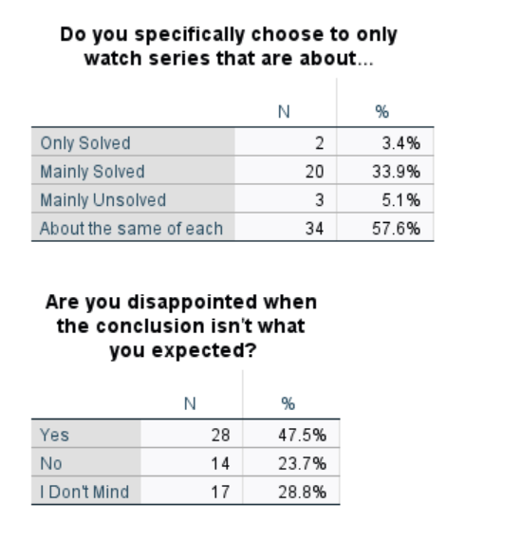
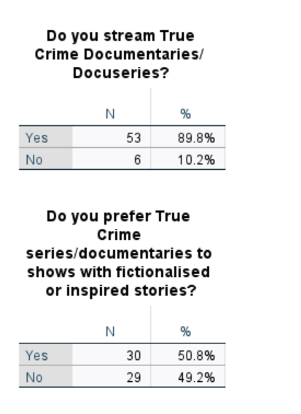

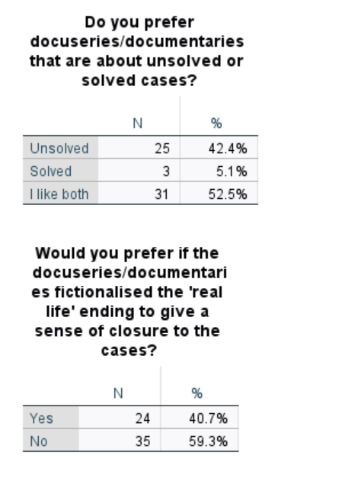
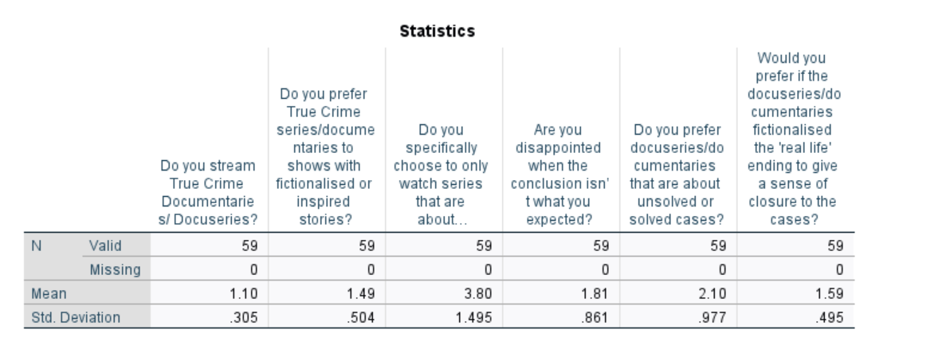

Appendix B

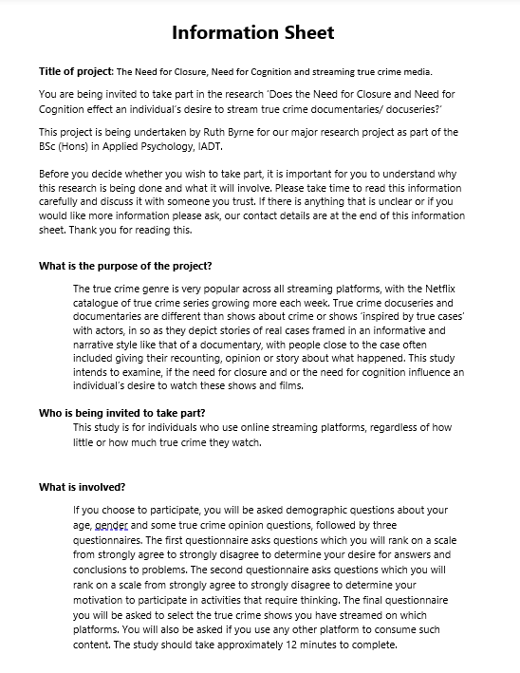
Information Sheet

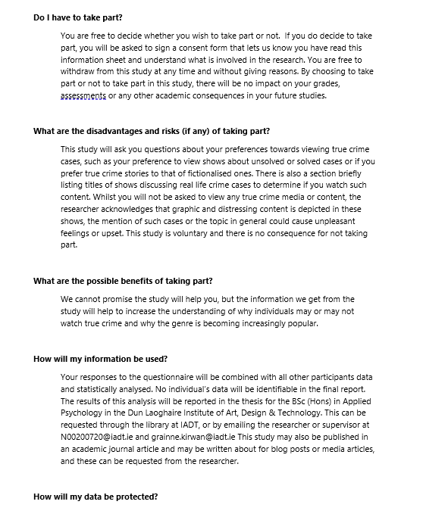

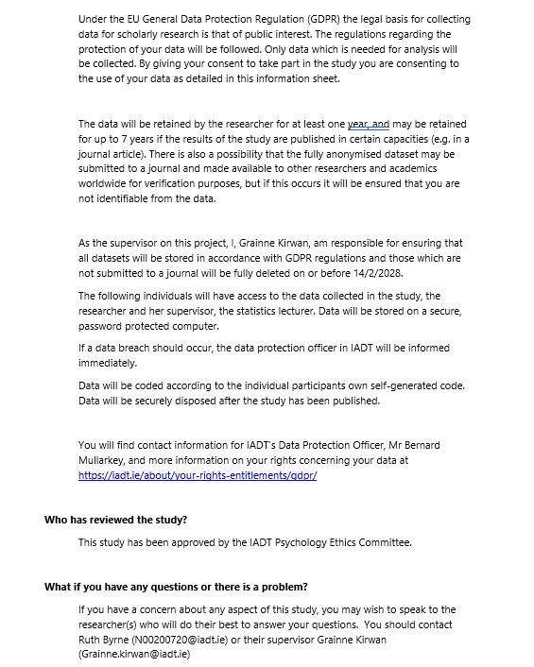

Appendix C

Consent Forms pre and post survey
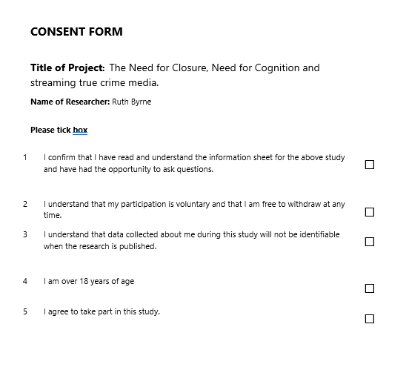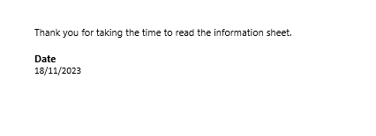
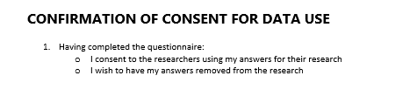

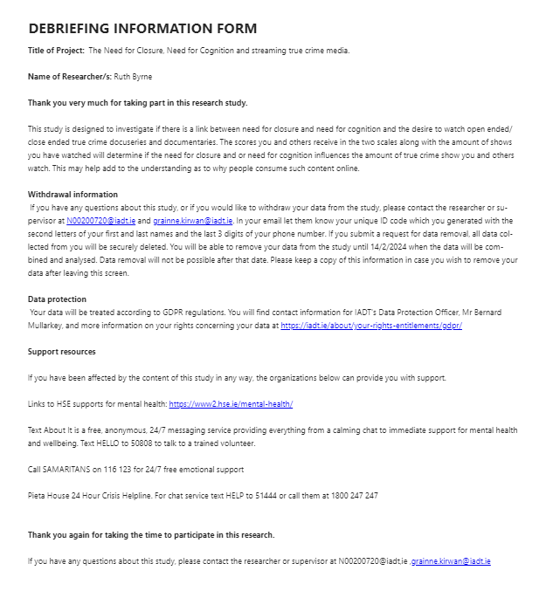
Appendix D

Debrief

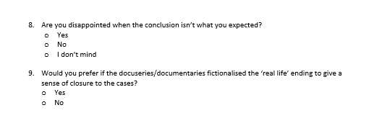
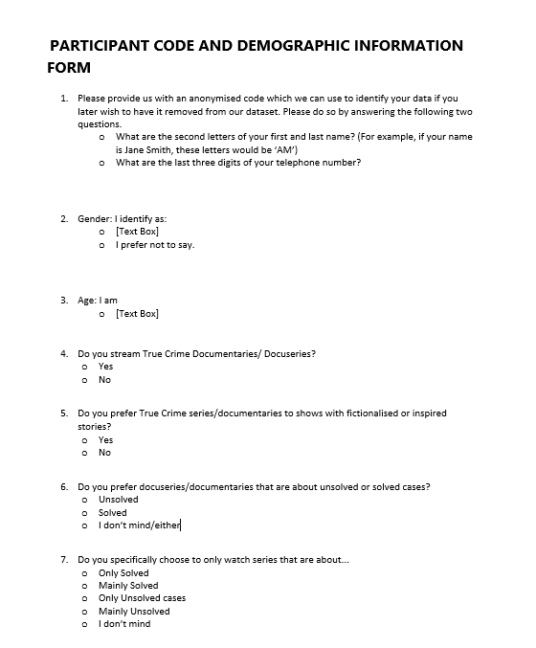
Appendix E

Demographic Questionnaire

Appendix F

Need For Closure Scale
(Kruglanski et al., 1993; Roets & Van Hiel, 2007)

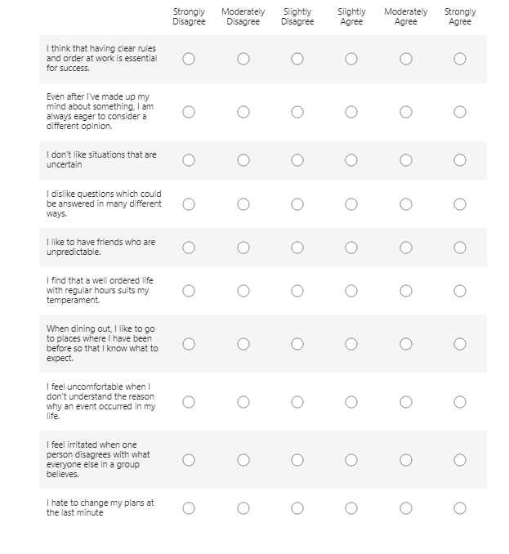
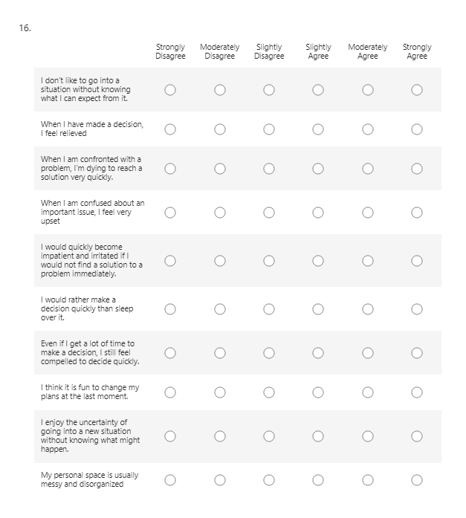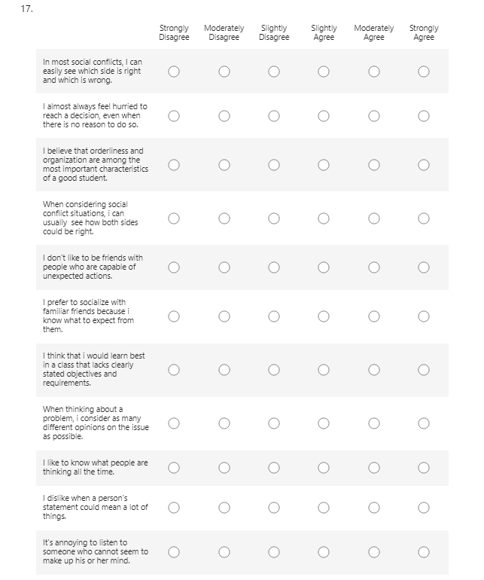

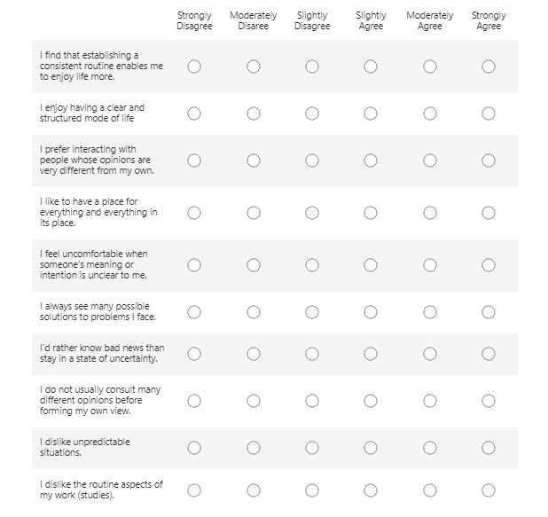

Appendix G

Need for Cognition Scale,
Originally Cacioppo and Petty (1982) Below is the abridged 6 item version developed by Coelho et al. (2018). 
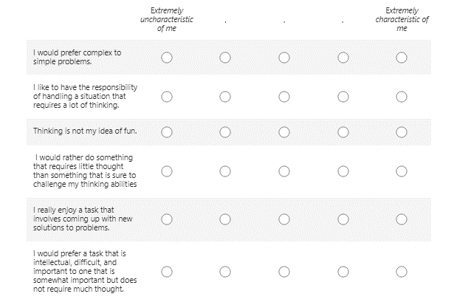

Appendix H

True Crime Documentary and Docuseries list
Displays all platforms, with open- ended question
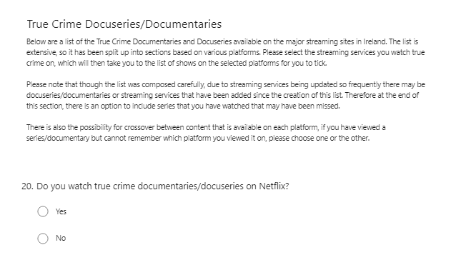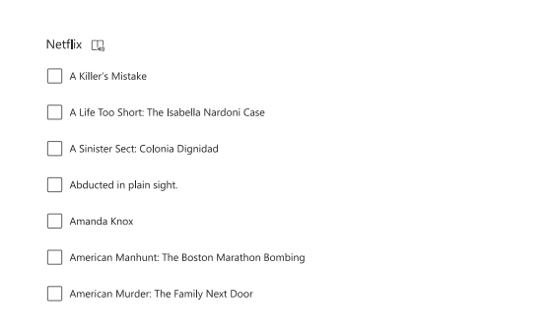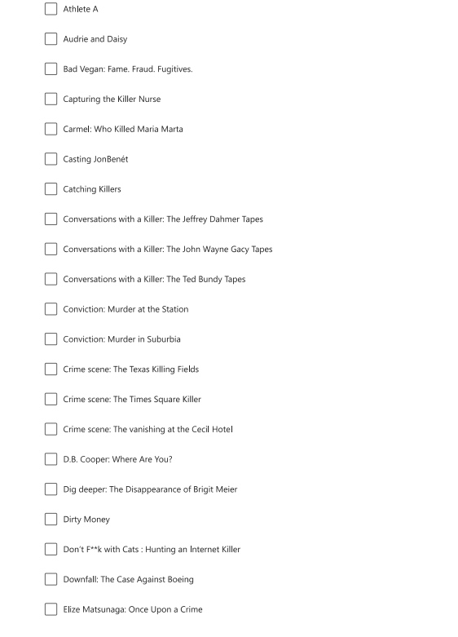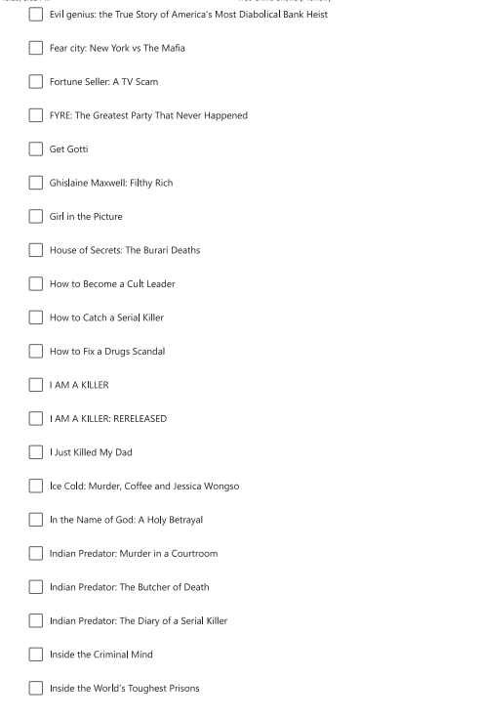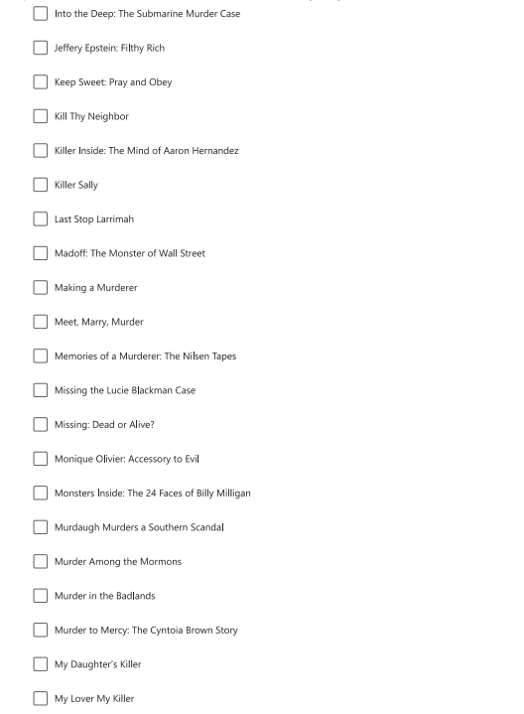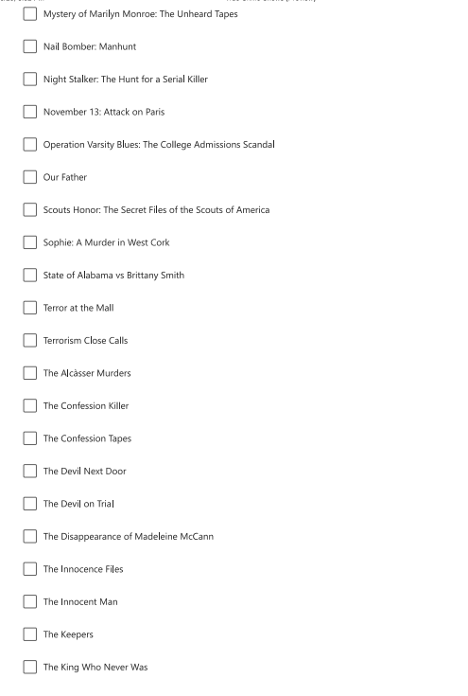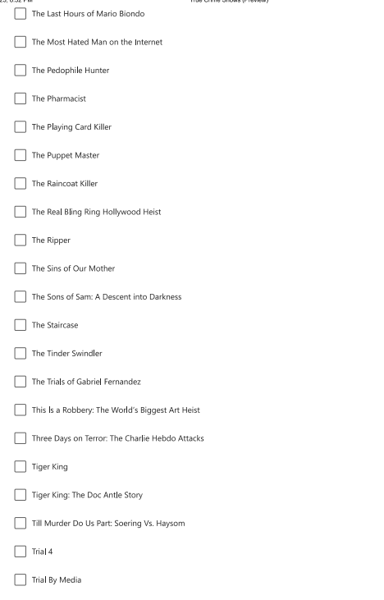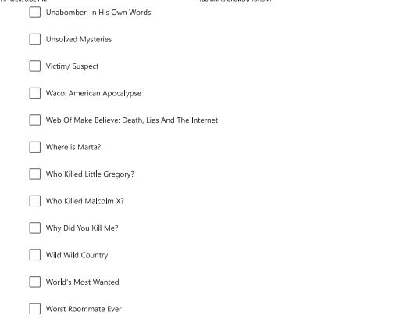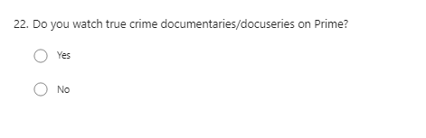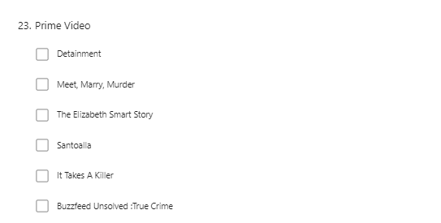
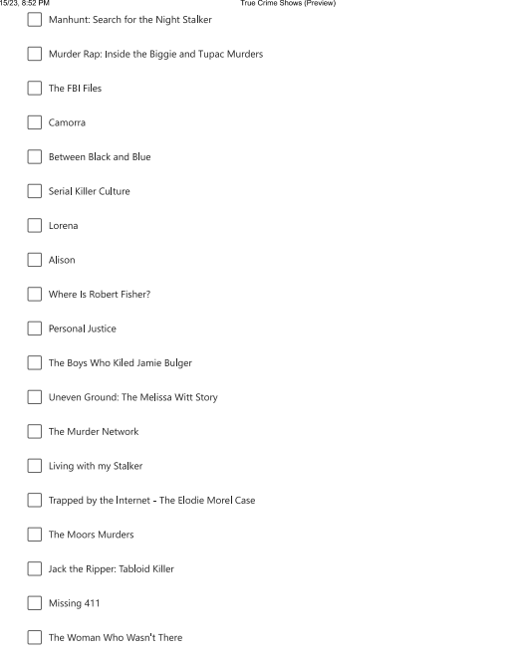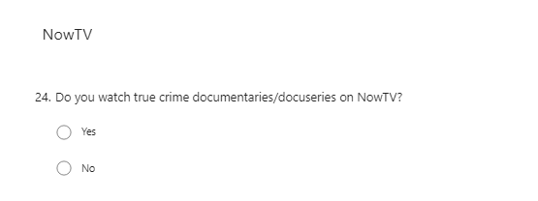
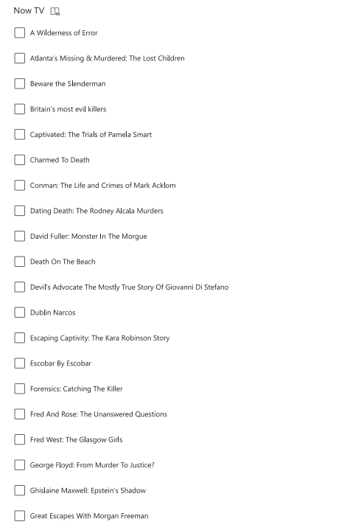
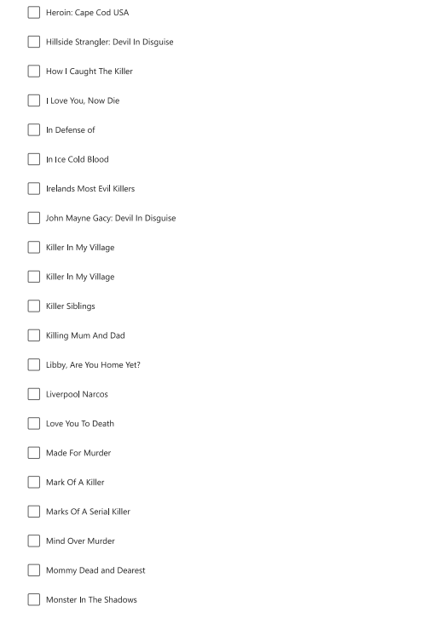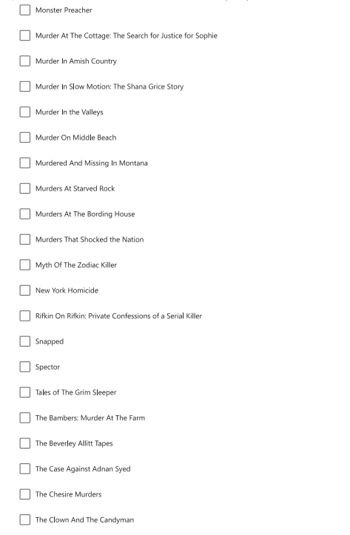
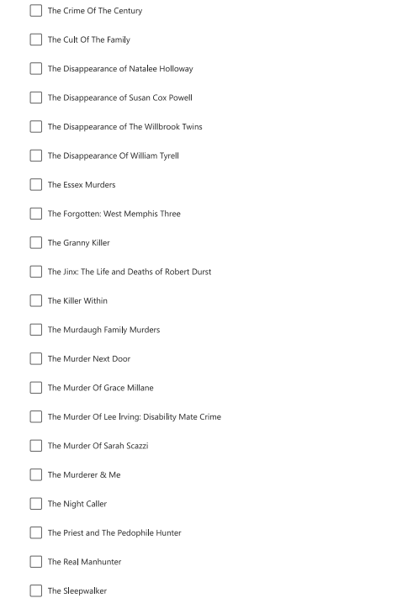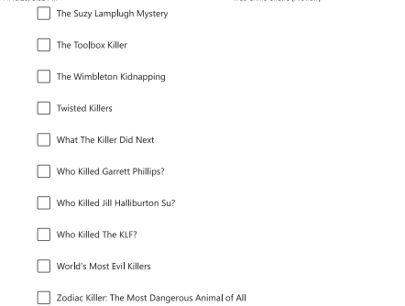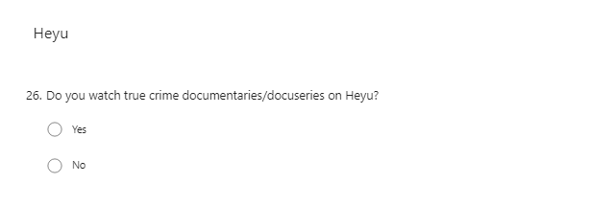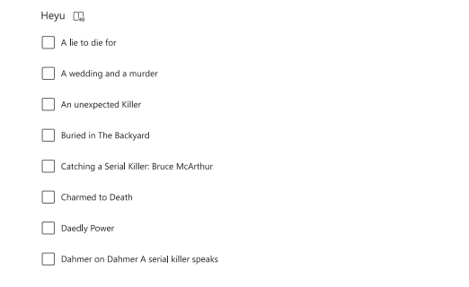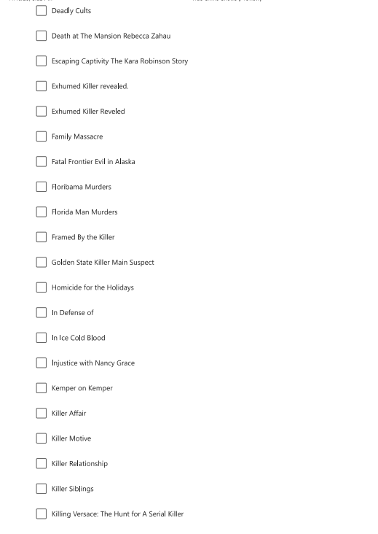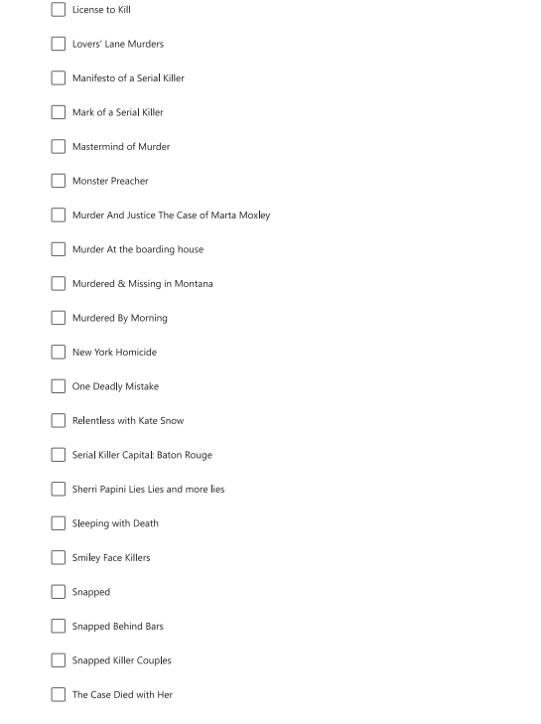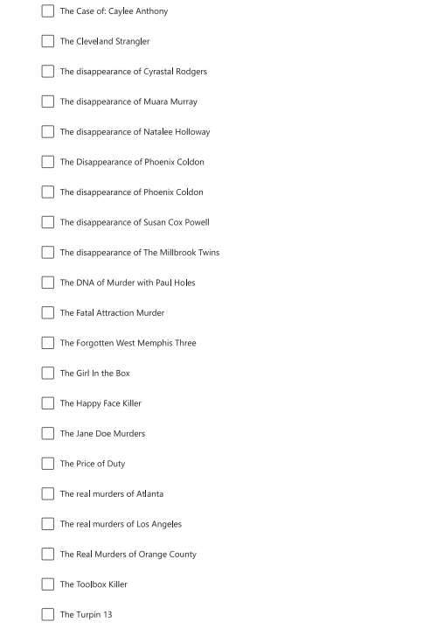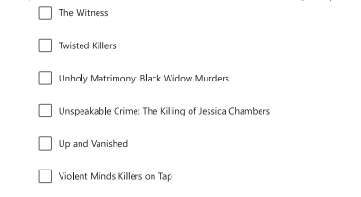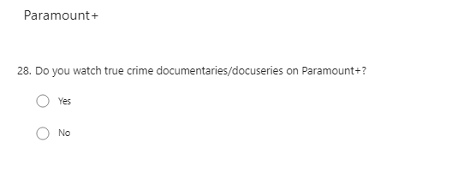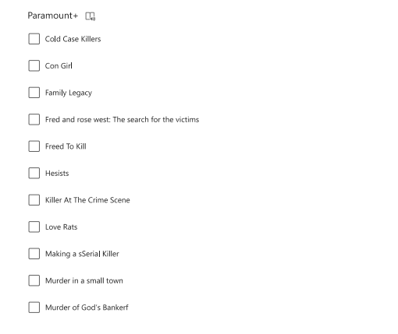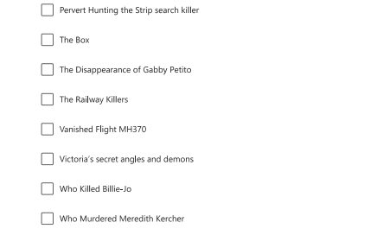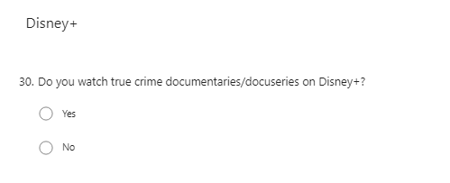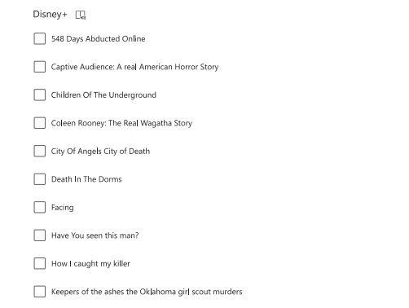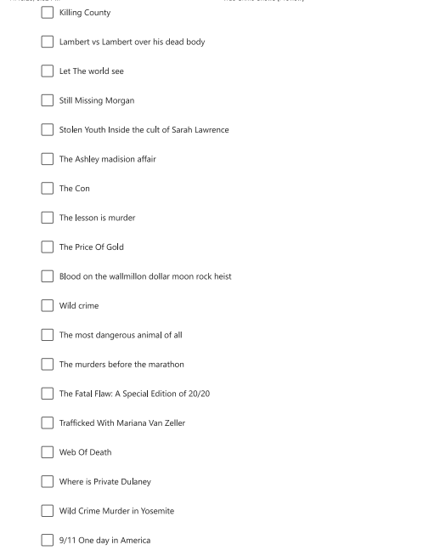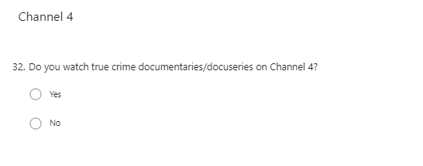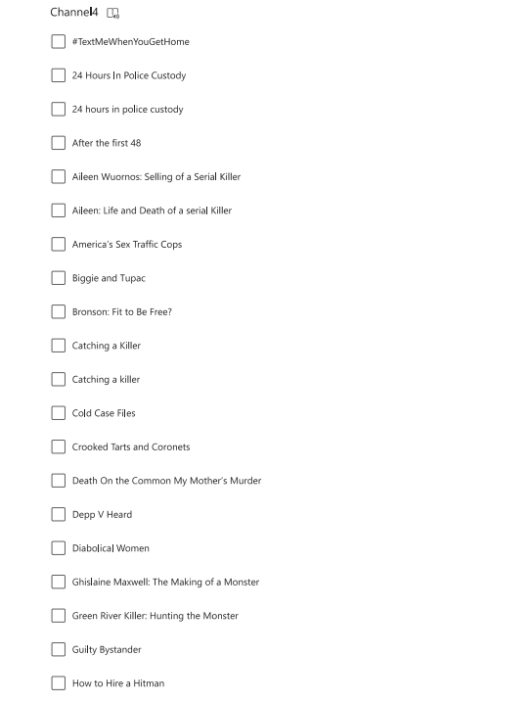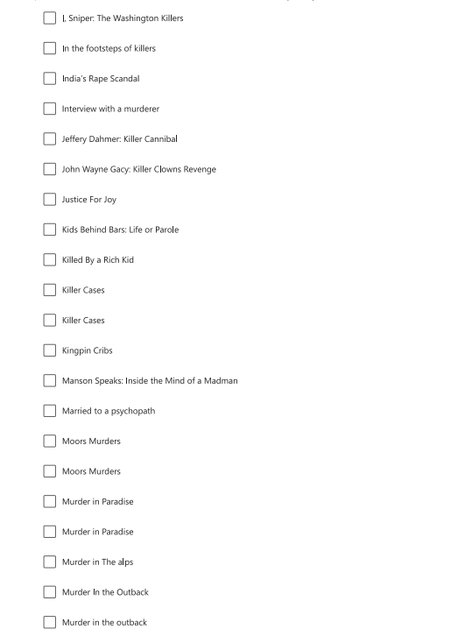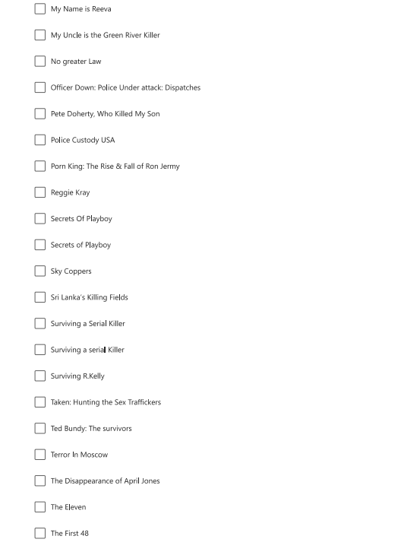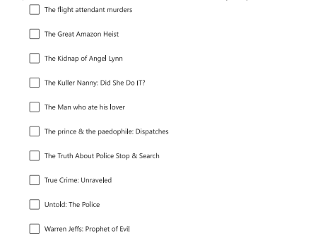
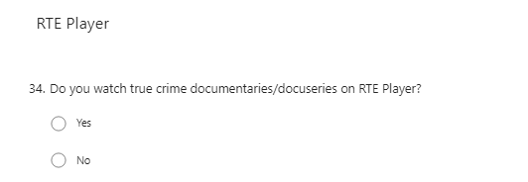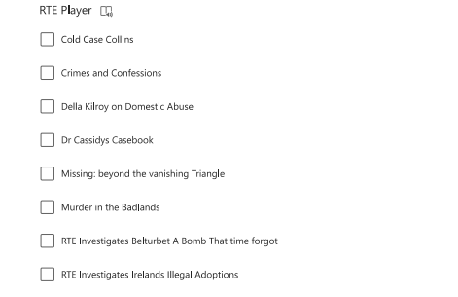
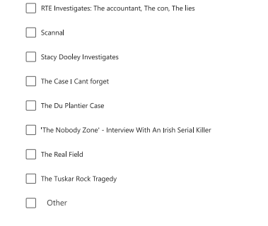
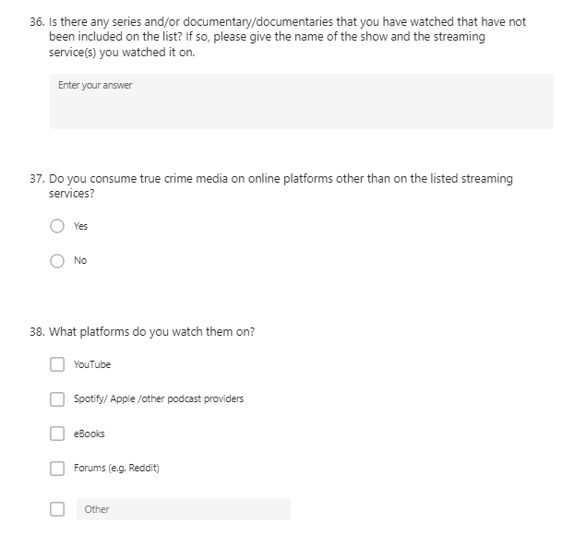

Appendix I

Cronbach’s Alpha for each Subscale of the Need For Closure
Need for Order.
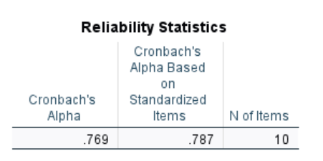
Need for Predictability
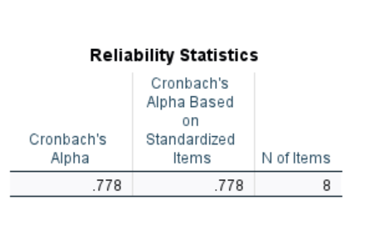
Decisiveness
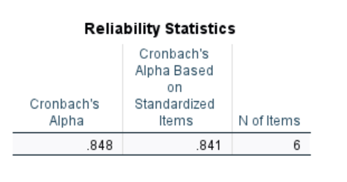
Avoidance of Ambiguity
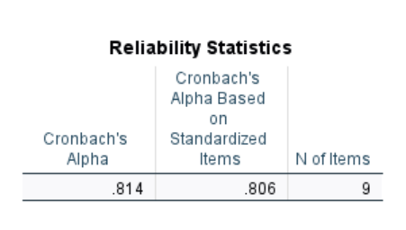

Closed-Mindedness
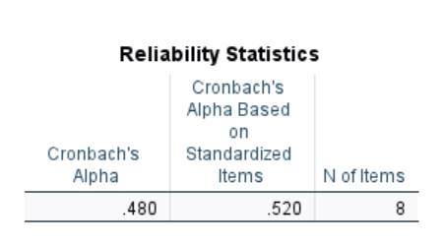

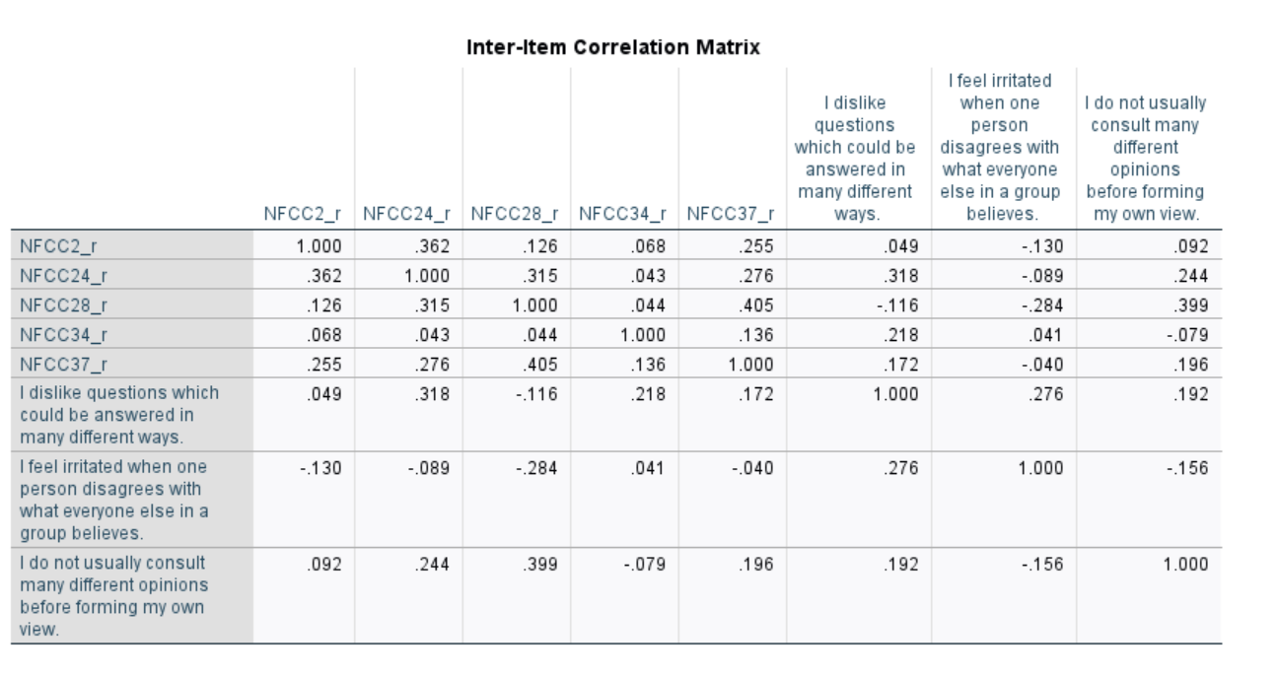

Appendix J

Cronbach’s alpha for Need for Cognition

Need for Cognition
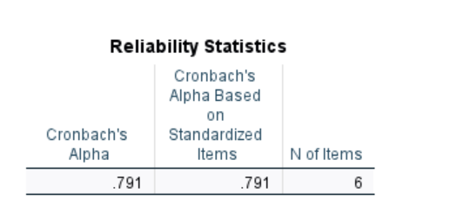

Appendix K

G*Power output for required statistical power.

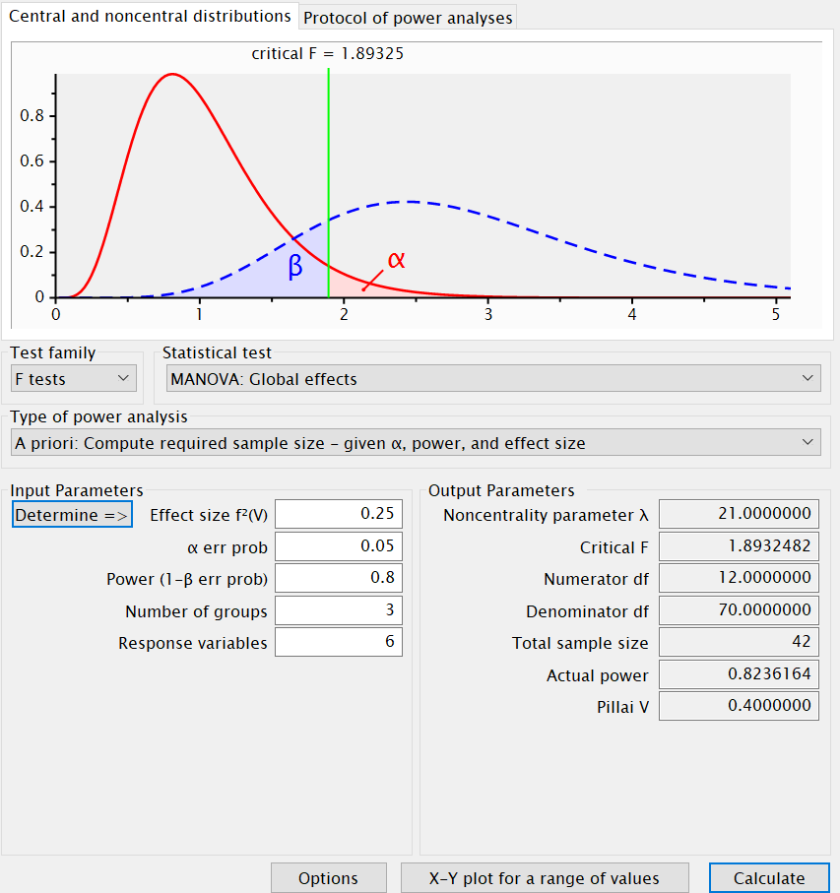

Appendix L

Box Plots after extreme outlier was removed.
Need for Order
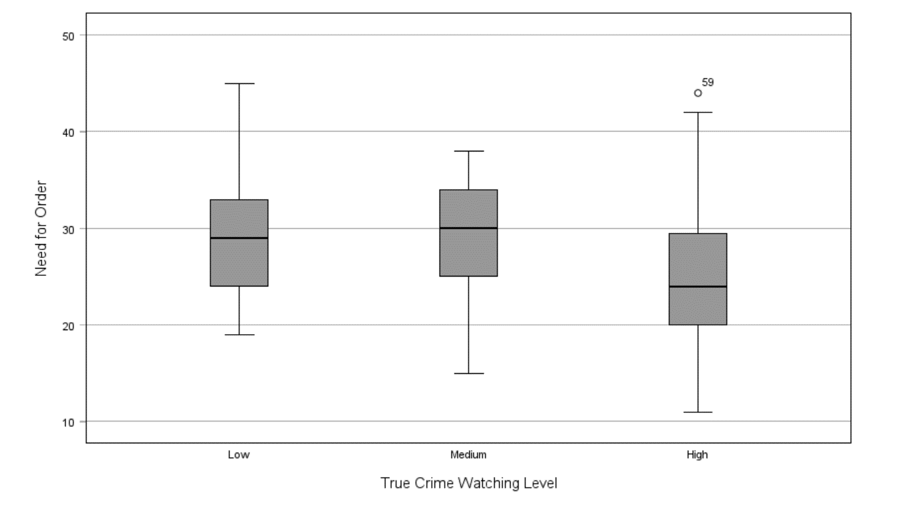
Need For Predictability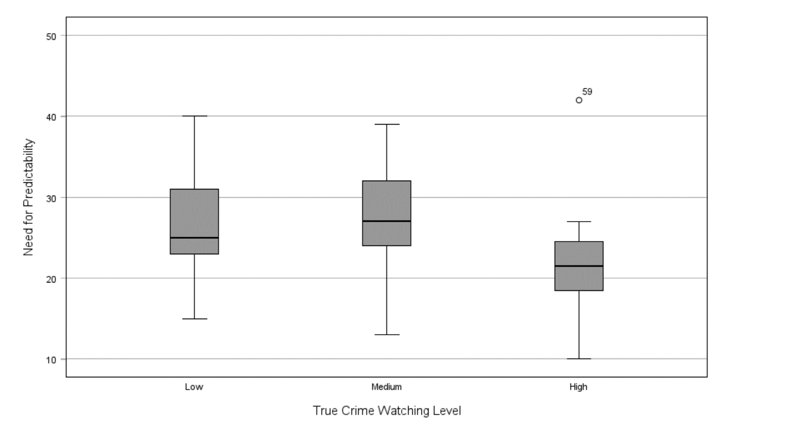

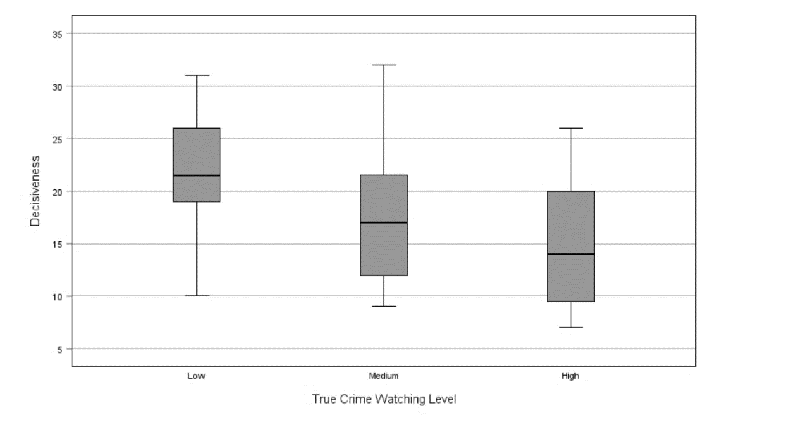
Decisiveness
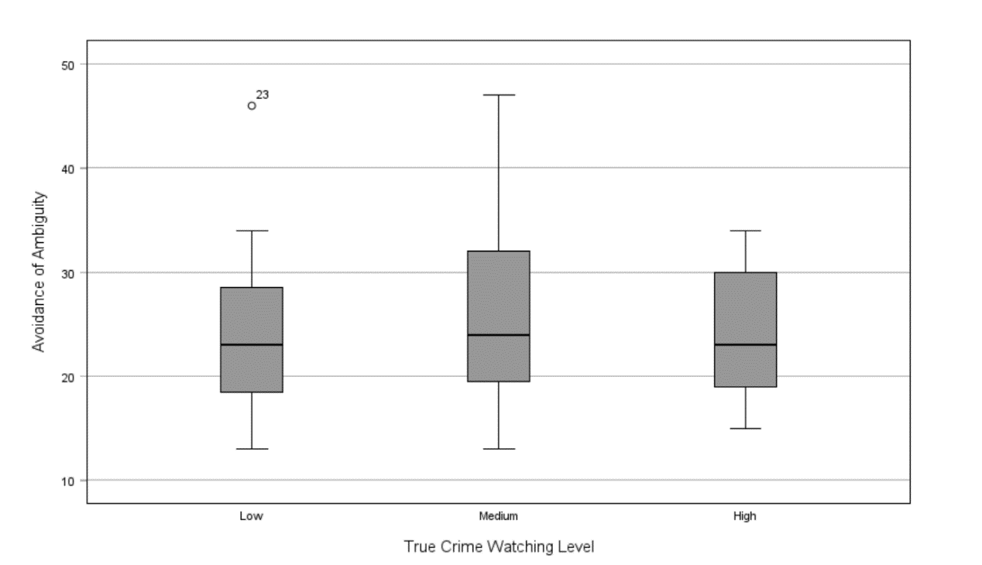
Avoidance of Ambiguity

Closed-Mindedness
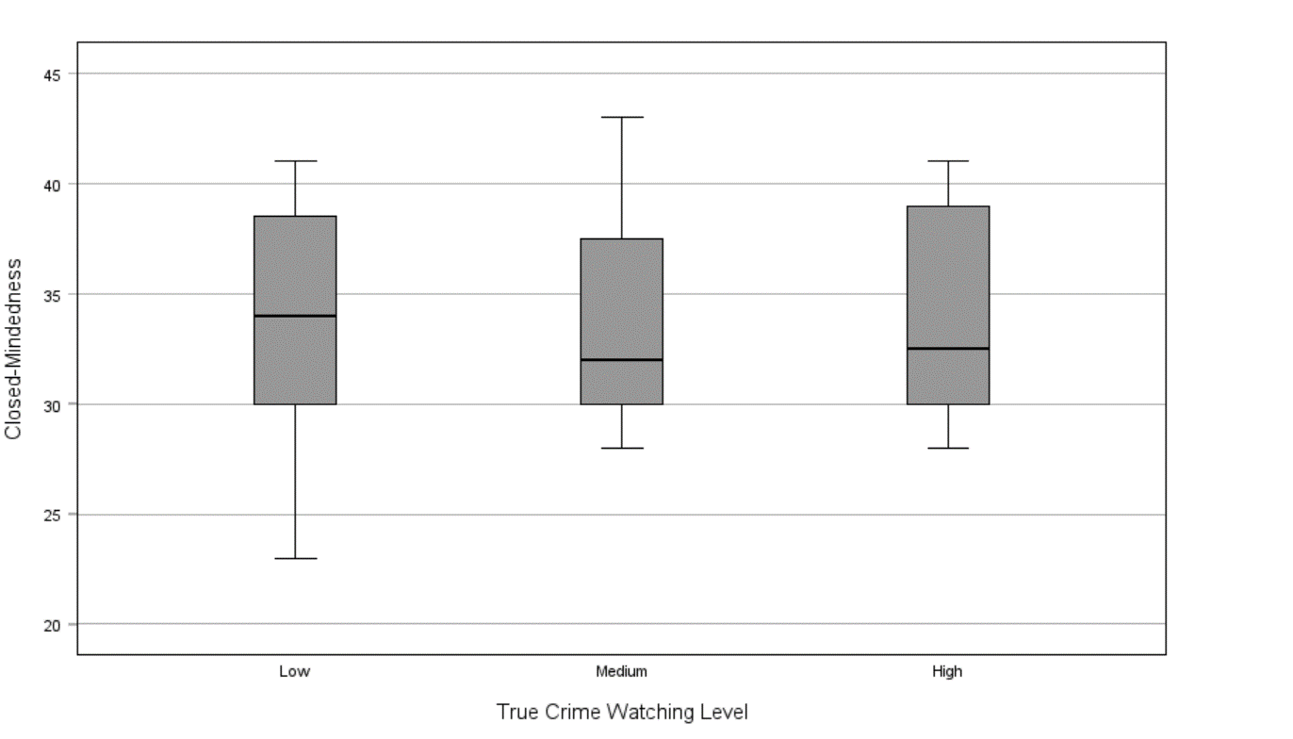
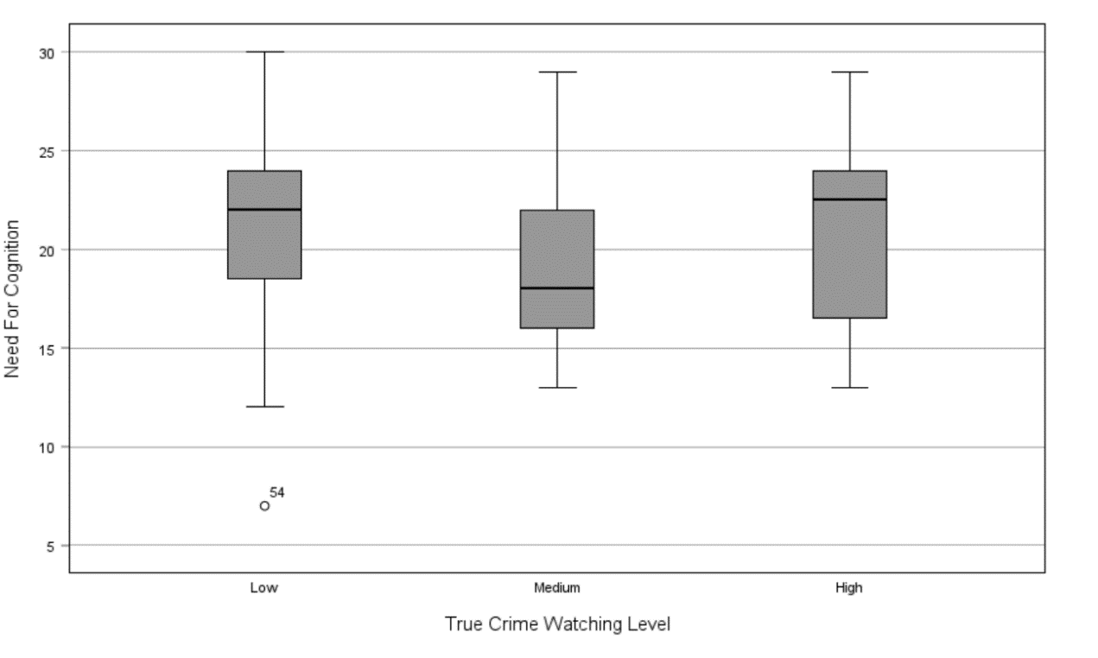
Need for Cognition

Appendix M

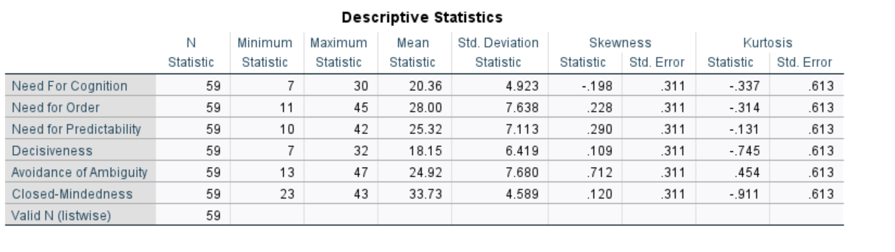
Skewness and Kurtosis for Dependent Variables

Appendix N
Correlations for Dependent Variables 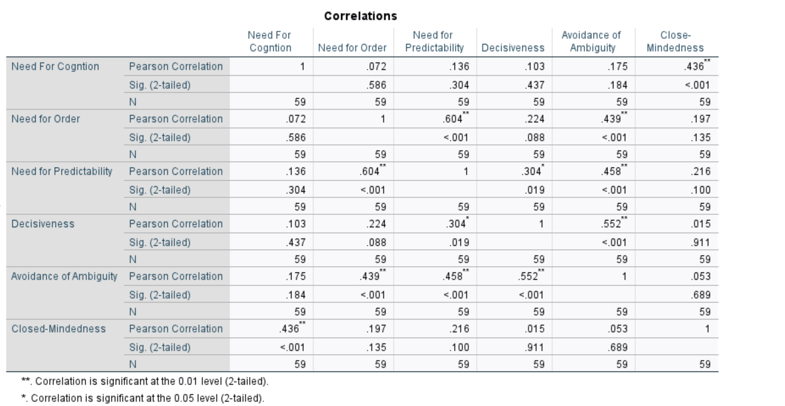

Appendix O

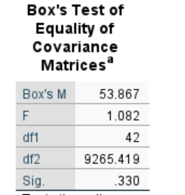
Box’s M Statistic

Appendix P

MANOVA result
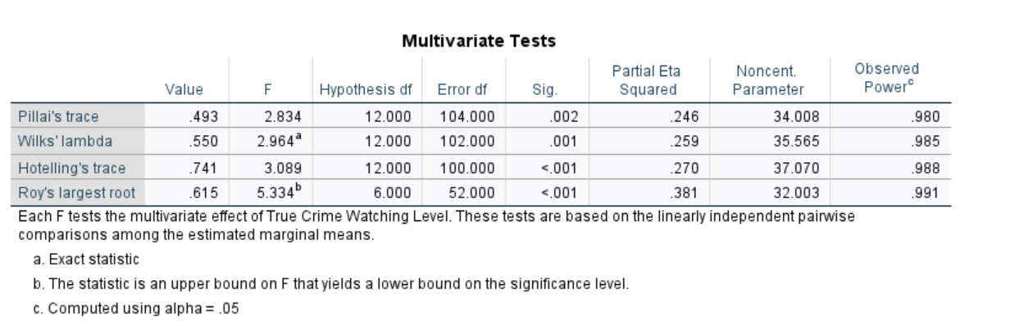

Appendix Q

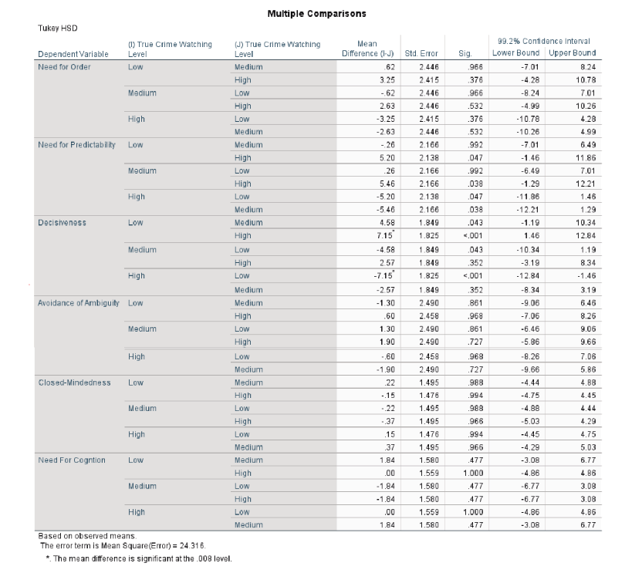
Tukey Post Hoc test

