

Exploring Real-Life Avatar Alignment with Player-Avatar Identification in Video Games

Niamh Whelan - N00200384
DL825 BSc [Hons] - Applied Psychology

Supervisor – Robert Griffin

Dissertation submitted as a requirement for the degree of BSc (Hons) in Applied Psychology, Dun Laoghaire Institute of Art, Design &Technology, 2024
Declaration
“I declare that this submission is my own work. Where I have read, consulted, and used the work of others I have acknowledged this in the text.”

Date: 07/04/2024

Signed: Niamh Whelan

Word Count: 4958

Acknowledgements

I extend my heartfelt appreciation to the dedicated staff and lecturers of IADT for their responsiveness to my inquiries and their contribution to my academic growth.

I would like to extend my sincerest thanks to my supervisor, Robert Griffin, for his unwavering support, invaluable guidance, and continuous feedback throughout the journey of this thesis.

Additionally, I am indebted to my family and friends for their enduring encouragement and belief in my endeavours.

Finally, I would like to thank all the participants of my study, this research would not be possible without their participation.

Table of Contents
Abstract 6
Introduction 7
The Landscape of Video Games 7
Literature Review 8
Identity and Virtual Identity 8
Avatar Appearance 8
Identity and Avatar Appearance 8
The Connection Between Real and Virtual 9
Psychological Dynamics in Virtual Interactions 9
Cognitive and Emotional Aspects of Player-Avatar Connection 10
Avatar Customisation and Psychological Implications 11
Variablity 12
Method 16
Research Questions 16
Hypotheses 16
Design 17
Participants 17
Materials 17
Process 18
Results 19
Table 1 19
Table 2 21
Table 3 21
Discussion 23
Appendices 25
Appendix A 25
Appendix B 26
References 37

Abstract
This research delved into the connection between how players identify with their avatars and their emotional involvement in video games. Using a cross-sectional correlational approach, data was gathered via online surveys from 38 individuals recruited through convenience and snowball sampling methods. Participants shared demographic details and rated their alignment with avatars, gaming experience, personality traits, and emotional engagement on Likert scales. The results revealed a positive link between player-avatar alignment and emotional engagement, influenced by individual traits. These findings shed light on the intricate interplay between players and their avatars in virtual worlds, offering practical insights for game development. Ethical clearance was secured, and participant treatment adhered to the guidelines outlined in the Psychological Society of Ireland’s Code of Ethics.

Introduction

The Landscape of Video Games
The realm of video games has become a platform, for delving into psychological dynamics (Koles & Nagy 2012; Nagy & Koles 2014). With than 40% of the population participating in gaming activities (Academy of Animated Art, 2022) and a gender split of 61% men and 30% women (Forbes, 2022) the impact of this trend is clear. Projections indicate a growth trajectory with an user base of 1.2 billion individuals in the Online Games market by 2027 (Statista, 2022).
At the heart of this subject lies the connection between players and their virtual avatars acting as avenues for self-expression and identity development (Koles & Nagy 2012; Nagy & Koles 2014). This bond highlights the intricacies of interaction within realms.
This study aims to explore elements. It aims to shed light on the significance of examining the gaming landscape from both societal perspectives. Moreover by expanding on existing research this investigation strives to place its discoveries in the context of culture and human relationships.
Developing hypotheses and objectives based on established theories will lay a foundation, for understanding video game dynamics. Therefore ensuring that the research methodology aligns, with these hypotheses is crucial for maintaining coherence and a logical progression in collecting and analysing data.
Understanding this subject thoroughly requires delving into the interactions and psychological processes involved in player avatar identification within video game settings. The main focus is on examining how players real world physical traits align with the characteristics of their avatars. This particular topic was chosen for its significance in uncovering the mechanisms behind player character relationships, and how they influence identity formation and self-expression in virtual environments. In exploring this aspect, the aim is to contribute to existing literature on video games and provide insight into the bond between individuals and their digital representations.
Situated within the domain of gaming psychology, identity development and human computer interaction (Biocca, 1997; Klimmt et al., 2009) this research seeks to delve into the dynamics that underlie the connection between one’s self and their digital persona. The review will examine aspects such as identity versus identity, avatar appearance and potential correlations, between these two concepts.

Literature Review

Identity and Virtual Identity
Studies have revealed that people often develop connections, to their representations referred to as avatars in gaming worlds (Freeman & Maloney 2021). These avatars act as reflections of oneself. Can impact how users view themselves and behave in spaces (Christoph et al., 2010). For example, individuals might project elements of their identities onto their avatars resulting in feelings of empowerment and self-improvement (Jin, 2009). It is crucial to grasp the intricacies of identity formation in video games to understand the mechanisms, behind player avatar identification. How it influences self-perception and social interactions.

Avatar Appearance
Avatar customisation is an aspect of expressing oneself and projecting identity, within gaming communities. Players often dedicate time and effort to create avatars that mirror their self-image and social persona. Research indicates that the appearance of avatars can impact users’ attitudes, behaviours and emotional experiences in environments. Moreover, personalising avatars has been linked to heightened immersion and enjoyment in video game settings. Understanding the reasons behind selections and the psychological processes involved in customisation is essential for exploring how avatars influence player avatar connection and self-expression, in gaming environments.

Identity and Avatar Appearance
People often like to create representations of themselves that mirror how they look in life or how they wish to appear (Trepte et al., 2009). The resemblance, between a person’s appearance and their avatar can impact how they see themselves interact with others and experience emotions in settings (Nosek et al., 2016; Lee et al., 2021). Moreover the way an avatar looks has been connected to how individuals think and behave affecting aspects like self-confidence concerns about body image and performance in activities (Kocur et al., 2020; Park, 2017; Peña et al., 2016).
Recognising the connection between a person’s attributes and their avatars visual representation is crucial for understanding the processes involved in identifying with game characters and its significance, for shaping ones identity and expressing oneself while gaming.

The Connection Between Real and Virtual
This study explores how the physical traits of players, in life are linked to the attributes of their avatars in games. By investigating this correlation and its impact on the bond between players and their avatars the study aims to provide insights into how player avatar interactions function in worlds. Through an approach this research seeks to expand upon existing knowledge on design. Insights from studies like those conducted by Kocur et al. (2020) Lee et al. (2021) Liew et al. (2018) Lin and Wang (2014) and Nosek et al. (2016) offer perspectives on the intricacies of player avatar connections paving the way for a deeper comprehension of the psychological processes involved in avatar creation and identity development within virtual realms.
These discoveries contribute to a understanding of how players real life identities intersect with their virtual personas emphasising the importance of customising avatars fostering social bonds and implementing interventions that enhance self-esteem in virtual settings.
Respondents will be asked to complete a survey where they will share information about customising their in game avatars and express their feelings regarding connection and resemblance, with their counterparts.
The research aims to explore the aspects that impact how players relate to their avatars, in video games shedding light on the bond between ones physical self and its digital counterpart.
What role does the resemblance between a players appearance and their virtual avatar play in shaping their connection, with their character?

Psychological Dynamics in Virtual Interactions
This study investigated how individuals perceive themselves in environments with a focus, on understanding identity expression and emotional engagement in realms. To explore this further it is important to review existing research.
In the world of video games, the connection between a players perception of their real world characteristics and there in game avatar becomes an area of interest. This link highlights the relationship between players physical identities and the virtual characters they control, prompting an examination of the emotional processes involved in player avatar interactions. Drawing from established theories this exploration seeks to navigate the complex dynamics of avatars and self-perception to uncover the various aspects of identity formation, within gaming environments.
Additionally, research conducted by Park (2017) Peña et al. (2016) Trepte et al., (2009) and Yee et al., Has contributed insights into this topic.
In 2007 more insights were provided on how people react to bodies the impact of avatar body size, on physical activity gamers approaches to creating avatars based on gender and sex and the continued influence of societal norms in virtual online spaces.
These findings enhance our comprehension of the interaction between players and their avatars as the effects, on shaping identity and emotional involvement in digital worlds.

Cognitive and Emotional Aspects of Player-Avatar Connection
Exploring the relationship, between gamers and their virtual alter egos reveals an issue that encompasses both cognitive and emotional aspects. Understanding how players reconcile their selves with their avatars mentally while also considering the emotional bonds formed in virtual gaming realms sheds light on the impact of identity alignment in cyberspace. Players consciously project aspects of their identities onto their personas creating a significant intersection where self-perception merges with digital representation influencing their sense of connection to the character. This exploration goes beyond surface level analysis of gaming sociology.
A study by Kumar et al. (2008) delved into how individuals construct and express their identities in environments highlighting the importance of forming ties within digital spaces. As users navigate their identities emotions play a role in shaping this intricate process. The correlation, between real life characteristics and avatar traits holds significance in this context.
Studying the origins and evolution of these connections not enhances our understanding of gaming psychology but also links to broader psychological areas such, as identity, emotions and human computer interaction. While emphasising the importance of establishing bonds in realms the researcher could delve deeper into specific participant demographics like age groups or levels of gaming expertise. Although exploring connections in shaping identities is valuable the study could offer more insights by specifying the number of participants involved and addressing any potential demographic biases. Furthermore a thorough analysis of participants emotional experiences could enrich the comprehensiveness.
Moreover while underscoring the significance of real life characteristics influencing avatar traits it would be beneficial for the paper to engage in a nuanced discussion on how this correlation impacts groups within the gaming community. Despite these considerations it significantly contributes to our comprehension of gaming psychology and its intersection with realms such as identity development and psychological processes, in human computer interactions.
The mental and emotional aspects tied to gaming encounters are meticulously examined, as demonstrated by Klimmt et al.s (2009) research. This study also intersects with identity formation within the realm of self-representation (Biocca, 1997).By delving into the aspects of creating identities through avatars in digital immersive gaming environments this study, along with the field of human computer interaction provides a comprehensive insight into how individuals engage with and mold their virtual characters (Nagy & Koles 2014; Green Hamann & Sherblom 2013; Hoffner & Buchanan 2005; Konijn & Hoorn 2005). The fusion of these diverse disciplines aids in gaining an understanding of the psychology that underlies the concept of player avatar connection.

Avatar Customisation and Psychological Implications
Understanding how players relate to their, in game characters involves studying the characteristics of real-life players. Attributes such as height, body shape and facial features play a role in how players project themselves into the world according to Hoffner & Buchanan (2005).
The ability to customise avatars within games is an element as noted by Green Hamann & Sherblom (2013). Players utilise these representations to express themselves creating identities they aspire to embody or exploring facets of their personalities. Another important aspect is the choices players make in altering their avatars and the reasons behind those decisions as discussed by Konijn & Hoorn (2005).
Advancements in technology have greatly enhanced creation fidelity in years. Platforms like ReadyPlayer.me highlight this progress, by offering users customisation options and lifelike avatars. Leveraging AI algorithms ReadyPlayer.me creates detailed avatars that closely resemble their real-life counterparts. Users can meticulously personalise features of their avatars with accuracy and detail.
Virtual reality platforms, like VRChat have taken customisation to heights offering users a wide range of tools to craft unique digital personas. Games such as Baldur’s Gate and The Sims 4 are renowned for their character customisation options allowing players to create avatars tailored to their liking. These innovations do not enhance the appeal of avatars but also enhance the immersive experience within virtual environments. Additionally, the user friendly interfaces and accessibility of these platforms make avatar creation more inclusive enabling people from backgrounds to express themselves in digital realms. In essence the advancement in avatar fidelity represents a milestone, in merging technology with self-expression influencing identity and social interactions in meaningful ways.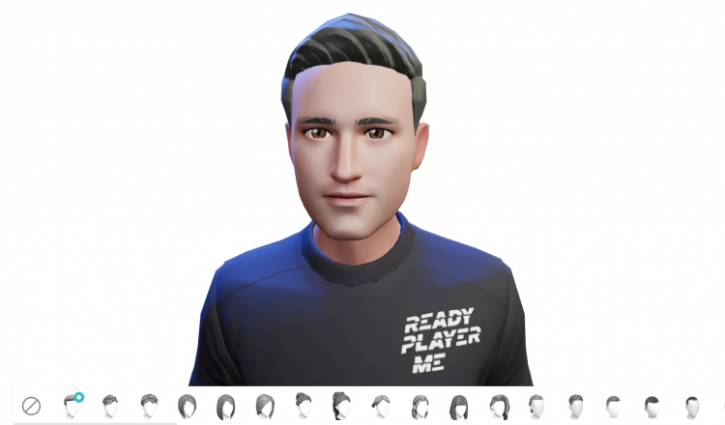
Appendix A

The integration of players real life characteristics, into their avatars has garnered significant attention in scientific research. Research in this field seeks to understand how players relate their selves to the personas they maneuver. Several studies have delved into the impact of customising avatars on involvement, self-perception and the bond, between the player and the avatar (Banks, 2015; Downs et al., 2019; Freeman & Maloney 2021).

Variablity
Lin and Wangs research, in 2014 offered insights into how players who closely resembled their avatars experienced emotional connections in gaming. However, to make the findings widely applicable it would be beneficial to include an more diverse group of participants. Relying solely on self-reported emotions could introduce biases so exploring measures of responses is recommended.
In contrast Downs et al (2019) explored the dynamics of player avatar identification uncovering how players relationships with their avatars impact their gaming experiences. While their work contributes significantly to understanding player avatar interactions it's important to recognise limitations in measuring self-identification. Future studies could investigate how individual differences like personality traits or gaming experience influence the connection between player avatar identification and gaming outcomes.
Together these studies highlight the relationship between user avatar representation and emotional engagement in gaming emphasising the nature of avatar portrayal, in gaming environments.
Despite the contributions made there is room, for research to address certain methodological limitations and delve into additional variables. This would lead to a understanding of the dynamics between players and their avatars in virtual worlds.
Studying how players physical characteristics influence their connection within game characters sheds light on the bonds formed within environments. The goal of this research area is to determine if a stronger link between oneself and their virtual representation enhances engagement. For instance a study by Koles and Nagy (2012) found a correlation between players who closely resembled their avatars and reported attachment and satisfaction in the immersive gaming world.
Examining the features of in game avatars and the level of user character identification provides insight into the emotional impact of avatar personalisation. Downs et al. (2019) showed that players who extensively customised their avatars felt a connection, with their counterparts. This underscores the value associated with shaping and personalising one’s depiction.
Previous studies that consider all three factors present a view of how life physical traits, avatar attributes and player avatar identification strength intersect. Nagy and Koles (2014) conducted a longitudinal analysis tracking participants who closely mirrored their selves through avatar representation.
The study not found that players stayed engaged consistently but discovered subtle changes, in how they identified with their characters over time. This deep understanding aligns with the theories proposed by Bandura (1986, 2002) Biocca (1997) Cohen (2001) and Lazarsfeld & Merton (1954) among others shedding light on the connections between players and their virtual personas.
However, while these studies provide insights into how users relate to their avatars they often encounter hurdles. Challenges like sample sizes differences in gaming experiences and the changing process of customising avatars make it difficult to draw broad conclusions. Additionally relying on self-report measures in studies introduces biases due to their subjective nature. Moreover there is a shortage of long term studies exploring the relationship between players and their virtual identities (Liew et al., 2018).
Research into the attributes of in game avatars and the depth of players emotional connection with them uncovers a web of psychological experiences within video games. Each element, from characteristics, to player identification impacts aspects of the player avatar bond (Fox, J., Gilbert, M., & Tang W. Y. (2018)).
When considering all three aspects together a more, in depth comprehension of the interaction between ourselves and digital counterparts emerges. Although there were challenges in the way the studies were carried out and areas that require exploration these research findings collectively push forward our understanding of player avatar connection to a nuanced level.
The existing body of work on how players form bonds with their avatars lays the groundwork for understanding how physical attributes in the world characteristics of in game avatars and the intensity of identification intertwine. However there remains a gap in knowledge regarding how specific combinations of these elements may impact engagement and the depth of attachment in gaming. While individual studies have examined how real life traits and avatar attributes influence the connection to one’s self independently there is an absence of thorough exploration into how these elements along, with overall identification strength contribute to this dynamic.

Appendix B
The practical implications of this research hold importance especially given the rise, in popularity of avatars and their expanding uses. Notable figures like Lex Friedman and Mark Zuckerberg have emphasised the potential of the avatar creation. With avatars becoming more realistic and the metaverse expected to grow avatars will have a role in interactions and future game development. Thus, understanding the intricacies of player avatar relationships is vital, for shaping environments and improving user experiences in gaming and other areas.

Method

Research Questions
RQ1: How does alignment between self-perception and virtual avatar appearance influence engagement in virtual interactions and social activities within virtual environments?
RQ2: How do individuals' perceptions of their virtual avatars' appearance influence their self-esteem and engagement in social interactions within virtual environments?
RQ3: What is the relationship between individuals' experiences in virtual environments and their self-perception in the physical world, including comparisons between their physical appearance and their virtual avatar's appearance, as well as the influence of virtual experiences on real-life self-confidence?

Hypotheses
H1: There will be a positive correlation between individuals' ratings of the importance of their virtual avatar's visual representation and their self-perception and confidence in virtual environments.
H2: Individuals who report feeling a stronger connection to their virtual avatar's appearance will exhibit higher levels of self-esteem and engagement in social interactions within virtual environments compared to those who feel less connected to their avatar's appearance.
H3: Engagement with virtual environments will positively influence individuals' self-perception in the physical world, as evidenced by increased tendencies to compare physical appearance to virtual avatar appearance and enhanced self-confidence in real-life situations, particularly among those who rate the importance of avatar appearance highly.

The research questions and hypotheses are based on combining discoveries to investigate how players real life traits, avatar customisation and identification, with their virtual selves intersect to affect emotional engagement, in video games. This study aims to deepen our comprehension of player avatar dynamics by offering a view of the complexities involved and how they shape players interactions with their identities.

Design
The study used a cross-sectional correlational design to explore how the connection, between players and their avatars in video games affects emotional involvement. The factors studied included player avatar alignment, which compares how closely players real life characteristics match those of their in game characters as individual traits like gaming experience and personality. Emotional engagement in worlds was the focus. Participants rated their perceptions of player avatar alignment, gaming experience, personality traits and emotional engagement on a Likert scale. Then being assigned to groups participants responses were treated as continuous variables, for analysis. To ensure the accuracy and reliability of the results controls were put in place through questionnaire design and statistical assessments to address any variables that could impact the findings.

Participants
Participants (N=38) with ages ranging from 18 to 54 years (M= 29.07, SD= 8.49) were recruited using convenience and snowball sampling methods. The recruitment process involved posting the survey link on Reddit, Instagram, as well as sharing it within on SurveyCircle. The sample comprised 16 women, 13 men, 2 non-binary individuals, and 1 participant who preferred not to specify their gender. Among the participants, the majority fell into the 18-24 years age group. The majority of participants were from Ireland. 41 responses were collected; however, 3 were removed due to invalid responses. Ethical approval for the study was obtained from the Department of Technology and Psychology Ethics Committee, and participants were treated in accordance with the guidelines outlined in the Psychological Society of Ireland Code of Ethics (PSI, 2019).

Materials
The study was carried out using Microsoft Forms, a survey tool. Microsoft Forms helped in creating a questionnaire to collect responses, from participants. Participants accessed the survey online through platforms like Reddit, Instagram and SurveyCircle. The questionnaire consisted of items aimed at evaluating aspects of participants perceptions and experiences related to the research questions of the study. It included queries about participants demographic details such as age, gender and country of residence. Moreover, the survey contained Likert scale questions to gauge participants feelings, preferences and experiences concerning identity and avatar representation. The Likert scale ranged from 1 to 5 with responses indicating levels of agreement or disagreement with statements, in the survey. The survey tool was administered online allowing participants to complete it remotely at their convenience.
Pilot Test
A trial run involving three individuals was carried out to check the functionality and clarity of the survey. It took an average of four minutes for participants to complete it.

Process
Following the guidelines set by the Psychological Society of Ireland (PSI) and the Institute of Art, Design and Technology (IADT) participants were instructed to access the questionnaire through Microsoft Forms. Upon entering the survey participants were given an information sheet outlining the purpose of the study, confidentiality measures and their rights, as participants. Participants provided consent before answering questions about demographics. Each participant received an identification code to ensure confidentiality in data management. After responding to questions participants filled out the Adaptive Self Scale. The questionnaire ended with participants agreeing to participate and receiving a debriefing that expressed appreciation for their involvement. Steps were taken to reduce factors impact, on results. All procedures followed ethical guidelines established by PSI and IADT.

Results

 |  | Frequency | Percent | Valid Percent | Cumulative Percent
GENDER | Man | 13 | 40.6 | 40.6 | 40.6
GENDER | Woman | 16 | 50.0 | 50.0 | 90.6
GENDER | Non-binary | 2 | 6.3 | 6.3 | 96.9
GENDER | Prefer not to say | 6 | 3.1 | 3.1 | 100.0
GENDER | Total | 38 | 100.0 | 100.0

Table 1
This table shows how the participants, in the study identified their gender. A total of 38 people took part.
Most participants identified as women making up 50.0% of the group.
Men made up 40.6% of the participants coming in as the group.
Nonbinary individuals accounted for a portion at 6.3%.
A few participants (3.1%) opted not to specify their gender.
Overall, there is an representation of genders in the study with slightly more women than men participating. This diverse mix allows for an exploration of research questions while being inclusive of gender identities.
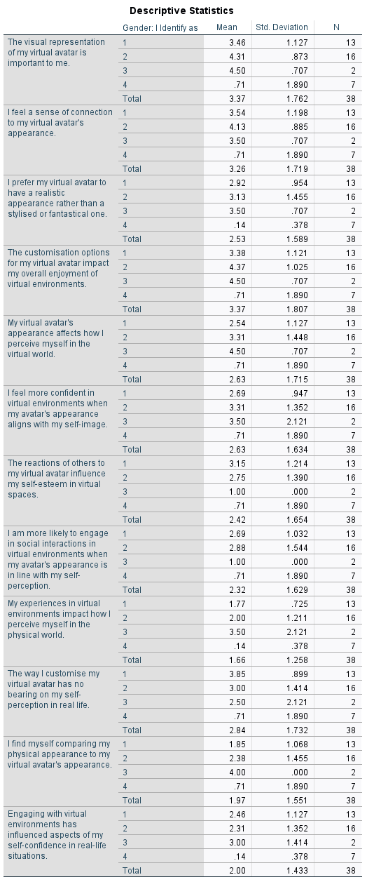

Table 2
This table displays information on how participants viewed their avatars based on statements, categorised by their gender identity. Each statement was rated from 1, to 4 on a Likert scale, where 1 represents disagreement and 4 represents agreement. An analysis was done to interpret these findings.
Most statements showed scores leaning towards agreement or strong agreement.
Participants generally agreed that the visual representation of their avatar holds significance for them creating a sense of connection, with its appearance. The customisation options available for their avatar also play a role in influencing their enjoyment of environments.
However, there were some differences in responses noted. While most participants acknowledged that their avatars appearance impacts how they perceive themselves within the realm there was less consensus on its effect on their self-image in the real world. Similarly, opinions varied regarding how others reactions to their influence their self-esteem within spaces.
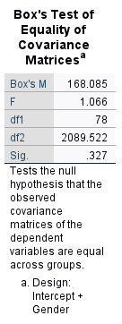

Table 3
Box’s Test of Equality of Covariance Matrices assesses whether the covariance matrices of variables are consistent across groups. In this examination Boxs M value is 168.085, with an associated F statistic of 1.066 having degrees of freedom (df1) at 78 and (df2) at 2089.522.
The p value associated with the test is.327 showing that the results are not statistically significant, at the alpha level of.05. As a result we do not reject the hypothesis indicating that there is no distinction in the covariance matrices of the dependent variables, among the groups categorised by the design encompassing both intercept and gender variables. This suggests that the assumption of covariance matrices holds true validating statistical analyses.

Discussion
The results of the study shed light on how players real life physical traits relate to their, in game avatars in the world of video games. The research aimed to uncover how aligning one’s self-perception with their virtual avatar impacts engagement in interactions the effects of individuals perceptions of their avatars appearance on self-esteem and social interactions and how experiences in virtual worlds affect self-perception in reality.
Hypothesis 1; There is a link between how individuals rate the importance of their avatars representation and their self-confidence and perception within virtual environments. The average rating for visual representation importance was 3.37 (standard deviation = 1.762).
An analysis of variance (ANOVA) was carried out to explore the connection between visual representation significance and self-confidence and perception within environments.
Hypothesis 2; People who feel a bond with their avatars appearance are likely to have levels of self-esteem and social interaction engagement in virtual settings compared to those who feel less connected to their avatars look. The average score, for feeling connected to the avatar’s appearance was 3.26 (standard deviation = 1.719).
An analysis was carried out to study how feeling connected to the avatars looks relates to self-esteem and participation, in interactions. The hypothesis suggests that involvement in worlds can have an impact on how individuals perceive themselves in real life by comparing their physical appearance to their avatars appearance and gaining confidence especially for those who value their avatars looks highly. The average rating for the influence of experiences on self-perception in the world was 1.66 (standard deviation = 1.258). Another analysis was done to investigate how engagement with environments affects self-perception in the world.
The results revealed a link between players actual physical traits matching their in-game avatars attributes and emotional involvement within virtual settings. Additionally individuals who felt closely connected to their avatars appearance reported levels of self-esteem and social interaction engagement within environments compared to those who felt less attached, to their avatars looks.
Furthermore, engaging with worlds has an impact, on how individuals see themselves in the real world. This is evident through their increased tendency to compare their appearance with that of their avatars and feel more self-assured in real life situations especially among those who place a high importance on their avatars appearance.
However, it is important to recognise limitations of the study. The sample size was relatively small. Participants were gathered using snowball sampling methods, which could restrict the applicability of the results. Additionally, the study relied on self-reported data, which may be influenced by biases and not fully capture the complexity of the concepts being studied.
Given these constraints future research should focus on replicating and expanding upon these findings using diverse samples obtained through random sampling techniques. Employing an approach could also provide insights into how player avatar alignment impacts psychological well-being and behaviour over time. Furthermore, incorporating measures like responses or behavioural observations alongside self-reported data could offer a more comprehensive understanding of this phenomenon.
In conclusion this study adds to the existing body of research on the relationship between players and avatars, in environments.
The research emphasises how crucial it is for individuals to align their self-image with their avatars appearance shedding light on how virtual identity influences peoples actions and experiences, in real life situations. Ultimately grasping the subtleties of player avatar harmony carries significance, for crafting settings and improving user interactions impacting not just gaming but a wide range of digital engagement fields.

Appendices

Appendix A

Appendix B
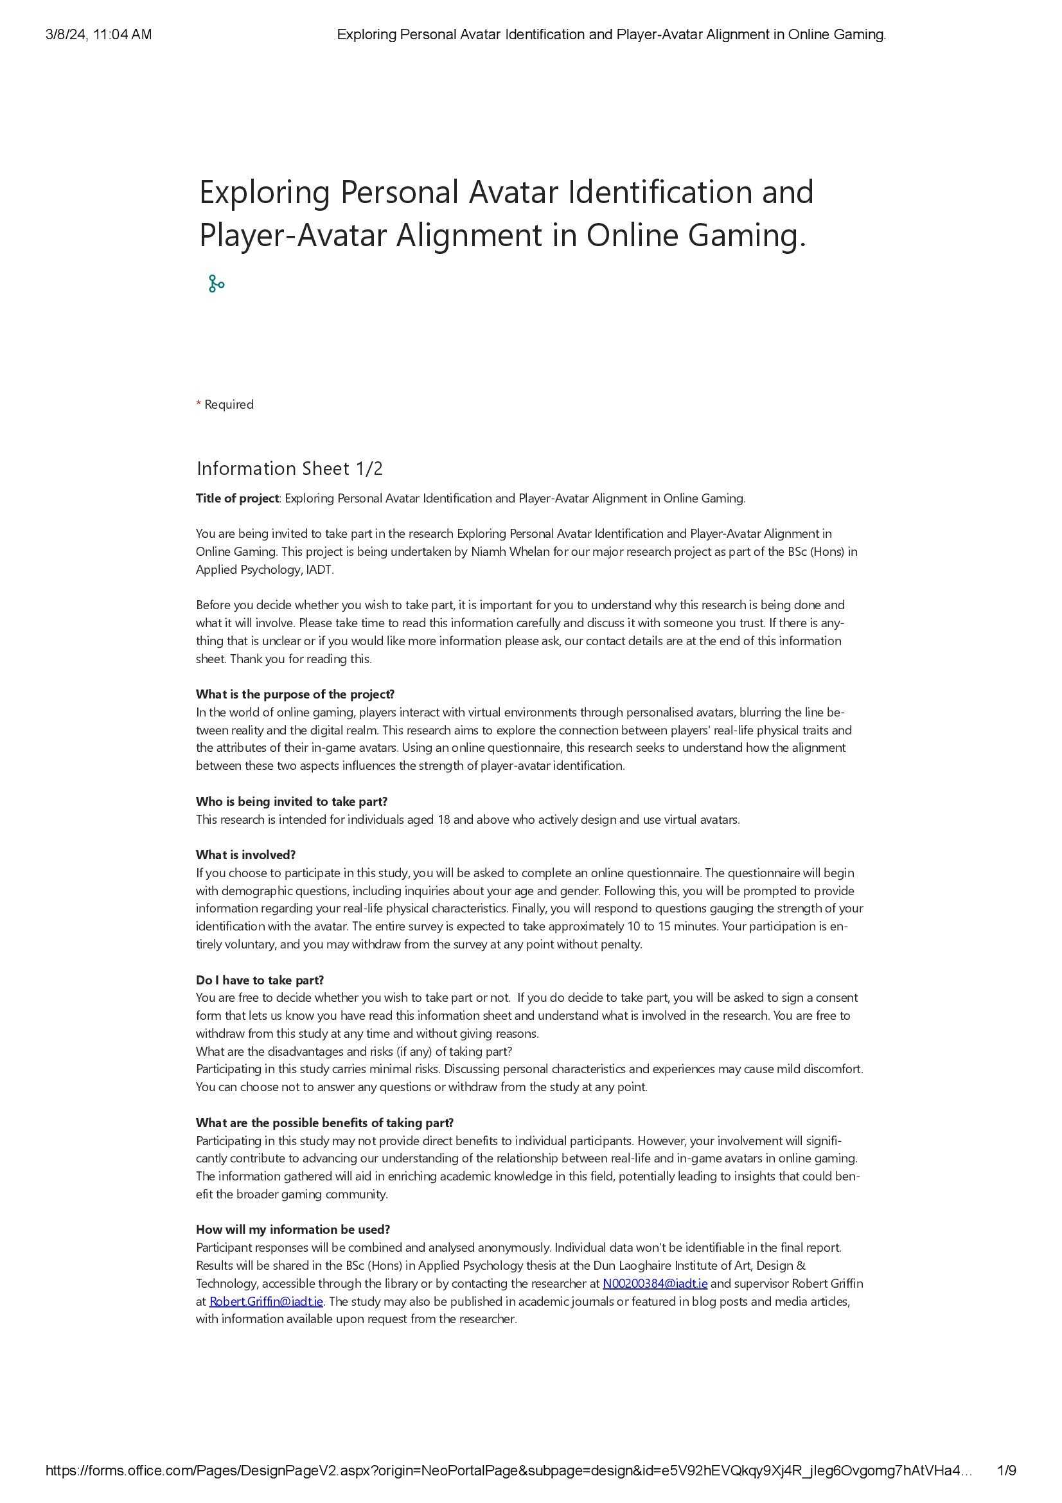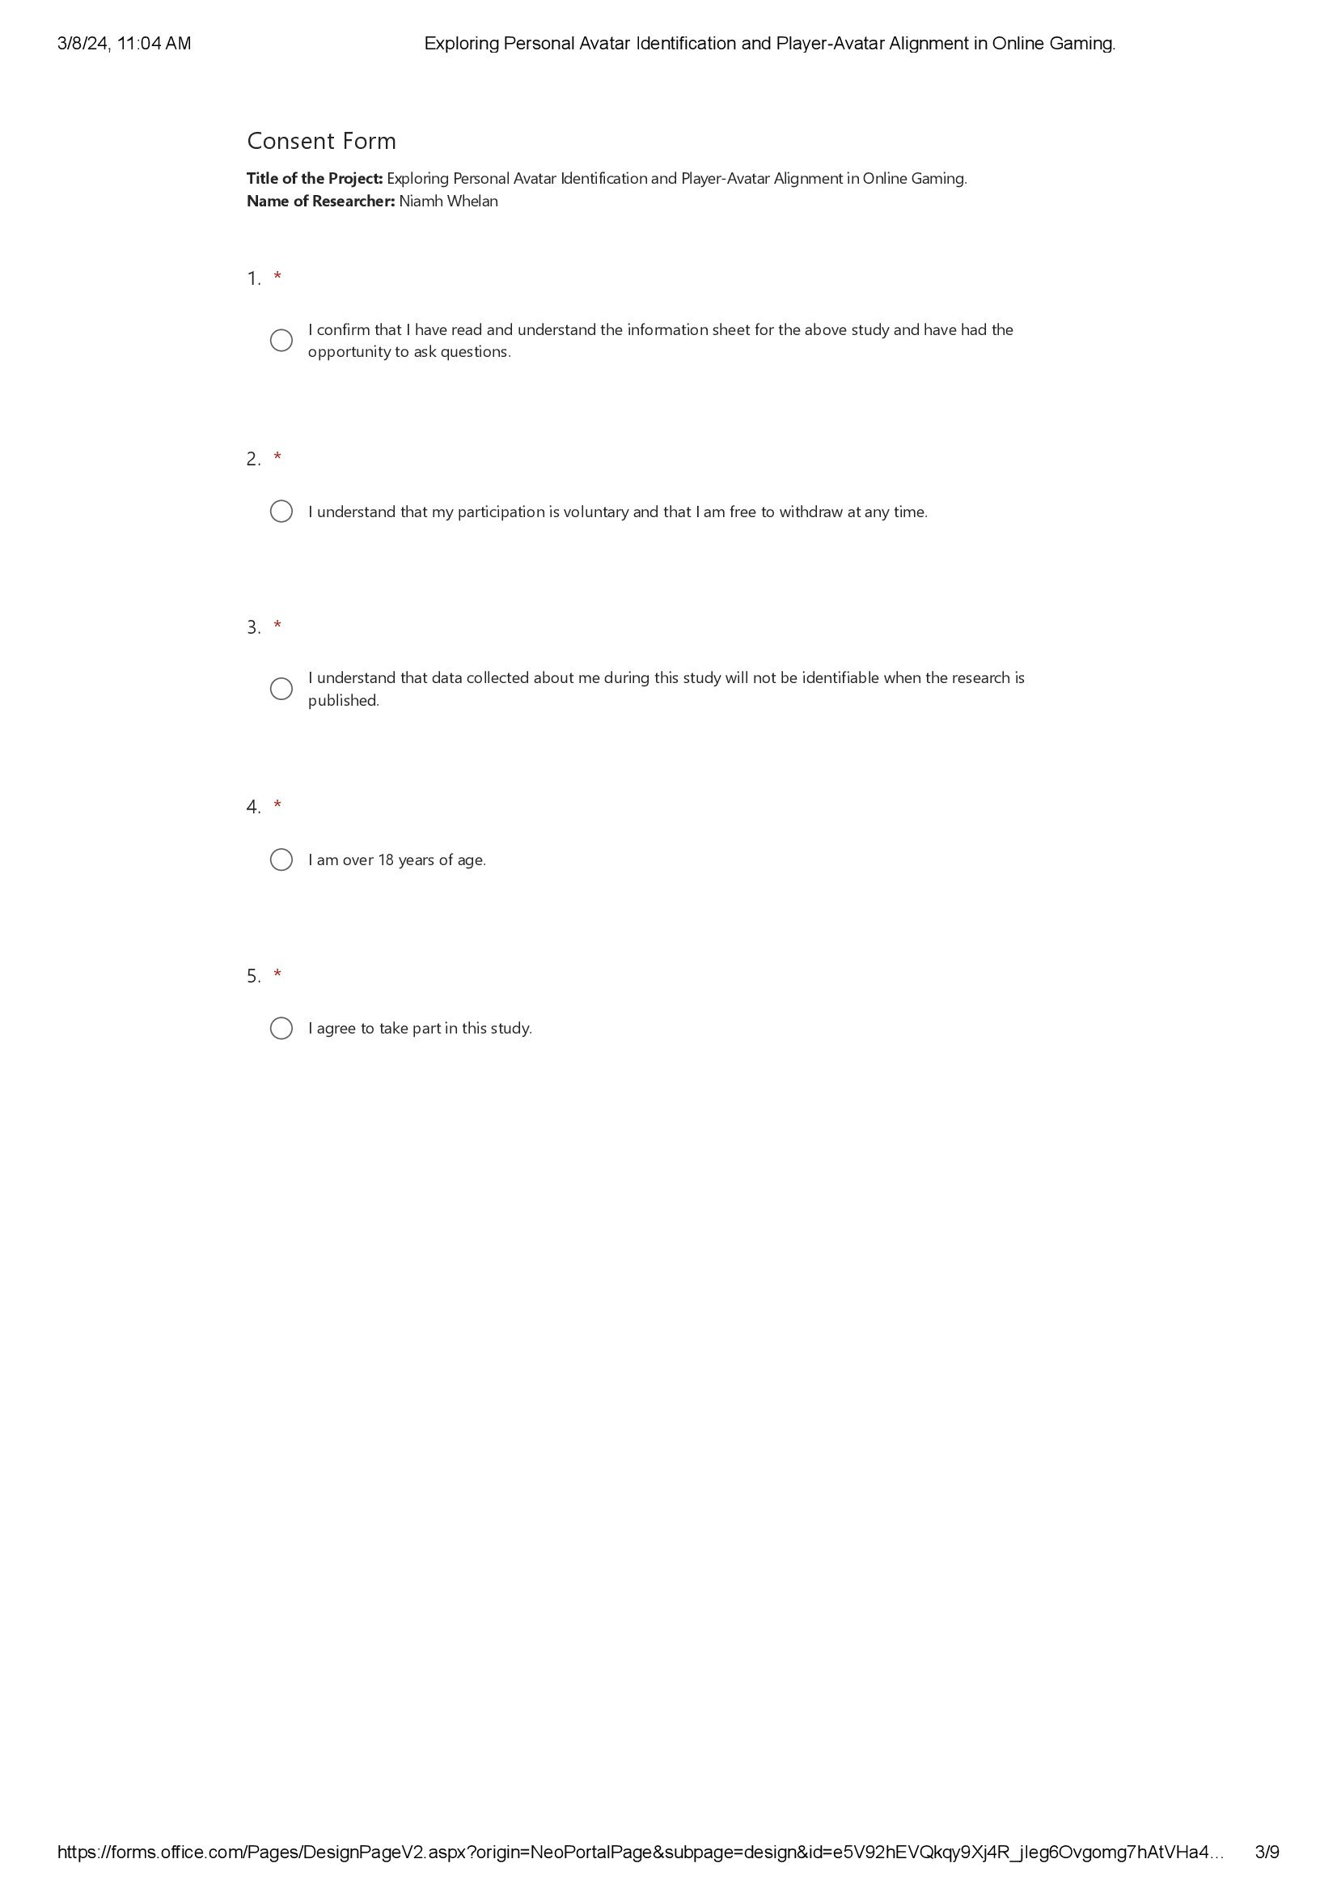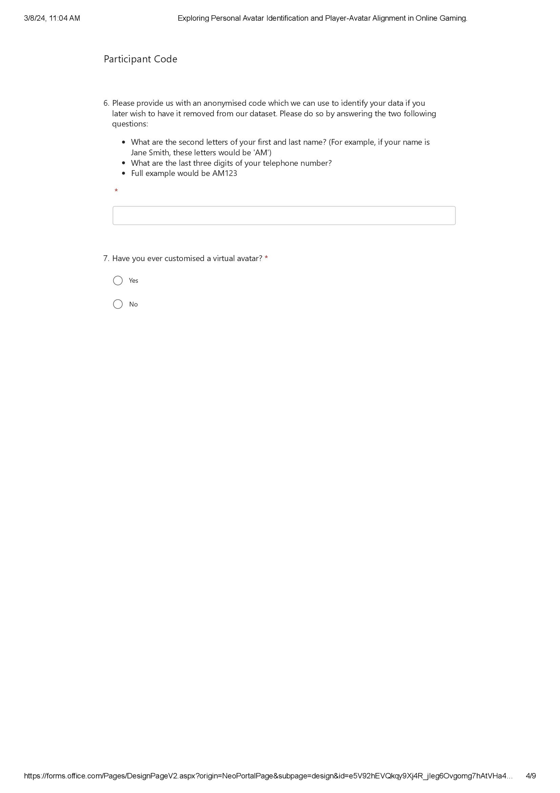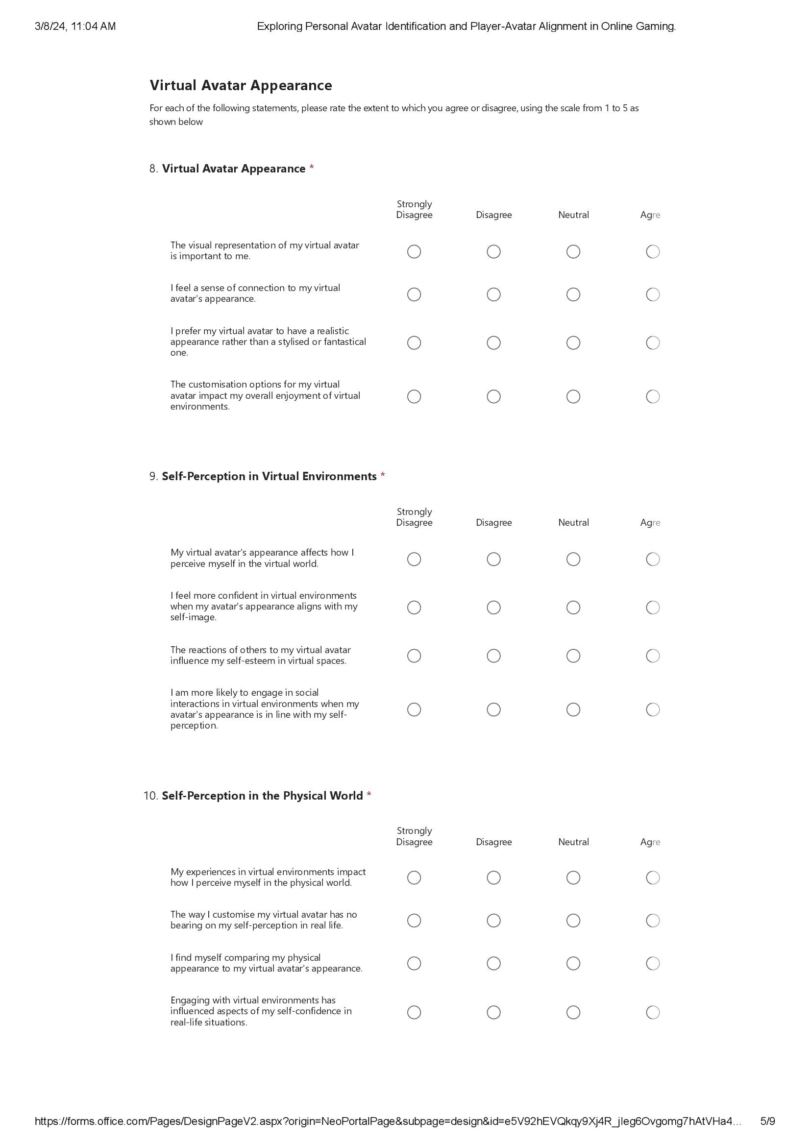

References
Atherton, S., Antley, A., Evans, N., Cernis, E., Lister, R., Dunn, G., Slater, M., & Freeman, D. (2014). Self-Confidence and Paranoia: An Experimental Study Using an Immersive Virtual Reality Social Situation. Behavioural and Cognitive Psychotherapy, 44(1), 56–64. https://doi.org/10.1017/s1352465814000496
Bandura, A., Ross, D., & Ross, S. A. (1961). Transmission of Aggression through Imitation of Aggressive models. The Journal of Abnormal and Social Psychology, 63(3), 575–582. https://doi.org/10.1037/h0045925
Banks, J. (2015). Object, Me, Symbiote, Other: A social typology of player-avatar relationships. First Monday, 20(2). https://doi.org/10.5210/fm.v20i2.5433
Barnett, J., & Coulson, M. (2010). Virtually Real: A Psychological Perspective on Massively Multiplayer Online Games. Review of General Psychology, 14(2), 167–179. https://doi.org/10.1037/a0019442
Blinka, L., & Mikuška, J. (2014). The role of social motivation and sociability of gamers in online game addiction. Cyberpsychology: Journal of Psychosocial Research on Cyberspace, 8(2). https://doi.org/10.5817/cp2014-2-6
Chen, V. (2023, August 24). Leveling Up The Gaming Gender Gap. Forbes. https://www.forbes.com/sites/forbesbusinesscouncil/2023/08/24/leveling-up-the-gaming-gender-gap/
Christoph, K., Dorothée, H., & Peter, V. (2009). The Video Game Experience as “True” Identification: A Theory of Enjoyable Alterations of Players’ Self-Perception. Communication Theory, 19(4), 351–373. https://doi.org/10.1111/j.1468-2885.2009.01347.x
Downs, E., Bowman, N. D., & Banks, J. (2019). A polythetic model of player-avatar identification: Synthesizing multiple mechanisms. Psychology of Popular Media Culture, 8(3), 269–279. https://doi.org/10.1037/ppm0000170
Farias, M., Maraldi, E., Wallenkampf, K. C., & Lucchetti, G. (2020). Adverse events in meditation practices and meditation‐based therapies: a systematic review. Acta Psychiatrica Scandinavica, 142(5). https://doi.org/10.1111/acps.13225
Fox, J., Gilbert, M., & Tang, W. Y. (2018). Player experiences in a massively multiplayer online game: A diary study of performance, motivation, and social interaction. New Media & Society, 20(11), 4056–4073. https://doi.org/10.1177/1461444818767102
Freeman, G., & Maloney, D. (2021). Body, Avatar, and Me. Proceedings of the ACM on Human-Computer Interaction, 4(CSCW3), 1–27. https://doi.org/10.1145/3432938
Harrell, D. F. (2010). Designing empowering and critical identities in social computing and gaming. CoDesign, 6(4), 187–206. https://doi.org/10.1080/15710882.2010.533183
Jin, S.-A. A. (2009). Avatars Mirroring the Actual Self versus Projecting the Ideal Self: The Effects of Self-Priming on Interactivity and Immersion in an Exergame, Wii Fit. CyberPsychology & Behavior, 12(6), 761–765. https://doi.org/10.1089/cpb.2009.0130
Katatikarn, J. (2023a, September 21). Online Gaming Statistics and Facts: The Definitive Guide (2023). Academy of Animated Art. https://academyofanimatedart.com/gaming-statistics/
Katatikarn, J. (2023b, September 21). Online Gaming Statistics and Facts: The Definitive Guide (2024). Academy of Animated Art. https://academyofanimatedart.com/gaming-statistics/#:~:text=More%20than%2040%25%20of%20the%20global%20population%20are%20gamers.&text=In%202019%20the%20world%20had
Klimmt, C., Hefner, D., Vorderer, P., Roth, C., & Blake, C. (2010). Identification With Video Game Characters as Automatic Shift of Self-Perceptions. Media Psychology, 13(4), 323–338. https://doi.org/10.1080/15213269.2010.524911
Kocur, M., Kloss, M., Schwind, V., Wolff, C., & Henze, N. (2020). Flexing Muscles in Virtual Reality: Effects of Avatars’ Muscular Appearance on Physical Performance. https://doi.org/10.1145/3410404.3414261
Lee, H.-W., Kim, S., & Uhm, J.-P. (2021). Social Virtual Reality (VR) Involvement Affects Depression When Social Connectedness and Self-Esteem Are Low: A Moderated Mediation on Well-Being. Frontiers in Psychology, 12. https://doi.org/10.3389/fpsyg.2021.753019
Liew, L. W. L., Stavropoulos, V., Adams, B. L. M., Burleigh, T. L., & Griffiths, M. D. (2018). Internet Gaming Disorder: the interplay between physical activity and user–avatar relationship. Behaviour & Information Technology, 37(6), 558–574. https://doi.org/10.1080/0144929x.2018.1464599
Lin, H., & Wang, H. (2014). Avatar creation in virtual worlds: Behaviors and motivations. Computers in Human Behavior, 34, 213–218. https://doi.org/10.1016/j.chb.2013.10.005
Nosek, M. A., Robinson-Whelen, S., Hughes, R. B., & Nosek, T. M. (2016). An Internet-based virtual reality intervention for enhancing self-esteem in women with disabilities: Results of a feasibility study. Rehabilitation Psychology, 61(4), 358–370. https://doi.org/10.1037/rep0000107
Online Games - Worldwide | Statista Market Forecast. (n.d.). Statista. https://www.statista.com/outlook/dmo/digital-media/video-games/online-games/worldwide
Park, J. (2017). Emotional reactions to the 3D virtual body and future willingness: the effects of self-esteem and social physique anxiety. Virtual Reality, 22(1), 1–11. https://doi.org/10.1007/s10055-017-0314-3
Peña, J., Khan, S., & Alexopoulos, C. (2016). I Am What I See: How Avatar and Opponent Agent Body Size Affects Physical Activity Among Men Playing Exergames. Journal of Computer-Mediated Communication, 21(3), 195–209. https://doi.org/10.1111/jcc4.12151
Trepte, S., Reinecke, L., & Behr, K.-M. (2009). Creating Virtual Alter Egos or Superheroines? Gamers’ Strategies of Avatar Creation in Terms of Gender and Sex. International Journal of Gaming and Computer-Mediated Simulations, 1(2), 52–76. https://doi.org/10.4018/jgcms.2009040104
Yee, N., Bailenson, J. N., Urbanek, M., Chang, F., & Merget, D. (2007). The Unbearable Likeness of Being Digital: The Persistence of Nonverbal Social Norms in Online Virtual Environments. CyberPsychology & Behavior, 10(1), 115–121. https://doi.org/10.1089/cpb.2006.9984

