

An RSLR analysing applicability of two theories to true crime media consumption.

Emily McQuillan
N00202104

Research supervisor:
Dr. Grainne Kirwan

Dissertation submitted as a requirement for the degree of BSc (Hons) in Applied Psychology, Dun Laoghaire Institute of Art, Design & Technology, 2024
Declaration

I declare that this submission is my own work. Where I have read, consulted, and used the work of others I have acknowledged this in the text

Word count: 6,930

Signed: Emily McQuillan Date: 7th of April 2024

Acknowledgements

I would like to give a special thank you to my research supervisor, Dr. Grainne Kirwan. Your continuous guidance, support and encouragement throughout my major research project has been immeasurable. Your patience during my times of doubt were greatly appreciated and your thorough suggestions for improvement helped me in submitting the best possible draft of my major research project.

I would also like to thank my parents, my sisters and my brother who have supported me throughout not only my final research project but, in my years, spent completing this degree. Your consistent support and words of encouragement are will be forever appreciated.

Finally, I would like to thank all of my lecturers who have taught me throughout the years completing this course, who both inspired me and also challenged me.

Table of contents

Abstract 6
1. Introduction 7
1.1 A Brief Introduction to ‘True Crime’ 7
1.2 The Rise in Popularity of True Crime 7
1.3 What is the impact of media portrayals of True Crime? 8
1.4 What is terror management theory and how does it relate to True Crime? 9
1.5 What is the Theory of Planned Behaviour and how does it relate to True Crime? 10
1.6 The current study 11
2. Method 12
2.1 Design 12
2.2 Data collection 12
Inclusion criteria: 13
Exclusion criteria: 13
2.3 Procedure 15
Phase one: Data Familiarisation 15
Phase Two: Generation of Initial codes 15
Phase Three: Generation of Themes 15
Phase Four: Reviewing Potential Themes 15
Phase Five: Refining, Defining and Naming Themes 16
Phase Six: Producing the Report 16
3. Results 17
3.1 Themes and subthemes 23
3.2 Theme one: The influence of media format on victimisation, social stereotypes, gender and perceived victimisation and True Crime as a source of empowerment. 24
3.3 Theme two: True Crime media as an educational resource into cultural and social interactions with violence. 27
3.4 Theme three: The influence of True Crime media on perception of law enforcement and the justice system. 28
4. Discussion 31
4.1 Theoretical implications 33
Terror management theory 33
Theory of planned behaviour 33
4.2 Practical implications 33
4.3 Strengths 34
4.4 Limitations 34
4.5 Future research 35
4.6 Conclusion 35
References 36
Appendices 39
Appendix A: Initial coding process sample 39
Appendix B: Initial thematic maps 42
Relationship between True Crime and fear of crime 42
How does terror management theory explain this relationship 43
How does this relationship influence attitudes and behaviours related to crime prevention and safety measures 44
Appendix C: 45

Abstract

Previous research has suggested that there is a relationship between fear of crime and true crime consumption, particularly in women. The present study aimed to answer three research questions;1.Is there a relationship between fear of crime and watching True Crime? 1a. How does terror management theory explain this relationship? And finally 1b. how does this relationship predict attitudes and behaviours related to crime prevention and safety measures? A rapid-structured literature review was carried out in order to synthesize the published articles on this topic. There were several inclusion and exclusion criterion, an example of an inclusion criteria were articles published between the years 2013-2024 and an example of exclusion criteria was duplicate articles, this left nine articles for a reflective thematic analysis. This was conducted in order to investigate the impact that True Crime consumption has on behaviours and thoughts relating to crime. The researcher identified three major themes which included: 1) the impact media format had on victimization, 2) how true crime serves as an educational resource into cultural and social interactions with violence and 3) how true crime impacts the perception of law enforcement and the justice system. A limitation was potential theoretic biases held by the researcher.

Introduction

1.1 A Brief Introduction to ‘True Crime’

True Crime is a genre of non-fiction media where the author examines “details of real crimes that involve real people” (Cambridge Dictionary, n.d.). It engages the audiences as it explores some of the behaviours, sinister or otherwise, of criminal minds. It does this by following and questioning the accuracies and inaccuracies of a criminal investigation and its outcome. This genre spans a number of media including books, documentaries, podcasts, movies, and TV shows. As described by Soto-Sanfiel and Montoya-Bermúdez (2022) societal curiosity about what is now known as ‘True Crime’ can be dated back in word of mouth from as far back as the 16th century. Although the medium in which the genre is consumed has evolved with technological advancements, the portrayal of the victims and offenders hasn’t evolved as quickly. This study will focus on the impact media portrayal has on the audience while considering two theories; Terror Management Theory and the Theory of Planned Behaviour. As the True Crime genre is ever growing in popularity, the present study aims to explain the impact in which this engagement has on its audience.

1.2 The Rise in Popularity of True Crime
In the 19th Century, literacy rates increased as new printing technology emerged. There was a rise in sensationalised journalism, and as a result public interest in the nature of criminal activity increased (Burger, 2016). As society progressed technologically, the circulation of True Crime spread from word of mouth to print media. Now in the digital era it is conveyed on a plethora of media platforms, which has garnered the genre an extensive mainstream audience. As explained by Yardley et al. (2018), podcasts only became a mainstream form of media consumption around 2014. They argued that the emergence of the True Crime podcast ‘Serial’ was responsible for the surge in popularity, with the term “the Serial effect” being coined as a way to explain the growth in popularity of an entire genre within podcasting. As a result, True Crime is the most popular podcast topic making up 24% of the top ranked podcasts (Atske 2023).

A rise in the genre’s popularity on television and streaming platforms can be driven by a number of factors, one of them being the format in which it is consumed. Historically, TV shows would be released on a weekly basis, with major broadcasting networks cultivating mass audiences using data-informed decision making. With the rise of streaming platforms such as Netflix, Disney+ and Amazon Prime, consumer habits were redefined. Specifically, when Netflix began independently commissioning their own production of media, they altered the manner in which these programmes had previously been presented to audiences. Where previously the industry standard was airing a pilot to gauge audience reactions, instead they filmed an entire series and released all of the episodes at once. This altered how it was consumed, as people were now able to determine at what pace they watched the TV show (Maher & Cake, 2023). As I will discuss at length in a subsequent paragraph regarding the Theory of Planned Behaviour, the ease at which True Crime media is consumed may factor into our understanding and prediction of peoples behaviours in relation to crime prevention and safety strategies.

According to a study by Vicary and Fraley (2010), women are more likely to consume True Crime media than men are. In a study done by Boling and Hull (2018), they found that 73% of podcast audiences for True Crime are overwhelmingly female. Women fear becoming a victim of crime more than men do, despite violent crimes being committed predominantly by men against men (Johansson & Haandrikman, 2021). As a result of this, learning what drives and causes someone to commit a violent crime might be a motivating factor in their True Crime consumption. Another factor may be that certain crimes such as rape and sexual assault are committed more frequently against women, which may heighten the fear of crime and drive them to seek out prevention strategies derived from True Crime (McDonald et al., 2021). However, whether women engage with True Crime media for entertainment purposes or strategic purposes, one must consider that engaging with True Crime media might also be the cause for such fear to begin with. In attempting to alleviate their fear of crime, True Crime consumers may instead simply learn of new ways in which they can become a victim (Vicary & Fraley, 2010).

1.3 What is the impact of media portrayals of True Crime?

When considering the impact of media on True Crime we must consider both the positives and the negatives. The purpose of True Crime is to recount crimes which were committed and the legal proceedings which follow the events (Vitis & Ryan, 2021). This brings into question how ethical the True Crime genre is for not only the victim but for the families of the victims. According to Vedric and Little (2022), True Crime often awards victimhood status to accused men rather than the women who are murdered. They argued that women victims are often erased from True Crime as there is an over representation of “dead beginnings”, where they are dead in real time and so their stories are taken over by the killers’ narratives rather than their own.

In media outlets, there have been articles published which praise True Crime media for bringing attention to ‘cold cases’, in some cases praising them for helping to bring criminals to justice (Bickerton, 2022). Another example of podcasts being used as a tool to voice injustices was two podcast investigations in Australia successfully exposed the justice system for its meagre response to allegations of child sexual abuse in large institutions (Brown , 2018). A 2020 article by Pâquet discusses how True Crime exposes police blunders, particularly in cases involving violence against women, and increases the level of accountability that police and the justice system are held to. However, according to Vitis and Ryan (2021) , in Australia where some cases that are brought to trial as a result of renewed attention following coverage in True Crime media, there have been questions raised about its interference in the criminal proceedings such as speeding up investigations and shaping court decisions.

1.4 What is terror management theory and how does it relate to True Crime?

Although it is not a thought that consumes the day of many people, humans are aware that one day they will die. We may be reminded of this in the event of the death of a loved one, exposure to death and violence in media, receiving a diagnosis for a terminal illness and so on (Lewis, 2013). In order to live a fulfilling life free from this reminder, we carry out certain behaviours and follow a set of beliefs. This theory is what is known as Terror management theory (Greenberg et al., 1986). This theory explores ways people alleviate their existential anxiety and confront their mortality by creating a meaningful life Creating a meaningful life might look like investing in a cultural belief system or worldview which instils standards to live a moral, good and prosperous life (Solomon et al., 1991).
When considering this theory in relation to True Crime consumption, one must look at mortality salience. According to the American Psychological Association dictionary (n.d.) mortality salience is defined as “awareness of the inevitability of one’s death. Terror management theory, mortality salience, coupled with death anxiety, is a motivating force behind a diverse set of actions designed to defend oneself or one’s social group when threatened”. This study aims to understand if engaging in True Crime may stem from a person's desire to understand the darker aspects of humanity and morality while also confronting and processing their own fears of morality and perhaps alleviate some of their anxiety about the fragility of life.

1.5 What is the Theory of Planned Behaviour and how does it relate to True Crime?

The theory of planned behaviour is a theory which also emerged over three decades ago by Icek Ajzen. According to Ajzen (1991) this is a theory which is intended to explain motivational influences on behaviour to determine, understand and predict behaviours. There are three conditions which need to be met for this theory in order to determine behaviour which include: 1) attitude to behaviour, 2) subjective norm, and 3) the perceived behavioural control.
Attitude to behaviour refers to any belief an individual might have that a certain behaviour or act will have a positive or negative contribution to their life. In the case of True Crime, this study aims to investigate whether one might believe that consuming True Crime media contributes positively to one’s life as it is believed that it helps in personal risk mitigation. The present study also aims to examine whether True Crime media consumers might perceive that their consumption contributes positively to their lives as it provides an emotional outlet to audiences. A study by Boling (2023), which involved interviewing podcast hosts, talked about the engagement of their listeners which came in the form of contacting the hosts with their own experience as the victim or target of a crime and so the theory of planned behaviour may predict this listener engagement. Additionally, True Crime media might have a high entertainment value to the consumer and contribute positively to their life by fulfilling their intellectual appetite for understanding real life unsolved mysteries which will be examined in this study.

When considering the latter two criteria subjective norm and perceived behavioural control, they could be considered to overlap closely in practice. Subjective norm refers to the wider social group’s beliefs or cultural norms and perceived behavioural control refers to how easy or how hard it is believed to be to display a certain behaviour (Ajzen, 1991). In the case of True Crime media, this study aims to examine whether shifts in social values and norms might make the media in question easier to discuss and promote. It might be considered more socially acceptable to reference one’s interest in the subject matter, due to a weakening in the taboo against morbid topics. This study aims to understand whether there could be possible changes in the norms in criminal reporting which could also contribute to generating more True Crime media, by making information more readily available. Relatedly, technological changes in media formats and platforms might lower the barriers to entry to access True Crime media and increase its visibility. This increased visibility may alter the perceived ease with which one might engage in True Crime consumption. This is borne out by the fact that not only is True Crime media available on major platforms, but it also tends to be the most popular available media on them. Both could work in tandem to promote greater consumption of True Crime media which this study is set out to determine. If all of these conditions are met, it is the best predictor for the person’s behavioural intention.

1.6 The current study

As women are consume more True Crime media than men (Vicary & Fraley, 2010) and are more likely to be portrayed as the victim (Vedric & Little, 2022). Despite being less likely to be victims of violent crimes than men, women have a higher fear of crime than men (Johansson & Haandrikman, 2021). When considering this, one must look at the relationship between True Crime media and fear of crime. When considering the content of True Crime, True Crime media focuses on stories which are dark in nature. This has the potential to cause existential anxiety in its audience (Lewis, 2013). This study aims to understand whether Terror Management theory can explain why people are drawn to True Crime despite narratives depicted. Finally, this present study aims to understand whether the Theory of Planned behaviour can predict the motivations in engaging in True Crime media.

The research questions under investigation are:
RQ 1: Is there a relationship between fear of crime and watching True Crime?
RQ 1a: How does terror management theory explain this relationship?
RQ1b: How does this relationship predict attitudes and behaviours related to crime prevention and safety measures?

Method

2.1 Design

A rapid-structured literature review (RSLR) and Braun and Clarkes reflective thematic analysis (Braun & Clarke, 2021) was employed to investigate the relationship between the consumption of True Crime media and fear of crime. The purpose of the RSLR is to synthesize research findings published across various databases to identify if a relationship between True Crime consumption and fear of crime exists. Articles included in the search were peer reviewed empirical articles with a time parameter between 2013-2024. This twelve-year timeframe was to ensure that the effect of the release of streaming platforms such as “Netflix” were considered in this analysis. Following the RSLR, a thematic analysis was employed on the remaining articles in order to identify and understand the potential impact this relationship has on a person’s behaviour and attitude. A limitation of this chosen research design includes the use of secondary research rather than primary research. This is a limitation as the research may not directly answer the chosen research questions. The use of secondary research over primary research is due to the sensitive topic, as it would not be granted ethical approval.

2.2 Data collection

Before data collection occurred, a green route ethics application was submitted to the Psychology Ethics Committee (PEC) at Dun Laoghaire Institute of Art Design and Technology (IADT). As there is no direct contact with participants the application was approved by the PEC.

An internet search of four data bases were used to find the relevant articles for review. Databases include SAGE journals premier, Taylor & Francis, EBSCO academic search complete and PsychINFO. The databases were accessed through the IADT library. The website “Notion” was used to keep track of articles which were included. Search terms for the databases included the terms “True Crime”, “fear of crime” and “behaviour”. Each search term was searched simultaneously through ‘advanced search’, at this point the time parameter and the option for ‘peer reviewed’ articles was also selected see figure 1 below for flowchart of the search process.

Key articles for review were determined by the following inclusion and exclusion criteria.

Inclusion criteria:

- Studies which were published from the year 2013-2024
- Peer reviewed empirical journal articles.
- Published in English
- Studies which focused on true crime in technological media for example podcasts, movies, TV shows or docuseries.

Exclusion criteria:

- Articles which discuss crime without any reference to media it is published in.
- Duplicate articles. For example, PsycINFO is a database which is found within EBSCO and so the duplicates were removed.
- Articles which discuss True crime in media such as books, plays or newspapers were excluded as this study focused on True Crime media consumption with reference to technological advancements.
- Non-empirical published papers, for example essays.

Figure 1.

Flow chart of database search method for RSLR.

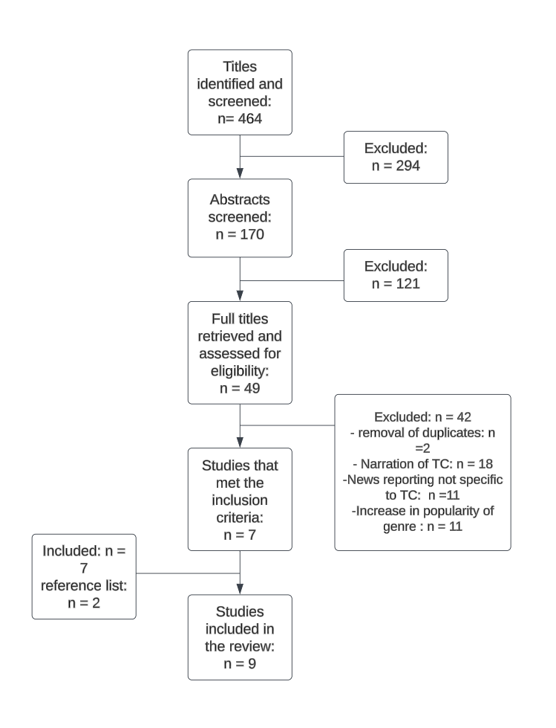

There were 464 articles considered following the initial database search. Following completion of the RSLR there were 9 articles considered for inclusion in the thematic analysis.

2.3 Procedure

Phase one: Data Familiarisation

During the duration of the final stage of the RSLR, which was reading the chosen articles to completion, the researcher began the familiarisation process. This allowed the researcher to gain an insight into the broad ideas being presented, this stage was done without making any notes. Following this first read, the articles were critically read while making preliminary notes, making possible connections, and making note of possible quotes.

Phase Two: Generation of Initial codes

During the coding stage, the chosen documents were read thoroughly. The purpose of the codes which were noted and developed were to aid in the development of the themes in the later stage of research. This stage was done to organise data in a systematic way. The researcher used inductive coding for this research. There were two types of coding used in order to capture the relevant and underlying concept. The first type of coding done was semantic coding. This was done by making note of the surface meaning of the data. Following this, latent codes were then done which aimed to identify underlying meanings within the data set to aid in the semantic codes. See appendix A for initial coding sample.

Phase Three: Generation of Themes

After initial codes had been developed, they were used to create a thematic map. This was done by grouping the sticky notes together in themes which were similar. This was done in order to see potential themes emerge. This step was repeated multiple times with several thematic maps being generated, see appendix B for initial thematic maps.

Phase Four: Reviewing Potential Themes

During phase four, the thematic map was refined and altered several times. This was done by assessing the quality of the themes which included going through the articles again to see if there is enough data to support it. This involved revising the previous phases to decide if the themes overlapped each other or if there are other themes which emerged within the themes etc. See figure 2 below for the final revised thematic map.

Phase Five: Refining, Defining and Naming Themes

Phase five was aimed to ensure that each theme produced was consistent with the research questions. The names of the themes were created to summarise what each theme is about without a reiteration of the content of a theme. See figure 2 below.

Phase Six: Producing the Report

The sixth and final phase of the thematic analysis was writing up a report on the findings. The report was to review the final results and to relate the findings to the research questions. This stage involved gathering the themes and sub themes to communicate the findings.

Results
The present study aimed to examine whether there was a relationship between True Crime media consumption and fear of crime and if Terror Management theory and the Theory of planned behaviour could explain this relationship. After the RSLR was completed, a reflective thematic analysis was conducted (see table 1 for characteristics of studies included in the analysis). The data consisted of textual analysis of published academic articles. Initial coding was done by making preliminary codes using key words in the chosen text. Following this, semantic codes of the general statement being presented were noted and finally latent codes were created which considered the text with consideration to the present studies research questions (see appendix A for sample preliminary coding). After each code was developed, provisional thematic maps were created (see appendix B). Initial thematic maps see each research question separated however as the themes closely related, they were combined as one thematic map with respective subthemes being created (see figure 2).

Table. 1
Characteristics of the studies included in the reflective thematic analysis.

Author | Title | Location | Sample | Methodology | Main findings
Rosenberge, 2021 | Media Consumption and Fear of Crime: Evidence of the Need for an Intersectional Approach | USA | 500 White, Black, and Hispanic/Latinx respondents using non-full probability sampling from across the USA. | An internet survey which contains measures of fear of crime, consumption of crime related media and measures of experiences known to impact opinions towards crime. | Fear of crime varies across race and gender. Hispanic/Latinx tend to have higher fear than white people. Age and living in an urban area can also affect a fear of crime. Consuming more television and crime related media can also increase fear of crime.
Rodgers, 2022 | “F*cking politeness” and “staying sexy” while doing it: intimacy, interactivity and the feminist politics of true crime podcasts | Canada | Participant observation, interviews and document analysis adapted for online ethnography. A portion of the data is drawn from social media spaces and in-depth interviews with participants. | Observation of closed ‘my favourite murder’ Facebook groups and one larger open Facebook group. Open request interviews done in these closed groups. Finally, observations of open and anonymous discussion platforms daily during the data collection period. After observation, a thematic analysis was conducted. | There were three main themes found. 1) Podcasts allow for women to collectively explore shared experiences of violence, finding comfort and validation that their fears are shared. 2) Podcasts such as this one encourages women to challenge power held by men and are encouraged to prioritize their own safety and finally 3) podcasts encourage anti-victim-blaming discourse
Soto-Sanfiel & Montoya-Bermúdez, 2022 | Consumption of true crimes and perceived vulnerability: Does the cultural context matter? | Singapore & Colombia | Two focus groups (FG) in Colombia and two in Singapore. Each FG was formed by five to six young volunteers. Half the 12 Singaporeans were of each gender. Their age range was 19 to –24 years. Among 11 Colombians 5 were males and 6 females. Their age range was 18 to 24 years. They all were college students or recently graduated | A semi-structured questionnaire that comprised five open questions that covered, apart from demographic data, aspects related to the reception of TCDs based on the theoretical background. The FG were recorded and later transcribed verbatim. Afterwards an inductive thematic analysis was applied. | How true crime documentaries (TCDs) are received in cultural settings with different crime rates. revealed that Singaporeans watch TCDs mainly for entertainment, to experience emotions, and to learn about past events, whereas Colombians mostly obtain survival skills, and learn about murderers and their cultural context realities.
Boling, 2022 | “It’s that ‘There but for the Grace of God Go I’ Piece of It”: Domestic Violence Survivors in True Crime Podcast Audiences | USA | 16 women who identify as domestic violence survivors and fans of true crime podcasts | In-depth qualitative interviews. An audience reception study which explores why these women are drawn to these podcasts and how they make meaning of the content. A feminist, critical cultural lens is used to examine how the content they consume intersects with their lived experiences. | Findings show that they are drawn to true crime podcasts for four main reasons: the appeal of audio media, the power of a good story, the educational value of the content, their therapeutic need for understanding, and camaraderie through community.
Yardley, 2018 | Forever trapped in the imaginary of late capitalism? The serialized true crime podcast as a wake-up call in times of criminological slumber | UK | Six serialized true crime podcasts in which a crime had occurred or was suspected to have occurred which devoted every episode of a podcast (or a season) to coverage of that specific case. Podcasts included in the study had been released between 2014-2017. | A reflexive thematic analysis was used to analyse podcasts episodes/seasons which was then interpreted by the researchers. | Main findings include questioning the extent to which academic criminology is equipped to engage in critical analysis of this media and address the questions that they raise about crime and society’s response to it in late capitalist society.
Vitis & Ryan, 2021 | True Crime Podcasts in Australia: Examining Listening Patterns and Listener Perceptions | Australia | Data from a survey of 124 university students attending a Queensland university in 2020. The online survey was open to currently enrolled students over 18 years of age who had listened to a TCP within the past seven years | An online survey was conducted to identify listening patterns, motivations, perceptions, and attributes. There were 34 items in total, with both closed and open-ended items, and the survey took approximately five minutes to complete. This article focuses on the closed questions in four domains of this survey. | Main findings for this study include listening preferences of short form podcasts typically listened to while driving, relaxing, cooking or cleaning. How respondents preferred podcasts which discussed one case per episode. Entertainment was a strong motivation for listeners and they were more interested in hearing about evidence gathering than the workings of the criminal justice system.
Smith & Ferguson, 2019 | Murder She Watched: Does Watching News or Fictional Media Cultivate Fear of Crime? | Trinidad | A stratified random sample of 3,003 respondents from Trinidad. The 2011 population and Housing census data with respect for municipality, enumeration district, households and income groups were used as the frame for selecting the sample and location of households. | A questionnaire was administered to the participants with a demographic scale and other scales which represented the chosen variables such as fear of crime, perceived risk of victimization, TV crime realism etc. A Poisson regression in SPSS with the robust estimation correlation matrix was conducted. | The impact of fictional media, news media, and reality TV as well as perceived crime risk were examined related to perceived fears of crime. Only perceived risk of crime victimization was related to fear of crime. No media variables predicted fear of crime. These results suggest that media exposure is not a primary route through which fear of crime develops.
Callanan & Rosenberger,  2015 | Media, Gender, and Fear of Crime | USA | A survey of 4,245 Californian adults 18 and older who were interviewed in 1999 by a computer-assisted telephone interviewing system. The survey asked respondents approximately 100 questions related to perceived risk of victimization, fear of crime, media consumption, and the criminal justice system. | A household survey who were interviewed in 1999 by a computer-assisted telephone interviewing system. The effects of media on criminal victimization risk and fear were examined using ordinary least squares (OLS) regression. Z-tests were conducted to determine if regression coefficients differed across gender. | Women perceived more neighbourhood crime risk than men. African Americans and Latinos perceived significantly more crime risk than White people but Asians perceived less than White people. Education, income and living in a house were negatively associated with perceived neighbourhood crime risk. Respondents with criminal victimization in the three years prior had higher levels of perceived crime risk, this was the strongest predictor of perceived crime risk. Only local news influenced perception of crime risk.
Callanan, 2012 | Media Consumption, Perceptions of Crime Risk and Fear of Crime: Examining Race/Ethnic Differences | USA | A statewide survey of 3,712 Californians surveyed between March- September 1999. | A conformity factor analysis was conducted on all crime salience items using principal components with varimax rotation. | Findings indicate some difference in the impact of crime-related media by different media forms and across race/ethnic groups. Consumption of local television news significantly elevated perceptions of risk and fear of crime for all groups. Crime-based reality programs produced equivalent fear, but the effects of newspaper and crime drama consumption were more variable. Realistic television content about crime was most influential on viewers' perceptions of and responses to crime than fictional accounts or newspapers.

3.1 Themes and subthemes
A total of three major themes were identified in the data. Each theme had a varying subthemes. As quotes are being chosen from published articles, they are taken verbatim to ensure integrity of the chosen theme. The themes and subthemes describe the influence of true crime media on either personal or sociologic perceptions of crime see figure 2 below. The main themes identified were firstly, the influence of media format on victimization. How True Crime media can be an educational resource into cultural and social interactions with violence. Finally how True Crime media can influence the perception of law enforcement and the justice system.

Figure 2

Revised thematic map of themes and subthemes.

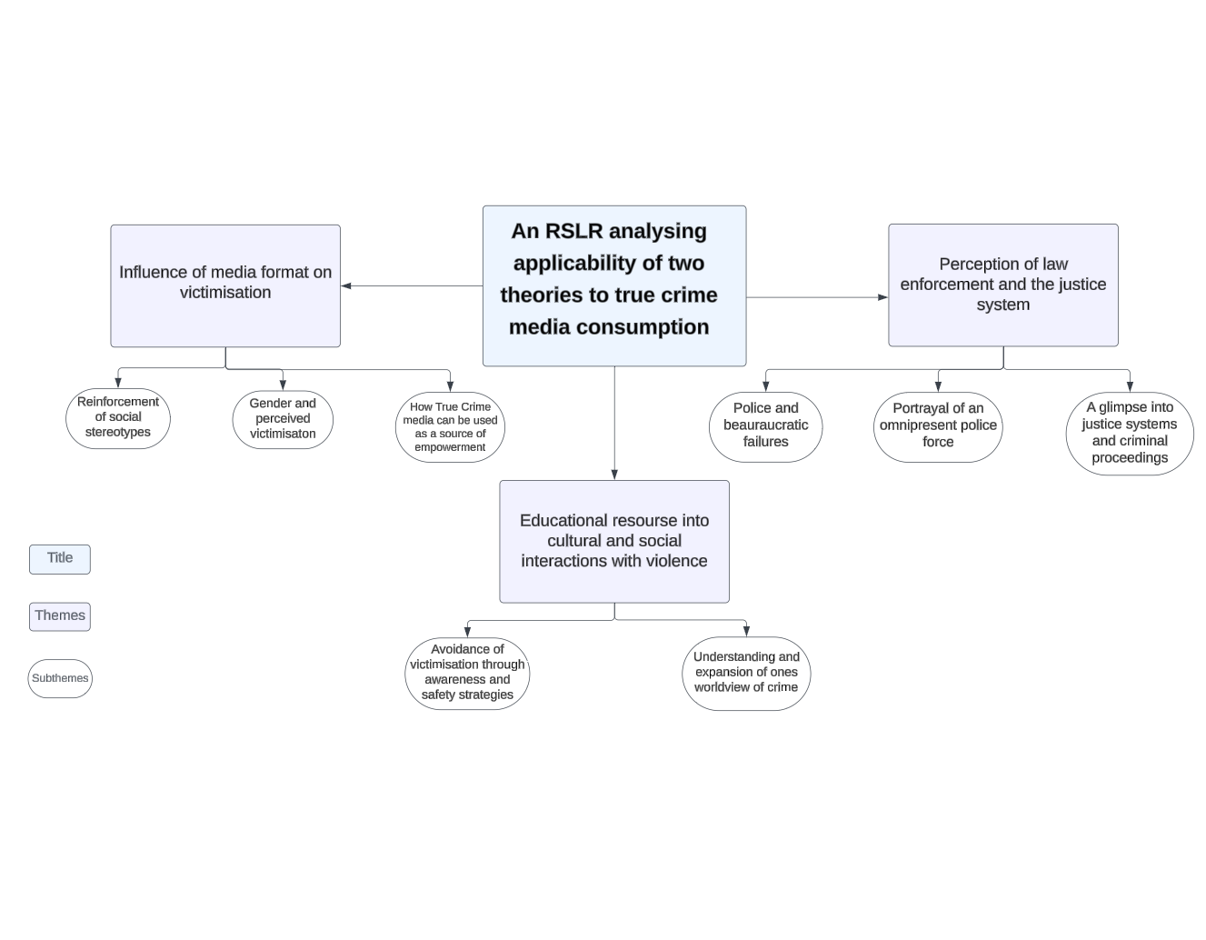

3.2 Theme one: The influence of media format on victimisation, social stereotypes, gender and perceived victimisation and True Crime as a source of empowerment.

The first theme describes the influence in which the media format of True Crime has on different societal viewers. This was further divided into three subthemes 1) The impact of True Crime on the reinforcement of social stereotypes. 2) The influence of True Crime on perceived victimisation, with particular reference to gender. 3) The influence of True Crime on the empowerment of its audience. This subtheme provides insight into how the media portrays the victim can instil a fear of crime or, alternatively empower its audience. This theme is most relevant to address research question 1, determining whether there is a relationship between True Crime and fear of crime.

Reinforcement of social stereotypes

It is established that True Crime media often disproportionately depicts the victim as a woman and the offender as a man despite crimes being predominantly committed by men against other men (Johansson & Haandrikman, 2021). Both gendered and racial stereotyping was a reoccurring theme:

“Media sources frequently perpetuate the concept of the “ideal” White female victim attacked by a stranger, as well as the “ideal” minority male offender This is achieved through depiction of White female characters as weak, easily victimized, and in need of protection from strong males” (Rosenberger et al., 2021, p. 693)

The media appears to report once off violence which occurs against women at a disproportionately higher rate than what is actually an accurate portrayal of crimes committed. This further perpetuates socialized stereotypes that women are more likely to be victims over men.

“It is well documented that crime content is a pronounced feature of mass media and distorts the reality of crime by disproportionately focusing on random violent crimes” (Callanan, 2012, p. 93)

“even news stories based on actual events give preference to female victims, even though violent victimization rates are ten times higher for men than they are for women. Thus, information about crime from the media may have significantly more effect on female consumers compared to men. Moreover, the portrayal of female victims in the media mirrors the gendered stereotype of women as victims, thus reinforcing these cultural stereotypes” – (Callanan & Rosenberger, 2015, p. 324)

The influence of True Crime media on perceived victimization, particularly in women

This study found that there was a gap in perceived victimization and actual risk of victimization in women which appears to be as a result of True Crime media. This study suggests that this may be explained by women’s heightened fear of crimes leading to sexual assault

“One of the most consistent findings in the large body of literature on fear of crime is that women express significantly higher levels of fear in comparison to men. Some have attributed this gender gap to women’s heightened sense of vulnerability to sexual assault, which is significantly more likely to occur to a woman than to a man. Many have argued that this fear spills over to fear of other person crimes that have the potential to lead to sexual assault, such as a robbery leading to rape” – Callanan & Rosenberger, 2015, p. 322)

Similarly to the previous subtheme, its appears this is due to the media perpetuating stereotypes of crimes creating a gap in perceived victimization versus risk of actual victimization.

“high amount of violence in mass media elevates the public’s fear of criminal victimization. It is well documented that crime content is a pronounced feature of mass media and distorts the reality of crime by disproportionately focusing on random violent crimes. Because the vast majority of Americans get their information about crime from mass media rather than personal experience” (Callanan, 2012, p. 93)

As mentioned previously that women have a heightened fear of sexual assault, the messages relayed from media sources may further increase the gap in the perceived victimization due to once off violence acts portrayed in media versus the actual risk of victimization.

“stereotypes advanced through media, such as the presence of the “super-predator” and “stranger danger” slogans, may feed perceptions that conflict with the reality that nearly half of all assaults, sexual and other, are committed by someone who is known to the victim” (Rosenberger et al., 2021, p. 694)

The influence of True Crime media on the empowerment of its audience

A frequent theme which emerged was True Crimes ability to empower its audience. As the content discussed in True Crime is darker in nature, upon first glance this theme may be jarring. Although the empowerment of its audience comes in the form of both a community with similar interests and validation to its audiences experiences.

“ to validate my survival story and to reassure that I’m not alone in getting myself into a whole lot of shit that I had to work really hard to get out of. When she started listening to true crime podcasts, it reminded her that she was not alone as a survivor of domestic violence… connection with the victims in true crime podcasts” (Boling, 2022, p. 999)

A subtheme which was frequent was True Crime medias ability to create a community. With specific reference to podcasts, it was noted that the audiences ability to passively listen if they choose or interact within the True Crime community with their own experiences was significant in discourses discussing strategies for safety or feelings of solidarity.

“true crime narratives, advanced by the “hyper-intimacy” and “interactivity” of podcasts, allow listeners to tap into personal experiences of fear and victimization while the online community encourages the listeners to view these experiences as part of a broader political discourse” (Rodgers, 2022, p.3,049 )

3.3 Theme two: True Crime media as an educational resource into cultural and social interactions with violence.

The second theme describes true crime media as a tool to understanding real life crime and violence. This was further divided into two subthemes of 1) the use of true crime as a tool in order to avoid victimization by implementing both safety strategies and increasing ones awareness. 2) understanding and expanding of ones worldview of crime.

Avoidance of victimization through awareness and safety strategies.

In addition to a community of people with similar interests, True Crime offers a space where people can turn to in order to gain insights for their own safety prevention strategies. This came in the form of educating themselves on past crimes committed in order to learn from that and implement safety strategies.

“ my participants sought out podcasts where they could become more educated, hoping to avoid victimization in the future, and where they felt empowered by a narrative devoid of victim-blaming” (Boling, 2022, p. 1008)

“Participants named specific survival skills they have learned by listening to true crime podcasts. Tina described: Don’t tell people your name. Don’t tell people where you live. As a runner, I try to never go running at the same time every day ... I don’t want anyone trying to put a pattern on my behaviour to where they can know when I’ll be gone and when I’ll come home” (Boling, 2022, p. 1004)

Understanding and expansion of ones worldview of crime.

True Crime media is popular across the world. A theme which emerged was people engaging in the genre to better understand the criminal mind or to better understand their own cultural context. For example, Colombia is a country known to have a high murder rate vs Singapore is known to have a low murder rate and so understanding their cultural context was motivation for watching True crime.

“Most Colombian participants say that learning why murderers commit crimes is their principal motivation for watching TCDs. Only one Singaporean mentioned this. Adopting the murderers’ perspectives and knowing about their psychological make-up helps them to understand the reasons for their crimes”
(Soto-Sanfiel & Montoya-Bermúdez, 2022, p. 569)

3.4 Theme three: The influence of True Crime media on perception of law enforcement and the justice system.

The third theme describes how the portrayal of law enforcement in the media can impact on ones assurance of their own personal safety. This was divided into three subthemes which include 1) highlighting of bureaucratic and police failures; 2) portrayal of an omnipresent police force; 3) A glimpse into the portrayal of criminal and justice system proceedings which in real life circumstances would be private.

Police and bureaucratic failures

As True Crime recounts real crimes committed against real people (Cambridge Dictionary, n.d.)., when discussing the case it is likely that how the police handled the case would be addressed. There have been critiques of True Crimes interference with criminal proceedings due to possible misinterpretations or sensationalising the gruesome crimes committed in the media.
“Australian TCPs have been accused of diminishing public trust in criminal justice institutions and subverting due process rights For example, in NSW Justice Fullerton recently decided to stay the jury trial of Chris Dawson due to the significant effect of the popular podcast The Teacher’s Pet on public perceptions of the case. In her decision, she described the public discourse generated by the podcast as: The most egregious example of media interference with a criminal trial process which this Court has had to consider in deciding whether to take the extraordinary step of permanently staying a criminal prosecution (R v Dawson)” (Vitis & Ryan, 2021, p. 295)
As well as interference with criminal proceedings, a theme which emerged was the publics mistrust of the police and how they have handled previous cases. This discourse is created by the medias portrayal of police and bureaucratic failures.
“The podcasts’ portrayal of the criminal justice system was also characterized by doubt and uncertainty, addressing questions like Can we trust the police? and Will law enforcement help us if we become the victims of crime?”- (Yardley et al., 2018, p.512)

Portrayal of an omnipresent police force

Much like the previous subtheme which talks about social stereotyping, True Crime also stereotypes the law enforcement. In True Crime it is often depicted that the perpetrator is male and also the law enforcement officer is male. It also

“It has been argued that true crime is dominated by the murders of white middle class women by white men, the cases solved largely by heroes and experts who also happen to be male This is said to reinforce misogynistic discourses in which all women are in danger and vulnerable to men’s violence but in which men are also their saviours and protectors as the law enforcement heroes who crack the cases”
(Yardley et al., 2018, p.507)

A glimpse into justice systems and criminal proceedings.

One of the most frequent motivational factors for engaging with True Crime was a glimpse into how evidence is found and about criminal proceedings.

“intended to change the criminal justice system by educating the public and addressing misconceptions surrounding the system. The potential for these texts to act as sites of public information is shaped by various authenticating devices. For example, TCPs provide access to the voices, experiences and narratives of victims, victims’ families, perpetrators, witnesses, legal actors, currently or previously incarcerated people and law enforcement” – (Vitis & Ryan, 2021, p. 296)

As the legal system can be hard to navigate, True Crime media offers people with no experience in the field of the law an understanding of what goes on behind the scenes and why there were certain outcomes in terms of bureaucracy etc.

“In addition to being more self-aware and conscious of their surroundings, participants also discussed how much they have learned about the inner workings of the criminal justice system. True crime podcasts accurately represent the reality of the bureaucracy involved”- (Boling, 2022, p. 1005)

Discussion

The present study aimed to examine whether there was a relationship between True Crime media consumption and a fear of crime and whether or not Terror management theory or the Theory of Planned behaviour could explain this relationship. Following the completion of a reflective thematic analysis, there were three major themes which were created in order to answer the research questions asked in this present study. The first theme was influence of the media format on victimization which had three subthemes of the reinforcement of social stereotypes, perceived risk of victimization with particular reference to gender and finally the use of true Crime media as a source of empowerment.

RQ 1: Is there a relationship between fear of crime and watching True Crime?

Previous literature suggests that women fear becoming a victim more than men do (Johansson & Haandrikman, 2021) and that the true Crime genres audience is predominantly female (Boling and Hull,2018). This study supported these findings. Additionally, this study found that True Crime media perpetuates gender stereotypes of both victims and offenders and law enforcement officers in the genre of True Crime. This was found to further enlarge the gap between perceived risk of victimization versus the actual risk of victimization. Furthermore, studies have found that True Crime media shifts listener behaviour and promotes risk-avoidance behaviours, termed “survival skills”, such as avoiding giving out one’s name to strangers (Boling, 2022, p. 1004) .
RQ 1a: How does terror management theory explain this relationship?
Terror management theory is the way in which we alleviate existential anxiety by carrying out a certain set of beliefs or behaviours (Greenberg et al., 1986).In a study done by Vicary and Fraley (2010), it was suggested that True Crime media teaches people new ways in which they can become a victim and as a result increase their fear of crime. The findings of this study contrasted this literature. A prominent theme created was how True Crime media created a community of likeminded people who offered a space which offered a non-victim blaming environment of empowerment. This study found that Terror Management theory explains the relationship between True Crime and a fear of crime as it acts as a buffer between ones existential anxiety by creating a sense of camaraderie within the community.

RQ1b: How does this relationship predict attitudes and behaviours related to crime prevention and safety measures?
True Crime media altered consumer’s crime-preventing behaviours in the manner described by Boling (2022, p. 1004) by altering the three conditions described in the Theory of Planned Behaviour. This is a theory which is intended to explain motivational influences on behaviour to determine, understand and predict behaviours using attitude to behaviour, subjective norm and perceived behavioural control (Ajzen, 1991). These conditions are attitude, subjective norms, and perceived behavioural controls.
Attitude: True Crime media altered people’s attitudes to crime-prevention, and made it appear more efficacious and necessary, and therefore to have a positive influence on the person’s life. While a study done by Vicary & Fraley (2010) suggested True Crime only teaches new ways one can be victimized, this study found that people engage in True Crime with the intention of learning how to avoid victimization through learning safety strategies or understanding their own cultural context of crime.
Subjective norms: By participating in community and sharing stories amongst listeners, and between hosts and listeners, this research found that True Crime media altered listeners’ perceptions of the norms around crime prevention behaviour and made it appear to be more common.
Perceived behavioural control: By shedding light on the failings of police and the judiciary, True Crime media increased the sense amongst listeners that they could control exposure to crime through behavioural modification and reduced the sense that they could do so by relying on public institutions. As True Crime is popular in both podcasts (Atske 2023) and streaming services (Maher & Cake, 2023), messages of police and bureaucratic failures can be widely accepted which ultimately can hold law enforcement accountable, but also reduce confidence in their capabilities in the meantime. This can be supported by a study done by Pâquet (2020).

4.1 Theoretical implications

Terror management theory

The present study found that the terror management theory explains why the genre of True Crime is popular within certain demographics. For instance, terror management theory describes how people alleviate their existential anxiety by creating a meaningful life (Solomon et al., 1991). This was reflected in the present study as a theme created was how True Crime media can act as a source of empowerment for its audience. In particular, True Crime podcasts allowed their users to be engaged in the podcasts while also validating any experiences in which they were victims or at risk of being a victim. Along with this, a sense of community was emphasized as a result. This reflects terror management theory as it reflects the creation of a meaningful life to alleviate any anxieties.

Theory of planned behaviour

The present study found that the three conditions which need to be met in order to determine, understand and predict behaviours were met. Firstly, with regard to attitude to behaviour, this can be seen with the theme of “educational resource into societal/cultural interactions with violence/crime”. This is where people watch it to avoid victimization by learning safety strategies and awareness and thus engaging in this behaviour would have a positive contribution. The second condition, subjective norm closely overlaps with the third condition, perceived behavioural control. Both of these conditions are met in this study. For example, as true crime has gained popularity through the increase in popularity of podcast and serialized true crime programmes, it has become more common to discuss and listen to true crime making it more of a cultural norm. In turn, a result of this popularity means that these technological changes has made it easy to tune into true crime media making it easier to display this behaviour.

4.2 Practical implications

This study highlights the importance of true crime media for several reasons. First, it creates a community of people with similar interests and allows a space to discuss stories of their own offering validation and a sense of agency. Second, it acts as an educational resource in order to prevent victimization by creating awareness around crime and lastly it highlights bureaucratic failures and an insight into legal proceedings. A practical implication of these findings may be the creation of an educational campaign. Rather than focusing on a television programme or listening to stories of victims to gain insight into victim prevention, an educational campaign which features common criminal tactics, safety measures and victim support could be used to empower individuals through a proactive approach. As True Crime media is so readily available, this study can aid mental health professionals in their understanding of excessive exposure to True Crime media in which they can develop intervention strategies for those who experience distress while watching this form of media. Finally, as this study has identified a mistrust in law enforcement due to True Crime highlighting police and bureaucratic failures, a practical implication of this study may be to highlight the specific areas of mistrust within the legal system and potentially support policy changes to work towards addressing the issues which contribute to the bureaucratic failures.

4.3 Strengths

The present study had a number of strengths. First, the time parameter set in the search process which accounted for the technological advancements and thus the evolution of this genre. Second, although this study used secondary research the chosen peer-reviewed articles featured primary research carried out by the authors and so the use of this real data can be argued as a strength. Finally, a strength of this study would be that it focused on understanding the experiences and perspectives held by those who watch True Crime media. The use of a thematic analysis allowed generalized interpretations to be drawn and more nuanced understandings of the data to allow for rich interpretations to be drawn.

4.4 Limitations

While the present study has several strengths, there are also limitations. For example, the timeframe was set between 2013-2024 which meant that the majority of the data was appropriate for this study. However, an article by Callanan and Rosenberger (2015) used data which was collected in 1999, and so is referencing less relevant delivery methods of Trur Crime media such ss podcasts and streaming service. A second limitation may be that, despite efforts of the researcher, identification and interpretations of themes may have been influenced by theoretical perspectives held previously by the researcher. This may have led to the overlooking of alternative themes which did not align with the expectations. A final limitation of this study may be that the timeframe set for the RSLR to be completed may have compromised the quality of the review as the speed in which it had to be done may not have allowed for as thorough data extraction.

4.5 Future research

Research on true crime, specifically the impact on one’s fear of crime, is not new in the area of psychological research. However, as podcasts are relatively recent forms of media, further research must be carried out on understanding the impact that the delivery of True Crime poses on one’s fear of crime. Additionally, as this study is an introduction to the topic of True Crime and fear of crime which was limited by ethical considerations, a suggestion for future research would be to carry out quantitative research on this topic to fill the gap in existing literature. For example, carrying out a quantitative study using the “Crime and Victimisation model questionnaire” (Central Statistics Office , n.d.) which would determine the participants fear of crime. Furthermore, a questionnaire which determines participants crime related media consumption. Suggestions for future research include researching whether individual personality traits such as introversion/extraversion can impact the relationship between True Crime media consumption and a fear of crime levels.

4.6 Conclusion

The present study conducted an RSLR in order to synthesize articles published in this area. Following this, a reflective thematic analysis was conducted in order to expand on the body of research on the relationship between true crime and fear of crime, whether terror management explains this and whether this relationship influences crime prevention and safety measures. The results suggest there is a relationship between True Crime media consumption and a fear of crime and that Terror Management Theory is a motivating force for people to confront their existential anxiety. It also suggests that the Theory of Planned behaviour predicts a person’s behavioural intention with True Crime media consumption.

References
Ajzen, I. (1991). The Theory of Planned Behavior. Organizational Behavior and Human Decision Processes, 50(2), 179–211. https://doi.org/10.1016/0749-5978(91)90020-T
American Psychological Association . (n.d.). Mortality Salience . In American Psychological Association. https://dictionary.apa.org/mortality-salience. Retrieved November 27, 2023.
Atske, S. (2023, June 15). A Profile of the Top-Ranked Podcasts in the U.S. Pew Research Center’s Journalism Project. https://www.pewresearch.org/journalism/2023/06/15/a-profile-of-the-top-ranked-podcasts-in-the-u-s/
Bickerton, J. (2022, September 3). How True Crime Podcasts Have Helped Crack Cases. Newsweek. https://www.newsweek.com/how-true-crime-podcasts-have-helped-crack-cases-christopher-dawson-1738791
Boling, K. S. (2022). “It’s that ‘There but for the Grace of God Go I’ Piece of It”: Domestic Violence Survivors in True Crime Podcast Audiences. Mass Communication and Society, 26(6), 1–23. https://doi.org/10.1080/15205436.2022.2061359
Boling, K. S. (2023). “We can do better. We can be better”: counter-narratives in true crime podcasts on domestic violence. Critical Studies in Media Communication, 1–18. https://doi.org/10.1080/15295036.2023.2265982
Boling, K. S., & Hull, K. (2018). Undisclosed Information—Serial Is My Favorite Murder: Examining Motivations in the True Crime Podcast Audience. Journal of Radio & Audio Media, 25(1), 92–108. https://doi.org/10.1080/19376529.2017.1370714
Braun, V., & Clarke, V. (2021). One Size Fits all? What Counts as Quality Practice in (reflexive) Thematic analysis? Qualitative Research in Psychology, 18(3), 328–352. https://doi.org/10.1080/14780887.2020.1769238
Brown, R. (2018, November 29). Maria James murder case reopened by coroner after ABC’s Trace podcast. ABC News. https://www.abc.net.au/news/2018-11-30/trace-podcast-subject-maria-james-murder-case-to-re-opened/10569792
Burger, P. (2016, August 24). The Bloody History of the True Crime Genre | JSTOR Daily. JSTOR Daily. https://daily.jstor.org/bloody-history-of-true-crime-genre/
Callanan, V. J. (2012). Media Consumption, Perceptions of Crime Risk and Fear of Crime: Examining Race/Ethnic Differences. Sociological Perspectives, 55(1), 93–115. https://doi.org/10.1525/sop.2012.55.1.93
Callanan, V., & Rosenberger, J. S. (2015). Media, Gender, and Fear of Crime. Criminal Justice Review, 40(3), 322–339. https://doi.org/10.1177/0734016815573308
Cambridge Dictionary. (2024, April 3). true crime. @CambridgeWords. https://dictionary.cambridge.org/dictionary/english/true-crime#google_vignette
Central Statistics Office . (n.d.). Crime And Victimisation Module Questionnaire - CSO - Central Statistics Office. Www.cso.ie. Retrieved April 5, 2024, from https://www.cso.ie/en/qnhs/qnhsmethodology/crimeandvictimisationmodulequestionnaire/
Chadee, D., Smith, S., & Ferguson, C. J. (2017). Murder she watched: Does watching news or fictional media cultivate fear of crime? Psychology of Popular Media Culture, 8(2). https://doi.org/10.1037/ppm0000158
Greenberg, J., Pyszczynski, T., & Solomon, S. (1986). The Causes and Consequences of a Need for Self-Esteem: A Terror Management Theory. Public Self and Private Self, 189–212. https://doi.org/10.1007/978-1-4613-9564-5_10
Johansson, S., & Haandrikman, K. (2021). Gendered Fear of Crime in the Urban context: a Comparative Multilevel Study of Women’s and Men’s Fear of Crime. Journal of Urban Affairs, 45(7), 1–27. https://doi.org/10.1080/07352166.2021.1923372
Lewis, A. M. (2013). Terror Management Theory Applied Clinically: Implications for Existential-Integrative Psychotherapy. Death Studies, 38(6), 412–417. https://doi.org/10.1080/07481187.2012.753557
Maher, S., & Cake, S. (2023). Innovation in true crime: generic transformation in documentary series. Studies in Australasian Cinema, 17(1-2), 95–109. https://doi.org/10.1080/17503175.2023.2224617
McDonald, M. M., James, R. M., & Roberto, D. P. (2021). True Crime Consumption as Defensive Vigilance: Psychological Mechanisms of a Rape Avoidance System. Archives of Sexual Behavior, 50. https://doi.org/10.1007/s10508-021-01990-1
Pâquet, L. (2020). Seeking Justice Elsewhere: Informal and Formal Justice in the True Crime Podcasts Trace and the Teacher’s Pet. Crime, Media, Culture: An International Journal, 17(3), 421–437. https://doi.org/10.1177/1741659020954260
Rodgers, K. (2022). “F*cking politeness” and “staying sexy” while doing it: intimacy, interactivity and the feminist politics of true crime podcasts. Feminist Media Studies, 23(6), 1–16. https://doi.org/10.1080/14680777.2022.2098799
Rosenberger, J. S., Dierenfeldt, R., & Ingle, H. (2021). Media Consumption and Fear of Crime: Evidence of the Need for an Intersectional Approach. Victims & Offenders, 18(4), 1–24. https://doi.org/10.1080/15564886.2021.1991069
Solomon, S., Greenberg, J., & Pyszczynski, T. (1991). A terror management theory of social behavior: The psychological functions of self-esteem and cultural worldviews. Advances in Experimental Social Psychology, 24, 93–159. https://doi.org/10.1016/s0065-2601(08)60328-7
Soto-Sanfiel, M. T., & Montoya-Bermúdez, D. F. (2022). Consumption of true crimes and perceived vulnerability: Does the cultural context matter? International Communication Gazette, 85(7), 174804852211314. https://doi.org/10.1177/17480485221131474
Vedric, N., & Little, J. (2022). True victims: men’s privilege, class, and violence against women in Making a Murderer and The Jinx. Feminist Media Studies, 23(3), 1–16. https://doi.org/10.1080/14680777.2022.2027495
Vicary, A. M., & Fraley, R. C. (2010). Captured by True Crime: Why Are Women Drawn to Tales of Rape, Murder, and Serial Killers? Social Psychological and Personality Science, 1(1), 81–86. https://doi.org/10.1177/1948550609355486
Vitis, L., & Ryan, V. (2021). True Crime Podcasts in Australia: Examining Listening Patterns and Listener Perceptions. Journal of Radio & Audio Media, 30(1), 1–24. https://doi.org/10.1080/19376529.2021.1974446
Yardley, E., Kelly, E., & Robinson-Edwards, S. (2018). Forever trapped in the imaginary of late capitalism? The serialized true crime podcast as a wake-up call in times of criminological slumber. Crime, Media, Culture: An International Journal, 15(3), 503–521. https://doi.org/10.1177/1741659018799375

Appendices

Appendix A: Initial coding process sample

Data extract sample | Preliminary coding | Semantic coding | Latent coding
Media sources frequently perpetuate the concept of the “ideal” White female victim attacked by a stranger, as well as the “ideal” minority male offender … This is achieved through depiction of White female characters as weak, easily victimized, and in need of protection from strong males | “Ideal” offender/victims | Stereotyping of crimes | How the media reinforces social stereotypes of crime can possibly have an impact on how actual victims of crime are seen (which don’t fit into ‘ideal’ victim)
The addition of interactive live shows and the emergence of hundreds of dedicated Facebook groups and Reddit discussion boards forged an online community that sharpened this critique of gender-based violence, addressing concerns including why women face problems of violence, openness about mental health, the injustices surrounding policing and sentencing crimes that relate to women, especially sex workers and women of colour. | Community | Communal empowerment of the most vulnerable in society | How True Crime media has created an environment where those who are affected by violent crimes/ predominantly depicted in violent crimes in media are reclaiming their power over those causing the victimization
Most Colombian participants say that learning why murderers commit crimes is their principal motivation for watching TCDs. Only one Singaporean mentioned this. Adopting the murderers’ perspectives and knowing about their psychological make-up helps them to understand the reasons for their crimes. | Why people commit crimes | Understanding of one’s cultural context | Using TC as a learning tool to understand why people turn to violent crimes, especially as they are coming from a ’violent’ country
I think it helps to own your own story, and I think it could be cathartic … I think maybe on a subconscious level I’m seeking out stuff where people have survived their own kind of trauma to validate my survival story and to reassure that I’m not alone in getting myself into a whole lot of shit that I had to work really hard to get out of. | Validation | Validation and reassurance that they’re not alone | TC offers survivors of domestic violence a space where they can privately be validated and reassured of the violence in their own life and offers a space to look back and see how far they’ve come
It has been argued that true crime is dominated by the murders of white middle class women by white men, the cases solved largely by heroes and experts who also happen to be male This is said to reinforce misogynistic discourses in which all women are in danger and vulnerable to men’s violence but in which men are also their saviours and protectors as the law enforcement heroes who crack the cases | ‘ideal’ victim/offender | Reinforcement of social stereotypes | Media portrayals impact on social stereotyping for the victim/offender and law enforcement
The podcasts’ portrayal of the criminal justice system was also characterized by doubt and uncertainty, addressing questions like Can we trust the police? and Will law enforcement help us if we become the victims of crime? | Doubt and uncertainty of police | TC sheds a light on the mistrust of police/law enforcement | TC discusses cases which are solved/unsolved and shed a light on police/bureaucratic failures ultimately causing a mistrust in law enforcement in the chance they themselves are victims
Media exposure to depictions of violent crime, whether in news or fictional media, may have such an effect that audiences would overestimate the frequency of criminal arrests and be unaware of the 25-year down- ward trend in criminal violence occurring in most industrialized nations | Overestimation of frequency of crime | Perceived victimization vs actual risk of victimization | The over representation of once off violent crimes may cause an increased perceived fear of crime vs what the actual risk of crime is
It can happen to anybody, but there’s a sense of belonging. There’s a sense of being part of a tribe. There’s a sense of being a part of a big group of people, and I think for people who suffer from domestic violence, having other people that you can identify with and can support you is really, really helpful. | Community | Despite the terrible circumstances, the ability to create a community of those alike | The ability to become empowered via community of people who have experienced domestic violence through use of TC media as a tool

Appendix B: Initial thematic maps

Relationship between True Crime and fear of crime

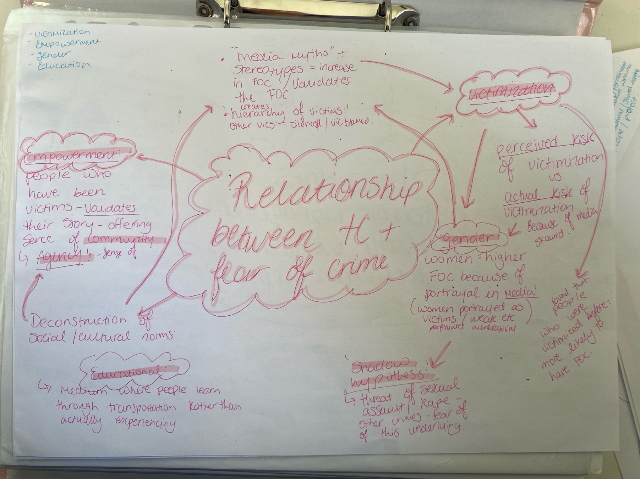

How does terror management theory explain this relationship


How does this relationship influence attitudes and behaviours related to crime prevention and safety measures

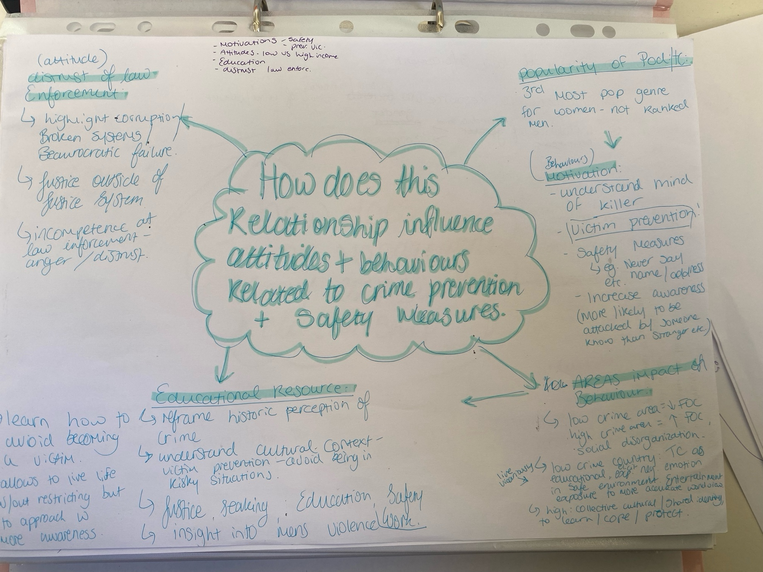

Appendix C:

As part of the dissemination component, I will be taking part in the IADT On Show 2024.

