Exploring the effects of background music’s tempo and key on working memory and emotional arousal

Seán Ó’Síocháin
N00192200
Research Supervisor: Dr. John Greaney

Dissertation submitted as a requirement for the degree of BSc (Hons)
Psychology Applied to Information Technology, Dun Laoghaire Institute of
Art,
Design & Technology, 2023


Declaration

I declare that this submission is my own work. Where I have read, consulted, and used the work of others I have acknowledged this in text.

Wordcount: 5,950

Signed: _________________________
Seán Ó’Síocháin

Date: 27th of March 2023

Acknowledgements

I would like to say thank you to my supervisor. Dr. John Greaney for his help and encouragement.

Also, I would like to say thank you to Dr. Grainne Kirwan and Dr. Christine Horn for all your guidance and support with statistics and research methods.

I would also like to sincerely thank Cliona Flood, Stefan Paz Berrios, Robert Griffin, Dr. Nicola Fox-Hamilton, and Dr. John Greaney for giving up time out of your lectures to facilitate my data collection, I could not have done it without you.

Thank you to all my family and friends who have supported me and been patient with me throughout this stressful period, especially my family and my partner Sheyma who helped me get through this stressful period.

I would also like to sincerely thank Dr. Rosaleen McElvaney for her feedback.

Lastly, I would like to thank all the participants who were willing to give me some time to take part in my study. Your enthusiasm and willingness to be involved has allowed me to create this thesis.

Table Of Contents:

Abstract……………………………………………………………………………...1
Introduction…………………………………………………………………………2
1.1 Background Music and Cognitive Functioning…………………………….2
1.2 Background Music and Working Memory…………………………………2
1.3 Characteristics of music: Key and Tempo………………………………….4
1.4 Yerkes Dodson Law of Arousal……………………………………………...6
1.5 The Current Study……………………………………………………………6
1.6 Research Questions (RQ) …………………………………………………….7
1.7 Hypotheses …………………………………………………………………….7
Method……………………………………………………………………………..…8
2.1 Design…………………………………………………………………………..8
2.2 Participants…………………………………………………………………….8
2.3 Materials………………………………………………………………………10
2.3.1 Music……………………………………………………………………...11
2.3.2 Reading Comprehension Extract…………………………………………11
2.3.3 Maths test………………………………………………………………….11
2.3.4 List of memory questions and final questions……………………………..11
2.3.5. Debriefing Information Form…………………………………………….12
2.3.6. Pilot test…………………………………………………………………..12
2.3.7. Ethical considerations…………………………………………………….12
2.4 Procedure…………………………………………………………………………13
2.4.1 Scoring the memory test …………………………………………………..13
2.4.2 Data Analysis………………………………………………………………13
2.4.3 Thematic Analysis …………………………………………………………14
Results…………………………………………………………………………………14
3.1 Relationship Between Key, Tempo, and Working Memor……………….…14
3.1.1 Overview 1…………………………………………………………………14
3.1.2 Test of Normality…………………………………………………………..15
3.1.3 Analysis…………………………………………………………………….15
3.2The Optimal Music Condition for Working Memory………………………..16
3.2.1 Overview 2 …………………………………………………………………16
3.2.2 Test of Normality………………………………………………………...…17
3.2.3 Analysis 2…………………………………………………………………...17
3.3 Thematic Analysis………………………………………………………….…...17
3.4 Task-Related themes……………………………………………………………18
3.4.1 Helped Memory……………………………………………………………..18
3.4.2 Distracting from task……………………………………………………….18
3.4.3 Increased Sleepiness………………………………………………………..18

3.5 Emotion- Related themes………………………………………………….…18
3.5.1 Music Enjoyment………………………………………………….……...18
3.5.2 A Sense of Relaxation………………………………………………….…19
3.5.3 A Sense of Pressure…………………………………………………........19
Discussion……………………………………………………………………………19
4.1 Overview………………………………………………………………………19
4.2 Relationships between Working Memory and Background Music……….20
4.3 Participants' emotional and cognitive experiences of doing a memory task…………………………………………………………………………………....20
4.4 Strengths and Limitations……………………………………………………22
4.5 Future Research………………………………………………………………23
4.6 Theoretical and Practical Implications ……………………………….…….23
4.7 Conclusion……………………………………………………………….……24
References…………………………………………………………………………...25
Appendices: ………………………………………………………………………....33
Appendix A: Yerkes-Dodson Inverted U………………………………………….33
Appendix B: Information Sheet…………………………………………………....34
Appendix C: Consent Form…………………………………………………….….36
Appendix D: Participant code and demographic information form……….……37
Appendix E: Reading Comprehension Extract (Bill Bryson)……………………38
Appendix F: Maths Worksheets………………………………………………...…39
Appendix G: Memory Questions………………………………………………..…40
Appendix H: Final Questions……………………………………………………....41
Appendix I: Debriefing Information Form……………………………………..…42
Appendix J: Inter-rater reliability scores for musical key table…………………43
Appendix K: Inter-rater reliability scores for musical tempo table ……………45
Appendix L: Ethical Approval…………………………………………………..…46
Appendix M: Provisional theme interrater reliability percentages. ……….……47
Appendix N: Thematic Analysis: Colour Coding…………………………...…….48
Appendix O: Thematic Map……………………………………………………..…49
Appendix P: Two Way Between……………………………………………………50
ANOVA………………………………………………………………………………50
Table P1: Normality Tables………………………………………………...……50
Table P2: Test of Equality of Variances…………………………………………51
Table P3: Two Way ANOVA Between Groups Output………………………..52
Figure P1: Graph Displaying Estimated Marginal Means for memory and key……………………………………………………………………………………53
Figure P2 Boxplot displaying comparing tempo groups in the memory scores data……………………………………………………………………………………54
Figure P3 Boxplot displaying comparing key groups in the memory scores data…………………………………………………………………………………….55
Figure P4 Graph illustrating Total Mean working memory scores (tempo & key)………………………………………………………………………………….…56
Appendix Q: One Way ANOVA………………………………………………...…..57
Table Q1: Normality Tables………………………………………………………....57
Table Q2: Test of Equality of Variances…………………………………………. ..58
Table Q3: One Way ANOVA Between Groups Output…………………………...59
Table Q4: Power Analysis Table…………………………………………………....59
Figure Q1 Boxplot displaying comparing the background music conditions memory scores data …………………………………………………………………………...60
Figure Q2 Mean working memory scores based on each background music condition. ………………………………………………………………………….…61
Appendix R: Frequency and percentages themes occurring in the thematic analysis………………………………………………………………………..….…..62
Table R1: Helped Memory……………………………………………………….…62
Table R2: Distracting from task……………………………………………...…….63
Table R3: Increased Sleepiness……………………………………………….….…64
Table R4: Music Enjoyment………………………………………………….….….65
Table R5: A Sense of Relaxation……………………………………………………66
Table R6: A sense of being pressured…………………………………………....…67

Abstract
Previous research into background music and its impact on cognitive functioning has lacked rigorous research methods, produced inconclusive findings, and employed varying background music interventions (de la Mora Velasco and Hirumi, 2020). The present study aimed to investigate the relationships between musical tempo, key, working memory and emotional arousal. Participants (N=79) were instructed to memorise information from an extract for ten minutes under one of seven background music conditions. After memorising, the participants underwent a maths task-switching component, (this incurs a higher perceptual load which may impair working memory) before completing a questionnaire consisting of reading comprehension questions about the extract and questions investigating emotional arousal. Qualitative data was analysed using Braun and Clarke’s (2006) thematic analysis to investigate emotional arousal. Key and tempo of background music did not have a statistically significant effect on working memory whilst studying. Furthermore, although the observed statistical power was low, there did not appear to be an ideal background music condition to facilitate working memory. Six robust themes were identified in the thematic analysis; ‘Music enjoyment’, ‘helped memory’, ‘distracting from task’, ‘a sense of relaxation’, ‘increased sleepiness’ and ‘a sense of pressure’. Following an evaluation of the strengths and limitations of the present study, the theoretical and practical implications of the results were examined, including recommendations for future research.

Introduction

1.1 Background Music and Cognitive Functioning:

Background music is music that plays while the listener’s primary attention is focused on another task, like studying (Radocy & Boyle, 1988). Executive functions are higher-level cognitive skills which manage other cognitive abilities and behaviours, including task-switching, cognitive inhibition and working memory (Diamond, 2013). Executive function is crucial to academic performance (Cortés Pascual et al., 2019), and in cognitive tasks like reading comprehensions (Nouwens et al., 2016). Previous research into the effect of background music on cognitive functioning (including working memory) demonstrated inconclusive findings (de la Mora Velasco & Hirumi 2020).
Further research is needed to explore these relationships, particularly given the rising popularity of studying with music. This thesis will provide an overview of literature exploring relationships between background music and cognitive functioning, highlighting research addressing the differential relationships between music characteristics like key or tempo and cognitive functioning. The rationale for the current study is outlined, followed by a detailed account of the methodology used to explore various hypotheses. The findings are then presented and discussed in the context of previous research in this field. Finally, conclusions offer direction for future research.
1.2 Background Music and Working Memory
Working memory is a component of executive functioning, which performs active maintenance of task-relevant information (Chai et al., 2018). Information received while engaging working memory is encoded into long-term memory for later retrieval (Cowan, 2010). Working memory is crucial for studying and academic performance, as it is the prerequisite for long-term memory storage (Bergman Nutley & Söderqvist, 2017).

Previous research reported conflicting findings on the relationship between background music and memory. Some research indicated that background music, compared to silence, had no significant effect on memory (Jäncke & Sandmann, 2010; Nguyen & Grahn, 2017). Ferreri et al. (2013), suggested that background music provided a richer context for encoding than silence, leading to less demand in the brain area responsible for executive function and thus an improvement in memory. In direct contrast Cassidy and MacDonald (2007), reported that participants performed worse in four recall tests while listening to background music. Moreover, a meta-analysis on eight studies suggested that background music had a small, detrimental effect on memory overall (Kämpfe et al., 2011). These findings demonstrate the ambiguity on the relationship between background music and memory.
Task-switching is a component of executive function important for working memory (Baddeley, 2012). Task-switching relies on working memory to ensure regulation and active maintenance of goal-related information. Task-switching incurs a higher perceptual load which may impair working memory, emulating a real-life studying scenario (Pizzie et al., 2019). As such, a task-switching exercise has been included in studies investigating working memory (Dodge & Mensink, 2014), and will be included in the present study.
Previous literature proposed that working memory influences reading comprehension results (Nouwens et al., 2016). As such, reading comprehension tasks have been used in research to test working memory (Dodge & Mensink, 2014). Some studies have indicated that background music may facilitate cognitive improvements leading to improved reading comprehension (Khaghaninejad et al., 2016). However, contrasting literature suggests that background music had a negative effect on reading comprehension (Du et al., 2020), and on the reading process (Kämpfe et al., 2011). These findings illustrate a need for further research into this area.

1.3 Characteristics of music: Key and Tempo

Music genre is distinguished by constituent characteristics like instrumentation, tempo, and keys (Merriam-Webster, 2023). Genres share commonalities, and music may merge multiple genres, meaning genre often does not accurately describe music. According to Greenberg (2016), music should rather be described by its constituent musical characteristics like key or tempo. Previous research compared the effect of different background music genres on working memory but has not isolated the constituent characteristics of music for investigation (Bottiroli et al., 2014; Dodge & Mensink, 2014).
The arousal-mood hypothesis argues that listening to music affects arousal and mood, which may then affect cognitive performance (Husain et al., 2002). The impact of music on the mood-arousal of listeners seemed to be determined by the tempo and the key of the music itself (Gabrielsson & Lindström, 2010). According to Hunter et al. (2010), listeners’ subjective happiness ratings were highest for up-tempo, major key music and sad ratings were highest for slow-tempo, minor key music. The relationship between key, tempo, working memory and emotional arousal are discussed in detail below.
Musical key is “a system of functionally related chords from major and minor scales” (DeVoto, 2007, p 1). It is believed that music in a minor key evokes negative emotions, whilst music in a major key evokes positive emotions (Hunter et al., 2010; Justus et al., 2018).
Numerous conflicting findings have been reported on the relationship between mood-arousal and working memory. According to Greene et al. (2010), memory is optimal when listening to positive-mood-arousing music (major key) and negative-mood-arousing music (minor key). In contrast, Nguyen and Grahn (2017), reported that background music of varying moods and arousal levels did not enhance memory overall. Moreover, recent research stressed the importance of subjective working memory capacity. Negative and positive emotional arousal only enhanced working memory performance in participants with a high working memory capacity, whilst negatively affecting working memory performance in participants with a low working memory capacity (Zhang et al., 2017).
Music tempo is the speed at which music is performed, measured in beats per minute (bpm), (Collins, 2023). Tempo is divided into; slow-tempo (60-76 bpm), mid-tempo (76-120 bpm) and up-tempo (>120 bpm), (Liu et al., 2018). Tempo is arguably the “most important feature in determining emotional responses to music” (Katagiri, 2009, p.14). Research conducted by Liu et al. (2018), reported that slow-tempo music evoked negative emotions like sadness, whilst up-tempo music evoked positive emotions like happiness and excitement.
There has been conflicting literature regarding the ideal musical tempo to optimise memory. Jäncke and Sandmann, (2010) reported that background music of varying tempos has no effect on memory. However, Chie et al. (2009), reported that participants achieved higher memory scores while listening to mid-tempo music (120 bpm). Further studies are needed to investigate the relationship between music tempo and memory functioning.
Very few studies have been published that simultaneously investigate the effect of key and tempo on working memory and emotional arousal (Liu et al., 2018). One is a study by Bottiroli et al. (2014) who examined the impact of tempo and key on the processing speed and memory of older adults. Mozart’s ‘Eine Kleine Nachtmusik’ (major key, 137 bpm) induced a positive mood and high arousal levels whereas Mahler’s Adagietto Symphony (minor key, 86 bpm) induced a negative mood and lower arousal levels. Results indicated that slow-tempo minor-condition background music improves both processing speed and memory, while only processing improves with up-tempo, major key background music. Notably, these authors did not investigate the effect of slow tempo, mid-tempo and up-tempo major and minor key music on working memory or emotional arousal, and as Avila et al., (2012) note, this music may have been familiar to participants, arousing a positive mood which may have been distracting. More recent literature has indicated that mid-tempo music is the most emotionally arousing tempo (Liu et al., 2018).
1.4 Yerkes Dodson Law of Arousal
The Yerkes-Dodson Law of Arousal (Dodson, 1915), states that there is an empirical relationship between arousal and performance level, with peak performance being an intermediate level of arousal (see Appendix A). Too little arousal is understimulating, and too much stress/arousal is overstimulating, both resulting in poorer performance.
Various studies have included the Yerkes-Dodson Law of Arousal in the design (Nguyen & Grahan, 2017). One study, using this theoretical basis, indicated that slow tempo music (60 bpm) optimises relaxation for children and adults, consequently improving focus and concentration, as 60 bpm is the ideal resting heart rate for humans (Gunter, 1995). Moreover, music with a tempo higher than 144 bpm (mid-tempo) reportedly begins to negatively affect concentration (Webster and Weir, 2005). Lastly, Chie et al. (2009) reported that participants achieved the highest memory scores while listening to intermediately arousing mid-tempo music (120 bpm), compared to the slow-tempo (60 bpm), up-tempo (165 bpm) and control conditions. This law may be a useful theoretical basis for evaluating the relationship between tempo, arousal and cognitive functionality, and the present study will attempt to evaluate its validity in predicting the effect of differing musical tempos on working memory.
1.5 The Current Study
As aforementioned research regarding background music’s effect on cognitive functioning has been largely inconsistent (de la Mora Velasco & Hirumi 2020). Previous research focused on comparing the effect of different background musical genres on working memory but failed to isolate the constituent characteristics of music like key and tempo (Dodge & Mensink, 2014; Bottiroli et al., 2014). It may be that isolating these characteristics may illuminate these effects. Furthermore, previous research has not included a mid-tempo condition as a middle-ground between highly arousing up tempo music and slightly-arousing slow tempo music (Liu et al., 2018).

Due to the increasing popularity of studying music recently, the relationship between background music and learning has been investigated more frequently (Schwartz, 2017). Students may apply these research findings to improve information retention and potentially exam results. This research may help institutions develop optimised studying strategies for students. Furthermore, research in this area may facilitate greater understanding into the relationship between music and cognition, and how music may be used as a tool to optimise cognition.
The current study primarily aims to explore the relationship between background music’s constituent characteristics (key and tempo) and working memory through use of a reading comprehension and task-switching component, as previously researched by Dodge and Mensink (2014). The current study will include a mid-tempo condition (Liu et al., 2018) and will consider the emotional and cognitive experiences of participants.
The independent variables in the current study are musical tempo (slow tempo (60 bpm), midtempo (120 bpm), uptempo (160 bpm) and key (minor or major). The dependent variable under investigation is the working memory of the participants.
1.6 Research Questions (RQ)
RQ1: Does tempo and tonality/key of background music have a significant impact on working memory?
RQ2: What is the optimal background music condition to facilitate working memory?
RQ3: How did the background music affect participants emotional and cognitive experience whilst doing a memory task?
1.7 Hypotheses
H1a: There will be a statistically significant difference between participants working memory, when comparing the tempo of the background music played.
H1b: There will be a statistically significant difference between participants working memory, when comparing the key of the background music played.
H1c: There will be a statistically significant interaction between tempo and key on working memory.
H2: There will be a statistically significant difference for the participants in their working memory scores, based on the music condition (including a silence condition).

Method
2.1 Design
The current study emulates a study by Dodge and Mensink (2014). The current study employed a quasi-experimental between subjects 3x2 factorial design. The independent variables were tempo (k=3; slow tempo (60 bpm), mid-tempo (120 bpm), and up-tempo (160 bpm) key (k=2; major key, minor key), and silence (control condition). The dependent variable was a working memory score from Dodge and Mensink’s (2014) test. Furthermore, participants answered two questions regarding how the music felt and the impact it had on memory. These responses were qualitatively analysed using a thematic analysis framework.

2.2 Participants
Participants with ages ranging from 18 to 28 years old were recruited during psychology lectures using convenient sampling (N = 79), (Males:27, Females:50, Non-binary: 2). A Consent Form was used to gain informed consent (Appendix B) and a.Participant Coding and Demographic Information Form was used to collect data from participants (Appendix C). All participants were Applied Psychology students from the Dun Laoghaire Institute of Art, Design and Technology (IADT), with some college training, but no qualification (100%). All participants were over 18 years old and consented to take part in the study. Most participants were female (63.34%). The demographics for the groups in each condition are displayed in Table 1 below.

Table 1
The experiment samples’ gender demographics’

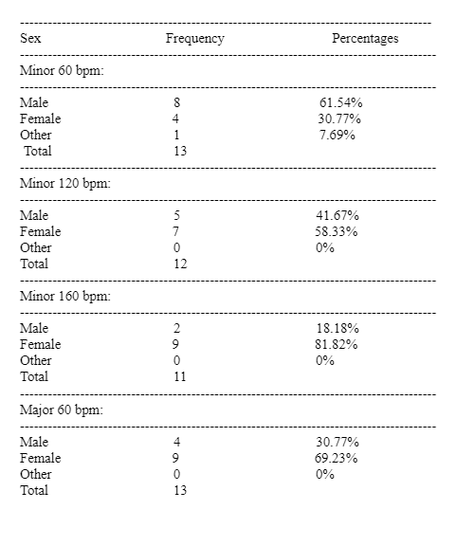

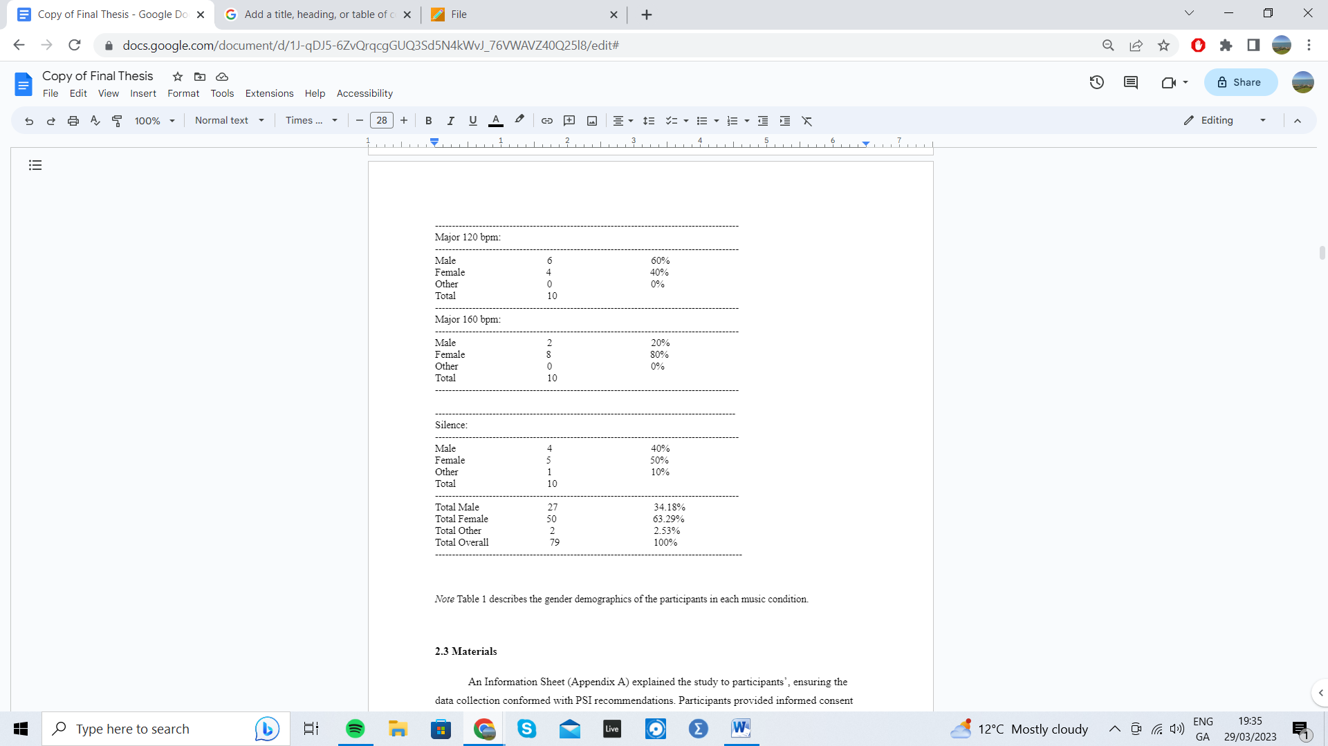
Note Table 1 describes the gender demographics of the participants in each music condition.

2.3 Materials
An Information Sheet (Appendix A) explained the study to participants’, ensuring the data collection conformed with PSI recommendations. Participants provided informed consent by ticking the relevant boxes on a Consent Form (Appendix B). Participants used the Participant Coding and Demographic Information Form (Appendix C) to create an anonymised code in case of a data removal request.

2.3.1 Music
The key and tempo of each piece was peer-reviewed by three producers using an online tempo and key measure called Tunebat, (n.d.), and through playing over each piece of music to confirm the key (key: Appendix J; tempo: Appendix K). Piano music, without any percussion, vocals, or other instrumentation was selected. The music’s tempo and key were consistent throughout each piece. In accordance with Liu et al. (2018) 60 bpm music represented the slow tempo condition, 120 bpm music represented the mid-tempo condition, and 160 bpm music represented the up tempo condition Although the tempo of six songs were increased using software, but researchers ensured these pieces sounded ordinary. This measure has been taken in previous research (Lin et al. 2023). Moreover, unfamiliar music was chosen to minimise distractors (Avila et al., 2012). Each condition’s music was combined into a single file to avoid any breaks between songs. These measures were taken to isolate the effects of tempo and key on the listener. The music that played for each condition is listed in (Appendices J & K) below.
2.3.2 Reading Comprehension Extract
The current study used an extract from ‘A Short History of Nearly Everything’ (Bryson, 2003), (Appendix D). The text was a single page, containing 530 words.

2.3.3 Maths test
Participants were given a maths task-switching distractor task (Appendix E). As per Dodge and Mensink (2014), the maths questions were randomly generated from TeachersCorner.net (n.d.). Every participant was given the same simple set of addition and subtraction problems to ensure fairness.

2.3.4 List of memory questions and final questions
Participants were asked ten questions concerning information such as names and dates from the Bill Bryson text (Appendix F). There were twenty-four pieces of information to memorise in total. A final questions sheet (Appendix G) was also given to participants, exploring the feeling the music aroused and the effect it had on memory.

2.3.5. Debriefing Information Form
A Debrief form (Appendix H) informed participants of their right to have their data removed before March 1st. It was also used to thank participants and provided information on support services.

2.3.6. Pilot test
A pilot test was conducted for the silence condition to test the study’s feasibility. Feedback (N=10) led the researchers to include three quantitative questions at the end of the study to get more detailed, subjective feedback, and to add more maths questions to the task-switching component.

2.3.7. Ethical considerations
Ethical approval was obtained through the Department of Technology and Psychology in IADT (Appendix L) after completing an amber route ethics application form. This study adhered to the code of Professional Ethics (the Psychological Society of Ireland, 2023). Participants created a partially anonymised code to allow the researchers to remove data if necessary. As previously stated, informed consent was obtained, and participants were appropriately debriefed.
2.4 Procedure
Permission was received from IADT lecturers to recruit first, second and third-year psychology students during lectures. The data was collected in two weeks, in three different classrooms and exclusively between 10am and 12pm as time of day may have a significant impact on memory (Hourihan & Benjamin 2014).
A comprehensive explanation of the study’s aims, and procedure was provided to each group. Important components of the Information Sheet, like confidentiality and anonymity, were emphasised while potential participants read over a copy (Appendix A). Participants were told that participation was voluntary and that they could leave the experiment at any time. Participants then signed a Consent form (Appendix B) and answered questions concerning gender, highest education level received and created a personalised, anonymised code with the Participant Coding and Demographic Information Form (Appendix C).
After these forms, participants spent ten minutes memorising the information on the reading comprehension extract (Appendix D). The current study doubled the time allocated by Dodge and Mensink (2014), to ensure participants had enough time to memorise. Participants were permitted to write on and underline the paper. Whilst the participants read the text, the background music condition was played at the same volume for every condition through a JBL Flip 4 speaker at an approximately equal distance from all the participants. After memorising, participants were instructed to complete as many of the maths questions as possible within a two-minute window (Appendix E).
After the maths task, participants answered as many of the memory questions on the extract as possible (Appendix F). Then the participants answered the Final Questions sheet (Appendix G), were instructed to read the debrief form (Appendix H) and were asked to tick a box to approve the use of quotations from their study.

2.4.1 Scoring the memory test
Achieving the maximum score for the memory test required correctly recalling 24 pieces of information. Any misspellings that were phonetically similar to the answer were accepted. The only exception to this was for question 7, which asked the participants’ to name elements from the extract. Fluoride was not accepted as a misspelling of fluorine, and magnesium was not accepted as a misspelling of manganese, as these are entirely separate elements. Half-points were awarded to correctly recalling half of a person’s full name, or correctly recalling a date to within the same century. The memory scores were inputted into SPSS to compute the statistical analyses.

2.4.2 Data Analysis
Statistical analyses and graphical figures and tables were produced using IBM SPSS (version 27.0).

2.4.3 Thematic Analysis
The participants' responses to the Final Questions; (A)” how did you feel about the music itself?”, (B) “how did the music affect your memory?” were both thematically analysed systematically using Braun and Clarke’s (2006) guide.
A predominantly framework approach to analysis was employed. The analysis included predominantly inductive elements with some definitive themes. Inter-rater coordination by the researcher and his classmates was included in the analysis, ensuring reliability and consistency of research methods (Belotto, 2018), (see Appendix M). This process was repeated in all the background music conditions, excluding silence as no music was played.
The responses were arranged in a word document that remained unedited to ensure the validity and integrity of the results (Leahey, 2008). Patterns identified in the responses to each question and were colour-coded appropriately (see Appendix N). This process summarised words and sentences into descriptive codes (Braun & Clarke, 2006), reducing the responses into manageable qualitative data points (Belotto, 2018). A thematic map was produced using researchers’ identified codes (see Appendix O). Only the responses of participants who consented to the future use of quotations were included in the thematic analysis.
Results

3.1 Relationship Between Key, Tempo, and Working Memory

3.1.1 Overview 1
The alpha value for all analyses was .05. The dependent variable was the working memory score. The independent variables were tempo (k = 3; slow, mid, up-tempo), and key (k = 2; minor, major).

3.1.2 Test of Normality
The data was normally distributed (Table P1). The descriptive statistics for each music condition and factor are displayed on Table 2 below. Any outliers are displayed on a boxplot (Figure J2).
Table 2
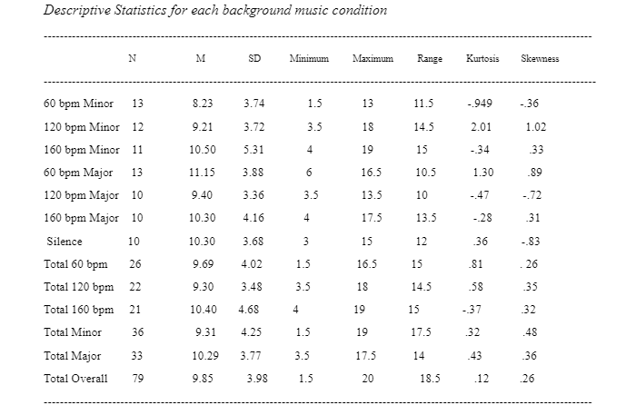
Descriptive Statistics for each background music condition

3.1.3 Analysis 1
A two-way between groups ANOVA was conducted to investigate RQ1: Does tempo and tonality/key of background music have a significant impact on working memory? (Appendix P). Memory scores were measured out of twenty-four. The assumption of homogeneity of variance was confirmed using Levene’s test of homogeneity (Table P2).
Hypothesis 1c stated that there would be a significant interaction between key and tempo on the memory scores for participants. This hypothesis was not supported, F (2,63)= 1.059, p=.353. The observed power was .227 (i.e., the power to detect a difference if there is one is 22.7%).
Hypothesis 1a stated that there would be a difference for the participants, on their working memory, based on the tempo of the background music played. This hypothesis was not supported, F (2,63)= .40, p= .672. The observed power was .112 (i.e., the power to detect a difference if there is one is 11.2%).
Hypothesis 1b stated that there would be a difference for the participants, on their working memory, based on the key of the background music played. This hypothesis was not supported, F (1,63)= .975, p= .327. The observed power was .163 (i.e., the power to detect a difference if there is one 16.3%). The output for this analysis can be viewed in the appendices (Table P3). The means for each condition are displayed in a graph (Figure P4). The estimated marginal means for each condition are displayed on a line-graph (Figure P1).

3.2 The Optimal Music Condition for Working Memory

3.2.1 Overview 2
The dependent variable was the working memory score. The independent variables were the various background music conditions (k = 7; minor key music (60bpm), minor key music (120bpm), minor key music (160bpm), major key music (60bpm), major key music (120bpm), major key music (160bpm) and silence).

3.2.2 Test of Normality
The data was normally distributed (Table Q1). Outliers are displayed on a boxplot (Figure Q3).

3.2.3 Analysis 2
A one-way ANOVA was conducted to investigate RQ2: What is the optimal background music condition to facilitate working memory? (Appendix Q). The assumption of homogeneity of variance was confirmed using Levene’s Test of Equality of Variances (p= .820) (Table Q2). Hypothesis 2 stated that there would be a difference for the participants on their working memory scores based on the background music condition. This hypothesis was not supported, F (6,72) = .742 ,p=.617. The observed power was small, .281 (i.e., the power to detect a difference if there is one 28.1%),(Table Q4). The means for each background music condition are visualised on a graph (Figure Q2).

3.3 Thematic Analysis
A thematic analysis was conducted to investigate (RQ3): How did the background music affect participants emotional and cognitive experience whilst doing a memory task? Six robust themes were identified in the analysis. Music enjoyment’ and ‘helped memory’ were deductively identified themes. ‘Distracting from task’, ‘a sense of relaxation’, ‘increased sleepiness’ and ‘a sense of pressure ' were inductively identified themes.
Themes were divided into ‘emotion-related’ or ‘task-related’ themes. ‘Helped memory’, ‘distracting from task’ and ‘increased sleepiness‘ were identified as ‘task-related themes’. ‘A sense of pressure or anxiety’, ‘music enjoyment’ and ‘a sense of relaxation’ were identified as ‘emotion-related themes. The frequencies and percentages of these themes occurring in each theme is displayed in a set of tables (Appendix R).

3.4 Task-Related themes

3.4.1 Helped Memory
Many participants reported that the music: ‘helped memory slightly’, ‘positively affected memory’ or ‘helped my memory from getting bored’. One participant reported that the background music ‘allowed me to relax and take in more information ‘. Moreover, one participant stated that ‘I enjoyed the music and tempo, and this seemed to help me remember’. 68.18% of participants reported that the music ‘helped memory’ in the mid-tempo conditions (Table R1).
3.4.2 Distracting from task
Participants reported that the music ‘distracted me from studying’ or that it ‘stopped me from hearing my inner voice’. One participant reported; ‘I think the music was too relaxed, so I felt distracted’. 59.09% of participants expressed that the music was most distracting in the up-tempo conditions (Table R2).
3.4.3 Increased Sleepiness
Participants reported that the music was ‘sleepy’ or made them ‘doze-off’ or ‘feel tired’. 46.15% of participants reported that the music ‘increased sleepiness’ in the slow-tempo music conditions. Moreover, one participant reported; ‘the music made me feel sleepy, so it was harder to memorise’ (Table R3).

3.5 Emotion- Related themes

3.5.1 Music Enjoyment
Participants stated that the music was ‘enjoyable’, ‘nice’, ‘pleasant’, ‘stimulating’ ‘uplifting’ or ‘satisfying’. 66.67% of participants in the major key conditions and 52.70% of participants in the minor key conditions reported ‘music enjoyment’ (Table R4).

3.5.2 A Sense of Relaxation
Participants reported that the music was ‘chilled’, ‘relaxing’, ‘soothing’, ‘calming’, and ‘peaceful’ predominantly in the slow tempo conditions, and to a lesser extent in the mid-tempo and up-tempo conditions. 88.46% of participants in the slow-tempo conditions described the music as ‘inducing a sense of relaxation’. One participant reported ’it relaxed me which helped block out background noise’ and another stated: ‘I really liked how relaxing the music was’. (Table R5).
3.5.3 A Sense of Pressure
31.82% of participants reported ‘feeling under pressure’ or that the music was ‘overbearing’ or ‘too fast and overwhelming’ in the up-tempo background music conditions. One participant stated, ‘I felt under pressure which might have distracted me from reading’ (Table R6).
Discussion
4.1 Overview
The current study aims to investigate the relationship between background music’s constituent characteristics (key and tempo) and working memory through use of a reading comprehension with a task-switching component. Moreover, it also aims to explore how background music affects participants' emotional and cognitive experience whilst doing a memory task. Although previous studies have investigated the relationship between music and working memory, very few have tested the relationship between music’s constituent characteristics and background music, instead focusing on genre (Dodge & Mensink, 2014; Bottiroli et al., 2014). As aforementioned, research in this area has reportedly been inconsistent and inconclusive (de la Mora Velasco & Hirumi 2020). The current study indicates that the tempo and key of the background music may not have a significant impact on working memory (RQ1), and there does not appear to be an optimal background music condition to facilitate working memory (RQ2). However, the exploration of participants' subjective emotional and cognitive experiences of doing a memory task reports novel findings (RQ3). These questions are explored in more detail below.
4.2 Relationships between Working Memory and Background Music
It was hypothesised that there would be a statistically significant interaction between tempo and key on working memory (H1a). This hypothesis was not supported, conflicting with previous research studies stating that slow tempo minor key music improves processing speed and memory (Bottiroli et al., 2014). The second hypothesis proposed that there would be a statistically significant impact on participants' working memory, based on the tempo of the background music played (H1b). This hypothesis was not supported, consistent with research conducted by Jäncke and Sandmann (2010) who report that background music of varying tempos has no effect on memory. Finally, it was hypothesised that there would be a statistically significant impact on working memory based on the key of the background music played (H1c). This hypothesis was not supported, which. is consistent with research conducted by Nguyen and Grahn (2017) who suggest that background music of varying moods and levels of arousal does not enhance memory overall. This may be explained by the participants’ subjective working memory capacities Zhang et al. (2017). These findings suggest that the tempo and key of background music do not have a significant impact on working memory (RQ1).
It was also hypothesised that there would be a statistically significant difference for the students in their working memory scores, based on the background music condition (including a silence condition), (H2). This hypothesis was not supported, consistent with previous research suggesting that background music, compared to silence, has no significant effect on memory, and that music of varying tempos and keys has no effect on memory (Jäncke & Sandmann, 2010; Nguyen & Grahn, 2017). Therefore, there does not appear to be an optimal background music condition to facilitate working memory (RQ2).

4.3 Participants' subjective emotional and cognitive experiences of doing a memory task.
Novel codes were identified whilst exploring the participants' subjective emotional and cognitive experiences of doing a memory task (RQ3). Participants positively described the slow-tempo music (60 bpm) as the most ‘relaxing’ and ‘sleepy’. Although slow-tempo music being described as ‘relaxing’ corresponds with previous literature (Gunter, 1995), it challenges the findings in studies in which participants report that slow-tempo music evokes mostly negative emotions (Liu et al., 2018) Furthermore, some participants stated that the music was ‘too relaxed and sleepy, negatively affecting memory’. This finding relates to previous research findings concerning the Yerkes-Dodson Law of Arousal, which states that slow-tempo music is under-stimulating (Nguyen &Grahan, 2017). Therefore, there appears to be some validity to this Law.
Participants reported that the music ‘helped memory’ most often in the mid-tempo conditions, consistent with research conducted by Chie et al. (2009). In contrast with literature indicating that mid-tempo music is the most emotionally arousing (Liu et al., 2018), the emotion-related themes in this study appeared most often in the slow-tempo and up-tempo background music conditions.
Participants commonly negatively describing the up-tempo music as ‘distracting’ and ‘inducing a sense of pressure or anxiety’, corresponds with previous literature relating to the Yerkes Dodson Law of Arousal which suggests that music with a tempo higher than 144 bpm (mid-tempo) may negatively affect concentration, (Webster & Weir, 2005). However, this description contrasts previous research suggesting that up-tempo music evokes positive emotions (Liu et al., 2018; Hunter et al., 2010). This indicates that further research into the emotional arousal of different musical tempos is necessary.
Participants reported that major key background music was the most ‘enjoyable’ and ‘helpful for memory’. This aligns with previous literature which proposes that the listener's subjective positive emotions are highest for major key music (Hunter et al., 2010; Justus et al., 2018). This further suggests that listening to music that positively arouses mood may benefit cognitive performance (Husain et al., 2002). Moreover, this finding is partially reported in previous studies which suggest memory is most enhanced in positive-mood-arousing music (major) and negative-mood-arousing music (minor) (Greene et al., 2010). However, in contrast with Greene et al. (2010), the participants in the current study did not report that minor music had a significantly positive effect on memory.
4.4 Strengths and Limitations
The current study has several strengths. Firstly, the current study focuses on testing music’s constituent characteristics (key and tempo) compared to previous research which investigated background music genres (Dodge & Mensink, 2014), (Bottiroli et al., 2014) . Genre labels often do not accurately describe music which should be described by constituent musical characteristics like key or tempo (Greenberg, 2016). Describing the music in terms of key and tempo in the current study allowed researchers to isolate the effects of musical characteristics.
Additionally, the current study controls for confounding or extraneous variables by removing familiar music (Avila et al., 2012), by peer-reviewing to ensure the key and tempo of the music was homogenous (Appendix J & K), and by collecting the data exclusively between 10am and 12pm (Hourihan & Benjamin 2014). Furthermore, the current study includes a mid-tempo condition, a measure which previous literature lacked (Liu et al., 2018). This allowed for a medium between highly arousing and slightly arousing music.
Lastly the current study demonstrates external validity through emulating a real-life studying scenario through including a reading comprehension, task-switching component and allowing participants to write on the paper. Previous literature proposes that working memory has an effect on reading comprehension results (Nouwens et al., 2016), as reading comprehension is a component of executive function important for working memory (Baddeley, 2012). Task-switching relates to working memory, and may incur a higher perceptual load, impairing working memory and emulating a real-life studying scenario (Pizzie et al., 2019).
Although the music was peer-reviewed, the music selected was not totally homogenous. Moreover, many of the participants recalled the wrong information correctly, thus demonstrating a functioning working memory. Responding with the wrong answer based on the questions’ wording is arguably indicative of a real-life studying scenario. However, how indicative of a real-life scenario it truly is remains to be answered.
Additionally, the observed power, (or the probability of rejecting a false null hypothesis) in each statistical test is very low (see Tables P3 and Q4). A low observed power may be indicative of both small sample sizes and low effect sizes (Serdar et al., 2021). Additionally, the majority of participants in the current study were females (see Table 1), which may affect results as women reportedly outperform men in visual working memory tasks (Harness et al., 2008).
4.5 Future Research
The use of more homogenous music could be considered in the future, possibly by having a musician play the same excerpt in a minor and major key, and in three different tempos. Future research should aim to balance the gender to ensure consistency (Harness et al., 2008), and to include more participants in each background music condition to reduce the possibility of a low observed power.
Lastly, future research could include questions relating specifically to whether the music made participants happy or sad, and whether the music was liked or disliked in each condition. Moreover, future research could consider the inclusion of a more objective emotional scale which has been used in research such as the Geneva Emotional Music Scale (GEMS), (Vuoskoski & Eerola, 2011).

4.6 Theoretical and Practical Implications
Understanding the relationship between background music and cognitive performance could help institutions and students develop more efficient studying strategies. The current study adds to the empirical literature surrounding the relationship between working memory, background musical tempo and key, and emotional arousal. Not only does this research support the progression of research relating to these topics and inform future research designs through its strengths and limitations, it also provides a qualitative insight into participants' emotion-related and task-related experiences of doing a working memory test. In future research, these findings may contribute to addressing the ambiguous relationship between the influence of background music on various cognitive domains (de la Mora Velasco & Hirumi, 2020).
4.7 Conclusion
The current study investigates the relationship between the key and tempo of background music on working memory and emotional arousal. The study’s design builds on previous research that confined such investigations to musical genre, despite the importance of considering constituent musical characteristics like key or tempo (Greenberg, 2016). In using a robust study design, the current study makes rigorous attempts to control for extraneous variables in the music selection and data-collection process and included a mid-tempo condition, lacking from previous studies (Liu et al., 2018). Although none of the hypotheses were proven, the qualitative data suggests the value in replicating this study design with a larger gender-balanced sample and a more appropriate form of qualitative analysis to assess the participants opinion of and emotional response to the music. This research may contribute to future investigations aiming to advance the empirical literature concerning the relationships between the key and tempo of background music and working memory and emotional arousal.

References
Avila, C., Furnham, A., & McClelland, A. (2012). The influence of distracting familiar vocal music on cognitive performance of introverts and extraverts. Psychology of Music, 40(1), 84–93. https://doi.org/10.1177/0305735611422672
Baddeley A. (2012). Working memory: theories, models, and controversies. Annual review of psychology, 63, 1–29. https://doi.org/10.1146/annurev-psych- 120710-100422
Belotto, M. (2018). Data Analysis Methods for qualitative research: Managing the challenges of coding, interrater reliability, and thematic analysis. The Qualitative Report. https://doi.org/10.46743/2160-3715/2018.3492
Bergman Nutley, S., & Söderqvist, S. (2017). How is working memory training likely to influence academic performance? current evidence and methodological considerations. Frontiers in Psychology, 8. https://doi.org/10.3389/fpsyg.2017.00069
Bottiroli, S., Rosi, A., Russo, R., Vecchi, T., & Cavallini, E. (2014). The cognitive effects of listening to background music on older adults: processing speed improves with upbeat music, while memory seems to benefit from both upbeat and downbeat music. Frontiers in aging neuroscience. 6 (284). https://doi.org/10.3389/fnagi.2014.00284.
Braun, V., & Clarke, V. (2006). Using thematic analysis in psychology. Qualitative Research in Psychology, 3(2), 77–101. https://doi.org/10.1191/1478088706qp063oa
Bryson, B. (2003). A short history of nearly everything. Broadway Books.

Calm Chords. (2019, March 26). Minor Key Relaxing Piano Music for Sleep, Calm Chords, Moonlight Serene Night Music [Video]. Youtube. https://www.youtube.com/watch?v=kH7qRf_KUyw&ab_channel=CalmChords
CashhBeats. (2020, February 12). [FREE] Nostalgic piano 120 BPM [Video]. Youtube. https://www.youtube.com/watch?v=IYeK3W5N0BA&ab_channel=CasshBeats
Cassidy, G., & MacDonald, R. A. R. (2007). The effect of background music and background noise on the task performance of introverts and extraverts. Psychology of Music, 35(3), 517–537. https://doi.org/10.1177/0305735607076444
Chai, W. J., Abd Hamid, A. I., & Abdullah, J. M. (2018). Working memory from the psychological and neurosciences perspectives: A Review. Frontiers in Psychology, 9. https://doi.org/10.3389/fpsyg.2018.00401
Chie, Q. T., and Karthigeyan, K. K. (2009). The effects of music tempo on memory performance using maintenance rehearsal and imagery. Sunway Academic. Journal. 6, 114–132.
Collins English Dictionary (n.d.) Tempo definition and meaning. https://www.collinsdictionary.com/dictionary/english/tempo
Cortés Pascual, A., Moyano Muñoz, N., & Quílez Robres, A. (2019). The relationship between executive functions and academic performance in primary education: Review and meta-analysis. Frontiers in Psychology, 10. https://doi.org/10.3389/fpsyg.2019.01582
Cowan, N. (2010). The magical mystery four. Current Directions in Psychological Science, 19(1), 51–57. https://doi.org/10.1177/0963721409359277
de la Mora Velasco, E., & Hirumi, A. (2020). The effects of background music on learning: a systematic review of literature to guide future research and practice. Educational Technology Research & Development, 68(6), 2817–2837. https://doi.org/10.1007/s11423-020-09783-4
DeVoto, M. (2007, October 30). Key. Britannica.p.1 https://www.britannica.com/art/key-music
Diamond, A. (2013). Executive functions. Annual Review of Psychology, 64(1), 135–168. https://doi.org/10.1146/annurev-psych-113011-143750
Dodge, L. & Mensink, M. C. (2014). Music and memory: effects of listening to music while studying in college students. University of Wisconsin-Stout Journal of Student Research, 13, 203-215.
Dodson, J. D. (1915). The relation of strength of stimulus to rapidity of habit-formation in the kitten. Journal of Animal Behavior, 5(4), 330–336. https://doi.org/10.1037/h0073415
Du, M., Jiang, J., Li, Z., Man, D., & Jiang, C. (2020). The effects of background music on neural responses during reading comprehension. Scientific Reports, 10(1). https://doi.org/10.1038/s41598-020-75623-3
Executive Function & Self-regulation (2020, March 24) Center on the Developing Child at Harvard University. https://developingchild.harvard.edu/science/key- concepts/executive-function/
Ferreri, L., Aucouturier, J. J., Muthalib, M., Bigand, E., & Bugaiska, A. (2013). Music improves verbal memory encoding while decreasing prefrontal cortex activity: an fNIRS study. Frontiers in human neuroscience. 7 (779). https://doi.org/10.3389/fnhum.2013.00779.
Gabrielsson, A., & Lindström, E. (2010). The role of structure in the musical expression of emotions. In P. N. Juslin & J. A. Sloboda (Eds.), Handbook of music and emotion: Theory, research, applications (pp. 367–400). Oxford University Press.
Greenberg D (2016, August 5) Opinion: Musical genres are out of date – but this new system explains why you might like both jazz and Hip Hop. University of Cambridge. https://tinyurl.com/University-Of-Cambridge.
Greene, C. M., Bahri, P., & Soto, D. (2010). Interplay between affect and arousal in recognition memory. Plos One, 5(7). https://doi.org/10/1371/journal.pone. 0011739.
Gunter, E. D. (1997). Superlearning 2000: Learning made simple everybody can learn. Milligan Books.
Harness, A., Jacot, L., Scherf, S., White, A., & Warnick, J. E. (2008). Sex differences in working memory. Psychological reports, 103(1), 214–218. https://doi.org/10.2466/pr0.103.1.214-218
Hourihan, K. L., & Benjamin, A. S. (2014). State-based metacognition: how time of day affects the accuracy of metamemory. Memory, 22(5), 553–558. https://doi.org/10.1080/09658211.2013.804091
Hunter, P. G., Schellenberg, E. G., & Schimmack, U. (2010). Feelings and perceptions of happiness and sadness induced by music: Similarities, differences, and mixed emotions. Psychology of Aesthetics, Creativity, and the Arts, 4(1), 47–56. https://doi.org/10.1037/a0016873
Husain, G., Thompson, W. F., &amp; Schellenberg, E. G. (2002). Effects of musical tempo and mode on arousal, mood, and spatial abilities. Music Perception, 20(2), 151–171. https://doi.org/10.1525/mp.2002.20.2.151
Jäncke, L., & Sandmann, P. (2010). Music listening while you learn: No influence of background music on verbal learning. Behavioral and Brain Functions, 6(1), 3. https://doi.org/10.1186/1744-9081-6-3
Justus, T., Gabriel, L., & Pfaff, A. (2018). Form and meaning in music: Revisiting the affective character of the major and minor modes. Auditory Perception & Cognition, 1(3-4), 229–247. https://doi.org/10.1080/25742442.2019.1597578
Kämpfe, J., Sedlmeier, P., & Renkewitz, F. (2011). The impact of background music on adult listeners: A meta-analysis. Psychology of Music. 39(4) https://doi.org/10.1177/0305735610376261.
Katagiri, J. (2009). The effect of background music and song texts on the emotional understanding of children with autism. Journal of Music Therapy, 46(1), 14. https://doi.org/10.1093/jmt/46.1.15
Khaghaninejad, M. S., Motlagh, H. S. & Chamacham, R. (2016). How does Mozart's music affect the reading comprehension of Iranian EFL learners of both genders? International Journal of Human Cultural Studies, 8(7). 489–499. https://www.researchgate.net/publication/303192685.
Ladino Mercado, S. (2021, April 22). Preludio en C major 100 bpm [Video]. Youtube. https://www.youtube.com/watch?v=_-adbgtbjwc&ab_channel=SEBASTIAN LADINO MERCADO.
Lam-Music, J. (2016, October 15). 160 BPM- Angels & Demons (2 Pianos) [Video]. Youtube.https://www.youtube.com/watch?v=mc47xX9x_dU&ab_channel=Jason LamMusic
Leahey, E. (2008). Overseeing research practice. Science, Technology, & Human Values, 33(5), 605–630. https://doi.org/10.1177/0162243907306702
Lin, H.-M., Kuo, S.-H., & Mai, T. P. (2023). Slower tempo makes worse performance? The effect of musical tempo on cognitive processing speed. Frontiers in Psychology, 14. https://doi.org/10.3389/fpsyg.2023.998460
Liu, Y., Liu, G., Wei, D., Li, Q., Yuan, G., Wu, S., Wang, G., & Zhao, X. (2018). Effects of Musical Tempo on Musicians' and Non-musicians' Emotional Experience When Listening to Music. Frontiers in psychology, 9. https://doi.org/10.3389/fpsyg.2018.02118
Merriam-Webster. (2023, March 24). Genre definition & meaning. Merriam-Webster. https://www.merriam-webster.com/dictionary/genre

Mintada MusicLibrary. (2022, November 11). Piano Loop 120 BPM [ C G Am F G ] [Video]. Youtube. https://www.youtube.com/watch?v=XUUkX0dyM4&ab_ ` channel=Mintada
Motoyuki. (2019, July 10). Pure Heart - 60 BPM Piano Music for Relaxation, Meditation, Tai Chi, Yoga, Clarity and Discernment [Video]. Youtube. https://www.youtube.com/watch?v=wonlpdan-nc&t=79s&ab_channel=Motoyuki
Mucenieks, T. (2019, April 10). Scott Joplin - Maple Leaf Rag [Video]. Youtube. https://www.youtube.com/watch?v=rBInnwV21DM&ab_channel=TomsMucenie ks
New Backing Tracks Every Friday (2018, April 25). Epic Ballad Backing Track - in B Minor [Video]. Youtube. https://www.youtube.com/watch?v=LZkqyxP_CEM& list=RDQQ0DM9M4jY&index=19&ab_channel=NewBackingTracksEveryFr iday
New Backing Tracks Every Friday (2018, January 3) Melancholy Guitar Backing Track- Piano Ballad - 120 bpm [Video]. Youtube. https://www.youtube.com/watch?v =QQ0DM9M4-jY&ab_channel=NewBackingTracksEveryFriday
Nguyen, T., & Grahn, J. A. (2017). Mind your music: The effects of music-induced mood and arousal across different memory tasks. Psychomusicology: Music, Mind, and Brain, 27(2), 81–94. https://doi.org/10.1037/pmu0000178
Nouwens, S., Groen, M. A., & Verhoeven, L. (2016). How storage and executive functions contribute to children's reading comprehension. Learning and Individual Differences, 47, 96–102. https://doi.org/10.1016/j.lindif.2015.12.008
Nowell, L. S., Norris, J. M., White, D. E., & Moules, N. J. (2017). Thematic Analysis: Striving to Meet the Trustworthiness Criteria. International Journal of Qualitative Methods, 16(1). https://doi.org/10.1177/1609406917733847
Pizzie, R., Raman, N., & Kraemer, D. J. (2019). Math anxiety and executive function: Neural influences of task switching on arithmetic processing. https://doi.org/10.31234/osf.io/knc9f
Psychological Society of Ireland (n.d.). Code of Ethics: Article: PSI. https://www.psychologicalsociety.ie/footer/Code-of-Ethics-1
Radocy, R. E., & Boyle, J. D. (2012). Psychological foundations of musical behavior (5th ed.). Charles C Thomas Publisher.
Rifkin-Topic, J. (2015, April 30). Pine Apple Rag [Video]. Youtub https://www.youtube.com/watch?v=X2QqA70Rxf4&ab_ channel=JoshuaRifkin-Topic
Sands, M. (2007, October 19). Winifred Atwell - Black and White Rag [Video]. Youtube. https://www.youtube.com/watch?v=vJx1jry3Ev8&ab_channel=MichaelSands
Schwartz, R. W., Ayres, K. M., & Douglas, K. H. (2017). Effects of music on task performance, engagement, and behavior: A literature review. Psychology of Music, 45(5), 611–627. https://doi.org/10.1177/0305735617691118
Serdar, C. C., Cihan, M., Yücel, D., & Serdar, M. A. (2021). Sample size, power and effect size revisited: Simplified and practical approaches in pre-clinical, clinical and laboratory studies. Biochemia Medica, 31(1), 27–53. https://doi.org/10.11613/bm.2021.010502
Simple Samples. (2022, May 22). Free piano loop 001 120 bpm [Video]. Youtube. https://www.youtube.com/watch?v=YeRzMtWAdpc&list=PL9BdtoyT75 AV5KRkq_-_z6hrwSQQjPzCd&ab_chanel=simplesamples.
Super Sound Bugs! (2015, May 28). [M/V] Rob Costlow - True Gemini [Video]. Youtube. https://www.youtube.com/watch?v=jQajyGxglGs&ab_channel =SUPERSOUNDBugs%21.
Teacher’s Corner.net (n.d.). Math Worksheets. https://teacherscorner.net/
Tunebat(n.d.). Song Key & BPM Finder. https://tunebat.com/Analyzer
Vuoskoski, J. K., & Eerola, T. (2011). Measuring music-induced emotion: A comparison of emotion models, personality biases, and intensity of experiences. Musicae Scientiae, 15(2), 159–173. https://doi.org/10.1177/1029864911403367
Webster, G. D., & Weir, C. G. (2005). Emotional Responses to Music: Interactive Effects of Mode, Texture, and Tempo. Motivation and Emotion, 29(1), 19–39. https://doi.org/10.1007/s11031-005-4414-0
Zhang, Y., Zhang, G., & Liu, B. (2017). Investigation of the influence of emotions on working memory capacity using ERP and ERSP. Neuroscience, 357, 338–348. https://doi.org/10.1016/j.neuroscience.2017.06.016
Zimmerman, D. (2014, November 8). Harlem Rag [Video]. Youtube. https://www.youtube.com/watch?v=raVfgg_yMrg&ab_channel =DickZimmerman-Topic

Appendices:
Appendix A: Yerkes-Dodson Inverted U
Graph Displaying Yerkes-Dodson Inverted U Model of Arousal showing the relationship between anxiety (arousal) and Performance

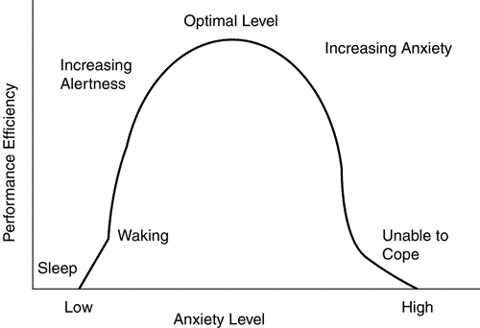
Note. Reprinted from ‘Physiologically Driven Rehabilitation Using Virtual Reality’ by Salva A. (2009), Foundations of Augmented Cognition. Neuroergonomics and Operational Neuroscience: 5th International Conference, P. 3

Appendix B: Information Sheet
Information Sheet
Title of project: Exploring the effects of background music on memory You are being invited to take part in the research: “The effect of background music on memory” (for every title)
This project is being undertaken by Seán Ó’Síocháin for my major research project as part of the BSc (Hons) in Applied Psychology, IADT.
Before you decide whether you wish to take part, it is important for you to understand why this research is being done and what it will involve. Please take time to read this information carefully. If there is anything that is unclear or if you would like more information, please ask. Our contact details are at the end of this information sheet. Thank you for reading this.
What is the purpose of the project? Many people listen to music whilst studying yet there is a lack of agreement on the best type of studying music. This study aims to address this issue.
Who is/Why are you being invited to take part? You are being invited to participate in this study because you are a college student who has to study and recall information on a regular basis.
What is involved? If you choose to participate, you will be asked to study a short reading comprehension extract for approximately 10 minutes, and to memorise as many of the details from the extract as possible. While you are studying the extract, there will be a specific background music playing over a speaker in the room. After this you will be given a further two short tasks involving recall.
Do I have to take part? You are free to decide whether you wish to take part or not. If you do decide to take part, you will be asked to sign a consent form that lets us know you have read this information sheet and understand what is involved in the research. You are free to withdraw from this study at any time and without giving reasons. Choosing to take part in this study will have no impact on any marks, assessments or future studies.
What are the disadvantages and risks (if any) of taking part? You will be required to study and memorise information and to answer basic math questions. If you feel unable or uncomfortable with doing so, you may choose not to answer questions or not take part in any section of the study if you do not wish to.

What are the possible benefits of taking part? This research may give you a better understanding of your own optimised studying conditions. Furthermore, the information we get from the study will increase our understanding of what the optimal conditions for studying are, and may help students to study more optimally in the future.
How will my information be used? Your data will be compared to the other groups under different musical conditions in order to better understand the optimal background studying music. All identifying information will be removed. The resulting data will be described in the final thesis for the BSc (Hons) in Applied Psychology in the Dun Laoghaire Institute of Art, Design & Technology. This can be requested through the library at IADT, or by emailing the researcher or supervisor at N00192200@iadt.ie or john.greaney@iadt.ie. This study may also be published in an academic journal article and may be written about for blog posts or media articles and these can be requested from the researcher.
How will my data be protected? Under the EU General Data Protection Regulation (GDPR) the legal basis for collecting data for scholarly research is that of public interest. The regulations regarding the protection of your data will be followed. Only data which is needed for analysis will be collected. By giving your consent to take part in the study you are consenting to the use of your data as detailed in this information sheet.
The data will be retained by the researcher for at least one year, and may be retained for up to 7 years if the results of the study are published in certain capacities (e.g. in a journal article). There is also a possibility that the fully anonymised dataset may be submitted to a journal and made available to other researchers and academics worldwide for verification purposes, but if this occurs it will be ensured that you are not identifiable from the data.
As the supervisor on this project, I, Dr. John Greaney am responsible for ensuring that all datasets will be stored in accordance with GDPR regulations and those which are not submitted to a journal will be fully deleted on or before date 7 years from data collection.
Only Seán Ó’Síocháin and Dr. John Greaney and Christine Horn will have access to the data. The data will be stored securely in a locked filing cabinet. If there is a data breach the data protection officer in IADT will be informed immediately. The data will be anonymised and the names of participants omitted. Participants’ names will be coded only in order to label and organise the data for the researcher’s convenience.
You will find contact information for IADT's Data Protection Officer, Mr Bernard Mullarkey, and more information on your rights concerning your data at https://iadt.ie/about/your-rights-entitlements/gdpr/
Who has reviewed the study? This study has been approved by the IADT Psychology Ethics Committee.
What if you have any questions or there is a problem? If you have a concern about any aspect of this study, you may wish to speak to the researcher(s) who will do their best to answer your questions. You should contact N00192200@iadt.ie or their supervisor john.greaney@iadt.ie
Thank you for taking the time to read this information sheet
Date: 04/02/23

Appendix C: Consent Form

CONSENT FORM
Title of Project: Exploring the effects of background music on working memory
Name of Researcher/s: Seán Ó’Síocháin
Please Tick Box
- I confirm that I have read and understand the information sheet for the above study and have had the opportunity to ask questions. [ ]

- I understand that my participation is voluntary and that I am free to withdraw at any time [ ]

- I understand that data collected about me during this study will not be identifiable when the research is published. [ ]

- I am over 18. [ ]

- I agree to take part in this study. [ ]

- I agree to be contacted about possible participation in future research projects. [ ]

- I agree for this data to be used in future research projects. [ ]
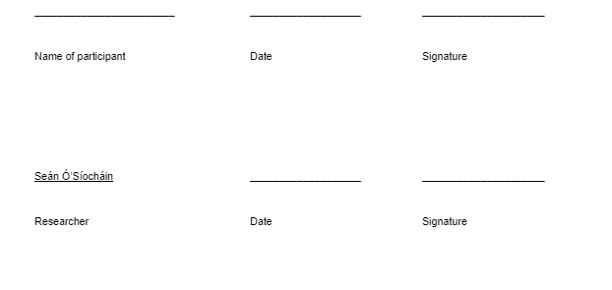

Append Appendix D: Participant code and demographic information form
PARTICIPANT CODE AND DEMOGRAPHIC INFORMATION FORM:
1. Please provide us with an anonymised code which we can use to identify your data if you later wish to have it removed from our dataset. Please do so by answering the following two questions
o What are the second letters of your first and last name? (For example, if your name is Jane Smith, these letters would be ‘AM’) What are the last three digits of your telephone number? (ie AM457)

__________

2. Gender: I identify as:
o Male
o Female
o non-binary
o I prefer not to say.
3. My pronouns are:
o He/him
o She/her
o I prefer not to say.

4. My highest level of education achieved is:
o No formal education
o Some primary level / national school education
o Completed primary level / national school.
o Some secondary level, but no state examinations
o Junior Certificate
o Leaving Certificate
o Some college or university or trade training, but no degree or qualification
o Trade / technical / vocational training
o College / university certificate, diploma, or ordinary degree
o Honours bachelor’s degree
o master’s degree
o Professional degree
o Doctorate degree
o other qualification
- I prefer not to say

Appendix E: Reading Comprehension Extract (Bill Bryson)
Chemistry as an earnest and respectable science is often said to date from 1661, when Robert Boyle of Oxford published The Sceptical Chymist —the first work to distinguish between chemists and alchemists—but it was a slow and often erratic transition. Into the eighteenth century scholars could feel oddly comfortable in both camps—like the German Johann Becher, who produced an unexceptionable work on mineralogy called Physica Subterranea, but who also was certain that, given the right materials, he could make himself invisible.
Perhaps nothing better typifies the strange and often accidental nature of chemical science in its early days than a discovery made by a German named Hennig Brand in 1675. Brand became convinced that gold could somehow be distilled from human urine. (The similarity of color seems to have been a factor in his conclusion.) He assembled fifty buckets of human urine, which he kept for months in his cellar. By various recondite Music & Memory Journal of Student Research 214 processes, he converted the urine first into a noxious paste and then into a translucent waxy substance. None of it yielded gold, of course, but a strange and interesting thing did happen. After a time, the substance began to glow. Moreover, when exposed to air, it often spontaneously burst into flame.
The commercial potential for the stuff—which soon became known as phosphorus, from Greek and Latin roots meaning “light bearing”—was not lost on eager businesspeople, but the difficulties of manufacture made it too costly to exploit. An ounce of phosphorus retailed for six guineas—perhaps five hundred dollars in today’s money—or more than gold.
At first, soldiers were called on to provide the raw material, but such an arrangement was hardly conducive to industrialscale production. In the 1750s a Swedish chemist named Karl (or Carl) Scheele devised a way to manufacture phosphorus in bulk without the slop or smell of urine. It was largely because of this mastery of phosphorus that Sweden became, and remains, a leading producer of matches.
Scheele was both an extraordinary and extraordinarily luckless fellow. A poor pharmacist with little in the way of advanced apparatus, he discovered eight elements—chlorine, fluorine, manganese, barium, molybdenum, tungsten, nitrogen, and oxygen—and got credit for none of them. In every case, his finds were either overlooked or made it into publication after someone else had made the same discovery independently. He also discovered many useful compounds, among them ammonia, glycerin, and tannic acid, and was the first to see the commercial potential of chlorine as a bleach—all breakthroughs that made other people extremely wealthy.
Scheele’s one notable shortcoming was a curious insistence on tasting a little of everything he worked with, including such notoriously disagreeable substances as mercury, prussic acid (another of his discoveries), and hydrocyanic acid—a compound so famously poisonous that 150 years later Erwin Schrödinger chose it as his toxin of choice in a famous thought experiment. Scheele’s rashness eventually caught up with him. In 1786, aged just forty-three, he was found dead at his workbench surrounded by an array of toxic chemicals, any one of which could have accounted for the stunned and terminal look on his face.

Appendix F: Maths Worksheets
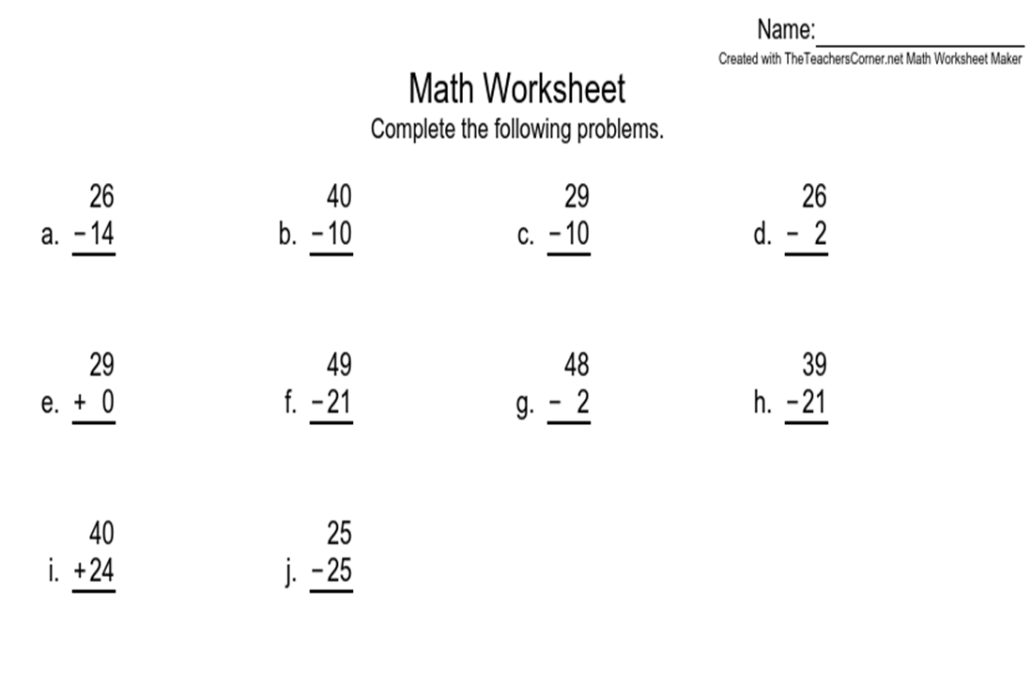
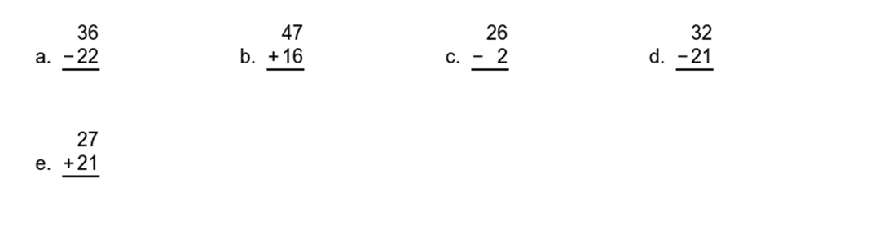

Appendix G: Memory Questions
1. When is chemistry said to date from?
2. Robert Boyle of Oxford published the Sceptical Chymist, the first work to distinguish what?
3. What was the name of the man who thought gold could be distilled from human urine and in what year?
4. How many buckets of urine did the chemist collect and where did he collect them?
5. At first, who was called on to provide the raw material to make phosphorus?
6. What was the full name of the chemist that devised a way to manufacture phosphorus in bulk without the slop or smell of urine? And in what year?
7. Name as many of the elements that the poor chemist discovered as you can.
8. Name as many compounds as you can that the same chemist discovered.
9. At what age did this poor chemist die?
10. How did this chemist die?

Appendix H: Final Questions
FINAL QUESTIONS:
      - How did you feel about the music itself?

2. How did the music affect your memory?

3. Please include any feedback or suggestions you may have.

Appendix I: Debriefing Information Form
DEBRIEFING INFORMATION FORM
Title of Project: Exploring the effects of background music on working memory.
Name of Researcher/s: Seán Ó’Síocháin Thank you very much for taking part in this research study. This study is designed to investigate the relationship between varying musical tempos (slow-tempo, mid-tempo and up tempo), varying musical keys (minor key (sad tone) and major key (happy tone) and working memory.
Withdrawal information If you have any questions about this study, or if you would like to withdraw your data from the study, please contact the researcher or supervisor at N00192200@iadt.ie, or: john.greaney@iadt.ie. In your email let them know your unique ID code (The second letters of your first and last name? (For example, if your name is Jane Smith, these letters would be ‘AM’) and the last three digits of your telephone number). If you submit a request for data removal, all data collected from you will be securely deleted. You will be able to remove your data from the study until 01/03/2023 when the data will be combined and analysed. Data removal will not be possible after that date. Please keep a copy of this information in case you wish to remove your data after leaving this screen.
Data protection Your data will be treated according to GDPR regulations. You will find contact information for IADT's Data Protection Officer, Mr Bernard Mullarkey, and more information on your rights concerning your data at https://iadt.ie/about/your-rights-entitlements/gdpr/
Support resources If you have been affected by the content of this study in any way, the organisations below may be of assistance:
IADT Student Counseling Service:
Email studentcounselling@iadt.ie or Drop in Monday- Friday 9am till 3pm https://www.mentalhealthireland.ie/resources/ https://www.aware.ie/support/support-line/ https://www.samaritans.org/ireland/samaritans-ireland/
Thank you again for taking the time to participate in this research. If you have any questions about this study, please contact the researcher or supervisor at N00192200@iadt.ie, or: john.greaney@iadt.ie.
CONFIRMATION OF CONSENT FOR DATA USE
1. Having completed the experiment:
o I consent to the researchers using my answers for their research
o I wish to have my answers removed from the research

Appendix J: Inter-rater reliability scores for musical key table (major/minor)

Inter-rater reliability for musical key (Major/Minor):
—-----------------------------------------------------------------------------------------------------------------------------------------
Researchers Background Music Condition Ryan: Charlie: Seán: Agreement (%):
—-----------------------------------------------------------------------------------------------------------------------------------------
Minor 60
Calm Chords (2019) 1 1 1 100%
Motoyuki (2014) 1 0 1 66%
—--------------------------------------------------------------------------------------------------------------------------------------
Minor 120
New Backing Tracks Every Friday (2018) 1 1 1 100%
New Backing Tracks Every Friday (2018) 2 time 1 1 1 100%
—-----------------------------------------------------------------------------------------------------------------------------------------
Minor 160
Jason Lam Music (2016) 1 1 1 100%
SUPER SOUND Bugs! (2015) 1 1 1 100%
Jurrivh (2018) 1 1 1 100%
—-----------------------------------------------------------------------------------------------------------------------------------------
Major 60 1 1 1 100%
Motoyuki (2019) 1 1 1 100%
Motoyuki (2019) 1 1 1 100%
—----------------------------------------------------------------------------------------------------------------------------------------
Major 120
CashhBeats (2020) 1 1 1 100%
Mintada MusicLibrary (2022) 1 1 1 100%
simple samples (2022) 1 1 1 100%
Michael Kim-Sheng 2020 1 1 1 100%
—-----------------------------------------------------------------------------------------------------------------------------------------

—---------------------------------------------------------------------------------------------------------------------------------------
Major 160
Toms Mucenieks (2019) 0.75 speed 1 1 1 100%
Joshua Rifkin-Topic (2015) 1.75 speed 1 1 1 100%
Michael Sands (2007) 1.25 times speed 1 1 1 100%
Dick Zimmerman (2014) 1.5 times speed 1 1 1 100%
SEBASTIAN LADINO MERCADO (2021) 2 times speed 1 1 1 100%
Michael Sands (2008) 1 1 1 100%
—-----------------------------------------------------------------------------------------------------------------------------------------
Note. Whether songs were considered to be in the correct key or not is illustrated by 1 and 0 respectively. (1= yes)(0=no). Songs not scoring unanimous agreement on both inter-rater scores (100%) were excluded from the music conditions

Appendix K: Inter-rater reliability scores for musical tempo table (slow, mid, up)
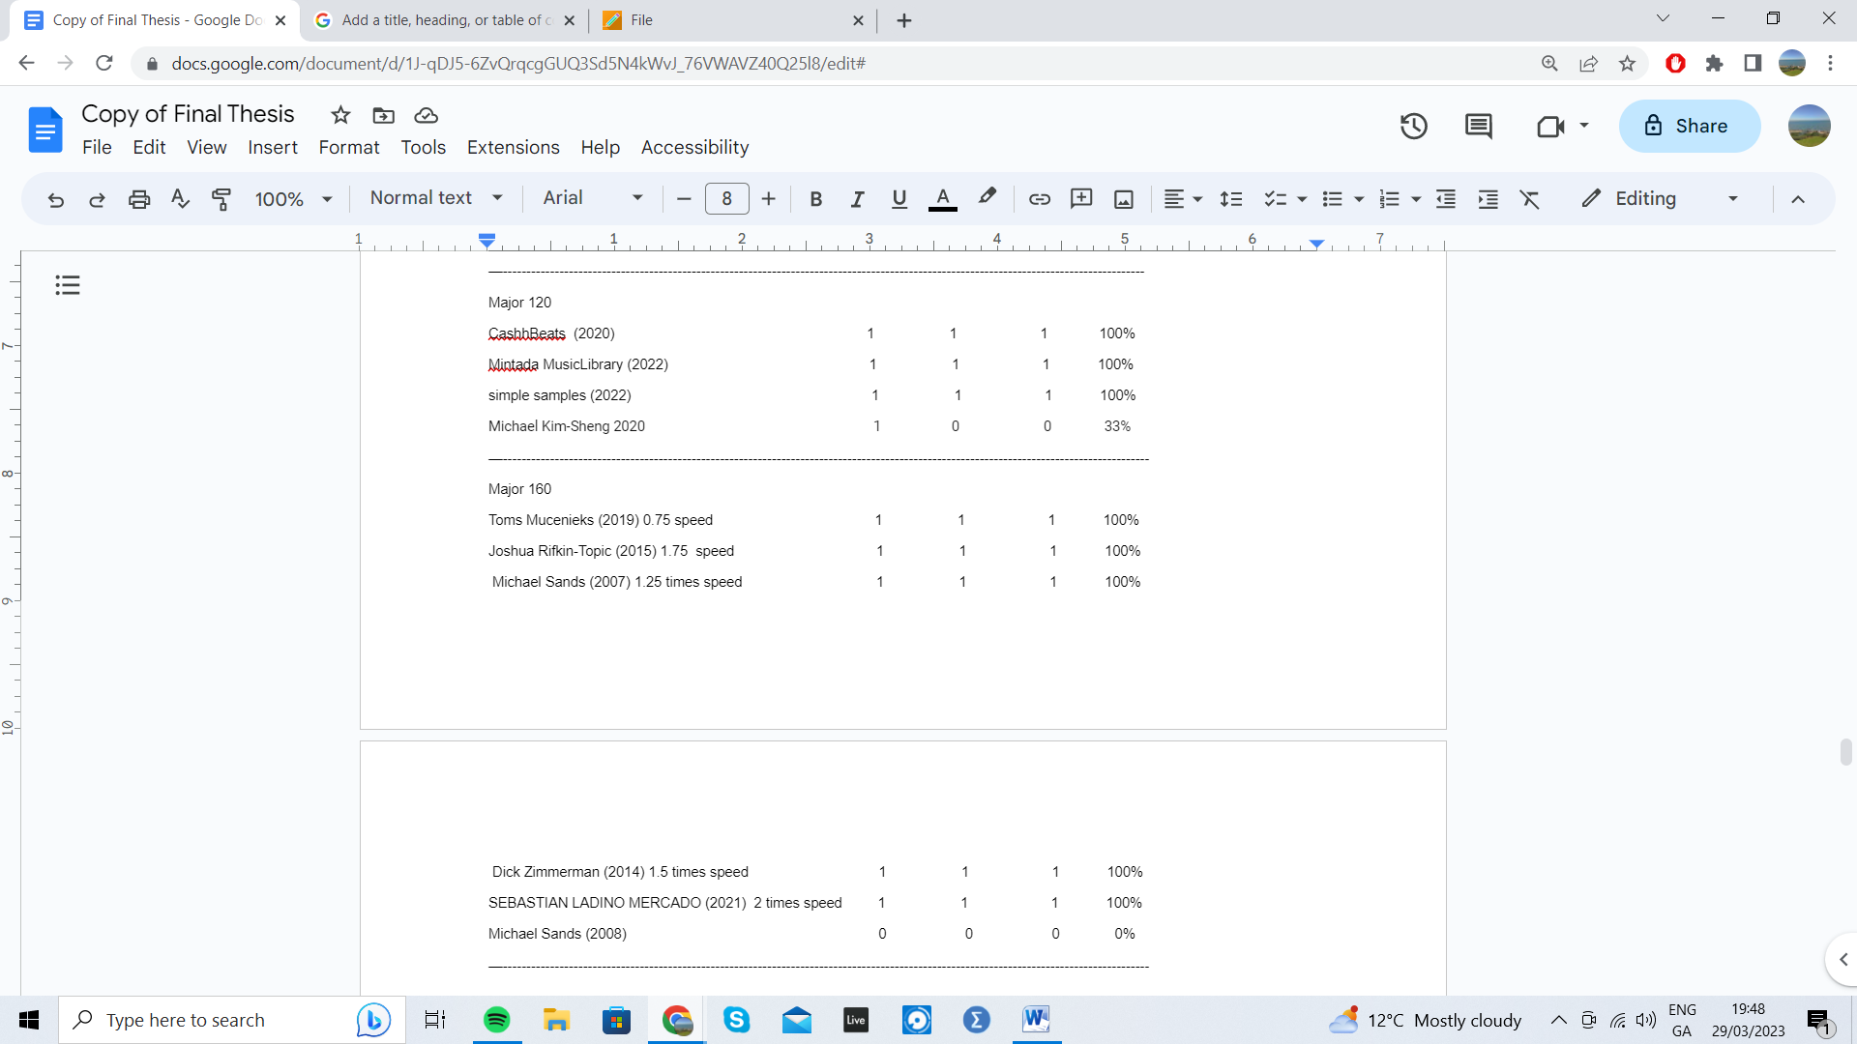
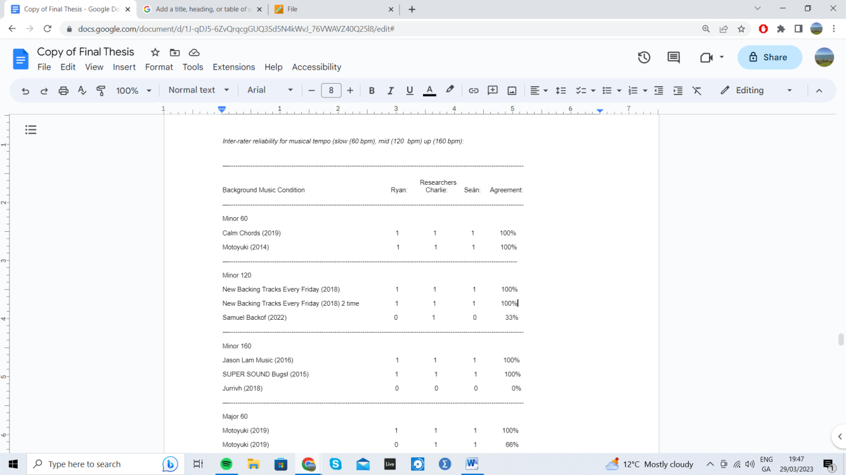

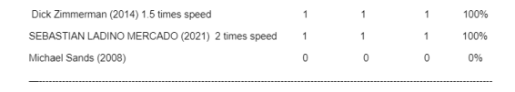
Note. Whether songs were considered to be in the correct tempo or not is illustrated by 1 and 0 respectively. (1= yes)(0=no). Songs not scoring unanimous agreement on both inter-rater scores (100%) were excluded from the music conditions.

Appendix L: Ethical Approval
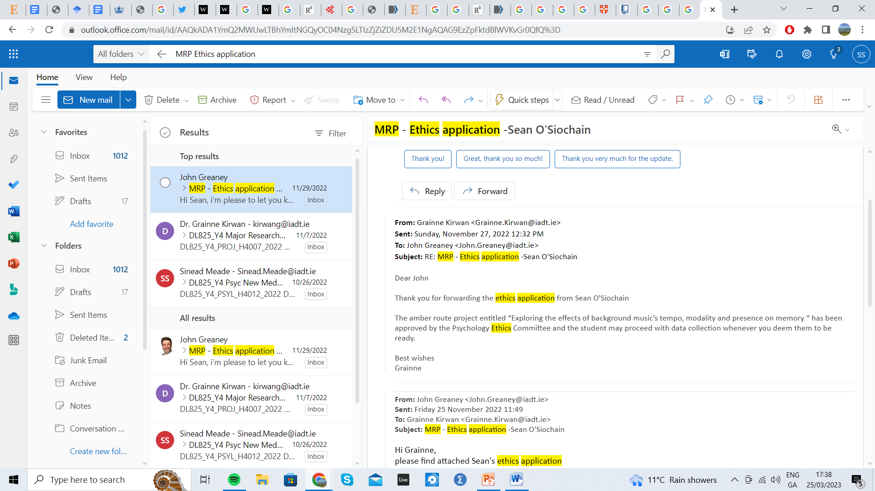

Appendix M: Provisional theme interrater reliability percentages.
------------------------------------------------------------------------------------------------------------
Researchers
Themes (*Excluded) S M O C E

- Music Enjoyment 1 1 1 1 1 100%
- Helped Memory 1 1 1 1 1 100%
- Distracting from task 1 1 1 1 1 100%
- A Sense of Relaxation 1 1 1 1 1 100%
- Increased Sleepiness 1 1 1 1 1 100%
- Adjustment* 1 1 0 1 0 60%
- Unsure* 0 0 1 0 1 40%
- Neutral* 1 0 0 1 1 60%
- A Sense Of Pressure 1 1 1 1 1 100%
Total Agreement - - - - -
Note. Whether themes were identified or not is illustrated by 1 and 0 respectively. Themes not scoring unanimous agreement (100%) were excluded from the results (*).

Appendix N: Thematic Analysis: Colour Coding

Question (A) (B)
Relaxed Enjoyable Improved my performance as I was relaxed

Themes Identified:
Music Enjoyment
Helped Memory
Distracting from task
A Sense Of Relaxation
Increased Sleepiness
A sense of pressure

Appendix O: Thematic Map
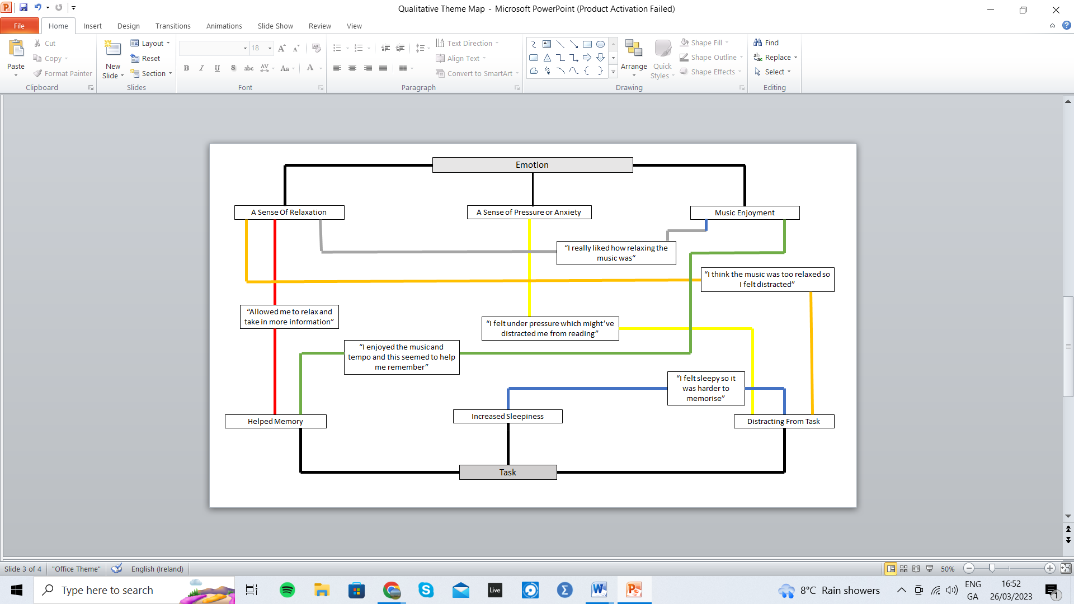
Note Quotes are displayed as an interaction between themes.ie “I felt sleepy, so it was harder to memorise” displays the interaction between the ‘increased sleepiness’ theme and the ‘distracting from task’ theme

Appendix P: Two Way Between ANOVA
Table P1: Normality Tables

Tests of Normality
 | tempo | Kolmogorov-Smirnovª |  |  | Shapiro-Wilk
 | tempo | Statistic | df | Sig. | Statistic | df | Sig.
memscore | slowtempo | .128 | 26 | .200* | .969 | 26 | .603
memscore | midtemp | .100 | 22 | .200* | .968 | 22 | .675
memscore | uptemp | .111 | 21 | .200* | .961 | 21 | .530
*. This is a lower bound of the true significance.
a. Lilliefors Significance Correction

 | key | Kolmogorov-Smirnovª |  |  | Shapiro-Wilk
 | key | Statistic | df | Sig. | Statistic | df | Sig.
memscore | minor | .105 | 36 | .200* | .957 | 36 | .175
memscore | major | .109 | 33 | .200* | .969 | 33 | .461
*. This is a lower bound of the true significance.
a. Lillefors Significance Correction

Table P2: Test of Equality of Variances
Levene's Test of Equality of Error Variances^{a,b}
 |  | Levene Statistic | df1 | df2 | Sig.
memscore | Based on Mean | .541 | 5 | 63 | .745
memscore | Based on Median | .523 | 5 | 63 | .758
memscore | Based on Median and with adjusted df | .523 | 5 | 58.000 | .758
memscore | Based on trimmed mean | .546 | 5 | 63 | .741
Tests the null hypothesis that the error variance of the dependent variable is equal across groups.
a. Dependent variable: memscore
b. Design: Intercept + key + tempo + key * tempo

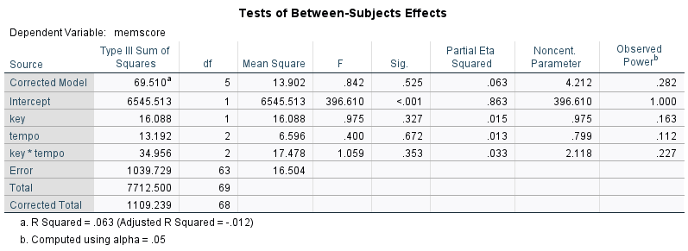
Table P3: Two Way ANOVA Between Groups Output

Figure P1
Graph Displaying Estimated Marginal Means for memory and key
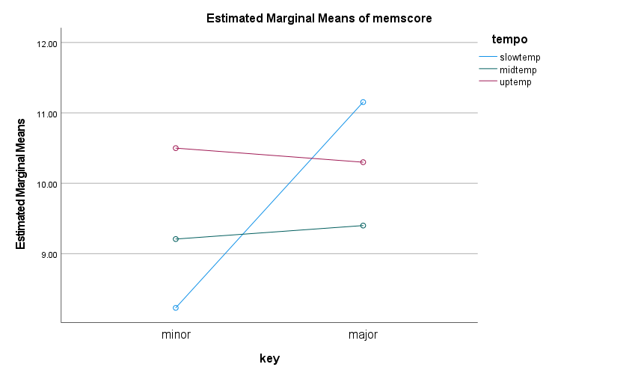
Note Estimated marginal means plot of memory scores as a function of tempo and key

Figure P2
Boxplot displaying comparing slow-tempo, mid-tempo and up-tempo groups in the memory scores data
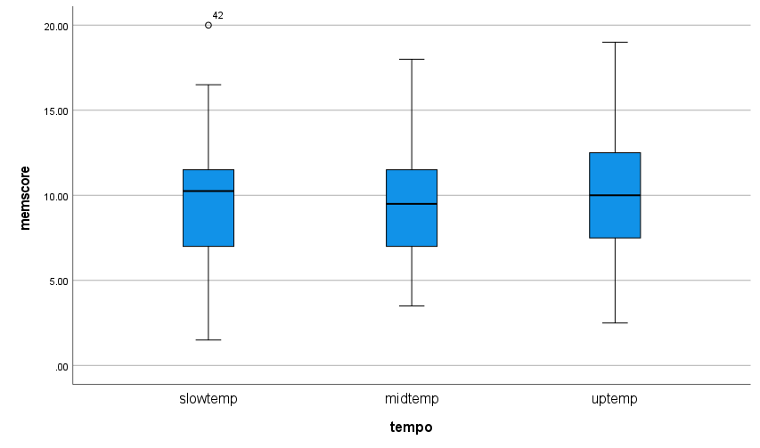
Note The medians are shown by the horizontal lines inside the boxes, the 25th and 75th percentiles are shown as the bottoms and tops of the boxes, and the minimum and maximum values are shown as the small horizontal lines below and above the boxes (if there were outliers they would be shown individually). The ranges are therefore the differences between the lower and upper horizontal lines, and the interquartile ranges are the differences between the lower and upper portions of the boxes.

Figure P3
Boxplot displaying comparing major key and minor key groups in the memory scores data
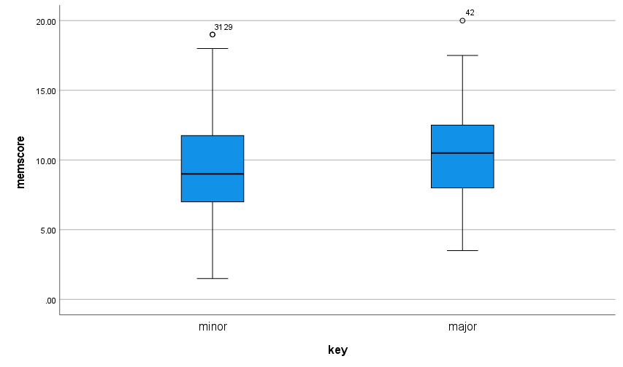
Note The medians are shown by the horizontal lines inside the boxes, the 25th and 75th percentiles are shown as the bottoms and tops of the boxes, and the minimum and maximum values are shown as the small horizontal lines below and above the boxes (if there were outliers they would be shown individually). The ranges are therefore the differences between the lower and upper horizontal lines, and the interquartile ranges are the differences between the lower and upper portions of the boxes.

Figure P4
Graph illustrating the Total Mean working memory scores as a function of tempo and key.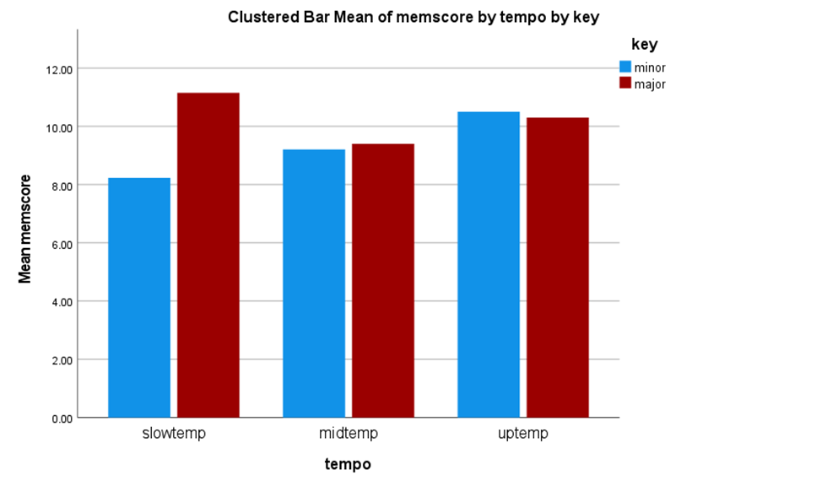

Figure 3: Total mean scores as a function of musical tempo and key.

Appendix Q: One Way ANOVA
Table Q1: Normality Tables
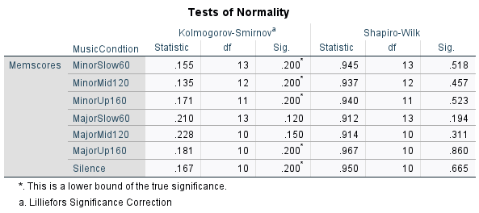

Table Q2: Test of Equality of Variances
Tests of Homogeneity of Variances
 |  | Levene Statistic | df1 | df2 | Sig.
Memscores | Based on Mean | .482 | 6 | 72 | .820
Memscores | Based on Median | .464 | 6 | 72 | .833
Memscores | Based on Median and with adjusted df | .464 | 6 | 66.570 | .833
Memscores | Based on trimmed mean | .487 | 6 | 72 | .816

Table Q3: One Way ANOVA Between Groups Output

ANOVA
Memscores
 | Sum of Squares | df | Mean Square | F | Sig.
Between Groups | 71.848 | 6 | 11.975 | .742 | .617
Within Groups | 1161.329 | 72 | 16.130
Total | 1233.177 | 78

Table Q4: Power Analysis Table
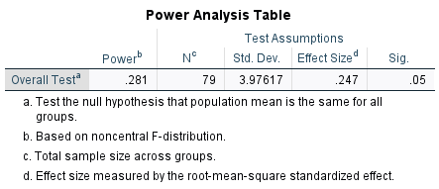

Figure Q1
Boxplot displaying comparing every background music condition in the memory scores data
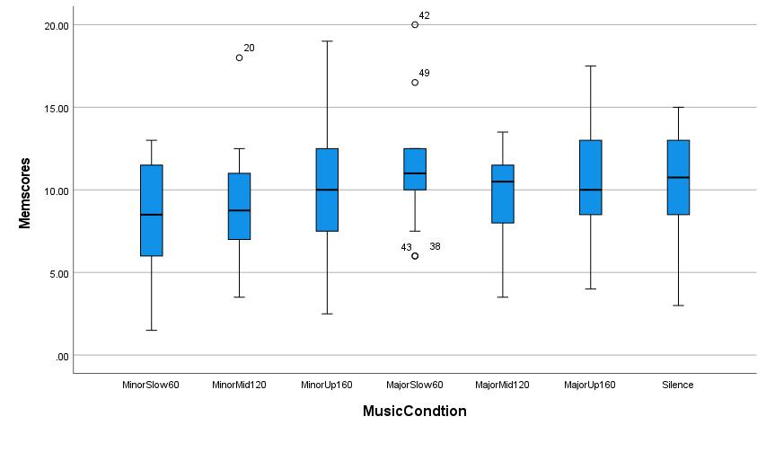
Note The medians are shown by the horizontal lines inside the boxes, the 25th and 75th percentiles are shown as the bottoms and tops of the boxes, and the minimum and maximum values are shown as the small horizontal lines below and above the boxes (if there were outliers they would be shown individually). The ranges are therefore the differences between the lower and upper horizontal lines, and the interquartile ranges are the differences between the lower and upper portions of the boxes.

Figure Q2
Shows the total mean working memory scores based on each background music condition.
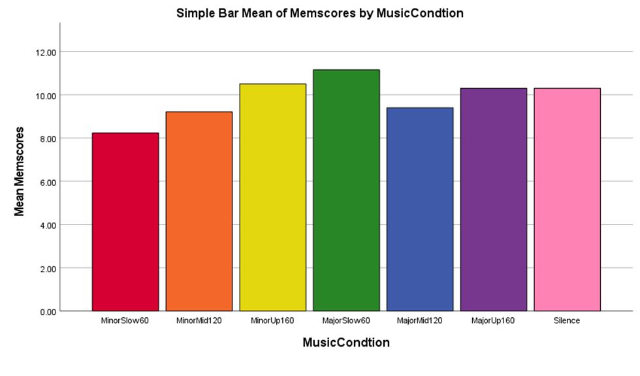
Figure 4: Total mean scores of each background music condition.

Appendix R: Frequency and percentages of themes occurring in the thematic analysis.

Table R1: Helped Memory
—------------------------------------------------------------------------------------------------------------------
Helped Memory Frequency Percentage
—------------------------------------------------------------------------------------------------------------------
Minor 60 bpm 5/13 38.46%
Minor 120 bpm 8/12 66.67%
Minor 160 bpm 2/11 18.18%
Major 60 bpm 6/13 46.15%
Major 120 bpm 7/10 70%
Major 160 bpm 2/10 20%
Total Minor 15/36 41.67%
Total Major 15/33 45.45%
Total 60 bpm 11/26 42.31%
Total 120 bpm 15/22 68.18 %
Total 160 bpm 4/22 18.18%
—------------------------------------------------------------------------------------------------------------------

Table R2: Distracting from task.
—------------------------------------------------------------------------------------------------------------------
Distracting from task Frequency Percentage
—------------------------------------------------------------------------------------------------------------------
Minor 60 bpm 2/13 15.39%
Minor 120 bpm 3/12 66.67%
Minor 160 bpm 7/11 63.63%
Major 60 bpm 2/13 15.39%
Major 120 bpm 2/10 20%
Major 160 bpm 6/10 60%
Total Major 10/33 30.30%
Total Minor 12/36 33.33%
Total 60 bpm 4/26 15.39%
Total 120 bpm 5 /22 22.72%
Total 160 bpm 13 /22 59.09%
—------------------------------------------------------------------------------------------------------------------

Table R3: Increased Sleepiness
—------------------------------------------------------------------------------------------------------------------
Increased Sleepiness Frequency Percentage
—------------------------------------------------------------------------------------------------------------------
Minor 60 bpm 6/13 46.15%
Minor 120 bpm 1/12 8.33%
Minor 160 bpm 0/11 0%
Major 60 bpm 6/13 46.15%
Major 120 bpm 1/10 10%
Major 160 bpm 0/10 0%
Total Minor 7/36 19.44%
Total Major 7/33 21.21 %
Total 60 bpm 12/26 46.15%
Total 120 bpm 2/22 9.09%
Total 160 bpm 0/22 0%
—------------------------------------------------------------------------------------------------------------------

Table R4: Music Enjoyment
—------------------------------------------------------------------------------------------------------------------
Music Enjoyment Frequency Percentage
—------------------------------------------------------------------------------------------------------------------
Minor 60 bpm 8/13 61.54%
Minor 120 bpm 6/12 50%
Minor 160 bpm 5/11 45.46%
Major 60 bpm 10/13 76.92%
Major 120 bpm 6/10 60%
Major 160 bpm 6/10 60%
Total Minor 19/36 52.7%
Total Major 22/33 66.67%
Total 60 bpm 18/26 69.23%
Total 120 bpm 12/22 54.50%
Total 160 bpm 11/22 50%
—------------------------------------------------------------------------------------------------------------------

Table R5: A Sense of Relaxation
—------------------------------------------------------------------------------------------------------------------
A Sense of Relaxation Frequency Percentage
—------------------------------------------------------------------------------------------------------------------
Minor 60 bpm 11/13 84.62%
Minor 120 bpm 6/12 50%
Minor 160 bpm 3/11 27.27%
Major 60 bpm 12/13 92.31%
Major 120 bpm 5/10 50%
Major 160 bpm 1/10 10%
Total Minor 20/33 60.61%
Total Major 18/36 50%
Total 60 bpm 23/26 88.46%
Total 120 bpm 11/22 50 %
Total 160 bpm 4/22 18.18%
—------------------------------------------------------------------------------------------------------------------

Table R6: A sense of being pressured.
—------------------------------------------------------------------------------------------------------------------
A sense of being pressured Frequency Percentage
—------------------------------------------------------------------------------------------------------------------
Minor 60 bpm 0/13 0%
Minor 120 bpm 0/12 0%
Minor 160 bpm 4/11 36.36%
Major 60 bpm 0/13 0%
Major 120 bpm 0/10 0%
Major 160 bpm 3/10 30%
Total Minor 4/36 11.11%
Total Major 3/33 9.09%
Total 60 bpm 0/26 0%
Total 120 bpm 0/22 0%
Total 160 bpm 7/22 31.82%
—------------------------------------------------------------------------------------------------------------------

