

Digital Resurrection in Franchise Cinema: A Study of the Intersection Between Nostalgia and an Emerging Technology in New Media

By Matthew Rankin

Dissertation Submitted to the Faculty of Film, Art and Creative Technologies in candidacy for the BA (honours) Degree in Animation (DL832)

Submitted 20th March 2023.

Declaration of Originality

This dissertation is submitted by the undersigned to the Institute of Art Design & Technology, Dun Laoghaire in partial fulfilment of the examination for the BA (Honours) (programme name). It is entirely the author’s own work except where noted and has not been submitted for an award from this or any other educational institution.

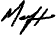
_____________________

Matthew Rankin

Acknowledgements

I want to express my gratitude to Michael Connerty in particular because without his direction and expertise, I wouldn’t have been introduced to the many important theorists and ideas that have influenced my thesis. I'd also like to thank Sherra Murphy, Tom Kennedy and the rest of the lecturing team in Animation, all of whom have made CCS such a great learning experience over 4 years. Lastly, I'd like to thank my mum and dad for their patience and support throughout my college experience.

Abstract

Like what Spirit photography did in the 19th century, different media forms like film, Television and the internet are revolutionizing how death and the corpse are visualized, mediated and distributed across global society in the 20th and 21st centuries.⁵⁸ First, I will examine the reasons for digital resurrection in popular franchises, particularly in relation to the power of nostalgia.

Drawing upon a marketing initiative by Kodak helps illustrate the connection between this emotion and our loved ones. This concept of nostalgia driving a desire to revisit our beloved characters by way of digital resurrection can then be further explored in the second chapter, particularly in relation to its use in franchise cinema. In this second section, I will explore how two popular franchises (Fast and Furious/ Star Wars) handled the technology. By examining these two different examples, I hope to illustrate the distinction between using digital resurrection out of necessity versus using it as an opportunity to explore the limits of computer-generated imagery (CGI). I will evaluate the familial, critical and fan reactions to these digital recreations in order to assess the impact of this emerging technology on our cultural landscape. Thirdly and lastly, I will explore the effects that this emerging technology is having on contemporary society primarily using Bolter and Grusin's theory of ‘Remediation’ to help illustrate this.

Table of Contents

Introduction 7

Chapter 1: Exploring the Role of Nostalgia in Driving the Phenomenon of Digital Resurrection in Franchise Cinema

Kodaks ‘Death Campaign’ 9-10
The Monopolization of Nostalgia in Cinema 11-14
Recasting 15
Digital Resurrection 16-18

Chapter 2: The Application and Reception of Digital Resurrection Technologies in Popular Film Franchises

Application In the Fast and furious franchise 20-23
Reception 22-23
Application In the Star Wars Franchise 24-31
Reception 32-34

Chapter 3: Examining the Cultural implications of Digital Resurrection in Contemporary Society

Remediation in Cinema 36-40
The Digital Afterlife 41-47

Conclusion 48-49
List of Works Cited 50-53

List of Figures

Fig 1.1: Advertisement, Thanksgiving 1930 - The last time we were ever to be together, Kodak, 1932. Page 10
Fig 1.2: Photograph, George Lucas sells Lucasfilm to Disney, Bloomberg, 2012. Page 12
Fig 1.3: Photograph, Bob Iger with Rupert Murdoch, Shutterstock, 2017. Page 12
Fig 1.4: Photograph, Steve Jobs shaking hands with Bob Iger at an Apple event, Paul Sakuma, 2006. Page 12
Fig 1.5: Film Still, Indiana Jones and the Dial of Destiny, Dir: James Mangold, Disney. Page 13
Fig 1.6: Film Stills Richard Harris in Harry Potter and the philosophers stone, 2001. And Michael Gambon in Harry Potter and the chamber of secrets, 2002, Dir: Chris Columbus, Warner bros. Page 14
Fig 1.7: Photograph, A CGI breakdown of the process to bring Paul Walker's final performance to screen, Hollywood Reporter. Page 20
Fig 1.8: Film Still, Furious 7, Dir: James Wan, Universal, 2015. Page 21
Fig 1.9: Photograph, Cody and Caleb Walker, 2018. Getty Images, Page 22
Fig 2.1: Film Still, Rogue One, Dir: Gareth Edwards, 2016, Disney. Page 23
Fig 2.2: TV Still, The Mandalorian, Dir: Peyton Reed, 2020, Disney. Page 24
Fig 2.3: TV Still, The Book of Boba Fett, Dir: Dave Filoni, 2022, Disney. Page 24
Fig 2.4: Film Still, The Crow, Dir: Alex Proyas, 1994, Miramax. Page 25
Fig 2.5: Film Still, Rogue One, Dir: Gareth Edwards, 2016, Disney. Page 26
Fig 2.6: Photograph, Similarities between Actor Guy Henry (Left) and Peter Cushing (right). Radio Times. Page 27
Fig 2.7: Film Still, Rogue One, Dir: Gareth Edwards, 2016, Disney. Page 28
Fig 2.8: Film Still, Rogue One, Dir: Gareth Edwards, 2016, Disney. Page 29
Fig 2.9: Photograph, Peter Cushing and Mark Hamill in a behind-the-scenes photograph on the set of the original Star Wars,1977, Empire. Page 29
Fig 3.1: Film Still, Rogue One, Dir: Gareth Edwards, 2016, Disney. Page 30
Fig 3.2: Photograph, the real Peter Cushing (left) versus his CG counterpart (right), 2016, ABC. Page 31
Fig 3.3: Photograph, CG process of Grand Moff Tarkin, 2016, FX guide. Page 32
Fig 3.4: Photograph, Peter Cushing as Doctor Frankenstein, 1957, Unknown. Page 33
Fig 3.5: Photograph, Beauty and the Beast Broadway musical of the fifties and sixties, Playbill. Page. 36
Fig 3.6: Film Still, Beauty and the Beast, Dir: Gary Trousdale and Kirk Wise, 1992, Disney. Page 36
Fig 3.7: Film Still, Toy Story, Dir: John Lasseter, 1996, Pixar. Page 37
Fig 3.8: Photograph, Austin Butler's depiction of Elvis and the man himself, People, 2022. Page 38
Figure 3.9. Photograph, Rami Malek's Freddie Mercury in Bohemian Rhapsody compared to the actual Queen Front man, Smooth Radio, 2020. Page 39
Figure 4.1. Photograph, James Dean at a gas station with his silver Porsche 550 Spyder he named Little Bastard, just hours before his fatal crash. Sept. 30, 1955. Time. Corbis Page 41
Figure 4.2. Commercial Still, Johnnie Walker Scotch Whisky, 2013. Page 42
Figure 4.3. Commercial Still, Snickers, 2016. Page 44
Figure 4.4. Commercial Still, Galaxy Chocolate, 2013. Page 44
Figure 4.5. Commercial Still, Dirt Devil Vacuums, 1997. Page 45
Figure 4.5. Commercial Still, Ford Motors, 2005. Page 45
Figure 4.6. Photograph, Tupac Shakur’s holographic reincarnation projected onto a stage alongside Dr Dre and Snoop Dogg at Coachella Music Festival, 2012. Washington Post. Page 46

Introduction

I’ve always had a fascination with the effect of nostalgia on the human brain ever since I did my leaving cert art project on it in 2018. Star Wars has a particular nostalgic effect on me because I grew up with the prequel trilogy and my parents grew up with the original trilogy.
The release of new Star Wars content provides me with a shared experience alongside my mum and dad that enables us to temporarily relive cherished memories from our own separate childhoods. When the new trilogy came out, we noticed an increasing reliance on contrived nostalgia to satisfy its audience.
Upon seeing Rogue One, I was fascinated with the artificial Peter Cushing on screen and have been ever since. For this thesis, my aim is to investigate the decision-making process and reasoning behind the revival of a character who had been absent for a considerable period. This takes up the majority of chapter 2. I also found the post-modern debate of continuing a character's arc without his originating actor very interesting and wanted to incorporate these ideas into my writing somehow.
When I initially conceived the idea for my thesis, my objective was to explore whether we could experience a similar degree of nostalgia when viewing a computer-generated representation of a beloved (or hated) character from our adolescence. What followed was an exploration into digital resurrection in multiple different media forms, and the role nostalgia plays in increasing usage of this emerging technology in contemporary society. In the first chapter, I outline the differences between recasting and Digital resurrection along with the multiple considerations which came with the latter. To open this thesis, I explored the monopolization of nostalgia in franchise cinema to introduce the idea that studios may use digital resurrection to capitalize on nostalgia.
Reading theories like remediation by Jay David Bolter and Richard Grusin and learning from theorists like Lev Manovich really helped inform my thinking. They became a crucial part of the third chapter and tied my ideas together.
Throughout this thesis, my aim is to present a balanced and impartial perspective on the potential of this emerging technology. I hope to highlight its ability to deceive but simultaneously illustrate how it could help our society.

Ultimately, I hope that by the end of this thesis, readers will be able to form their own opinions on using digital resurrection to bring deceased individuals back to life in the virtual realm.

Chapter One

The Role of Nostalgia in Driving the Phenomenon of Digital Resurrection in Franchise Cinema

Introduction
When the shutter of a camera opens, it sequentially exposes the film that is within the camera to light and captures a still image. This image transforms a transient moment in time into something that is indelible and when viewed after death, can evoke nostalgia in circumstances that involve grief. In essence, that is what Kodak's marketing campaign, which I will describe, unintentionally demonstrated. To investigate the effects of nostalgia in the moving image, it requires an understanding of its effects in the still image medium first.
By understanding this, it will help inform why nostalgia is such an important asset in the film industry and why it is now continuously being utilized as a commercial tool to connect with its audience. In addition to a film’s setting and story, its characters can hold comparable nostalgic value. So, what happens when the characters' originating actor is no longer around to fill the role? They have two options, the latter of which requires five important considerations before being implemented. Each of which will be covered in this chapter.

Kodaks Death Campaign
Since its creation in 1816 by Frenchman Joseph Nicéphore Niépce¹, the camera has long been seen as an instrument for ‘memorializing the departed’3 When death does occur, images can ‘have a meaningfulness that outweighs and cuts through the usual nostalgia when such documents are taken for granted’2 (Golding,2021) The photograph captures a fleeting moment and can serve as a concrete depiction of what is missing.
In Kodak and the Lens of Nostalgia (2000), Nancy Martha West recalls the "Death Campaign," a Kodak marketing initiative that was ordered in 1932 but never executed. Intimate, even morbid words went with family portraits in a series of magazine advertisements. West states that through this initiative “Kodak acknowledged for one brief moment that we take photos to ward off death and sorrow’(West,2000)³ The photograph can play a significant role in remembrance because of its ability to capture fading visual memories and turn them into tangible objects.
1. ‘When Was the Camera Invented? Frenchman Credited with Invention of Camera in 1816.’ USA TODAY
2. Golding, Dan. ‘The Memory of Perfection: Digital Faces and Nostalgic Franchise Cinema’. Convergence: The International Journal of Research into New Media Technologies, vol. 27, no. 4, Aug. 2021, pp. 855–67
3. Nancy Martha West. Kodak and the Lens of Nostalgia. (Cultural Frames, Framing Culture.) Charlottesville: University Press of Virginia. 2000

One such statement, which accompanies one of these portraits, highlights a picture of a grandfather aiding his grandson in moving a wheelbarrow. The photo was juxtaposed with a morbid statement underneath it "That was the last time Dad was with us."
Another advert reads, "She died the year after Sally was born, you know—," this time with an image of a woman in a summer dress. It is not particularly surprising that the campaign was later abandoned given its insensitive subject matter. However, it does highlight human's emotional connection to an image while highlighting their importance within our culture. ⁴
“The cult of remembrance of loved ones, absent or dead, offers a last refuge for the cult value of the picture”
Walter Benjamin The Work of Art in the Age of Mechanical Reproduction ⁵
The emergence of modern technologies and the obsolescence of older ones can create a sense of loss and disconnection from one's past. Nostalgia can bridge that gap and allow people to look back on their lives. It is a strong emotion that can be harnessed in popular media to bring back pleasant memories and sensations from the past, fostering connections between individuals and their pasts as well as with one another.

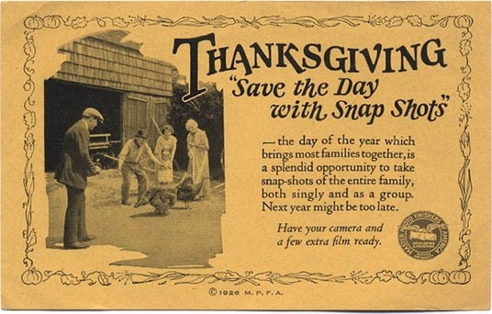
(Figure 1.1. One of the adverts for kodaks discontinued ‘Death Campaign’)

4. Harris, Racheal, et al. Photography and Death: Framing Death Throughout History, Emerald Publishing Limited, 2020
5. Benjamin, Walter. The Work of Art in the Age of Mechanical Reproduction, Penguin Books, 2008.

The monopolization of Nostalgia in Cinema
Jeff Greenberg, a professor of social psychology at the University of Arizona writes that in the 1970s, the youth were raised on films with themes that were targeted towards a “child's psychological sensibilities”⁶. Particularly in Star Wars, good and evil are depicted in extremely unambiguous terms for younger audiences. Children can identify with and want to imitate the triumph of good over evil and these are themes that are particularly prevalent in this franchise. Collectively, these elements create a fantastical and immersive experience that appeals to a child's sense of wonder and imagination.
According to Greenberg, Nostalgia is fundamentally about subjective experiences and a link to the past. Audiences are "Naturally drawn to things they are familiar with," and many people who grew up with and identified with the Star Wars brand continue to do so because of its familiarity and relatability.
The power of nostalgia in franchise cinema has been well documented. A media franchise is defined in the dictionary as “An intellectual property involving the characters, settings and trademarks of an original work of media (Usually, a work of fiction), such as a film, a work of literature, a television program or a video game.”⁷Recently, franchises like Jurassic Park and Blade Runner have leveraged their nostalgic charm to establish deep emotional connections between their characters and their viewers. Nostalgia holds significant value and appeal in the film industry because it can attract an audience. If a studio decides to bring back a character who has sentimental value to viewers, it is guaranteed to generate revenue from curious paying consumers. It has a particular resonance in the realm of franchise cinema, as it allows legacy characters to transcend time and space.
Effectively, nostalgia raises audiences' expectations because there is a demand for these characters to be handled delicately and "in a way that resonates with their childhood."(Greenberg,2019)⁶ These legacy characters can evoke memories of youthful reminiscence for generations who revered, idolized, or even feared them as children. It’s This appetite for nostalgia in the modern digital age that will only increase on-screen instances of digital resurrection in various forms of media.
6. ‘For “Star Wars” Fans, Nostalgia Shapes Expectations’. University of Arizona Research, Innovation & Impact, 15 Feb. 2019
7. Film franchise: Definition of Film franchise and Synonyms of Film franchise (English)

With specific reference to contemporary Hollywood cinema, the film industry's increasing reliance on franchising and nostalgia as financial strategies is reflecting a developing harmony of creative, technological, and commercial forces centred on the control and expansion of intellectual property (IP). ⁸
Thanks to the likelihood that these movies will be commercially successful based on their preexisting fanbases, a studio's ambition to develop new franchises and spinoffs based on its existing IP is becoming noticeably obvious. In Jason Sperb's book ‘Flickers of Film: Nostalgia in the time of digital cinema’ He talks extensively about The Walt Disney Company’s effective monopolization of Nostalgia. In Peter Kunze's Review of Sperb’s book, He reiterates this by saying that “Few corporations have commodified nostalgia as well as Disney has” (Sperb,2017)⁹
Kunze believes that Disney's Continued acquisitions of popular IP like Marvel, Lucasfilm and Pixar are evidence of the media conglomerates ongoing “Efforts to colonize and capitalize” on our “childhoods”^{9.} lucrative assets like The Simpsons, Toy Story and Star Wars were all acquired with the intention of reviving retrospective properties which echo experiences in our adolescence.

8. Lomax, Tara. The Franchise Era: Blockbuster Hollywood in the 2010s…and Beyond – Senses of Cinema . 21 Sept. 2013,
9. Kunze, Peter C. Review of Flickers of Film: Nostalgia in the Time of Digital Cinema, by Jason Sperb. The Velvet Light Trap, vol. 79, 2017,

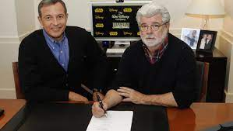
(Figures 1.2. Disney CEO Bob Iger acquiring Lucasfilm from George Lucas for 4 billion dollars in 2012)

(Figure 1.3. Bob Iger and ex-CEO of 21st-Century Fox- Rupert Murdoch, just before Disney Bought Fox for 71.3 billion Dollars in 2020)
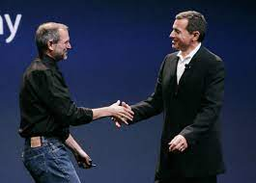
(Figure 1.4. Pixar CEO Steve Jobs shaking Bob Iger’s hand. Jobs sold Pixar to Disney for 7.4 billion dollars in 2006)
In 2023, Disney is set to debut a de-aged Harrison Ford as Indiana Jones In the popular franchise's 5th entry ‘The Dial of Destiny (Dir: James Mangold, 2023). Rumours circulated that the title protagonist would be recast due to Ford's age and the taxing demands of the role. For moviegoers, the character and Ford are practically intertwined. As 2018's Solo had shown, replacing him with a respected actor like Alden Ehrenreich does not guarantee that the recasting will be well-received by a fanbase. Ford was willing to reprise this role again and given the power of nostalgia in this franchise, it was both a logical and potentially profitable decision for Disney to include him in the project.¹⁰
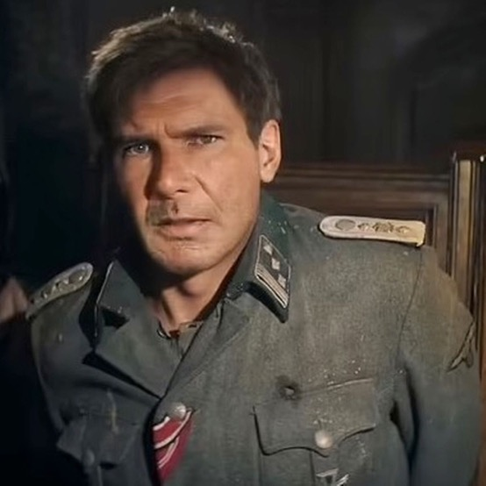
(Figure 1.5. A de-aged Harrison Ford in Indiana Jones 5 ‘The Dial of Destiny’)
10. ‘Forget Digital Resurrection: Let the Dead Stay Dead’. Financial Times, 17 Jan. 2023
However, what happens when a studio decides to use a character whose actor is no longer around to play the role?
They have two options.
- Recasting
Recasting in the film industry is the process of finding another actor for a role previously filled by a different actor. Recasting a role involves significant risk and is not always embraced by audiences, therefore affecting the film's performance commercially. As seen by Solo (Dir: Ron Howard, 2018), Alden Ehrenreich's portrayal of a part that has become inseparable from Harrison Ford did not connect with its fanbase.
One of the most successful recasting's in cinema is Michael Gambon as Dumbledore in the Harry Potter series. The passing of Richard Harris after the sequel Chamber of Secrets (Dir: Chris Columbus,2002) prompted Warner Brothers to hire Gambon for the following Films in the studios' lucrative franchise.
Harris embodied Dumbledore's compassionate and hopeful aura that reflects the idealistic character from the books. Whereas Gambon provided the character with the added edge and inner turmoil that was needed for the series' concluding movies. Rarely is a recasting acknowledged and valued independently from the performance of the original actor as this example is. Both iterations of the character are Excellent and are different enough to be considered independent from each other.

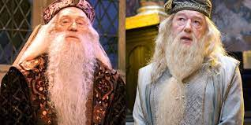
(Figure 1.6. Richard Harris (Left) and Michael Gambon (Right) portraying Dumbledore in The Harry Potter Franchise)
- Digital Resurrection
Digital resurrection refers to the posthumous performances in media ¹⁰ it's the concept of using artificial intelligence and other digital technologies to recreate an artificial representation of a person after they have passed away. The High Technology Law Journal published one of the first references regarding digital resurrection in 1993. It speculated about the effects that these emerging technologies would have on entertainment law and intellectual property.¹⁰ It is the most extreme form of the two methods discussed and the primary focus of this Thesis. Previously a celebrity's career would cease abruptly upon their death. Thanks to the development of this digital technology, actors can now artificially perform in new movies posthumously. A post-mortem acting career can be
However, it requires a variety of important considerations before being used as a method in production.
- Legal - Obtaining Consent from the deceased actor's estate is paramount to avoid expensive legal repercussions. The right to publicity is a concept in the law that refers to an individual's right to control the commercial use of their name, image, likeness, (NIL) or other recognizable aspects of their identity.¹¹ If that individual has passed, then that right is transferred over to their estate.¹² The celebrity rights act was first introduced by the Californian government in 1984. After an actor passes away, this legislation transfers the estate the rights to their NIL ¹³. This act can be enforced through civil litigation and is protected by law in many Jurisdictions. However, in many areas like Britain, this is not the case. In the Uk, there is no right to publicity after you have passed ¹⁴ To use a person's NIL, you would need to establish the location of the deceased person's domicile or real residence before checking to determine whether that state has legislation of this kind in effect and if so, what exactly it regulates. In her description of the situation’s sad reality, Professor Lillian Edwards outlines that one's privacy dies upon their death. she continues “It hits so many sore buttons and yet the law doesn’t cover it. Right now, it’s privacy by obscurity.”¹⁵
10. ‘Forget Digital Resurrection: Let the Dead Stay Dead’. Financial Times, 17 Jan. 2023
11. ‘Publicity’. LII / Legal Information Institute,
12. bh and law. ‘Can I Legally Use The Image of a Famous Person (Who’s Dead)?’
13. Celebrities Rights Act of California-Personality Survives Death | Stimmel Law
14. Debruge, Kristopher Tapley, Peter, et al. ‘“Rogue One”: What Peter Cushing’s Digital Resurrection Means for the Industry’. Variety, 17 Dec. 2016
15. Dunne-Miles, Matthew ‘Deepfakes, Dead Relatives and Digital Resurrection’. The Face. 6th April 2021,
- Ethical - Using these technologies raises multiple ethical and philosophical questions about the nature of consciousness and the value of human life. The recreation of a person’s likeness after they have passed has the potential to relegate the human body to a trivial puppet. It could potentially breach the decency of a person's anatomy and autonomy while violating the preservation of human dignity. It is also important to recognize a person's legacy and whether this digital version of them truly aligns with the individual and their own principles that it is purported to emulate. Additionally, the impact and psychological effects on Loved ones should also be observed and respected. The existence of a digital replica might make those who loved and cared for the deceased individual uncomfortable, which could ultimately prolong their grieving process. The version on screen also shouldn’t alter the way loved ones remember and miss this person. While Digital resurrection blurs the lines between life and death It might provide a sense of closure if done sensitively.
- Technical – In ‘New Media: A User’s Guide 'Lev Manovich Writes that in the past, creating technologies like cameras, tape recorders, and video recorders that could automate the production of media was a priority. Using these technologies over one hundred and fifty years has meant that there has been a massive accumulation of data into photo, audio and film archives. Consequently, the next phase of media evolution is focused on creating technologies that can store, organize and facilitate easy access to this large volume of data.¹⁶ Many digital resurrection technologies (DRT) like ‘Deep faking’ rely on accessing these vast quantities of data in order to in order to operate effectively. It uses this data to “swap faces in video and digital content to make realistic-looking fake media”¹⁷ The technical feasibility of digital resurrection relies on the quantity and quality of data available. The more material that is available surrounding a deceased actor, the more accurate the recreation of this person's likeness will be. A wide variety of Data like high-resolution imagery, videos and 3D scans would be needed to faithfully create the most precise digital replica. If this content is not widely available, the believability of the final product will suffer.

16. Manovich, Lev. New Media: A Users Guide. 1999
17. Krusling, James. Research Guides: Deepfake Technology

The believability of a virtual face is reliant on a phenomenon known as ‘The Uncanny Valley’. Japanese roboticist Masahiro Mori first used the Term in 1970 to describe the sense of “unease or revulsion” when viewing a “computer-generated figure or humanoid robot bearing a near-identical resemblance to a human being”¹⁸. The Uncanny Valley is a complex physiological phenomenon that is difficult to conquer with VFX alone. It requires a combination of advanced technology and a deep understanding of the human psyche. The complexity of each brain makes it difficult to predict a person's reaction to digital faces. The way we perceive these creations is influenced by our own experiences, expectations, and emotions, which therefore makes it difficult for VFX houses to create a digital creation that is universally accepted as realistic. Two examples commonly regarded as some of technology's most effective applications will be covered in-depth in the following chapter.
- Financial - Given that these are emerging technologies, the price would mostly depend on the expenses of its development and research stages. Currently, there is only one commercial service for digital resurrection, which I will discuss in chapter three. Collecting, processing, protecting this data, developing and animating the digital replica, and finally, the postproduction process are expensive financial factors that studios must consider before undertaking. “The creation of digital faces are creative, technical and financial decisions above all^{“2} (Golding, 2021)
- Reception – The idea of Digital resurrection is a new concept that many still find hard to digest. The specific way the technology is portrayed and the setting in which it is used will certainly influence how viewers respond to it. If a Film portrays digital resurrection sensitively and positively, highlighting it as a means of preserving cherished memories for loved ones, people may be more receptive to the idea. However, viewers might be critical of the technology if the film uses digital resurrection to abuse or manipulate the deceased. Additionally, while some viewers find the idea of digital resurrection to be unsettling or morally dubious, others find it intriguing and thought-provoking.

18. Exhibition ‘Uncanny Valley’. Wave Pool, June 8th - July 27th, 2019

Chapter 2
The Application and Reception of Digital Resurrection Technologies in Popular Film Franchises

Introduction
The use of digital resurrection raises moral concerns regarding the ability of estates to authorize such applications and the ramifications for the legacy of the deceased individual involved. This chapter explores both the moral and practical complexities of digital resurrection.
A societal evaluation of the subject will be provided by analyzing the critical and interpersonal reactions to this technology in franchise cinema, which will explore ethical themes like consent, power dynamics, and exploitation.

Application In the Fast and furious franchise

Furious 7 (Director: James Wan, 2015)
Come May 19th 2023, The Fast and the Furious film series will have ten films that have together grossed over 6 billion dollars globally, according to CNBC¹⁹. The franchise's longevity has partially been attributed to one of its endearing protagonists- Brian O'Conner. Paul Walker portrayed him with a warm charm and relatability that resonated with audiences globally.
Halfway through production on the seventh instalment of the series, Paul Walker was killed as a passenger in a fatal car accident. Universal and director James Wan considered scrapping the movie entirely, but they decided against it because of the film's high budget and an obligation to their loyal audience and star Paul Walker. In Ben Laney's academic journal ‘Bringing the dead back to life: preparing the estate for a postmortem acting role. 2020’ He writes that when an actor dies during filming, it often necessitates the use of digital resurrection as shown in this instance. Hollywood is generally comfortable with using it out of obligation to the franchise fanbase and film crew or through hesitancy to reinvest in restarting a costly production from the very beginning. ²⁰
Screenwriter Chris Morgan rewrote Brian O'Conner's fate intending to honour Walker and his work. Universal Studios employed Joe Letteri and his Weta FX team to handle the delicate task of sensitively retiring his character with digital resurrection technologies.²¹
20. Laney, Ben. Bringing the Dead Back to Life: Preparing the Estate for a Post-Mortem Acting Role. 7 Feb. 2020. Social Science Research Network
21. Schaefer, Sandy. ‘How Furious 7 Finished Paul Walker’s Scenes After His Death’. ScreenRant, 17 Aug. 2020
Weta used a trusted blend of body doubles, archival footage and CGI to bring Walker back to the screen, with methods akin to those used to virtually resurrect Oliver Reed in 'Gladiator’ (Dir: Ridley Scott, 2000). Along with an array of stunt doubles, Paul Walker's brothers Caleb and Cody contributed their physical similarities that were needed to simulate his stature in long and rear shots.²² Depending on the scene, A fully digitalized face or repurposed archival footage was then superimposed onto these doubles for scenes that required Walker to speak.
The longer a digital face is shown on screen, the more it invites analysis from audiences aiming to spot discrepancies in its digital form. The film's VFX Supervisor Martin Hill acknowledges this in an interview with Vanity fair. He spoke on how it wasn’t the outlandish action sequences that needed the most work, but rather the closeup shots where Walker delivers his dialogue. He attributes this to the fact that there is a lack of “kinetic cutting” and frantic action to distract from the digital face on screen.²³ Director James Wan felt it was imperative that spectators should not enter this movie trying to identify which is the digital Paul Walker and which isn’t because doing so would remove the emotion from that moment. For Wan, the result needed to serve as a heartfelt eulogy to his legacy rather than a distraction. ²³
In the film's concluding shots, A computer-generated Paul Walker is shown driving towards the sunset on the horizon. Concurrently ending his career as a high-stakes street racer and signifying the conclusion of his character arc in the franchise. A moving musical number and a montage including Walker's voice gave solace to fans still grieving his passing.
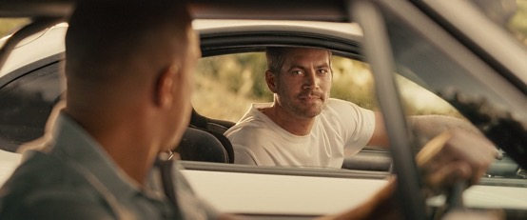
(Figure 1.8. The final Render of a fully digital Paul Walker in the film’s final scene)

22. Patterson, John. ‘CGI Friday: A Brief History of Computer-Generated Actors’. The Guardian, 27 Mar. 2015
23. Nast, Condé. ‘Here Are Three Paul Walker Furious 7 Scenes That Proved Especially Hard to Digitally Create’. Vanity Fair 20 Oct. 201
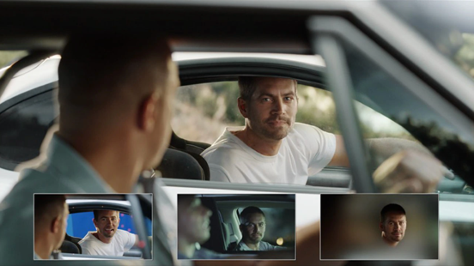(Figure 1.7. A CGI breakdown of the process to bring Paul Walker's final performance to screen, Via Hollywood Reporter)
Walker's tragic death proved to be a “catalyst” for a cinema outing. Fans were eager to see how the filmmakers “massaged” the plot to accommodate the circumstances. They also wanted to see whether the 50 million dollars spent on digitally resurrecting Walker was justified^{24.} This film's effective application of digital resurrection demonstrated the technologies psychological capabilities. It proved that when used correctly, it has the power to elicit a passionate response in audiences and provide fans with a fulfilling emotional experience. Thanks to these factors, Furious 7 grossed over 1.5 billion at the global box office and is still the highest-grossing film in the franchise. ²⁵
Reception
Familial
Paul Walkers' only Daughter Meadow has yet to publicly respond to the film. His brothers however, expressed their gratitude for being a part of the Furious 7 project. They believed it aided their grieving process at how “Tastefully” it was done. ²⁶ Caleb told People that Paul would be proud of the film's outcome and commented on the emotional impact it would have on its viewers. He added that after watching the film, one will appreciate their loved ones more because You just never know when you will see someone for the final time. ²⁷
24. Shoard, Catherine. ‘ The Strange Case of Fast & Furious Star Paul Walker’. The Guardian, 14 Apr. 2015
25. Fast & Furious: Domestic & Global Box Office Revenues 2022’. Statista
26. ‘ Paul Walker’s Brothers Say Filming Furious 7 Helped Them Grieve His Death ’.People magazine
27. ‘ Paul Walker’s Brother Cody Walker on Furious 7: “I Think Paul Would Be Proud ”’.People magazine
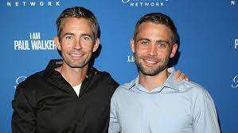(Figure 1.9. Caleb and Cody Walker, Paul’s Brothers)
Critical
The reviews for Fast & Furious 7 were mostly favorable. The movie won plaudits for its outstanding action set pieces and moving farewell to Paul Walker. However, some critiqued the plot of the film for being convoluted²⁸ while others called it “repetitive”²⁹ The San Francisco Chronicle reacted negatively towards the film's plot but was complimentary towards its display of the technology. They recognized that Walkers' reincarnated digital form in the final scene was “An authentic moment that comes closest to acknowledging the technological artifice and making art out of it” but did nonetheless call it “Weird and awkward”³⁰. In contrast, Time called Walkers' “Final moment” a “Sleek, poignant, unforced grace”³¹. The AV club reassured audiences that the seamless use of these visual effects would dispel “Natural fears of uncanny creepiness”³² To this day, the film's emotional application of the technology receives widespread recognition as one of the most effective and appropriate examples of digital resurrection in cinema. Its impact on both fans and critics is easily noticeable. The film's affecting finale highlights the franchise's core values of family, loyalty, and friendship, while respectfully paying homage to Walker's role in the series in a moving and gorgeous manner.
28. Foundas, Scott. ‘SXSW Film Review: “Furious 7”’. Variety, 17 Mar. 2015
29. Mendelson, Scott. ‘“Furious 7” Review: Part Seven Can’t Measure Up To “Fast Five”’. Forbes
30. LaSalle, Mick. ‘'Furious 7’ Is Creepy and Long ’. SFGATE, 2 Apr. 2015
31. ‘Review: In Furious 7, Gravity Is for Wimps ’. Time, 1 Apr. 2015
32. ‘Furious 7 Says Goodbye to Paul Walker with Wall-to-Wall Action Absurdity’. The A.V. Club, 2 Apr. 2015

Application In the Star Wars Franchise

While simultaneously allowing for the introduction of new characters and the opportunity to see current characters in new circumstances, Star Wars has leveraged the fond memories associated with its original trilogy to establish a strong emotional bond between its library of characters and their followers. Star Wars has always pushed the boundaries of revolutionary VFX and in recent years has become accustomed to using de-ageing software to recreate the nostalgic power of its first three films.
In the past 7 years, Audiences have been treated to de-aged versions of the film's iconic protagonists and antagonists from past films. We suspend our disbelief because, on some level, there is an enjoyment to watching these actors reprising their roles as our childhood heroes and villains on the big screen. “The now normalized suspension of disbelief inherent in the consumption of media entertainment and popular culture helps to facilitate this process”(Sherlock,2013)³³

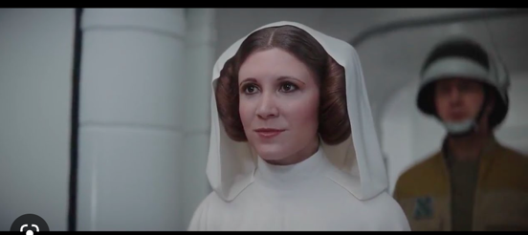
(Figure 2.1. A de-aged Carrie Fisher as Leah Skywalker in Rogue One, 2016 Film Still)

33. Sherlock, Alexandra. ‘Larger Than Life: Digital Resurrection and the Re-Enchantment of Society’. The Information Society, vol. 29, no. 3, May 2013, pp. 164 –76.
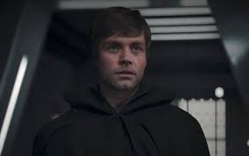
(Figure 2.2. A de-aged Mark Hamill as Luke Skywalker in season 2 of The Mandalorian, TV Still,2020)
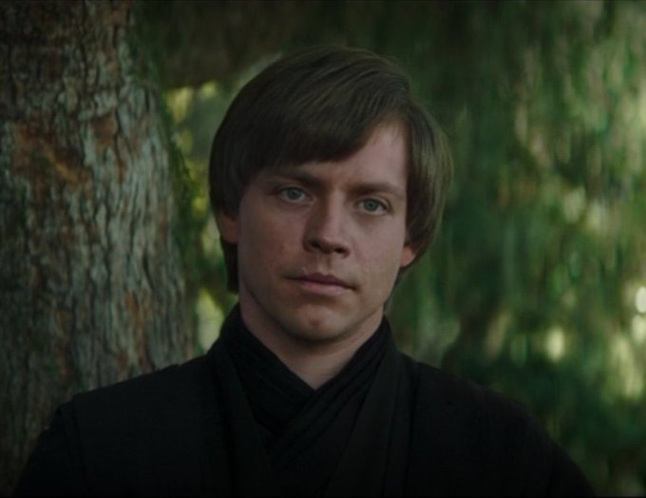(Figure 2.3. The technology improved when A de-aged Mark Hamill appeared again as Luke Skywalker in The Book of Boba Fett two years later., TV still, 2022)
Rogue One (Director: Gareth Edwards, 2016)
In 2016, VFX house ‘Industrial Light and Magic (ILM)’ harnessed new computer technology to integrate the deceased into scenes with people who were alive. Lucasfilm tasked supervisor John Knoll and his team at ILM with digitally recreating the late Peter Cushing's persona ¹⁵ on screen for their new franchise entry. Gareth Edward's Star Wars prequel ‘Rogue one’ required Cushing's legacy character ‘Governer (or Grand Moff) Tarkin’ to appear on screen twenty years after the actor lost his battle with prostate cancer in 1994.
Digital resurrection in cinema is often warranted when an actor dies before production is completed. Films like ‘Fast 7’ and ‘The Crow (1994, Dir: Alex Proyas) have all had to use the technology to finish their films in the wake of their leading actor's death. What distinguishes ‘Rogue One’ from other films that have tried the virtual recreation of the deceased, is the fact that the movie's production had not begun when the actor passed away. Dr Lisa Bode from the University of Queensland emphasizes the important contrast between using digital resurrection to bring an actors last performance to mourning audiences and using it to bring actors back for contemporary performances long after they have passed.³⁴

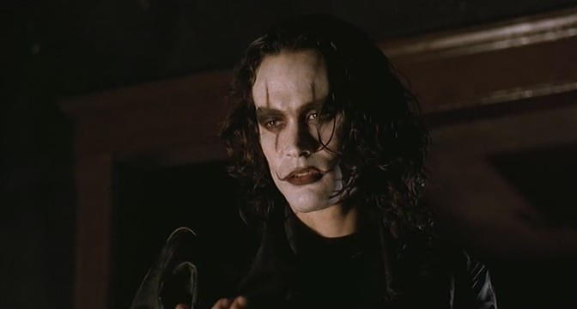
(Figure 2.4. Brandon Lee in 1994’s The Crow- The first film to digitally resurrect using CGI after Lee’s tragic death on set)

34. Bode, Lisa. ‘ Deepfaking Keanu: YouTube Deepfakes, Platform Visual Effects, and the Complexity of Reception’. Convergence: The International Journal of Research into New Media Technologies, vol. 27, no. 4, Aug. 2021, pp. 919 – 34
In the original trilogy, Tarkin was the chief of operations within the ‘Deathstar.’ The filmmakers felt it would be difficult to omit such an important antagonist from a narrative that prominently featured the weaponized space station as a vital plot device³⁵. in Alexi Sargeant's essay ‘The Undeath of Cinema’ he questions whether Cushing's character was necessary to the plot of this Star Wars tale. The script's newer cast of original Imperial villains could've carried the film without the inclusion of legacy characters like Darth Vader and Grand Moff Tarkin. They served the film for nostalgic purposes to satisfy older audiences, which ultimately generates more capital for the studio.
Sargeant believes that Disney was simultaneously using the film to assess the capabilities and limitations of digital resurrection while also testing how fans would react to seeing the technology in action on screen.³⁶
To gain access to Cushing's image rights, Lucasfilm courted the executor of his estate- Joyce Broughton. The studio owned the copyright to Cushing's original performance and therefore didn’t have to but did so out of courtesy to prevent a negative reaction from fans.
When Cushing passed without an heir, His former secretary Joyce Broughton received his assets. Specifics of her involvement in the film and the financial arrangement she made with Lucasfilm/ Disney are covered by a confidentiality agreement and are not available to the General public. There is however an indication of the estate's involvement by way of the film's closing credits. They read “With Special Acknowledgment to Peter Cushing, OBE” and “Special Thanks to The Estate of Peter Cushing, OBE.”³⁷

(Figure 2.5. The closing credits of Rogue One, film still, 2016)
35. Itzkoff, Dave. ‘How “Rogue One” Brought Back Familiar Faces’. The New York Times, 27 Dec. 2016
36. Sargeant, Alexi. ‘The Undeath of Cinema’. The New Atlantis
37. Debruge, Kristopher Tapley, Peter, et al. ‘“Rogue One”: What Peter Cushing’s Digital Resurrection Means for the Industry’. Variety, 17 Dec. 2016
If the actor who invented the part is no longer around to play them, it might be challenging to keep the character's authenticity. This may be particularly true if the actor's physical attributes or mannerisms closely resemble the role. Peter Cushing's imposing stature and unique facial structure are so synonymous with the role that separating the actor from the character is impossible. Actor Guy Henry was cast thanks to his close resemblance to Cushing after Broughton gave her blessing to the project.
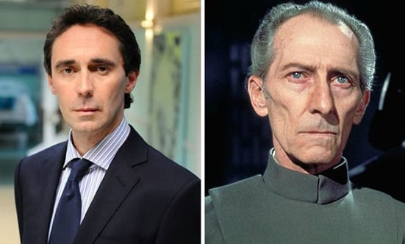
(Figure 2.6. Similarities between Actor Guy Henry (Left) and Peter Cushing (right)
Henry had similar attributes like Height and body shape, while also being able to mimic the vocal mannerisms Cushing possessed. This supplied a perfect base for animators and modelers at ILM to work off. During production, a Rig was mounted on Henry’s head that caught subtle performances in his face through motion capture technology. Motion capture is a widely used VFX method in the film and games industry that records an actor's performance on a stage through multiple cameras placed around the actors' surroundings. These cameras automatically transfer this data in Realtime to a virtual environment. With Guy Henry's movements, ILM was then able to adjust every frame so they could bring his performance further in line with the archival footage of Peter Cushing. In an interview with the New York Times, Knoll compared the process to an alternate version of applying makeup that was far more arduous and technical^{35.}
35. Itzkoff, Dave. ‘How “Rogue One” Brought Back Familiar Faces’. The New York Times, 27 Dec. 2016
To give a sense of how faithful ILM and Henry were to the source material, John Knoll detailed How they often compared Guy Henry's motion-capture performance and Peter Cushing's daily footage from "Star Wars.’ By doing so, they were able to highlight slight tics in the original actor's delivery and then apply it to the 3D Puppet of Governor Tarkin. The Animators noticed that Cushing didn’t move his upper lip when making an “aah” noise. He would Instead make a squarish shape with his bottom lip that exposed his mandibular teeth¹⁸. (Pictured below in figure 2.7)
In 1984, Cushing willingly made a mould of his face for the movie ‘Top Secret’ (David Zucker, Jerry Zucker and Jim Abrahamson, 1984) which he starred in. Animators at Industrial Light and Magic then took this resin cast from an archive and scanned it into a 3D space. Using a cocktail of both this scan and the motion capture of Guy Henry, the VFX house built a Cg model that managed to capture his likeness with remarkable accuracy.³⁸ Cushing's digital puppet acts like a time capsule, with every nook and cranny unique to a 71-year-old on a day in 1984.

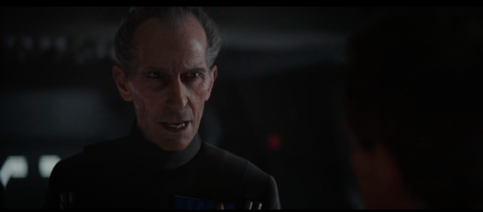
(Figure 2.7. The CG Peter Cushing exposing his mandibular teeth while making an aah noise)

38. The prosthetic that Peter Cushing wore in the bookshop scene involved the making of a cast of his face to fit it to. This same cast was used 30 years later by ILM to build a CGI model of his face for Rogue One (2016). https://www.imdb.com/title/tt0088286/trivia/
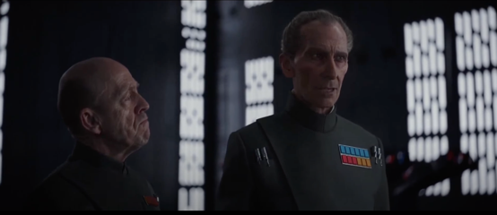
(Figure 2.8. Grand Moff Tarkin in Rogue One, Film Still, 2016)
In Lev Manovich's “What is Digital Cinema (1995)’ he writes that Animated films accentuate their fictional characters to flagrantly highlight that these “Images are mere representations”. (Manovich, 1995, P.6)
Manovich believes cinema’s integrity rests in its capacity to be seen as an accurate depiction of reality. With Live action features, they tend to mask their visual effects shots because they’d rather audiences be under the paradoxical illusion that it was filmed practically rather than manufactured in A VFX house.³⁹
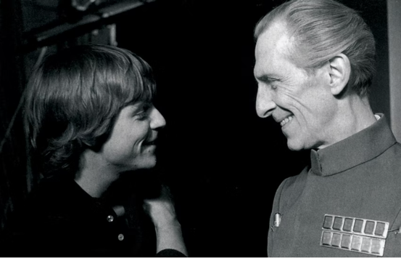
(Figure 2.9. Peter Cushing and Mark Hamill in a behind-the-scenes photograph on the set of the original Star Wars,1977)

39. Manovich, L. (1995). Digital cinema. In Hal Foster (Ed.), The Anti-Aesthetic: Essays on Postmodern Culture (pp . 193-214)
However, instead of partially obscuring their work to hide these imperfections, ILM overtly emphasized their finished product to express sheer confidence in the result. In Dan Goldings' journal ‘The memory of perfection: Digital faces and nostalgic franchise cinema’ he points this out. Unlike the dinosaurs from 1993's Jurassic Park, this virtual construction is seen in full view rather than only briefly to conceal its digital nature, inviting the ‘closest inspection possible.’
In the Film, Cushing's piercing computer-generated visage is “Presented in overwhelming closeup, framed from Cushing’s mouth to his eyebrows, as if daring the audience to find fault in its recreation.” They are forced to make a dubious ‘Judgement’ about whether this ghostly apparition, perceived in the audience’s memory as much as on the screen in front of them’ has been “successfully invoked.” (Golding,2021) ²

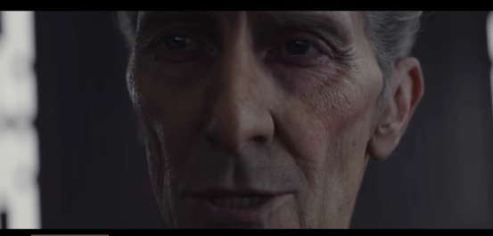
(Figure 3.1. In the Film, Cushing's piercing computer-generated visage is “presented in overwhelming closeup, framed from Cushing’s mouth to his eyebrows, as if daring the audience to find fault in its recreation.)

2. Golding, Dan. ‘The Memory of Perfection: Digital Faces and Nostalgic Franchise Cinema’. Convergence: The International Journal of Research into New Media Technologies, vol. 27, no. 4, Aug. 2021, pp. 855–67

Reception
Familial
Cushing had no kids of his own and never remarried after his wife passed away in 1971. He did have a brother, but it is not known how his extended family responded to the film. In an interview with BBC Radio 1 Gareth Edwards said the family members were "Very pleased" with the result. 40
Joyce Broughton reacted emotionally when she saw her old friend onscreen. In an interview with Variety, she briefly talked about why the film provoked such an evocative reaction within her.
“When you’re with somebody for 35 years, what do you expect? I can’t say anymore because I get very upset about it. He was the most beautiful man. He had his own private way of living.” ^{37.}
Joyce Broughton to Variety, 2016
Broughton's comments potentially show that this synthetic portrayal of a man she loved and cared for was able to trigger both powerful memories from her past and evoke strong emotions in her present.
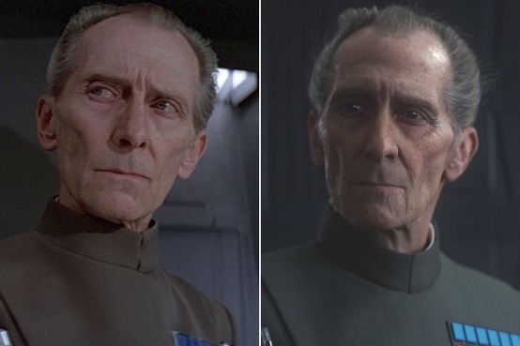
(Figure 3.2. The real Peter Cushing (left) versus his CG counterpart (right)
37. Debruge, Kristopher Tapley, Peter, et al. ‘“Rogue One”: What Peter Cushing’s Digital Resurrection Means for the Industry’. Variety, 17 Dec. 2016
40. ‘BBC Radio 4 - The Film Programme, Rogue One’. BBC,
Critical
The film's groundbreaking visual effects garnered a mixed bag of reviews. On the positive side, many applauded the technical marvel employed to revive the imperial commander. The Guardian likened viewing this artificial Peter Cushing to travelling back in time to the nostalgic era of the 70s and 80s when Star Wars was born.⁴¹ Similarly, The Hollywood Reporter wrote that the film took CGI to “new and perfected lengths”^{42.}
On the negative side, David Ehrlich branded Tarkin's “Lifeless digital husk” a “Blight on the most beautiful Star Wars film to date”⁴³. Likewise, many agreed the character was a visual distraction with Kristy Puchko from CBR branding the concept and execution “off-putting”^{44.}
The New York Times (NYT) considered that Tarkin's inclusion could wade into debates about postmodernism and the ethical implications of prolonging a fictional character's Lifecycle long after the factual death of its originating actor ^{45.}
Sargeants' essay raises an interesting concern surrounding the morality and power estates hold over someone's image. He questions how the late actor's estate (including Joyce Broughton) could possibly have understood the desires of a man who passed away over two decades ago, using emerging technologies that weren't even around throughout His 81 years on this earth.³⁶
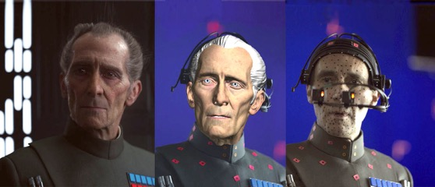
(Figure 3.3 Guy Henry (right) with the facial rig that transferred his movements onto the 3D Tarkin maquette (Middle)
36. Sargeant, Alexi.’The Undeath of Cinema’. The New Atlantis
41. Bradshaw, Peter. ‘Rogue One: A Star Wars Story Review – a Sleek Addition to the Fleet’. The Guardian, 15 Dec. 2016.
42. McCarthy, Todd. ‘“Rogue One: A Star Wars Story”: Film Review’. The Hollywood Reporter, 13 Dec. 2016
43. Ehrlich, David. ‘“Rogue One” Review: The First “Star Wars” Spinoff Is a Scrappy Space Adventure That Plays Things Painfully Safe’. Indiewire, 13 Dec. 2016
Consent is at the center of issues brought up by the New York Times and Alexi Sargeant. Is it morally correct that there is private financial gain from the public use of a deceased person's image?
The film also ignited discourse about whether the film would've received Cushing's seal of approval. Indiewire hosted a fascinating debate between film critics on this topic. Ironically, Cushing played the role of Viktor Frankenstein in 1957, a character who becomes obsessed with creating life and unleashes a monster made from dead human body parts. Joshua Rothkopf from Time out points out the irony of this critical negativity. Rothkopf believes that Cushing would have gotten a “Kick out of” seeing his reanimated corpse on screen given his career in the horror genre. ⁴⁴
Germain Lussier concludes the debate by likening it to the skeptical conversations in 1920s Hollywood about the use of colour and sound in films. She continues that digital resurrection is just a progression in the evolution of film as an art form, and like those early sound and colour pictures the quality is only going to increase.⁴⁴

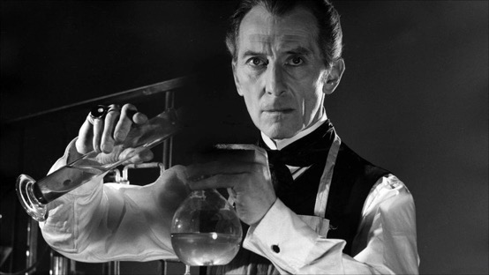
(Figure 3.4. Peter Cushing as Doctor Frankenstein, 1957)

44.Ehrlich, David. ‘Are the Special Effects in “Rogue One” Unethical? — Indiewire Critics Survey’. Indiewire, 19 Dec. 2016
45. Itzkoff, Dave. ‘How “Rogue One” Brought Back Familiar Faces’. The New York Times, 27 Dec. 2016. NYTimes.com,
,

Chapter 3

The Cultural impacts of Digital Resurrection on Contemporary Society

Introduction
In a segment for 60 Minutes on CBS titled ‘A Living for the dead’, Presenter Steve Croft detailed the commercial benefits of utilizing the departed for films and product campaigns. He morbidly stated that ‘Dead celebrities can be more lucrative, and sometimes a lot less trouble.” (Sherlock, 2013). As technology continues to advance, new possibilities arise for remediating and resurrecting past media forms and individuals. The intersection of remediation and digital resurrection has opened a new frontier in filmmaking, offering new ways to recontextualize and revive old historical figures to tell new stories. This chapter assesses both the negative and positive impacts that this emerging technology potentially could have on media forms like film, education, music and marketing.

Remediation in Cinema

This remediation of computer graphics by film has its economic and practical dimensions, since Disney and other major studios want to maintain the structure of their industry and retain their paying customers”
“Remediation: Understanding New Media”, book, Jay David Bolter and Richard Grusin, 1999

Remediation is when a medium is seen within our society as the renovation of another, it is ‘The formal logic by which new media refashions prior media forms’.⁴⁶ An example of remediation is the laptop, as it has adapted older media forms like typewriters and televisions and transformed them into a new form of technology.
“Remediation: Understanding New Media” is a Book by Jay David Bolter and Richard Grusin that discusses this concept in depth and will be the primary focus of this third chapter. Botler and Grusin argue that their theory can also work in reverse. They call this process retrograde remediation.⁴⁷
It is the idea that in a continually evolving media environment, older media forms absorb aspects of newer, more effective media forms in order to survive. This is a frequent occurrence in animated films, which have imitated Hollywood's live-action features for decades and adapted tales, myths, and legends, like “Anastasia, Pocahontas, and Pinocchio”.

46. ‘What Is Remediation?’ FutureLearn,
47. Bolter, J. D., & Grusin, R . (1999). Remediation: Understanding new media. MIT
Bolter and Grusin argue that Beauty and the Beast (Dir: Gary Trousdale and Kirk Wise, 1992) is a prime example of retrograde remediation because it replicates various established filmic techniques, such as the tracking shot, that is challenging to recreate using traditional manual animation. Instead, the film employs CGI technology to imitate these techniques and create a seamless integration of old and contemporary aesthetics. The two authors describe this film as “Eclectic,” because it not only remediates traditional Film but also the Broadway musical of the fifties and sixties. (Bolter and Grusin, 1999, p.147)
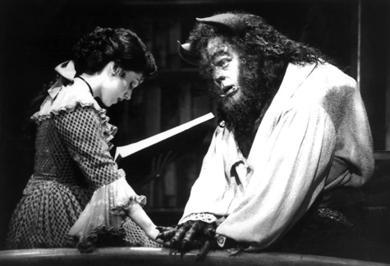
(Figure 3.5. Beauty and the Beast Broadway musical of the fifties and sixties)
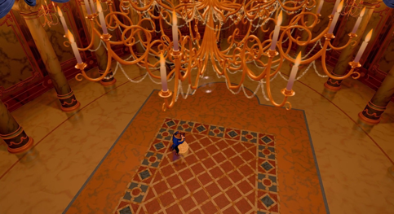.
(Figure 3.6. The tracking shot in beauty and the beast was an eclectic mixture of 2D and 3D techniques.)
Toy Story (Dir: John Lasseter, 1996) is another example of an animated film that could be described as eclectic, as it uses retrograde remediation in both its storytelling and visual style. This fully CG animated film, considered the first, creates a familiar nostalgic experience for audiences by trying to employ computer animation that mimics the appearance and feel of classic hand-drawn animation. In addition, it also takes the classic buddy-cop formula in storytelling and adapts it into a unique dynamic between conversing toys. (Bolter and Grusin, 1999, p.149)
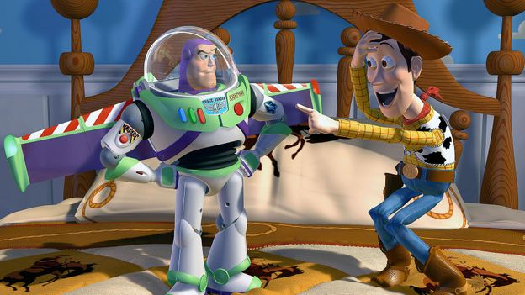
(Figure 3.7. A unique dynamic between conversing toys.)
As described in the technical considerations at the end of chapter one, I detailed how most DRTs rely on vast quantities of existing media like photographs, videos and audio recordings. It then uses this data to create a virtual depiction of a deceased individual. The classification of digital resurrection as a form of remediation arises from its utilization of digital technology to transform and adapt pre-existing media forms like the three examples listed above. Even when something new is produced, the resulting product is nonetheless universally recognizable by our culture as being related to its initial form. The digital resurrection using CGI of actors like Peter Cushing and Paul Walker is influenced and created by existing media like photographs, videos and audio recordings that contain these two men. The aim of VFX companies adopting digital resurrection is to make their “synthetic images indistinguishable from photographs” (Bolter and Grusin, 1999, P.28). As discussed in chapter one there are a few hurdles that must be overcome first, mainly the uncanny valley, before complete photorealism is achieved. Once complete photorealism is achieved, it is possible that societies may confront a scenario where distinguishing between authentic and fabricated media becomes increasingly challenging.
In the Indiewire debate mentioned in the previous chapter, David Ehrlich wrote that Rogue One was the beginning of a long descent down a “Slippery slope”.⁴³ The slippery slope argument refers to the theory that digitally aided immortality will revive countless streams of actors from bygone eras for new performances. A world where dead actors coexist onscreen with living ones would bring limitless creative potential to future filmmakers. Prospectively, we could see Leonardo DiCaprio appear onscreen with Marlon Brando or even Scarlett Johansson with Grace Kelly. Perhaps more interestingly, is the future of the film biopic. The use of digital resurrection in biopics might end the need for actors by substituting computer-generated characters. This might mean that performances produced by a machine using data, which might lack the same life and vitality as human performance, could be used to replace artistic interpretations of historical people. Examples like Austin Butler's depiction of Elvis (Director: Baz Luhrmann, 2022) or Rami Malek's Freddie Mercury in ‘Bohemian Rhapsody’ (Director: Dexter Fletcher,2018) would cease to exist.
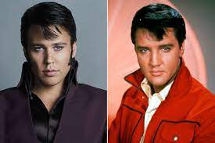(Figure 3.8 Austin Butler's depiction of Elvis)
43. Ehrlich, David. ‘“Rogue One” Review: The First “Star Wars” Spinoff Is a Scrappy Space Adventure That Plays Things Painfully Safe’. Indiewire, 13 Dec. 2016,
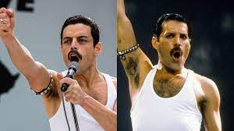
(Figure 3.9. Rami Malek's Freddie Mercury in ‘Bohemian Rhapsody)
John Knoll predicted that these CG solutions would not become mainstream because they were “Extremely labour-intensive and expensive to do.” ⁴⁸ Moore's Law is described as a techno-economic model that was introduced by Gordon Moore in 1965 and has relevance to Knolls' prediction. This theory forecasted that the functionality and performance of our computers would double and become cheaper bi-annually^{49.}
While Moore's hypothesis has changed significantly since, who is to say that these technologies will not become more economical and budget friendly in the future?⁵⁰ Pending the cost-effective evolution of these technologies, casting agents could soon have access to a vintage “movie star dollhouse”⁵¹

48. Guerrasio, Jason. ‘The Most Controversial Part of “Rogue One” Has Finally Been Explained’. Insider
49. Shalf, John. ‘The Future of Computing beyond Moore’s Law’. Philosophical Transactions of the Royal Society A: Mathematical, Physical and Engineering Sciences, vol. 378, no. 2166, Mar. 2020
50. Nast, Condé. ‘The Messy Legal Scrap to Bring Celebrities Back from the Dead’. Wired UK
51. Knight, Kyler. ‘How Hollywood Is On the Verge of Resurrecting Movie Stars with CGI’. MovieWeb, 17 Oct. 2022

The Digital afterlife
In 1999, Bolton and Grusin discussed how digital technology may enable us to reproduce historical events, people, and locations in an increasingly lifelike and immersive manner, giving us the impression that these digital humans are here with us, and we could experience the past firsthand.
In 2019, a merger between property licensing specialist CMG worldwide and content creation studio Observe Media ⁵² demonstrated an increasing convergence of intellectual property licensing and XR technologies. XR stands for extended reality which revolves around a variety of technologies like virtual, augmented and mixed-reality systems ⁵²
This tech combines real and virtual worlds to create new and immersive experiences for consumers in the modern digital age.
Since its foundation in 1981 by CEO Mark Roesler, CMG has built an impressive portfolio of over 400 iconic figures, including early clients like James Dean and Elvis Presley. This company could monetize and commercially exploit the likeness of the many legendary entertainers, Musicians, athletes, and historical figures in their catalogue. A roster which holds NIL rights to famous personalities like Jean Harlow, Andre the giant, Jerry Garcia, and Malcolm X to name a few.⁵³ Worldwide XR recognized a niche gap in the market and the economic potential of bringing historical and contemporary personalities to life in a virtual environment. Worldwide XR intends to expand beyond the film industry and venture into school, museum, and music settings.⁵⁴ The company's CEO Travis Cloyd has envisioned a future classroom where students are learning directly from a historical figure about their life, rather than learning about it through a textbook or from a teacher.

52. Roettgers, Janko. ‘Team Behind Digital James Dean Forms New Company to Resurrect Other Legends (EXCLUSIVE)’. Variety, 12 Nov. 2019
53. Clients – CMG Worldwide
54. Cosgrove, Elly. ‘A Digitally Resurrected James Dean Is Just the Beginning, as Team Forms New CGI Effects Company’. CNBC , 12 Nov. 2019

While digital resurrection for commercial benefit through the medium of film could seem a little exploitative to some, the potential benefits of using the technology in education systems could potentially facilitate learning in new and fascinating ways that have yet to be seen.
In 2019, it was announced in the media that James Dean would appear posthumously in a film called ‘Finding Jack’. A Film that centers around a soldier who refuses to leave his dog behind following the conclusion of the Vietnam war. With Worldwide XR involved, filmmakers Anton Ernst and Tati Golykh bought James Dean's image rights from his estate after they authorized the project. Dean is currently being virtually revived to front a project he had no creative input on. The announcement provoked widespread condemnation amongst many within the acting community. “This is awful. Maybe we can get a computer to paint us a new Picasso,” Chris Evans wrote on Twitter. Elijah Wood reiterated the sentiment “This shouldn’t be a thing.” ⁵⁵. Zelda Williams' perspective on the matter is particularly notable considering her late father Robin Williams registered a deed that restricted the use of his image for fears it might be exploited. Per his Will, no films or promotional materials starring him may be released before 2039. He donated his NIL rights to the Windfall Foundation, a charity that was set up in his name. Zelda Williams wrote on Twitter that these filmmakers were “Puppeteering the dead for their ‘clout’ alone and it sets such an awful precedent for the future of performance.”⁵⁵
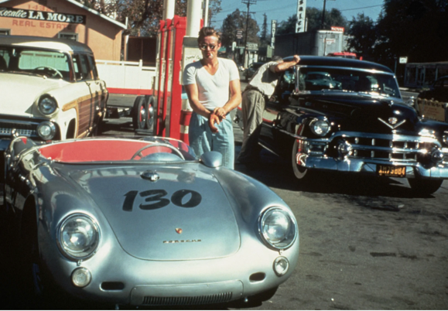(Figure 4.1. The last photo was taken of James Dean, pictured with his Porsche 550 Spyder, at a petrol station on the 30^{th of} September 1955, hours before the tragic car accident which took his life. From: TIME)
55. Drury, Sharareh. ‘ Chris Evans, Elijah Wood and More Criticize James Dean CGI Casting: “This Shouldn’t Be a Thing ”’. The Hollywood Reporter, 6 Nov. 2019
Zelda Williams' concern is that these CG reincarnations will diminish acting as a craft. Many believe that no matter how well-intentioned or well-executed an instance of digital resurrection is, it will always have “An absence.” because “Acting is the art of presence.” ³⁶
You could justify Peter Cushing's involvement in Rogue one because of his past connections to the saga. His affection for the Star Wars brand was well documented and ‘The Empire Strikes Back’ (Dir: Irvin Kershner, 1980) is widely credited with reviving his faltering career at the time. However, James Dean had no prior participation in any franchise as his brief filmography consisted of three unrelated films.
There is a universal unease that reviving actors from the dead is purely motivated by financial gain rather than the consideration for an individual's legacy, as seen with the ‘Finding Jack’ announcement. It can be argued that Studios are effectively removing power from the departed by adopting digital resurrection, and by connecting their likeness with a product they had no input over; are effectively vandalizing a deceased actor's artistic integrity.
In recent years, the trend of using deceased celebrities in advertising campaigns and musical performances has been on the rise. Using CGI, Johnnie Walker sparked controversy in 2013 when they digitally resurrected Bruce Lee to promote their Scotch Whisky brand. Despite his known distaste for alcohol during most of his adult life, the spirits company somehow still felt it was appropriate to use Lee as a spokesperson for a product he never would have promoted in his own lifetime. ⁵⁶
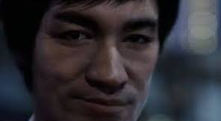(Figure 4.2. A fully Computer-Generated Bruce Lee in Johnnie Walkers scotch whisky commercial, 2013, Tv Still)
56. how, Jason. ‘ Johnnie Walker’s Bruce Lee Video: Tasteless Ad or Brilliant Marketing for Scotch in China ?’ Wall Street Journal, 12 July 2013
Marilyn Monroe was also revived to front a new Snickers “You're not you when you're hungry” Advertising campaign. The Superbowl commercial that went with the marketing was widely criticized for its distasteful sexualization of the actress (Figure 4.3). We have also seen advertisements where Audrey Hepburn consumes chocolate (Galaxy,2013. Figure 4.4), Fred Astaire dances with Vacuums (Dirt Devil, 1997. Figure 4.5), and Steve McQueen drives a 2005 Ford Puma (Ford, 2005. Figure 4.6). Digital resurrection isn't just restricted to media forms like marketing and filmmaking, one of its most famous applications was a Concert performance at the Coachella Music and Arts Festival. VFX house ‘Digital Domain’ controversially projected Tupac Shakur’s holographic reincarnation onto a stage alongside Dr Dre and Snoop Dogg in 2012 (Figure 4.7).⁵⁷
Bolter and Grusin's theory of remediation suggests that digital resurrection is not a new concept, but rather an extension of the long-lasting human desire to preserve and commemorate the memory of the deceased through various media forms like photographs, sculptures, and paintings.
Victoria J. Haneman agrees that Humanity is constantly using technology to further its existential search for immortality. Digital Resurrection technologies that use deep learning algorithms, which humans have created, are now “Redefining the meaning of death, as the living leverage technology to maintain an emotional connection with the dead “⁵⁸
However, Stephen Bush believes it is important to respect the idea that our departed loved ones “Are the product both of the things they want to tell us about themselves, the things they withheld from us and the truths about themselves that they didn’t even know or lived in a state of semi-conscious denial about” He continues that this is “Impossible to recreate”⁵⁹ With regards to digital resurrection.

“Digital immortality both over- and undervalues the artists it purports to memorialize. It sanctifies all the half-drafts and incomplete performances the artist left behind—mining them for an endless string of future releases—while disregarding all the revisions and edits the living artist would have undertaken”
Sternbergh, Adam. ‘The Strange Year of the Posthumous Performance’. Vulture,

57. Tupac Coachella Hologram: Behind the Technology. CBS, 9 Nov. 2012,
58. Haneman, Victoria J. Digital Resurrection. 28 Dec. 2021. Social Science Research Network,
59. ‘Forget Digital Resurrection: Let the Dead Stay Dead’. Financial Times, 17 Jan. 2023.
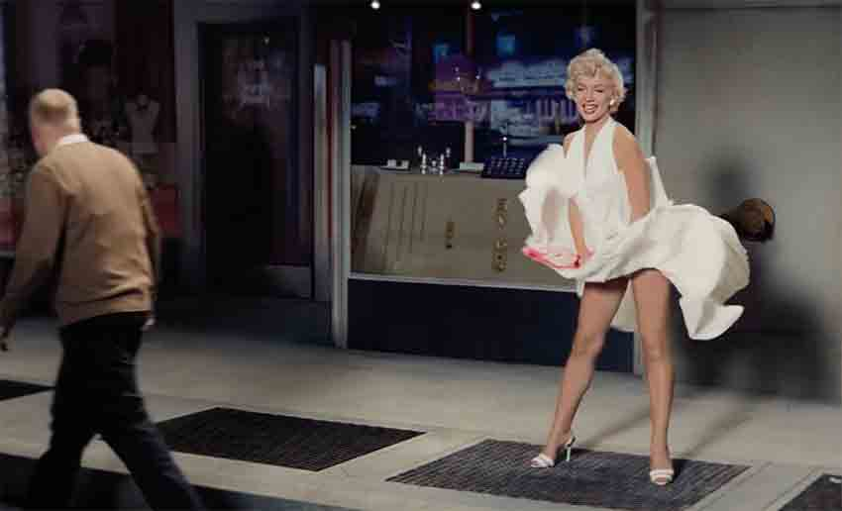
(Figure 4.3. A Tv still of a digital Marilyn Monroe in Snickers “You're not you when you're hungry” Superbowl commercial,2016)

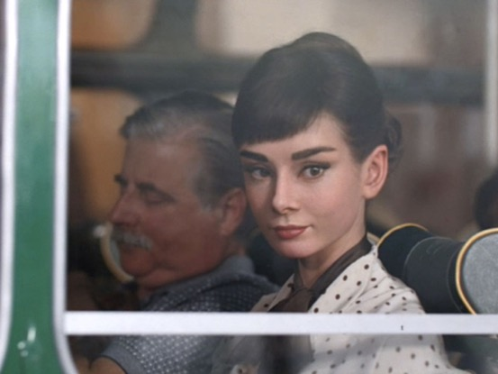
(Figure 4.4. A CG Audrey Hepburn promoting Galaxy Chocolate in 2013, Tv still)

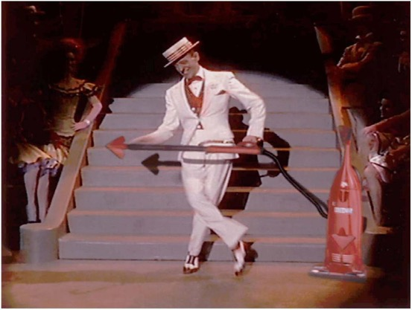
(Figure 4.5. A Manufactured Fred Astaire dances with Vacuums manufactured by dirt Devil,1997, Tv Still)

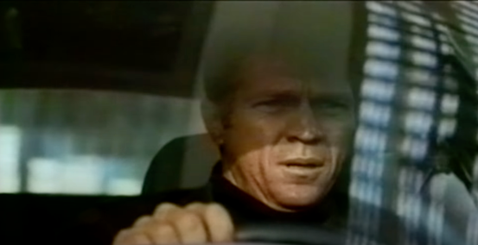
(Figure 4.6. digitally resurrected Steve McQueen driving a ford puma, 2005)

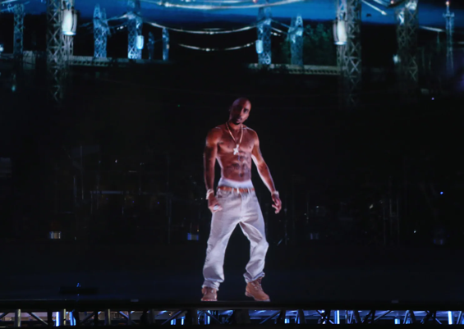

(Figure 4.7.Tupac Shakur’s holographic reincarnation projected onto a stage alongside Dr. Dre and Snoop Dogg at Coachella Music Festival in 2012)

Conclusion

Through the application of theories like remediation, I have come to realise that this emerging technology may represent a natural evolution in the way we consume media content. As with previous forms of media that have displaced earlier technologies, I believe that we will eventually come to accept it despite any initial scepticism or concerns.

Throughout this thesis, I found myself constantly questioning the power estates hold regarding the possession of a famous individual's NIL rights. Simply put, digital resurrection cannot be used as a method in production Without their approval.

Upon learning about CMG Worldwide, I realised the blame shouldn’t rest solely on Companies capitalizing off nostalgia, but on the estates enabling them to do so.
Although most estates have the best intentions for their loved ones, there are always exceptions to this. In my research, I learned about the strained relationship Prince had with his family. Unfortunately, he passed away without leaving a will and as a result, his NIL rights were inherited by family members whom he did not have a good relationship with. It is uncomfortable to consider that in the future, my image could be in the control of individuals who dislike me, who could exploit them for their own financial gain.

While researching for the third chapter, it got me thinking about the future implications of this technology once it reaches its full potential. One intriguing notion is that my digital footprint could be utilized to create a digital replica of myself, taking from my social media activity and other online interactions to establish its personality.
While learning about Worldwide XR it did occur to me that while the use of digital resurrection for commercial benefit through the medium of film does seem a little exploitive. However, the potential benefits of using the technology in education systems could potentially facilitate learning in new and fascinating ways.

With every new technology, there are many advantages and disadvantages. Digital resurrection has positive advantages in film and bereavement therapy, but it also has negative potential regarding exploitation, consent and false attribution. False attribution is a term that describes a scenario where a person attributes a quote or action to someone else that they didn’t say or do.
With this technology, there is a possibility that people may fail to distinguish between a statement made by a digital representation of an individual and something that was said by the person while they were alive.

Governments around the world are grappling with the issue of fabricated media, which can interfere with elections. New breakthroughs in technology like digital resurrection will only make the problem of falsified images even more pervasive. A.I systems that can mimic human voices are now coming to prominence and only adding to this concern. Writing this thesis has made me realise that without proper regulation, our trust in media is likely to erode further if regulatory bodies don’t take action to address it.
List of Works Cited

Benjamin, Walter. The Work of Art in the Age of Mechanical Reproduction. Repr, Penguin Books, 2008.
Bode, Lisa. ‘ Deepfaking Keanu: YouTube Deepfakes, Platform Visual Effects, and the Complexity of Reception’. Convergence: The International Journal of Research into New Media Technologies, vol. 27, no. 4, Aug. 2021, pp. 919 – 34. DOI.org (Crossref), https://doi.org/10.1177/13548565211030454.
Bolter, J. D., & Grusin, R . (1999). Remediation: Understanding new media. MIT Press.https://monoskop.org/images/a/ae/Bolter_Jay_David_Grusin_Richard_Remediat ion_Understanding_New_Media_low_quality.pdf

Bradshaw, Peter. ‘Rogue One: A Star Wars Story Review – a Sleek Addition to the Fleet’. The Guardian, 15 Dec. 2016. www.theguardian.com , http:// www.theguardian.com/film/2016/dec/13/rogue-one-a-star-wars-story-review- felicity-jones-gareth-edwards .
Chow, Jason. ‘ Johnnie Walker’s Bruce Lee Video: Tasteless Ad or Brilliant Marketing for Scotch in China ?’ Wall Street Journal, 12 July 2013. www.wsj . com, http://blogs.wsj.com/scene/2013/07/12/johnnie-walkers-bruce-lee- video-tasteless-ad- or-brilliant-marketing /.
Cosgrove, Elly. ‘A Digitally Resurrected James Dean Is Just the Beginning, as Team Forms New CGI Effects Company’. CNBC , 12 Nov. 2019, https://www.cnbc.com/2019/11/12/worldwide-xr-is-formed-to-bring-actors-like- james- dean-to-life-on-the-screen.html .
Debruge, Kristopher Tapley, Peter, et al. ‘“Rogue One”: What Peter Cushing’s Digital Resurrection Means for the Industry’. Variety, 17 Dec. 2016, https://variety.com/2016/film/news/rogue-one-peter-cushing-digital-resurrection-cgi-1201943759/.

Debruge, Kristopher Tapley, Peter, et al. ‘“Rogue One”: What Peter Cushing’s Digital Resurrection Means for the Industry’. Variety, 17 Dec. 2016, https://variety.com/2016/film/news/rogue-one-peter-cushing-digital-resurrection-cgi-1201943759/.
Drury, Sharareh. ‘ Chris Evans, Elijah Wood and More Criticize James Dean CGI Casting: “This Shouldn’t Be a Thing ”’. The Hollywood Reporter, 6 Nov. 2019, https://www.hollywoodreporter.com/news /general-news/ chris-evans-elijah-wood-more- criticize-james-dean-cgi-casting-shouldnt-be-a-thing-1253004 /.
Dunne-Miles , Matthew ‘Deepfakes, Dead Relatives and Digital Resurrection’. The Face. 6th April 2021, https://theface.com/society/deepfakes-dead-relatives-deep- nostalgia-ai-digital-resurrection-kim-kardashian-rob-kardashian-grief-privacy .
Ehrlich, David. ‘“Rogue One” Review: The First “Star Wars” Spinoff Is a Scrappy Space Adventure That Plays Things Painfully Safe’. IndieWire , 13 Dec. 2016, https://www.indiewire.com/2016/12/rogue-one-review-star-wars-1201757457 /.
Ehrlich, David. ‘Are the Special Effects in “Rogue One” Unethical? — Indiewire Critics Survey’. Indiewire , 19 Dec. 2016,
Foundas, Scott. ‘SXSW Film Review: “Furious 7”’. Variety , 17 Mar. 2015, https:// variety.com/2015/film/reviews/sxsw-film-review-furious-7-1201453751 /.
Golding, Dan. ‘The Memory of Perfection: Digital Faces and Nostalgic Franchise Cinema’. Convergence: The International Journal of Research into New Media Technologies, vol. 27, no. 4, Aug. 2021, pp. 855–67
Guerrasio, Jason. ‘The Most Controversial Part of “Rogue One” Has Finally Been Explained’. Insider , https://www .insider.
Haneman, Victoria J. Digital Resurrection. 28 Dec. 2021. Social Science Research Network, https://papers.ssrn.com/sol3/papers.cfm?abstract_id=3995687
Harris, Racheal, et al. Photography and Death: Framing Death Throughout History, Emerald Publishing Limited, 2020
Itzkoff, Dave. ‘How “Rogue One” Brought Back Familiar Faces’. The New York Times, 27 Dec. 2016 . NYTimes.com, https:// www.nytimes.com/2016/12/27/movies/how-rogue-one-brought-back-grand-moff- tarkin.html .
Itzkoff, Dave. ‘How “Rogue One” Brought Back Familiar Faces’. The New York Times, 27 Dec. 2016. NYTimes.com, https://www.nytimes.com/2016/12/27/movies/how-rogue-one-brought-back-grand-moff-tarkin.html.
Knight, Kyler. ‘How Hollywood Is On the Verge of Resurrecting Movie Stars with CGI’. MovieWeb, 17 Oct. 2022, https://movieweb.com/hollywood-resurrecting-dead-movie-stars-with-cgi/.
Krusling, James. Research Guides: Deepfake Technology: Home. https://ggu.libguides.com/c.php?g=1171737&p=8559629.
Kunze, Peter C. Review of Flickers of Film: Nostalgia in the Time of Digital Cinema, by Jason Sperb. The Velvet Light Trap, vol. 79, 2017, p. 131-132. Project MUSE muse.jhu.edu/article/648155 .
Laney, Ben. Bringing the Dead Back to Life: Preparing the Estate for a Post-Mortem Acting Role. 7 Feb. 2020. Social Science Research Network, https://papers.ssrn.com/abstract=3598316.
LaSalle, Mick. ‘'Furious 7’ Is Creepy and Long ’. SFGATE, 2 Apr. 2015, https://www.sfgate.com/movies/article/Furious-7-creepy-and-long-6173472.php .
Lomax, Tara. The Franchise Era: Blockbuster Hollywood in the 2010s…and Beyond – Senses of Cinema . 21 Sept. 2013, https://www.sensesofcinema.com/2019/cinema-in-the-2010s/the-franchise-era- blockbuster-hollywood-in-the-2010sand-beyond /.
Manovich, L. (1995). Digital cinema. In Hal Foster (Ed.), The Anti-Aesthetic: Essays on Postmodern Culture (pp . 193-214). Bay Press. http://manovich.net/content/04-projects/009-what-is-digital- cinema/07_article_1995.pdf
Manovich, Lev. New Media: A users Guide. 1999 http://manovich.net/content/04- projects/026-new-media-a-user-s-guide/23_article_1999.pdf

McCarthy, Todd. ‘“Rogue One: A Star Wars Story”: Film Review ’. The Hollywood Reporter, 13 Dec. 2016 , https://www.hollywoodreporter.com/movies/movie-reviews/ rogue-one-a-star-wars-story-review-955566 /.
Mendelson, Scott. ‘“Furious 7” Review: Part Seven Can’t Measure Up To “Fast Five”’. Forbes , https:// www.forbes.com/sites/scottmendelson/2015/03/26/furious-7- review-part-seven-cant-measure-up-to-fast-five /.
Nast, Condé. ‘ Here Are Three Paul Walker Furious 7 Scenes That Proved Especially Hard to Digitally Create’. Vanity Fair , 20 Oct. 2015, https://www.vanityfair.com/hollywood/2015/10/paul-walker-furious-7-scenes-digitally- recreated .
Nast, Condé. ‘ The Messy Legal Scrap to Bring Celebrities Back from the Dead’. Wired UK . www.wired.co.uk, https:// www.wired.co.uk/article/james-dean-dead- actors-rights . Accessed 11 Mar. 2023.
Patterson, John. ‘ CGI Friday: A Brief History of Computer-Generated Actors’. The Guardian, 27 Mar. 2015 . The Guardian, https://www.theguardian.com/film/2015/mar/27/paul-walker-furious-seven-brief-history- of-computer-generated-actors
Roettgers, Janko. ‘Team Behind Digital James Dean Forms New Company to Resurrect Other Legends (EXCLUSIVE)’. Variety , 12 Nov. 2019, https://variety.com/2019/digital/news/james-dean-worldwide-xr-1203401302 /.
Sargeant, Alexi.’The Undeath of Cinema’. The New Atlantis , https://www.thenewatlantis.com/publications/the-undeath-of-cinema
Schaefer, Sandy. ‘How Furious 7 Finished Paul Walker’s Scenes After His Death’. ScreenRant, 17 Aug. 2020 , https:// screenrant.com/fast-furious-7-paul-walker-brothers- scenes-cgi-how /.
Shalf, John. ‘The Future of Computing beyond Moore’s Law’. Philosophical Transactions of the Royal Society A: Mathematical, Physical and Engineering Sciences, vol. 378, no. 2166, Mar. 2020 , p. 20190061. DOI.org (Crossref), https://doi.org/10.1098/rsta .2019.0061.
Sherlock, Alexandra. ‘Larger Than Life: Digital Resurrection and the Re- Enchantment of Society’. The Information Society, vol. 29, no. 3, May 2013, pp. 164 –76
Shoard, Catherine. ‘ The Strange Case of Fast & Furious Star Paul Walker’. The Guardian, 14 Apr. 2015. The Guardian, https://www.theguardian.com/ commentisfree/2015/apr/14/fast-and-furious-death-paul- walker.
West, Nancy Martha. Kodak and the Lens of Nostalgia. (Cultural Frames, Framing Culture.) Charlottesville: University Press of Virginia. 2000. Pp. Xviii, 242. Cloth $55.00, Paper $16.95’. The American Historical Review , Oct. 2001. DOI.org (Crossref), https://doi.org/10.1086/ahr/106.4.1372 .
Whitten, Sarah. ‘The 13 Highest-Grossing Film Franchises at the Box Office’. CNBC, https://www.cnbc.com/2021/01/31/the-13-highest-grossing-film-franchises-at- the-box-office.html. Accessed 12 Feb. 2023.

Other
‘ Fast & Furious: Domestic & Global Box Office Revenues 2022’. Statista, https://www.statista.com/statistics/608148/box-office-revenue-fast-and-furious /. Accessed 12 Feb. 2023..
‘ For “Star Wars” Fans, Nostalgia Shapes Expectations ’. University of Arizona Research, Innovation & Impact, 15 Feb. 2019 https://research.arizona.edu/stories/star- wars-fans-nostalgia-shapes-expectations .
‘ Forget Digital Resurrection: Let the Dead Stay Dead’. Financial Times , 17 Jan. 2023. https://www.ft.com/content/ff009304-5501-4f89-8893-7909f88509a8
‘ Furious 7 Says Goodbye to Paul Walker with Wall-to-Wall Action Absurdity’. The A.V. Club , 2 Apr. 2015, https://www.avclub.com/ furious-7-says-goodbye-to-paul- walker-with-wall-to-wall -1798183305.
‘ Paul Walker’s Brother Cody Walker on Furious 7: “I Think Paul Would Be Proud ”’. Peoplemag, https://people.com/movies/paul-walkers- brother-cody-walker-on-furious-7- i-think-paul-would-be-proud /. Accessed 12 Feb. 2023.
‘ Paul Walker’s Brothers Say Filming Furious 7 Helped Them Grieve His Death ’. Peoplemag, https://people.com/ movies/paul-walkers-brothers-say-filming-furious-7- helped-them-grieve-his-death /. Accessed 12 Feb. 2023.
‘ Review: In Furious 7, Gravity Is for Wimps ’. Time, 1 Apr. 2015 , https:// time.com/3766037/furious-7-review-paul-walker-vin-diesel /.
‘ When Was the Camera Invented? Frenchman Credited with Invention of Camera in 1816.’ USA TODAY USA TODAY, https://www. usatoday.com/story/tech/2022/06/14/when-was-camera-invented- history/7615372001/.
‘BBC Radio 4 - The Film Programme, Rogue One’. BBC,https://www.bbc.co.uk/programmes/b085014n
‘Forget Digital Resurrection: Let the Dead Stay Dead’. Financial Times, 17 Jan. 2023. https://www.ft.com/content/ff009304-5501-4f89-8893-7909f88509a8
‘Publicity’. LII / Legal Information Institute, https://www.law.cornell.edu/wex/publicity. Accessed 14 Mar. 2023
‘What Is Remediation?’ FutureLearn, https://www.futurelearn.com/info/blog. Accessed 11 Mar. 2023.
Celebrities Rights Act of California-Personality Survives Death | Stimmel Law. https://www.stimmel
Clients – CMG Worldwide. https://www.cmgworldwide.com /clients/. Accessed 25 Feb. 2023.
Exhibition ‘Uncanny Valley’. Wave Pool, June 8th - July 27th, 2019, https://www.wavepoolgallery.org/uncannyvalley#:~:text='The%20Uncanny%20Valley'%2C%20a,in%20the%20person%20viewing%20it.
http://dictionary.sensagent.com/Film_franchise/en-en/
https://www.bhandlaw.com/can-i-legally-use-the-image-of-a-dead-famous-person/
The prosthetic that Peter Cushing wore in the bookshop scene involved the making of a cast of his face to fit it to. This same cast was used 30 years later by ILM to build a CGI model of his face for Rogue One (2016). https://www.imdb.com/title/tt0088286/trivia/
Tupac Coachella Hologram: Behind the Technology. 9 Nov. 2012, https://www.cbsnews.com/news/tupac-coachella-hologram-behind-the-technology/.

