New Media Studies 

Faculty of Enterprise & Humanities | Department of Humanities & Arts Management

Final Year Project submitted in part fulfillment of
Bachelor of Arts (Honours) in New Media Studies

Student Name: Oisín Keegan

Student Number: N00192230

Project Title: Today’s internet culture of pornography and propaganda is harming the young people in our society.

Project Type: Journalistic Essay

Declaration of Ownership: I declare that the attached work is entirely my own and that all sources have been acknowledged: □X

Date: ________13/04/2023___________________

Today’s internet culture of pornography and propaganda is harming the young people in our society.
Young people are viewing vile and graphic content on a near daily basis.
“The way our children engage with people like Andrew Tate is something we really need to keep an eye on,” says Jenny Crampton, a Social, Personal and Health Education (SPHE) teacher at Newpark Comprehensive School. She’s concerned about how much the internet effects day to day life within the school. “I think we’ll look back in 20 years and wonder how on earth we allowed our children to access such stuff.”
CyberSafeKids and the National Parent’s council have started a new campaign titled ‘#SameRulesApply’, aiming to promote awareness around the type of content children should and should not be viewing.

I spoke with Alex Cooney, CEO and Co – Founder of CyberSafeKids a not-for-profit charity operating in Ireland which aims to protect children from the potentially damaging effects of the internet. She said that she helped to set up the organization “with the acknowledgement that children will be online and with the aim to equip them with the skills and knowledge that will allow them to be safer.”
Ctrl + Click picture to listen to audio. (Image: CyberSafeKids.ie)
Cooney explained that “we realize that we need to go beyond education because we can do so much to equip children and young people to be in those online spaces, but we also need these spaces to be made safer for children.”
A survey conducted by CyberSafeKids involving over 2,000 participants aged 8 to 12 provided some startling results when it comes to children’s internet usage. 92% of children surveyed claimed to own a smart device, including 89% of 9-year-olds. 29% said they can go on the internet whenever they want, with 15% saying “there are no rules”.
Their conclusions found that an increase of young internet users “creates a situation where exposure to damaging content is inevitable”, says Cooney. She also says that tackling this issue is no easy task “but what we do know is that it starts with effective online supervision”.
What role does porn play in society?
According to eChildhood, the average age of first exposure to pornography is at age 11, although the lack of research in the area has hindered the accuracy of such results. Regardless, this seems to be a truth that many parents are scared to face. I spoke with cyberpsychologist Nicola Fox – Hamilton about pornography and how best to view the issue. She prefers to view this early access to porn as a reality we must deal with head on, particularly by deploying good parenting skills to limit the harmful impacts.

“It is important to be having conversations with kids about the type of things they might come across on the internet and how they might deal with things that they find upsetting” – Nicola Fox - Hamilton

She argued that there’s no straight answer to the question of when a child should be allowed access to the internet relatively unsupervised. She said, “How old a child should be before unrestricted internet access simply depends on how vulnerable and emotionally sensitive that child is”. If they feel afraid to confide in their guardian about a bad online experience they’ve had, then they’ll be forced to “bottle it up” and perhaps draw their “own misguided conclusions about reasoning for the content itself.”

Is porn harmful?
Research on this issue has not been entirely conclusive. UNICEF express the harms as being: ‘poor mental health, sexism, objectification and sexual violence’. In order to take a closer look at how these harms manifest, I spoke with Elma Murphy, a psychotherapist whose focus is in the field of childhood and adolescent studies.

“I have dealt with 12-year-olds who have seen things that no one should ever have to see”
- Elma Murphy

Murphy highlights the extensive problems that she has come across regarding adult relationships after compulsive pornography consumption. She expressed that “a large chunk” of her client base are “men in their early twenties with relationship problems stemming from the porn they watched when they were younger”.
She adds that the nature of the porn being viewed is what fuels “unrealistic perceptions of women and how they are expected to act” in sexual scenarios. Murphy’s clients often shy away from stating the kind of porn they view, if any, however she feels their behaviours and attitudes give her strong indications.
The potential for Pornography addiction is also a cause for concern according to Murphy. “In the past it was 16 and 17-year-olds viewing this stuff, now it’s 14-year-olds” she warns. “Kids of this age are not equipped to deal with that kind of imagery”. Murphy goes on to explain how porn hits “the same addiction centres as substances do”, and that it can lead to a similar relationship dynamic that drug addicts have to their chosen drug.
AddictionCenter.com, a resource for those affected by addiction claim that ‘one the most common reports are of porn addiction or feeling a compulsion to watch porn and not being able to stop.’ They also claim that 10% of adults in the US admit to having a porn addiction. Regardless of the points listed above, some researchers such as Fox - Hamilton still argue that we cannot draw these conclusions without further research.

“It’s actually a misconception that pornography is harmful to all who view it. In many cases it can have negative effects, but many children are quite resilient too.”
- Nicola Fox – Hamilton

Fox – Hamilton expressed that she believes exposure to pornography at a young age is most likely going to have an undesirable result, however she also added that this is not always going to be the case. Some researchers support this point of view, such as Andrea Waling, researcher at La Trobe University, who claims that it promotes sexual confidence amongst young adolescents and can cause a positive community formation for LGBTQ people.
An investigation was conducted in The National Library of Medicine by Aleksandra Dwulit and Piotr Rzymski on the topic of pornography. Their investigation offers insights that raise questions about research that has been conducted on this topic to date.
They surveyed over 6000 Polish University students to determine harms, habits and trends amongst young adolescent porn users. The study continues to be cited in countless science journals related to pornography use amongst adolescents.
The survey claims that nearly 80% of participants are viewers of pornography, with the median age of first exposure being just 14 years old. The majority did not perceive porn to have had negative effects on their relationships and sexual function, however more that 10% confessed to having an unhealthy addiction to viewing pornography.
The survey also claims that over 55% of those who view pornography stated that they see no effects from viewing porn, while 28% of users say it has beneficial qualities. These perceptions of the effects of pornography appear to contradict the narratives expressed by the psychologists I have spoken to.
Most interestingly, they note that most students did not perceive that pornography had negatively affected them, yet most claimed that pornography use “may have adverse effects on human health”. In their conclusions, Dwulit and Rzymski point out that: “This, in turn, may potentially indicate that how pornography is perceived by young adults may not be driven by their own experience but by cultural factors, and opinions formulated by authorities and media”.

Algorithms and the Molly Russell Case
“An algorithm is a set of online rules that track our interests and push content towards us that it perceives we might like”, explains Robert Griffin, lecturer at IADT with a masters in cyberpsychology. He expressed his fears around the type of content that children are viewing, even when they don’t actively seek it.
He explains that internet algorithms are somewhat of a grey area. “Social media companies don’t want you to know too much about how their algorithms work because they’d essentially be letting out their secrets.”
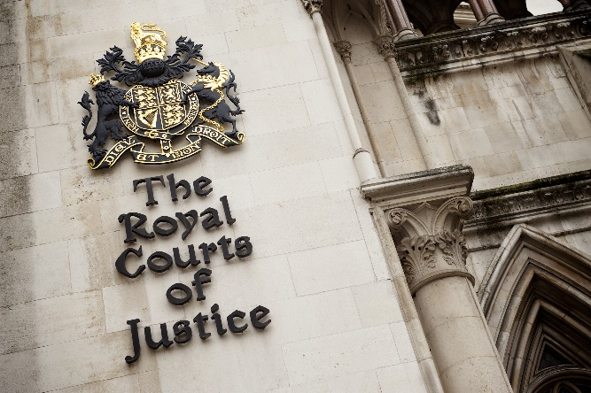
My conversation with Alex Cooney touched upon a case which illustrated a need for “increased protections for children accessing the internet.” The case involves a 14-year-old girl named Molly Russell who “sadly took her own life as a result of content she had been viewing on social media”. When her father began his search for answers, he found that “she had been viewing a lot of propaganda which encouraged self-harm”.
Tech companies Meta and Pinterest appeared in London’s High Courts for questioning about their algorithms. (Image: Shutterstock.com)

“Her father very passionately believed that this content was not sought out but instead was actively promoted to her.” - Alex Cooney

Cooney explained how the social media sites involved, such as Instagram, Pinterest, Snapchat and WhatsApp, made it near impossible for Russell’s father to access the specific content she had been subjected to.
After an inquest into her death, the coroner “ultimately found that those services had in fact promoted harmful content” and that this content had “exacerbated Russell’s existing feelings of depression and suicidal ideation.”
Instagram and Pinterest have now claimed to make it “a lot harder for such damaging material to be available on their platforms” however Cooney claims that they haven’t gone far enough.

Andrew Tate
Andrew Tate is a former kickboxer who has risen to fame in recent years because of his controversial views about women and feminism “In the nature of our world, something that is more extreme ends up becoming most popular – rather than what is actually true”, points out Colman Noctor, a child and adolescent psychotherapist who has a keen interest in the effects of contemporary media on children’s development.
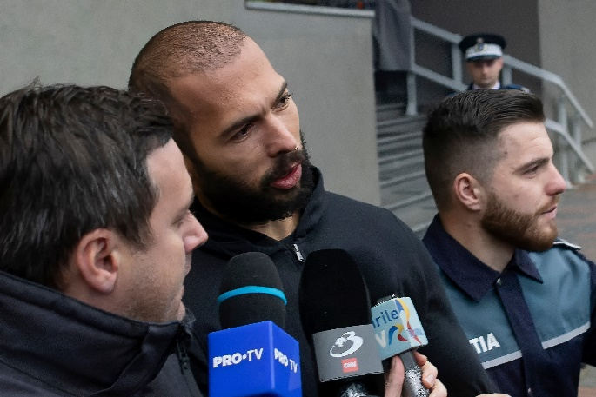
Noctor is cognisant of how rapidly Tate’s following has grown and expresses concerns about the consequences of it. “In July of last year, he was searched more than The Kardashians and Donald Trump combined.” When a public figures audience is comprised mostly of teenagers and young adults, the messages they convey can prove to be dangerously influential.
Tate speaks to media outside a court in Romania. He is accused of Human Trafficking and Rape. (Image: Shutterstock.com)

“For every 10 people who watch his video’s, if nine roll their eyes and one doesn’t, it’s that one that you need to worry about”
- Colman Noctor

Noctor expresses that Tate may appeal to disillusioned young males because of a new era of ‘wokeness’, described as a way of thinking that if you’re not in total agreement with a certain view, then you must be “totally against it.” The predominantly left leaning media landscape has left some young people feeling as if they’ll be demonised by expressing certain unpopular opinions, Noctor points out. “It seems that ‘wokeism’ has taken over and I think he speaks to those who are concerned about that.”
Persuasion and radicalisation
Noctor describes the formula that leads to radicalisation as being quite simple. He compares it to the recent controversy about Ireland’s housing of migrants. You just need to approach a group and tell them that immigrants “are here to take our jobs and sexually assault our daughters and the government isn’t going to do anything about it.” Soon enough you will have radicalised people to “buy into a movement to stop it”.
Influencers like Tate” pose a risk to the young people in our society” because of their ability to persuade people into believing certain narratives, points out Fox - Hamilton. “Some of us are more likely to be persuaded by what are known as ‘peripheral cues', meaning the person themself, how charismatic they are, how attractive they are, how good their storytelling skills are - while the rationale in what they are saying can be left behind.’
Both Fox – Hamilton and Noctor make similar points regarding the vulnerability of young men and how this content may affect them. Noctor points out that young men are “particularly vulnerable to radicalisation by figures such as Tate”. This is because they are amid “a struggle to find out what masculinity means to them” and Tate appears to speak to that.

“Some young men think the rise of feminism means the dissolution of manhood”
- Colman Noctor

My conversation with SPHE Teacher Jenny Crampton provided a useful insight into how harmful internet content can affect the teenagers that she teaches. She began by pointing out that her colleague’s son is in 6th class and when asked if he had ever heard of Andrew Tate, claimed that “he follows him on Instagram and didn’t understand how there was any problem with the content that he posts”
Crampton says that her students don’t often directly discuss with her the content they view online, however she says, “I can say with absolute certainty that the content being viewed on the internet and social media over the weekend is rippling back into school life on a daily basis”.
She claims that she is aware of the kinds of content that her students are watching because “it can be seen with increased misogyny and racism heard in the corridors during break time”. She continues, pointing out that “In schools we are seeing a snapshot of what is happening out there in society”.
Regulation
I asked Murphy whether she thought children are protected enough from harmful internet content. Her response was: “No, not at all. As far I’m concerned, social media sites get away with blue murder”.
“Many young people try to find groups that they can attach to. If they can’t find this socially in school, then they’ll find it online.” Murphy believes that for this reason we need effective legislation to protect children from unrestricted internet access.

Ireland’s media landscape is not total chaos, however. On the 10th of December 2022, The Online Safety and Media Regulation Act 2022 was signed into law by President Michael D. Higgins.
The new law has dissolved the Broadcasting Authority of Ireland and puts a new Media Commission and Online Safety Commissioner in its place. Cooney explains that there is an “Online Safety section within the Act” and that it specifically attempts to “regulate harmful content online.”
Ctrl + Click picture to listen to Audio (Image: CyberSafeKids.ie)
More specifically, she adds, “it targets a sort of grey area of content that is not quite illegal but is deemed harmful. That’s a tricky area to regulate because it is subjective.”
This Act moves away from allowing “self-regulation by social media companies which is where we have been up until this point”, and instead is demanding that they “adhere to a standard that is set by an external regulator.”
Concerns were raised regarding how the Act could infringe on the right to free speech, Cooney points out. “There must be protections in place for children online and that shouldn’t infringe on the right to express yourself freely. It may be the case that we need to see the topic of children as a separate subject which requires additional layers of protection”.
When asked if children are protected enough from harmful content on the internet, Cooney responded “No, absolutely not”, however, she acknowledges that laws such as the Online Safety and Media Regulation Act 2022 are a step in the right direction.

