Institute of Art, Design and Technology, Dun Laoghaire. Dept. of Design and Visual Arts

Exhibition Design: The Importance of Visitor-Oriented Design within the Museum and Exhibition Space

By
Elsa Murray
Design for Stage and Screen February 2023

Submitted to the Department of Design and Visual Arts in candidacy for the Bachelor of Arts Degree in Design for Stage and Screen
Faculty of Film, Art and Creative Technologies

STATEMENT OF ACADEMIC INTEGRITY/ DECLARATION OF ORIGINALITY

This dissertation is submitted by the undersigned to the Institute of Art, Design & Technology, Dún Laoghaire in partial fulfilment for the BA (Hons) in Design for Stage and Screen. It is entirely the author’s own work, except where noted and has not been submitted for an award from this or any other educational institution.

Signed:

ABSTRACT

This thesis examines exhibition design as an integral mode of communication for the visitors experience and how it can make these experiences more immersive.
This topic explores the societal influences on these cultural spaces through theories of the construction of cultural hegemony, the dominating cultural beliefs and ideas of society, alongside a deep dive into the history and perceptions of exhibitions, from 16th-century curiosity cabinets to the modern metropolitan museums they’ve evolved into today.
The historical breakdown of these spaces allows for the exploration of exhibitions and museums as mediators of information through their design choices, as the designs of these spaces are one of the primary methods of conveying the narrative of the presentation of the object. These findings are explored within the scope of contemporary exhibitions of the Victoria & Albert Museum in South Kensington, London, where the design choices are examined from a visitor experience perspective.
Furthermore, the design choices are explored within the narratives placed upon these exhibitions as they reflect the cultural hegemony of the society they’re situated in.
These investigations are made with reference to various sociology and design theories in order to provide a nuanced analysis of exhibition and museum design as a complex and multi-faceted form of visual storytelling.

ACKNOWLEDGEMENTS

I want to thank both Siobhán O’Gorman and Liam Doona for their invaluable advice, guidance and encouragement throughout the completion of this thesis. I also want to thank my parents, James Murray and Doreen Kilfeather, my brother Jamie Murray and my friend Hannah Moran for taking the time to read my work and offer feedback and for all their unfailing support over this past year.

TABLE OF CONTENTS

ABSTRACT ......................................................................................................................3 ACKNOWLEDGEMENTS ..............................................................................................4
LIST OF FIGURES ..........................................................................................................6
INTRODUCTION ............................................................................................................8
CHAPTER ONE: Cultural Hegemony and its influence on the Museum/Exhibition Space................................................................................................................................11
1.1 The Creation of Space and Hegemony.....................................................12
1.2 The Influence of Cultural Hegemony on Society...................................14
1.3 The Evolution of the Perception of the Museum and Exhibition Space...................................................................................................................16
1.4 Breaking Down Contemporary Exhibitions...........................................19
CHAPTER TWO: Designing Effective Exhibitions for the Visitor Experience......................................................................................................................27
2.1 The Visitor Experience..............................................................................28
2.2 Approaching the Design............................................................................29
2.3 Assessing the Design………………………………....................................33
CONCLUSION ................................................................................................................46
WORKS CONSULTED ..................................................................................................50
LIST OF FIGURES
Figure Page
- Dirand, A. (2019) V&A ‘Christian Dior: Designer of Dreams' installation view. URL:https://www.wallpaper.com/fashion/christian-dior-designer-of-dreams-opens-victoria-and-albert-museum (Accessed: 5th September 2022).............................................................21
- Victoria & Albert Archives (2020). Wedding Gown, 1952-53 (made) URL: https://collections.vam.ac.uk/item/O1460276/wedding-gown-wedding-gown-dior-christian/(Accessed: 5th September 2022)……………………………………………………22
- Gwatkin, A. (2022) Ensemble, Craig Green SS21. URL: : https://www.vam.ac.uk/exhibitions/fashioning-masculinities-the-art-of-menswear(Accessed: 5th September 2022)…………………………………………………………………………..25

- Bitgood, S (1994) Stephen Bitgood’s “Designing Effective Exhibits: Criteria for Success, Exhibit Design Approaches, and Research Strategies”, page 4. (Accessed: 10th October 2022)………………………………………………………………………………………….31

- Dirand, A (2019) V&A ‘Christian Dior: Designer of Dreams' installation view. URL: https://www.wallpaper.com/fashion/christian-dior-designer-of-dreams-opens-victoria-and-albert-museum (Accessed: 5th September 2022).....................................................................35
- Dirand, A (2019) V&A The Garden. URL: : https://www.cntraveller.com/gallery/christian-dior-at-the-victoria-albert-museum ……………………………….....................................................................37
- Harpers Bazaar (2019) Dior in Britain. URL: https://www.harpersbazaar.com/uk/fashion/fashion-news/a28895674/christian-dior-designer-of-dreams-most-visited-exhibition-v-and-a/………………………………...........................................38
- Victoria & Albert Museum (2022), Undressed, Installation View of Fashioning Masculinities, V&A London, URL: https://www.vam.ac.uk/articles/inside-the-fashioning-masculinities-exhibition .……………………………………………………………………..............……..41
- Victoria & Albert Museum (2022), Overdressed, Installation View of Fashioning Masculinities, V&A London, URL: https://www.vam.ac.uk/articles/inside-the-fashioning-masculinities-exhibition ……………………………………………………………..……..42
- Victoria & Albert Museum (2022), Overdressed, Installation View of Fashioning Masculinities, V&A London, URL: https://www.vam.ac.uk/articles/inside-the-fashioning-masculinities-exhibition ……………………………………………………………..……..42
- Victoria & Albert Museum (2022), Redressed, Installation View of Fashioning Masculinities, V&A London, URL: https://www.vam.ac.uk/articles/inside-the-fashioning-masculinities-exhibition ……………………………………………………………..….......................…..43
- Victoria & Albert Museum (2022), Finale, Installation View of Fashioning Masculinities, V&A London, URL: https://www.vam.ac.uk/articles/inside-the-fashioning-masculinities-exhibition ……………………………………………………………..……..........................................45

INTRODUCTION

The purpose of this thesis is to explore the impact and necessity of considered visitor-oriented design within the exhibition and museum space by exploring how these cultural spaces are shaped by the society they exist within and how visitors perceive and engage with said spaces. Museum and exhibition spaces are complex, multi-layered entities with the role of empowering curiosity and providing space for education and discussion for all members of society. The designed interiors of these spaces are the vessels of communication that the visitor depends on to guide them through them. Without it, they are stepping into a chasm of artefacts and objects of all kinds, with no direction or help to make sense of them all (Roppola, 2013, 2 Exhibition Design as Mediation). The design has the power to make these spaces accessible for their audiences, to contextualise and adapt the information they are presented with, giving it the capacity to make or break a visitor's experience (Roppola, 2013, 2 Exhibition Design as Mediation).

The approach for this thesis research is holistic. To understand the need for considered exhibition design, one must consider how these cultural spaces came to be and are perceived by the audience interactions and society as a whole. They are highly complex spaces requiring a rounded analysis to understand their theoretical and physical configurations (Roppola, 2013, 2 Exhibition Design as Mediation). Through this research, we have found that the concept of exhibition design is broken down into separate entities, the physical construction of the space and the concept-making of exhibition narratives being the primary sources and not necessarily being dealt with as a whole. These aspects of exhibition creation are all fundamental parts of the process and need to be dealt with as a collective (Roppola, 2013, 2 Exhibition Design as Mediation)

Research Aims and Objectives
This thesis seeks to provide a broad overview of how society constructs the social space that surrounds us and how we have influenced the cultivation and presentation of the museum and exhibition space in contemporary society. This theoretical overview will serve as a basis to examine the complexity of how the physical space has manifested itself over time and how it serves those who engage with it. Establishing how the physical space came to be and the importance of the design as a form of communication will be further explored and broken down into the proven strategies of exhibition design as well as visitor perception and how this influences the design of the exhibition space (Bitgood, 1994 and Roppola, 2013).

Organisation of Research Material
Chapter One: entitled 'Cultural Hegemony and its Influence on the Museum and Exhibition Space', begins with a breakdown of the construction of social space within society and by whom this space is constructed. This breakdown is conceived through the theories of French philosopher Henri Lefebvre to develop the concept of how the Hegemony we construct and exist within influences the creation and perceptions of cultural spaces. This chapter then proceeds to examine how members of society are influenced by the museum space and what reflects upon those who construct them within the second subsection of this chapter, drawing on the theories of French sociologist Pierre Bourdieu concerning his research on the formation of tastes and classes (Bourdieu, 1979, Chapter 1). Furthermore, the evolving perception of museum spaces is examined in the third subsection of this chapter by looking at curiosity cabinets of the 16th century up until more modern museums were constructed from the 17th to 19th century during the Age Of Enlightenment to map the development of the perception of objects and artefacts within these spaces (Impey and MacGregor, 2000, p 16-20). After establishing this historical and social baseline, the fourth subsection of this chapter deals with case studies I developed on two private exhibitions of the Victoria & Albert Museum in South Kensington, London. Here, the conceptual framework behind these exhibitions and how they present the specific narrative they have constructed within the spaces is explored.

Chapter Two: ‘Designing Effective Exhibitions for the Visitor Experience', is the start of breaking down the design of the spaces themselves, examining strategies and studies for the visitor experience. The first section of this chapter begins by dissecting the visitor experience, examining what exhibition design provides for the visitor and what they expect from these spaces. The visitor studies created by Tiina Roppola relating to visitors' perceptions and expectations of museums are the primary points of discussion. The ethics and power of museums are broken down, relating to how design can shape the narrative the museum wants the visitor to experience, thus directing their experience (Roppola, 2013, 2 Exhibition Design as Mediation). The second subsection of the chapter deals with the design approaches themselves, breaking down what it is about the design of these spaces that makes them more or less effective from a visitor's perspective. Here, the design criteria of Stephen Bitgood are broken down, examining from his research what elements of design is crucial when creating an immersive experience for the visitor. For the final section of this chapter, Bitgood's (1994) criteria are applied alongside the visitor studies of Roppola (2013) to my exhibition case studies of the Victoria & Albert museum. Here, we work through the exhibitions, examining what use of visitor-oriented design has been applied and what makes the spaces more effective as an immersive and educational experience.

As a Production Design student, this thesis was particularly relevant to the theory and work expected of my degree and in line with my interests. As I explored this vast area, there appeared to be few scholars and sources who thoroughly investigated immersive design theories that included both the physical construction and the theory behind the effective design, which brought me from French Marxism all the way to design theory. This thesis provides some insights into the necessity of visitor-inclusive design and explores what it is about said design that can make these museum experiences more immersive.

CHAPTER ONE
Cultural Hegemony and its influence on the Museum/Exhibition Space

Museum spaces and exhibitions are a product of our society, shaped by our history, culture and economic standings, by the people who comprise it. They hold all of what we deem to represent us, both positive and negative, presenting our progress and failures. They dictate how we perceive these ideas through careful selection, choosing works that best illustrate the discussions and views they are trying to communicate to us as a society and visitors. As spaces, they have evolved throughout history in many ways: their purpose, access and physicality, creating new observation methods and providing opportunities for curatorial influences on the objects within these spaces, thus influencing how those who engage with them perceive the information they are being presented.
From 16th-century curiosity cabinets housing the treasures of worldly nobles, to the public opening of collections presented in grand buildings during the Age of Enlightenment, all have the same goal, to create an environment for discovery and discussions that the ordinary person may not encounter or be presented with otherwise.
However, we must ask who is making these careful decisions, why they are making such particular selections, and to what end goal are they trying to achieve? Who decides what ends up immortalised and idealised in these spaces? How have these objects or ideas been selected to represent us as a society? What makes them so integral? Moreover, why are they being chosen at all?
In this chapter, we will explore and apply these questions to the theories and discussions of various scholars and philosophers, including French Marxist philosopher and sociologist Henri Lefebvre and French sociologist Pierre Bourdieu, to gain a deeper understanding of these spaces and their purpose within society. While exploring these scholars and their theories on culture and social politics, we will examine the evolution of the museum and exhibition space alongside them to provide a more linear connection between the two and how they directly inform each other.
By gaining a deeper understanding of this area, the findings can be applied to the private exhibitions, Fashioning Masculinities: The Art of Menswear and Christian Dior: Designer of Dreams, of the Victoria and Albert Museum in South Kensington London, which I attended in May of 2022 and July of 2019, later in this chapter. I want to clarify the methodology and reasonings in place when curating the objects within museum spaces and the curation of the buildings and what they represent to the societies in which they exist.

1.1 The Creation of Space and Hegemony

Understanding the construction of space and how such processes occur is a fundamental step when exploring how spaces such as museums and exhibitions have come to be and the modes they follow in contemporary society. In Henri Lefebvre’s book, The Production of Space, he argues that (social) space is a social product created and reproduced by those who make it up, primarily by those deemed highest in society. In Lefebvre's analysis, he is referring to the capitalists of society (Lefebvre, 1991, 26). By product, Lefebvre explains that it is not simply a product amongst others but an amalgamation of all things, sequences, and sets of operations living together as one and everything and cannot be deemed as merely a simple object. It results from all things that have happened in our society, provides space for new actions, and sets boundaries for others (Lefebvre, 1991, 73). This social space is broken into three sub-categories, spatial practice (the perceived/physical space), the representation of space (the conceived/abstract space) and the representational space (the lived/mentally appropriated space). These spaces work together to help us create and produce the environment we live in and, in the process, mould us and help us evolve as members of our societies (2020, The Production of Space: Henri Lefebvre | CMS College Kottayam | Department of Sociology, YouTube, https://www.youtube.com/watch?v=BH-p9H43AiA). These spaces, as previously acknowledged, are controlled socially and culturally by the dominating class of that area. Lefebvre's theory uses the capitalists of society to break down this cultural Hegemony by discussing their elevation in society as the producers to those on the lower tiers, the consumers. The producers have abundant wealth, be it capital, knowledge or assets, that allows them to dominate the social space and perceive and construct it as they choose. The consumers, or the ordinary people, are subject to the producers' decisions. In line with their interests, the dominant class decides what is to be presented for all to observe and relate to as individuals, meaning their ideas are the ones taking up this space more effortlessly.

This analysis of the Hegemony's impact on social space provides insightful information on how and why cultural spaces are constructed within our societies. However, how does one make groups such as society's consumers join together to carry out the goals and developments of the dominant class?

To analyse this relationship, Lefebvre uses the urban development of the Tuscan area from the thirteenth century to examine how the producers (in this instance, the urban oligarchy consisting of wealthy merchants and burghers) develop their inherited land into something grand and profitable. According to Lefebvre, these members of society created a system, the metayage (a type of land tenure whereby the cultivator [métayer] does not own the land but uses it and pays rent in kind to the owner), for these lands, which transformed what were the slaves and serfs into métayers. These serfs, now métayers, have the incentive to work for these oligarchs as they are benefactors of the system themselves, albeit on a different level, and are now personally interested in production. This symbiotic relationship helped vastly develop the area as those who worked needed to be fed and housed, making agriculture a priority and increasing urbanised development on the land, thus generating more wealth and power for those within the dominant social standing, making both parties benefactors in their own right. This boom in production and surplus wealth allowed more lavish spending to occur, creating structures such as monuments and palaces, allowing the artists of the time to express what was happening around them in their work, giving a new perspective of this world a physical representation reflecting the social space and its achievements of that time (Lefebvre, 1991, 78-79). This analysis gives us insight into how these dominant classes maintain their positions in power while still exerting their beliefs onto the surrounding members of society. They create an environment where there are benefits to all who get involved in their mission, incentivising those to join them and succeed, creating a hegemony that all fall in line with and, for the most part, are unaware of.

Using Lefebvre's theories on the production of social space as determined by Hegemony, we can understand how space is considered a social product, as it can be represented in line with the ideas of the dominant class, therefore influencing the consumer's interactions and perceptions of said space. Taking these ideas, we can now examine how the dominant class affects the cultural spaces within our communities, like museums and exhibitions, which further enforce the cultural Hegemony of the space. Simultaneously in this argument, I shall draw on the theories of French sociologist Pierre Bourdieu concerning his exploration of consumer taste formation and how members of societies' beliefs and tastes are garnered by the cultural environment they are exposed to. In Lefebvre's examination of the urbanisation of Tuscany, he discusses how, with the surplus money created from production, artists and creatives alike were employed to build various structures for the city. Having been given this chance to create, they took inspiration from their surroundings, reflecting the perspective of the space in these works, which promoted the ideas of the dominant class. Lefebvre recognises here, "These artists 'discovered' perspective and developed the theory of it because a space in perspective lay before them because such a space had already been produced"(Lefebvre,1991,79). Lefebvre's theories suggest that not only is the space designed for production as well as being embellished by the artists employed, but that even the artistic choices made by the creatives, who may believe were from their own insight, are heavily influenced by the social space already existing around them, much like the presentation and selection of the content in cultural spaces, like the museum and exhibition.

1.2 The Influence of Cultural Hegemony on Society

Museums are physical representations of the society we live in and have evolved from, presenting us with significant objects and exhibits that reflect the world around us, allowing us to engage with and learn from them in a pre-determined environment. The selection of said objects and questions posed within these spaces may seem arbitrary to some members of society but are quite the opposite. Museums and exhibitions are influential cultural spaces that can educate and communicate with those who interact with them through various mediums. This belief places a particular ethical obligation on such institutions, as they have a duty to their visitors to contextualise the objects with historical and social accuracy and represent the society and its beliefs, all while falling within the cultural Hegemony of said society. In Pierre Bourdieu's book, Distinction: A Social Critique of the Judgement of Taste, he discusses how the dominant classes dictate the “norms” and tastes within a society, influencing how people perceive particular objects and experiences. He focuses a majority of his research and theory on how the class system is affected by these “established’ tastes and how this, in turn, creates a multitude of experiences that can occur to individuals based on several structural factors, such as education, wealth, place of residence and age (Bourdieu, 1979, chapters 1 and 5). This ideology reflects how cultural Hegemony, constructed by the dominant classes of society, directly impacts the perception of cultural spaces. The dominant classes relating to cultural Hegemony are rich in cultural capital. Being rich in said capital means those members of society have experienced a broader and more culturally rich education concerning history, science and the arts. Having this capital gives them social precedence over the consumer classes as they have had greater access to said resources based on structural factors. For example, living in an affluent urbanised area with more significant amounts of people, cultural spaces (museums, galleries, theatres), and higher education (Universities) will give a member of society a greater likelihood to be a part of influencing the cultural Hegemony as opposed to someone from a working-class rural background who would have statistically less access to resources that were available to the former (Bourdieu, 1979, chapter 1).

In Douglas E. Allen and Paul F. Anderson’s (1994) research paper, "Consumption and Social Stratification: Bourdieu's Distinction", they breakdown these experiences and, in turn, how it affects those who do not fall within the dominant class,

“Thus, in western industrialised societies, classical music, opera, legitimate theatre, books on philosophy, knowledge of foreign languages, modern art collections, and subscriptions to academic journals are just a few of the cultural forms that are unquestionably (and unquestioned) elements of the legitimate or dominant culture. While members of the middle and working classes may eschew such cultural forms (indeed, they may well view them with suspicion or disdain), their position at the pinnacle of the cultural hierarchy goes unchallenged. ” (Allen and Anderson, 1994, 70-74).

It is discussed how those who have not experienced the culture of the dominant class (legitimate arts and culture as described above) do not know better than to accept these taught experiences as fact. Because they have not attained the “legitimate” cultural knowledge due to a lack of cultural capital to question these seemingly arbitrary and integral socially structured subjects, they accept these ideas as norms, not choices. (Allen and Anderson, 1994, 70-74). This idea of the unquestioned acceptance of the “legitimate culture” within consumer society demonstrates the power of the dominant class and their ability to dictate the cultural climate of the society where they reside. Suppose we apply this notion that the dominant class dictates the cultural Hegemony and how those outside of this class perceive the beliefs and ideas of this group as a certainty. In that case, we can understand how impactful these cultural spaces are on the formation and conditioning of tastes and opinions for the people of the other parts of society. The content presented in these spaces aligns with the beliefs of the dominant class, which boosts the cultural Hegemony, cementing these beliefs as norms within the lower classes of society.

However, it is essential to note that as these cultural spaces (museums/exhibitions) are now commonplace and more accessible in most societies (and for a large part, free entry for either everyone or members of a specific area) with greater access to information than ever before, alongside internet accessibility, people are less limited in gaining cultural capital if they so desire, compared to when Bourdieu’s studies were conducted back in the mid 20th century. However, it must be stated that his theory still applies conditionally in contemporary society, as to gain cultural capital, or to want to gain it in the first place, still requires a level of interest that may only be gained through experience or exposure that for the most part is down to structural factors.

1.3 The Evolution of the Perception of the Museum and Exhibition Space

Museums as entities have existed and evolved for thousands of years, from personal cabinets of the 17th century full of curiosities collected from the worldly travels of the aristocratic gentleman to grand-scale modern metropolitan museums full of treasures organised with the scientific and educational intention to be viewed by the masses, all the way back to 530 BCE when the first 'museum-space', Ennigaldi-Nanna's museum built by Princess Ennigaldi in modern Iraq at the end of the Neo-Babylonian Empire (Encyclopaedia Britannica 1997, p 481). Despite their continuous evolution, they have served the same core purpose: to empower curiosity and provide space for education and discussion, regardless of the audience size. To understand the cultural and societal significance of museum spaces and how Hegemony influences them, I will be exploring their evolution and growth during the 16th century into the Age of Enlightenment as this chapter progresses, starting with the 16th century when the mere concept of museums resided within the homes of wealthy aristocrats and royals for personal pleasure or to present to any noble guests they entertained (Roppola, 2013, 2 Exhibition Design as Mediation). The collections of curiosities and antiquities of the elite are some of the first presentations of semi-organised study and scientific interest in modern history. These collections resided in spaces within the home known as either cabinet-of-wonder/wonder rooms (German: Wunderkammer) or curiosity cabinets (German: Kunstkammer) (Impey and MacGregor, 2001, 16-20). These curiosity cabinets housed exotic, rare, sometimes freakish objects collected on the worldly travels and expeditions of aristocrats and royals, ranging from items of the natural world, such as botanical specimens or the skins of beasts or even horns of unicorns, to man-made implements and garments of ancient civilisations (Impey and MacGregor, 2001, 16-20). While not organised like the museums we see in contemporary society or even of museums nearer this time, the cabinets held thematic continuity in that all the collected objects held an aura of spectacular and peculiarity. This transitional period when society moved away from the church and towards science, is well represented in these spaces. The selection of objects demonstrates more secular curiosity and an interest in discovering more about the world around them and its history; the cabinets provided an environment for intellectual discussions between the owners of said cabinet and those they invited over to view it (Roppola, 2013, 2 Exhibition Design as Mediation). It is essential to be aware that those who owned and contributed to such cabinets and rooms were of the wealthier class of society, meaning that this sharing of information and discovery remained almost exclusively within the said class; therefore, “Power was correspondingly ingrained in this: knowledge was seen as authoritative by virtue of it originating from those with nobility” (Roppola, 2013, 2 Exhibition Design as Mediation). The exclusivity of accessing these cabinets and the knowledge gained from such encounters would inform how museums are perceived and presented in the coming years. Because of this, those who will build and curate the museums of the coming age will dictate what will be exhibited and how, thus, establishing norms and expectations within this new world of museum spaces.
The first public museum spaces opened their doors during the 1700s, including the Louvre in 1793 and the British Museum in 1753, giving ordinary people access to objects previously reserved for the highest of society. Moving into the Age of Enlightenment, governing bodies pushed a more secular view of the world onto the people of society through these museums and exhibitions of objects. This was to encourage the education and civilisation of the masses, painting themselves as patrons of the people, “public archives intent on doing public good” (Roppola, 2013, 2 Exhibition Design as Mediation). They acted as mediators of knowledge, simultaneously presenting and contextualising the objects within a scientific criterion, allowing the public to interact with and learn from what they saw. This criterion was encyclopaedic in its display nature,

“Botanical specimens were arranged taxonomically according to Linnaean classifications, and later, animal and human specimens were arranged according to Darwinian evolutionary schemes. Works of art were arranged chronologically into periods, and cultural artefacts according to ethnographic classifications.” (Roppola, 2013, 2 Exhibition Design as Mediation).

As described in the above quotation, this method was the earliest makings of exhibition design within these museum spaces, placing objects in consecutive sequences based on the exhibits. This medium determined museums as factual spaces, giving the impression of unbiased and objective information for the public to experience and make their own opinions. Nevertheless, it is crucial to understand that despite these spaces' seemingly objective representations of the objects they were exhibiting, conscious decisions are made by curators and patrons when choosing what will be exhibited and how. (Roppola, 2013, 2 Exhibition Design as Mediation) The French Salon, first introduced by the French Government in 1667 and further established in 1737, is a prime example of how the presentation and, crucially, the inclusion of objects within exhibition and museum spaces influences the general public’s perception of what is not only legitimate but is also correct (Brodskaya, 2010, p 7). The French Salon, an annual exhibition displaying contemporary art of the time, was a pillar of the French art world and had a powerful influence over what was accepted as the “standard” for contemporary art. It comprised a censorious jury of academics from the École des beaux-arts, who were precisely chosen from a pool of the Académie des Beaux-Arts (one of the five Academies of the Institut de France) among its members (Brodskaya, 2010, p 7). The criteria to be considered for the exhibition were rigid and unforgiving, only accepting work portrayed in the Academic style, composed of biblical or Greek mythological scenes typically portraying idealised renditions of nature, landscapes, portraiture or the female form.
Furthermore, the finishes of these works required highly professional realised compositions, imperceptible brushwork, and accurately captured renditions of perspective and the human form (Brodskaya, 2010, p 7). All of these were inadmissible requirements for being considered for the Salon. Any submissions that failed to meet these requirements were dismissed and deemed unfit, thus, determining the view of what was accepted as legitimate and illegitimate art. The Salon jury dictated what they deemed acceptable to exhibit, which impacted the general public’s opinions, and what they equated as authentic art by not exhibiting works outside their rigid criteria. This case demonstrates the power of those making curatorial decisions for museums. Their decisions to include or exclude particular objects from these cultural spaces directly impact the public's perception of said objects, cementing the notion that museums and exhibition spaces have the power to influence and dictate the standard of what is deemed legitimate knowledge and taste, thus falling in line with the cultural Hegemony of that society.
Drawing on the research and findings of Lefebvre and Bourdieu, these views and norms are set by the wealthy members of society, those with access to and more cultural capital, the dominant class. Hence, the dominant class dictates the representation of Hegemony within these cultural spaces as they are the members of society with the most structural factors, such as class position and education, meaning they have the most decisive influence within society. Taking this into account, we can understand the power and ethical responsibilities that come with the curation of these cultural spaces as museums, up until this point, have been perceived as pillars of actuality to the public eye, which leads them to believe that museums within society represent the truth as presented to them. As a product of their past, museums will always be emblems of discovery and information to the people within society; thus, they will always affect how people perceive the information exhibited within them. However, making it known that the objects within these museums are being exhibited through a specific lens, they can enter these spaces knowing that whilst the information they engage with is accurate, it is not necessarily the entire story surrounding the said exhibits within this space. For examining the representation of contemporary museums and exhibitions within our society, I shall be drawing on private exhibitions of the Victoria & Albert Museum (commonly referred to as the V&A) in South Kensington, London, to analyse the progression of museum spaces and how they represent the cultural Hegemony of the society we live in today.

1.4 Breaking Down Contemporary Exhibitions

When examining contemporary exhibition spaces and trying to understand the impact of cultural Hegemony on these spaces, I reviewed previous experiences of notable exhibitions and embarked on additional analytical visits to then-current exhibitions to attempt to identify and understand the influence and representation of the societal Hegemony within these exhibitions. During the autumn of 2022, I partook in an exhibition design course, Principles of Exhibition Making, hosted through the V&A over a six-week period, where I had the opportunity to speak with members of the V&A’s own curatorial and research team as well as guest speakers involved on previous and current exhibitions of the museum. These guests included the curator of the Dior exhibition, Oriole Cullen, which I will discuss next, and the designer and curator of the exhibition Fashioning Masculinities, Rosalind McKever and Jayden Ali, discussed later in this chapter.

These conversations gave me valuable insight into the methodology behind these exhibitions and the reasonings for choosing the narrative routes they resulted in. Across the world, museums are placing objects within contextualised narratives, as we are to see, to inform the public what lens they are being placed within, allowing them to understand that what they are seeing is only one part of the whole picture. This prevents museum spaces from wielding the same level of power they once commanded in previous centuries as those who presented their contents with a sense of finality supported by either science or those who curated the objects and had greater access to knowledge of culture and the arts (Roppola, 2013, 2 Exhibition Design as Mediation).

For the first part of my analysis, I revisited my experience of the Christian Dior: Designer of Dreams private exhibition held from February 2019 to August 2019 in the Victoria & Albert Museum of South Kensington, London. By examining my unbiased experiences from the time through a more critical lens, I have since acquired them throughout my research for this thesis. For context, this exhibition was designed by French exhibition designer Nathalie Crinière and curated by Irish curator Oriole Cullen. It is one of if not the most successful private exhibitions ever put on at the museum based on demand and visitor numbers, reaching well over half a million throughout its eight-month extended exhibiting period (V&A, 2019). For this exhibition, the curators wanted to examine Dior’s relationship with Britain, the Christian Dior himself and the evolution of the house. The prescribed narrative examines a cultural Dior-inspired utopia, highlighting the achievements and ingenuity of the brand and designer and its positive and inclusive impact on the people of Britain. The exhibition comprised hundreds of pieces from the Dior and V&A archives, from signature looks to fragrances and cosmetics. The visitor is brought through the space, encountering different design experiences per collection as each follows a theme seen in Dior’s work, all highly stylised and portraying an idyllic utopia. Presenting the exhibition under such exquisite design demands reinforces this utopian framework of the collection, exciting and rejuvenating the work of Dior for the visitors to see. Though this exhibition enticed hundreds and thousands of people to travel for it, myself included, it cannot be missed how positively this exhibition could influence the people of Britain’s views on the house, as their relationship to the designs and designer is a crucial focus in this exhibition, a purposeful curatorial and design choice on the institutions part. The V&A is aware of the audiences they entice when launching new exhibits or private exhibitions, meaning they present these objects with their audience's interests in mind. It attracts those interested in the work of Dior or inspires others to go based on this promise of connection between the illustrious designer and the society they are part of.

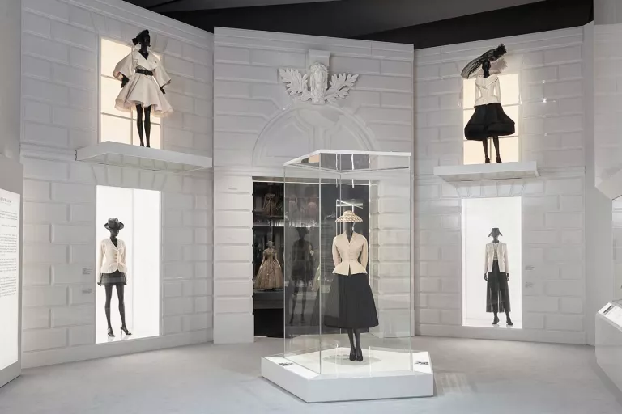
Fig 1. V&A ‘Christian Dior: Designer of Dreams' installation view.
Photography by Adrien Dirand
Source: https://www.wallpaper.com/fashion/christian-dior-designer-of-dreams-opens-victoria-and-albert-museum

The presentation of “cultural utopia/Dior-inspired utopia” is immediately presented to visitors as they enter the exhibition (fig 1.). As seen in the image on page 21, the entrance features a space exhibiting an original Bar Suit alongside recent renditions by successors of Dior himself. The Bar suit was designed by Christian Dior for his New Look Spring/Summer collection in 1947 and is considered a quintessential emblem of the collection (V&A, 2019). After dealing with two world wars within the last 20 years in which most of Europe was involved, recreational fashion dwindled to the bottom of the list of importance. This collection was revolutionary for women's fashion in the post-war era, filled with gloom and gave it a new lease of life. Knowing the cultural context in which the Bar Suit was created makes the spatial design of the exhibit an interesting choice for several reasons. Firstly this highly polished contemporary presentation is entirely contradictory to the actual surroundings in which the suit would have found itself back in the late 1940s, which, as highlighted, was a “gloomy post-war world”. From the guest talks I attended during the Principles of Exhibition Making course, I discovered that the design of this space is supposed to represent the façade of the original Dior boutique on 30 Ave Montaigne, Paris, a nod to the origins of the brand to kick off the exhibition and give a sentimental representation of said origins. This considered design and curatorial decision firmly plants the visitor in an idealised utopia of Dior instead of demonstrating it in the cultural context from which it came. This curatorial decision further highlights the importance of choosing the conceptual and visual framework to present your objects, as this dictates how the visitors consume and perceive them.

The fourth section, Dior in Britain, was a pivotal space within the exhibition, focusing on Dior’s relationship with Britain, directly coinciding with the narrative of Dior’s relationship with Britain. Here, the curators selected a wide range of garments, photographs and prints, demonstrating Dior's nationwide reach.
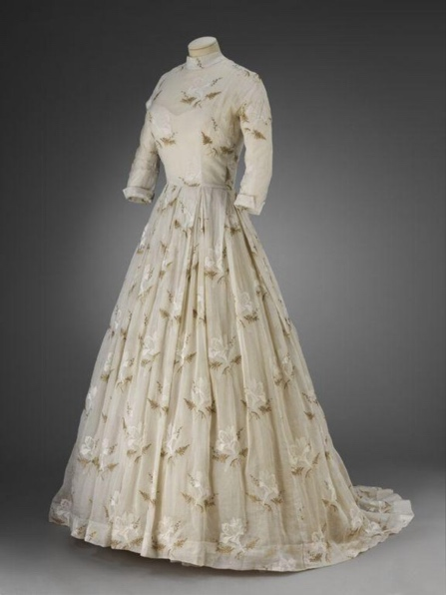

Fig 2. Wedding Gown, 1952-3 (made)

Jane Stoddart’s gown was exhibited within Dior in Britain

Photograph courtesy of V&A Archives

Source:https://collections.vam.ac.uk/item/O1460276/wedding-gown-wedding-gown-dior-christian/

Of these objects, the ones that struck me as the most influential were those related to Britain's general public, magazines and prints of the everyday woman, not just those with celebrity statuses wearing Dior. One of these key objects on display was a wedding dress lent to the museum for the exhibition by a woman named Jane Stoddart (fig 2.). At age 19, she wore this gown for her wedding day in St John’s Wood Church in 1953 and was photographed wearing it at her childhood home in Stratford Place in London (V&A, 2019). Both the dress and wedding photographs were on display in the same space that held the gown designed for Princess Margaret’s 21st birthday, thus providing a connection to those who felt brands like Dior were out of their reach and only accessible to the English aristocrats, cementing the connection between Dior and Britain by showing that anyone could own Dior and be part of this relationship.

Both of these spaces within the exhibition present this Dior utopia to the visitors, highlighting the brand's signature looks and showing the human connection Dior had with its consumers, aristocratic or not, thus painting a pleasing picture of Dior and his fashion house’s relationship to the immediate audience, the people of Britain. This exhibition narrative is clearly defined from start to finish, through the exhibition's title to the contextualisation alongside exhibits, educating visitors of the lens they are to look through to engage with the information presented to them.

The second exhibition I analysed was Fashioning Masculinities: The Art of Menswear, one of the more recent private exhibitions hosted by the V&A, which ran from mid-March to early November of 2022. I attended this exhibition twice in May of 2022, attempting to garner a different experience each time. Unlike Dior, I attended this exhibition while researching for my thesis, thus giving me a more critical framework from the onset, meaning I had to place myself in two minds throughout my experiences to have a less narrow frame when experiencing the space. Friends accompanied me the first time as I wandered around the space, trying to push my recently acquired analytical frame out of my mind and experience the space as a more casual but interested visitor. On my second visit, I went alone, spending over three hours wandering the space, going back and forth between exhibits and breaking down how the space communicated its overarching narrative.

Interestingly, on both my visits, I noticed similarities between visitors, a lot of which consisted of well-dressed young men as well as many others positioned in front of exhibits deep in conversation that, upon passing, sounded deeper than simply commenting on whether they liked what they saw or not. The audience attracted to this exhibition appeared to consist of those already interested or familiar with the content placed before them, which aligns with the idea that museums and exhibitions reflect the ruling Hegemony of society and provide environments to discuss relevant objects or politics.

The exhibition, co-designed by curator Rosalind McKever and founding director/head of JA Projects Jayden Ali, was a deep dive into how masculinity has been represented in fashion throughout history and where these ideas of masculinity are delineated from. This new mode for exhibiting menswear in the V&A offers some explanation and an opportunity for discussion for the visitors on the topical affair that is masculinity and its representation in our society today. As well as exploring masculinity, this exhibition also dealt with the representation of the male form, both marginalised and idealised, throughout its narrative in a variety of ways, from Greek and roman marble sculpture casts of muscular gladiators to photographs of disabled and queer bodies of all shapes, sizes and ethnicities. This allowed the visitor to see how far the concept of masculinity stretches and prompted them to look outside their preconceived ideas. As highlighted, the subject matter and framework posed to the visitors are situated within the cultural Hegemony of our society and are particularly pertinent today. The V&A's usual mode of presenting fashion exhibitions in the past has been about the designer of a particular brand and the evolution of the fashion house, as seen in previous exhibitions including, Balenciaga: Shaping Fashion (May 2017-Feb 2018) and the highly acclaimed Alexander McQueen: Savage Beauty (March-Aug 2015). However, for Fashioning Masculinities, the approach is more focused on the culture and evolving Hegemony that circulates masculinity and its representations through fashion as opposed to the clothes alone.

This is demonstrated clearly from the start through the first exhibit. The visitor is presented with ‘Ensemble’ (p 14, fig 3.), a deconstructed piece by London designer Craig Green from Spring/Summer 2021 collection. Here, Green is taking traditional tailoring and re-sculpting it with energy and emotional intensity. He hangs a metal frame with a different shirt, jacket and trouser components to suggest the potential for reconfiguration and an infinite scope of possibilities for menswear. The design embodies the exhibition's message; menswear can be and do anything. The symbolism of this image will resurface as a constant motif throughout the exhibition, consciously or unconsciously, when encountering the exhibits. Accompanying this striking exhibit is a piece of writing, courtesy of the V&A, summarising the questions they are exploring and want to share with their audience;

“Do Clothes make the man?

For centuries, masculine fashion has been a vital mechanism for imposing conformity or expressing individuality. Through sculpture, paintings, photography and fashion, this exhibition charts the shifting modes portraying masculine style: shaping bodies, flaunting status or wealth, constructing or deconstructing tailoring norms, and ultimately revelling in beauty.
Today, a period of unprecedented vitality in the men’s fashion industry is coinciding with a wide reconsideration of gender identity and action on equality. From the runway to the street, the red carpet to Instagram, makers and wearers inspired by art history and a range of fashion cultures are seeking liberation from limited models of masculinity.
Now we invite you to stride, saunter or sashay into a world exploring and celebrating how designers, tailors and artists, clients, models and sitters, fashion and refashion masculinities.” (V&A London, Kensington, 2022)
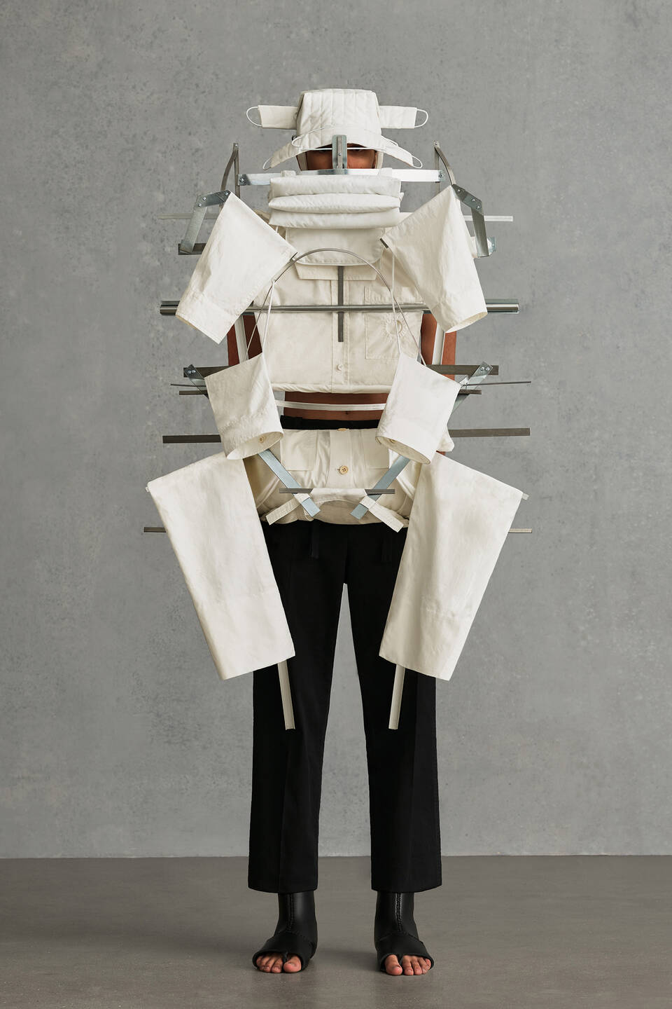

This piece by Green and the accompanying quote surmise the purpose of the exhibition, which is to explore menswear and its ability to break down masculinity throughout history and its relation to the evolving views surrounding masculinity’s representation within contemporary cultural Hegemony.

Fig 3. Ensemble, designed by Craig Green for Spring/Summer 2021 Collection
Photography by Amy Gwatkin,
Source: https://www.vam.ac.uk/exhibitions/fashioning-masculinities-the-art-of-menswear

To conclude this chapter, it is apparent that these exhibitions and the frameworks they have been presented and curated in demonstrate how cultural Hegemony influences the museum spaces in its curation of the objects they hold and the questions they pose to them, and therefore influencing the views and challenging the opinions of the visitors. Exploring and applying the social theories established by Lefebvre (1991) and Bourdieu (1979), I gained a deeper understanding of how the societies we live in demonstrate the impact of those in power. From my particular frame of the study, cultural spaces, i.e. museums and exhibitions, it became clear that those who dominate the Hegemony can reflect their ideas and beliefs through these spaces through the presentation and contextualisation of the objects within them. These social-cultural spaces are integral to the formation and affirmation of said Hegemony as they present the dominant classes' ideas in a visual and digestible way for their audiences to connect and interact with, allowing the general public of society to engage with these ideas on a more personal level as opposed to in previous times when this, now widely available knowledge, was only accessible to the elites of society or then through museums that were not transparent about the narrative lens they posed on such information and objects. Nowadays, museum transparency makes visitors aware of the lens applied to the objects within these spaces, making it clear that this is not the only perspective to observe these objects and information within. Nevertheless, museum spaces still allow visitors to enter a contextualised environment to engage with the information, thus expanding the horizons of those who visit.

CHAPTER TWO
Designing Effective Exhibitions for the Visitor Experience

When we enter museums and galleries, we are often struck by the presentation of the spaces consciously or unconsciously. From the moment of entry, these spaces are already shaping our experience, whether or not we have directly interacted with the objects or exhibits of interest. Museums as spaces require engagement to succeed; they need inquisitive visitors who are, on a level, interested in discovery and information. How they encourage this engagement and intrigue, depends on the presentation of their exhibits and the environments, physical or conceptual, as this provides a means for the visitors to enter into the world of these objects and connect with them. Design is an integral key for creating this path of entry for visitors, as it can communicate with more or less complexity how they should perceive and view these exhibits.
For this chapter, I will continue our journey through the exhibition and museum space, analysing it from a design perspective and how the use and effectiveness of exhibition design influence the visitor experience of the space and the exhibits. When discussing how visitors experience museums and the importance of design as a mode of communication, I will draw drawing from the work of the design-led education specialist and assistant professor of the University of Canberra Australia Tiina Roppola’s visitor-centred research book “Designing for the Museum Visitor Experience”, where she breaks down the museum space concerning its relationship to the visitor's interactions with it and within it. She explores the internal processes of the visitor's perspective on these spaces and their expectations and approaches to understanding and interacting with them. This gives us critical insights into the importance of including the visitors in the design conversations when approaching these spaces. Then, for breaking down the design techniques implemented into exhibitions and what has been discovered as more or less successful, I draw on Stephen Bitgood's "Designing Effective Exhibits: Criteria for Success, Exhibit Design Approaches, and Research Strategies" and applying them to my exhibition case studies, Christian Dior: Designer of Dreams as well as Fashioning Masculinities: The Art of Menswear, from the Victoria and Albert Museum in South Kensington London, alongside Roppola’s analysis of visitor frames and how they influence the visitors perspective of exhibitions they attend. By exploring these studies and relating them to my own experiences of these exhibition spaces, I want to discover more about what makes an exhibition space more or less successful from a design perspective.

2.1 The Visitor Experience

Designing museum spaces for visitors to enhance their experience is crucial when creating influential exhibitions. The purpose of exhibitions and museums is to provide a curated space that contextualises objects within specific frameworks, varying from historical, social and scientific and outlines to the visitor what these frameworks are. As discussed in chapter one of this thesis, Cultural Hegemony and its influence on the Museum/Exhibition Space, museums are cultural spaces that provide an opportunity to reflect objects within a narrative in connection with the cultural Hegemony of that area. This form of mediation positions exhibition design as stagecraft, meaning that “museums as fabricated stages, performance spaces for pedagogical and political purposes” (Roppola, 2013, 2 Exhibition Design as Mediation section) and, by their very nature, are staged spaces which are highly curated to persuade the visitor of the framework they are placing on a set of objects. This naturally comes with ethical responsibility for the museum; as discussed in the quote below, museums have an obligation to communicate their stage crafting and narratives to those who visit them to provide transparency to their visitors on the objects and issues being discussed within museums. These cultural spaces' role is to educate and inspire those who visit them, not to abuse their power and subjugate those who visit one way of looking.

“If many museumgoers are not in a position to analyse both the contents of a museum and the frameworks of persuasion staging it, then museums are custodians not only of artefacts but also of power” (Preziosi and Farago 2004).

I discussed how cultural spaces are a social product cultivated by those in power, the dominant class, to represent their ideas and beliefs as they have greater access to knowledge and wealth ( Lefebvre, 1991, Bourdieu, 1979). As museums have evolved, the mediation of the exhibits and their frameworks have become more recognised so that the visitors who engage with these spaces and objects understand that the presented stance is not the only lens to observe the objects through.
With the development and evolution in exhibition design, the presentation of exhibits within the space has moved more towards creating an immersive experience for the visitors rather than simply displaying them as they are without a contextualised framework (Roppola, 2013, 3 ‘Experience’ in Museums). In Roppola’s (2013) research, the visitor expectations of space are expressed through what she has named the process of framing that she derived from her study. “Framing”, as she calls it, is the mode people either bring with them/acquire or expect when interacting with museum and exhibition spaces. In her chapter on Framing, she discusses the types of “frames” she encountered throughout her interviews, categorising answers participants gave her relating to their own experience and expectations of the museum. The three categories she formulated based on the participant's answers were; Institutional Frames, Reframing and Exhibit Frames (Roppola, 2013, 5 Framing Section). Each of these headings contains several sub-headings; for example, within Institutional Frames, she focuses on a sub-frame dubbed the “Displayer of Artefacts Frame”, which derives from visitor's expectations to see authentic objects within museums, “I think the value of the museum is that there are real pieces there.”(participant answer, Roppola, 2013, 5 Framing Section). Her frames provide insight to those designing and curating museum and exhibition spaces, as they can gain a more representational idea of what the visitor wants and expect to see within these spaces. By knowing this information, designers can either lean into or away from this framework, depending on the experience they wish to provide for the visitor and what makes for effective design choices. As this chapter progresses, I shall reference and discuss the other existing frames created by Roppola (2013) as they relate to the case study exhibitions of the V&A and affirm Stephen Bitgood’s “Designing Effective Exhibits: Criteria for Success, Exhibit Design Approaches, and Research Strategies”.

2.2 Approaching the Design

When researching “what makes for effective exhibition design?” there is little to discover regarding the theory and evidence behind what makes an exhibition successful from a design perspective. Most books and journals detail the physical process of constructing and planning the design of exhibitions but do not include supported evidence of visitor satisfaction or how to create an exhibition that effectively immerses and educates the visitors. When creating museum and exhibition spaces, involving the target audience in the design conversation is integral, as their opinions and experiences can significantly improve the design strategies necessary when creating immersive experiences. As stated previously, museums have evolved from encyclopaedic formats. They now require a more discerning narrative to engage with the visitor and pique the interests of those unfamiliar with the content being presented to them (Roppola, 2013, 3 'Experience' in Museums).
Bitgood's (1994) criteria for success give us insights into how to create an effective exhibition space that immerses the visitors in the content being presented to them. The primary focus of his research is how the visitor interacts with an exhibition space, what exhibit design techniques have been proven most effective, and how one may reproduce such effects. Bitgood (1994) breaks effective design strategies down into three sections; Criteria for Success, based on visitor measures and critical appraisal; Exhibit Design Approaches, how and to what end one designs and curates the exhibits and the space they are presented in; and lastly, Research and Evaluation Studies, where he suggests quantitative and qualitative research strategies to gain better insight into how visitors reacted and engaged with the spaces themselves (fig 21.). His analysis relating to his Criteria for Success and Research and Evaluation Studies both heavily rely on feedback from both visitors, critics and experts alike, examining either publicised opinions and examinations of hosted exhibitions or directly engaging with visitors to discuss their thoughts and experience (Bitgood, 1994, 12-14). From my engagement with his criteria and the fieldwork by Roppola (2013), the most effective assessment method is direct engagement with the visitors, preferably as they interact with the spaces and are unaware of being observed. This type of study allows researchers to see for themselves how the visitors behave in the space and interact with the exhibits, such as stopping and reading, which gives insight into the holding/viewing power of the exhibits as well as pointing at and discussing the exhibits with their fellow museumgoers, demonstrating direct engagement with the exhibit as opposed to passive viewing (Bitgood 1994, Roppola 2013, 5 Framing Section).
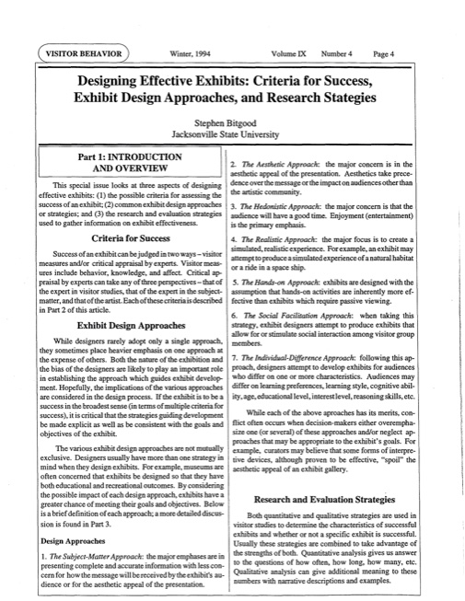
Fig 4. Stephen Bitgood’s “Designing Effective Exhibits: Criteria for Success, Exhibit Design Approaches, and Research Strategies”, 1994, page 4

In addition, the benefits of having a discreet researcher observing and then interacting with the visitor after they have experienced the exhibits allow a more authentic interaction as unknowing participants are not as performative as those who are aware of their observation. Visitors who engage in museum studies may make claims about their experience, for example, state they read all museum labels and guides but, in fact, did not, thus creating inaccurate results that designers and curators require to produce effective experiences for their visitors (Bitgood, 1994, 4). Accurate results relating to visitor interactions with the space and their experiences allow exhibitions and museums to create spaces more effectively based on the types of visitors they wish to attract and their goals for the exhibition.
When discussing the most efficient approaches to exhibition design, Bitgood (1994) breaks these approaches down into three core categories. Firstly, the Subject Matter Approach; comprises a design approach primarily focusing on exhibiting the objects as informationally accurately as possible with little regard for the aesthetic and contextual presentation of this exhibit itself; the priority is relaying the object's message. Next is the Aesthetic Approach; this approach is the opposite of the subject matter approach, prioritising the overall aesthetic appeal of the exhibit while potentially disregarding the subject and the message it is trying to convey. Finally, the Hedonistic approach prioritises a fun and entertaining experience for the visitors, with little regard for the learning and educational aspect of the exhibits. While all of these approaches have been documented as effective, Bitgood (1994) stresses the importance of understanding the goals of the experience and exhibition and that the approach chosen should entirely depend on the outcome desired for the experience. He suggests a balance of more than one approach, as overemphasising or neglecting an approach may result in an ineffective or less successful experience for the visitor (Bitgood 1994, p 4). Knowing what approach to apply when designing and curating an exhibition should be influenced by the types of audience the museum is trying to attract as well as what this audience's expectation of the space entails (Roppola, 2013, 3 ‘Experience’ in Museums). When approaching the design of an exhibit, Bitgood (1994) refers to studies by other scholars examining the concreteness and immersive nature of exhibition spaces, namely that of Bob Peart (1984), the impact of exhibit type on knowledge gain, attitudes, and behaviour. Curator, 2, relating to their analysis of the effectiveness of dioramas and multi-layered media in exhibition spaces. Peart (1984) examined exhibits on a scale from concreteness to abstraction, meaning he classified pure concrete objects as "three-dimensional" versus pure abstract objects as "one-dimensional". The scale of concreteness varied from pure concrete to purely abstract; the variable is either the existence or absence of context, meaning the presence/absence of labels, sound and accompanying imagery. From his study, he found that the most concrete object, the exhibit featuring the multi-layered contextualising media, to be the most effective way of exhibiting the object from a visitor experience perspective (holding power, viewing time and knowledge gain) (Peart, 1984, 220-237 and Bitgood, 1994, 8). This study is further reinforced by the research of Roppola (2013) when analysing the frames within Reframing, such as the Interpretative Media Frame, which essentially breaks down the effectiveness of having a multi-media layered exhibition. In this interaction with the visitor,
"I think it is more in-your-face. Yeah. Whereas before it was all behind glass. Not that you can touch, I guess, here either, a lot of things, some things you can but generally everything was cordoned off . . . New design, new techniques, new technologies has made it more interesting, more appealing." (Roppola, 2013, 5 Framing Section)
Roppola highlights how the visitor qualifies his description of the absence of glass, stating that while he knew this meant that the objects still could not be handled despite being physically more accessible, the exhibits felt less 'removed' and invited a more intimate interaction. To continue, she references the Explanatory Frame, which falls into the category of Exhibit Frames, where she infers from her visitor participant interviews that while visitors can have an appreciation and enjoy the aesthetic appeal of an exhibit, they felt frustrated by a lack of informational contextualisation. The following are excerpts from the interviews conducted concerning this framing,
“There was a whole lot of objects, a bit of a collage without much explanation that begged for a bit. . . . [W]hats this piece about; why is that piece there? . . . [A] little bit of a story behind them would have been useful.162I guess it’s the question why they would be there without any real explanation . . . What is in here? What is in there? Without any explanation I think it would be better not here. It raises questions that aren't going to be answered.163”(Roppola, 2013, 5 Framing Section)
“There are some displays I don't like here . . . they're trying to be too artistic. Do you know what I mean? Like a museums a museum and, yes, you've gotta make your displays look good, but not at the expense, I think, of information.168”(Roppola, 2013, 5 Framing Section)
These visitor interactions further highlight the need for understanding the expectations of your audience from both a learning and enjoyment aspect, as failing to understand and incorporate the necessary elements can lead to an unfulfilling and unsatisfactory experience.

2.3 Assessing the Design
After establishing what makes exhibition spaces more or less immersive from a visitor's perspective in theory, I wanted to apply these theories to contemporary exhibitions I myself have experienced as a visitor. The private exhibitions of the V&A in South Kensington, London, in my personal experience, have always been excellent experiences, leaving me more informed about the topics discussed and thrilled by the settings in which they are placed. The curators design choices hugely influenced their ability to communicate the object's history and contextualise them within the space. The exhibitions I will discuss are fashion-related, but their narrative and design presentations differ significantly. The Christian Dior: Designer of Dreams exhibition was a more traditional mode of the V&A, as I learned from the course Principles of Exhibition Making, in the sense that they chose to break down the evolution and accomplishments of a fashion house alongside the established designer of said house. This is seen throughout the space; the visitor is brought right through, from Dior's beginnings as an individual and the creator of the house to the houses' success and evolution beyond the designer, right through to Dior as we see it today. This exhibition style aims to give a rounded impression of both the designer and the fashion house. Moving onto Fashioning Masculinities: The Art of Menswear, we are presented with a thematic narrative discussing the representation of masculinity and the masculine body through fashion, more specifically, menswear. This exhibition, unlike Dior, uses the objects within to examine a general discussion in society today. This was acknowledged during the V&A course I partook in as they highlighted how this exhibition style was new for the V&A. The narrative placed on these objects reflects the cultural Hegemony of society today, as conversations and representations of masculinity and sexuality have never been more ubiquitous. Museums using their physical spaces and reputation as holders of historical and valued objects to reflect meaningful discussions today demonstrate their importance within contemporary society. By providing environments for people to discuss the politics of our society, they are endorsing the cultural Hegemony of said society. To examine the exhibitions highlighted above, I shall reference and discuss the frames and arguments created by Roppola (2013) and implement Bitgood's (1994) research and design strategies as I progress through each exhibition.
When examining the Dior exhibition, the immediate design choice that stood out to me was the aesthetic approach prioritised by the designers. Throughout the exhibition, the design and presentation of the objects fuelled the 'exquisite' Dior-inspired utopian narrative. This design choice engages not only with the thematic concerns of the exhibition, the success and life of Dior as well as his relationship with Britain but also engages and accentuates the subject matter on display. As Bitgood (1994) discusses, the culmination of design approaches is the ideal mode to design within, as the educational integrity of the exhibition is kept, as well as highlighting its subject matter.
Fig 5. V&A ‘Christian Dior: Designer of Dreams' installation view.
Photography by Adrien Dirand
Source:https://www.wallpaper.com/fashion/christian-dior-designer-of-dreams-opens-victoria-and-albert-museum

The initial exhibit presented to the visitor at the exhibition's entrance is one of the many examples throughout the space that provides this aesthetic and subject matter balance. The Bar suit, as pictured above (fig 5.), is presented in a pentagon-shaped glass case in the middle of the room, allowing it to be viewed in the round. It is accompanied by more modern renditions of the suit, created by successive creative directors of Dior, along the wall behind displayed at two-storey elevations. Its elegant, monochromatic composition reflects the subject matter within the space, heightening the experience for the visitor compared to if they viewed this subject alone against a muted backdrop. The purpose of selecting the Bar Suit as the first exhibit for the visitor to encounter is to set the tone for how the visitor will approach the rest of the exhibition. As they continue through the exhibition, they relate to what they were introduced to and how they should view the exhibits in front of them (Roppola, 2013, 1 Envisaging the Discipline). The importance of silhouette and the female figure, what the New Look collection meant for Dior moving forward with his designs, all of these musings only come about if you set them up for consideration. These ideas may never occur to viewers who see these pieces in an alternate context. However, setting them up in this specific format as a designer and curator allows the visitors to explore a thought process you have set up for them to contemplate. This is the ultimate goal of an exhibition, to present the subject matter in a form that presents information in a way that allows the viewer to come to informed conclusions and reasonings.
Another prime example of the subject matter being accentuated by the design aesthetics of the space is in the seventh section of this exhibition, where the visitor is presented with The Garden exhibit (Fig 6). This exhibit centres on floral-inspired haute couture pieces by Dior, the design inspired by Dior’s floral fragrance collection we see within the same exhibit. Here, the subject matter and aesthetic approaches are working in tangent to create a more contextualised experience. The aesthetic design of this space is inspired by the subject matter, primarily the perfumes, which we can see exhibited behind glass in a case on the left of the image. The laser-cut paper flowers are primarily jasmine and roses, representing the core notes of Dior’s initial fragrance collections. As well as the hanging paper flowers demonstrating the subject matter of this space, we also see it in the floral-inspired gowns and dresses created by Dior. Also, in the fragrance case is a selection of photographs and prints of those who inspired Dior and helped create these fragrances. The subject matter is reinforced by the aesthetic appeal of the space, allowing the information to be effectively communicated both visually and through the descriptive labels, demonstrating the importance of balancing and combining design approaches as required in order to create a more immersive visitor experience. To add, from another immersive design standpoint, having a selection of the couture presented in the open invites a more intimate relationship with the visitor as there is no physical barrier between them, as observed through Roppola’s (2013) interviews with visitors when examining visitor frames (Roppola, 2013, 5 Framing Section).
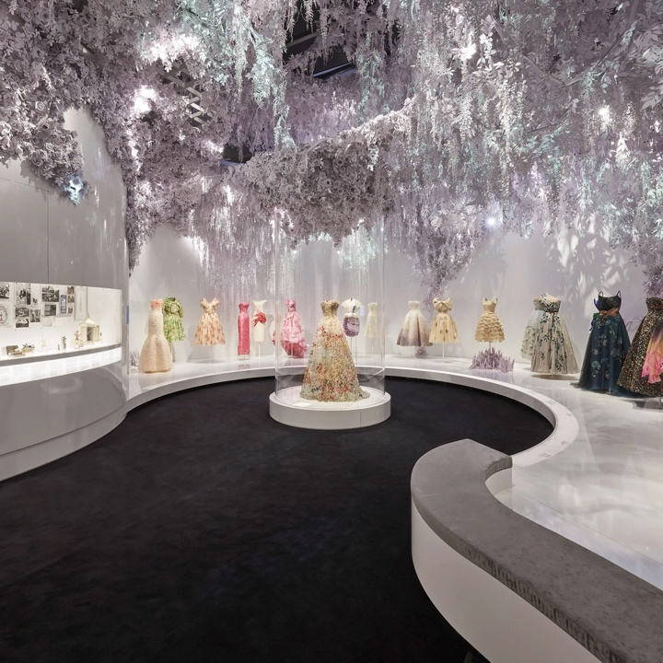
Fig 6. Christian Dior: Designer of Dreams, The Garden
Photography by Adrien Dirand
Article by Charlotte Davey, 2019
Source: https://www.cntraveller.com/gallery/christian-dior-at-the-victoria-albert-museum

As the visitor moves through the exhibition, the transitions between different concepts and subject matter are made clear through changes in the design; this is demonstrated through the choice of colour schemes and decorative elements, as seen in fig 6., The Garden Section, and the clear labelling of the space. While this may seem like a minor part of the exhibition, providing clarity and correctly contextualising the objects within the exhibits is crucial for the visitors to understand better the material they are interacting with. As Roppola (2013) highlights, when discussing visitor frames, the contextualisation of exhibits allows the average visitor to properly engage with the subject matter (Roppola, 2013, 3 ‘Experience’ in Museums). This is why gaining feedback from both experts and visitors is vital to creating an accessible exhibition space; if we created exhibitions designed solely for the experts of the field, then it would make the exhibition relatively inaccessible for the majority of the visitors who encounter it (Bitgood, 1994, 5-6).
The layering of multi-media in exhibition spaces is another technique and engaging frame that is demonstrated throughout this exhibition space, as highlighted in the fourth section of the exhibition. Dior in Britain explores Dior’s fascination and relationship with British, primarily English aristocratic culture. Here, a showcase of designs, photographs, prints and objects are displayed, all highlighting Dior’s mark on British fashion and beauty, as well as a selection of gowns and other ensembles, three of which are highlighted in particular (Fig 7).
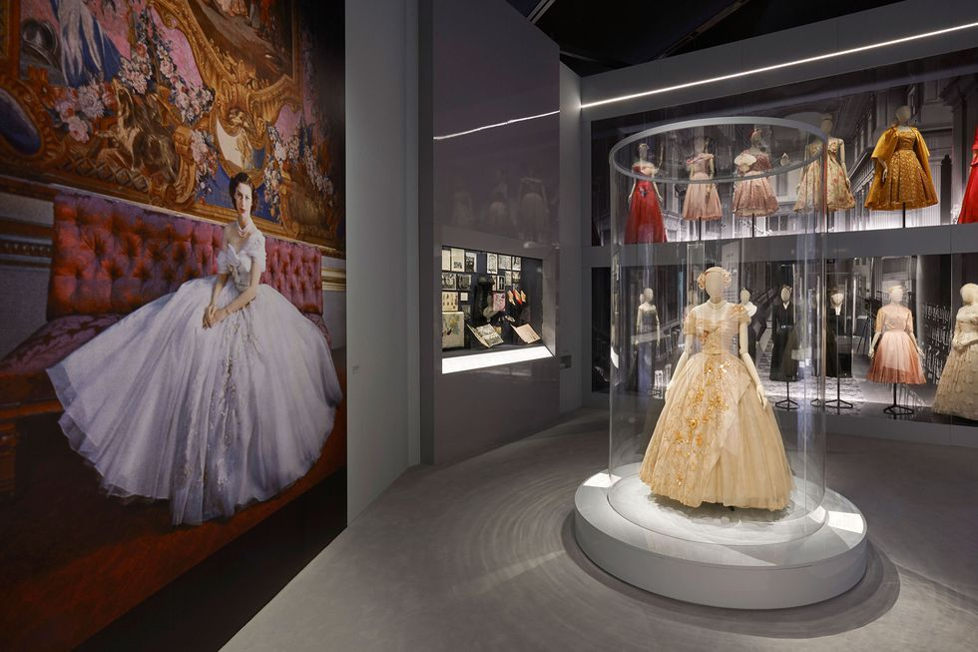
Fig 7. Christian Dior: Designer of Dreams, Dior in Britain,
Photography by Harper’s Bazaar, article by Amy De Klerk
Source: Source: https://www.harpersbazaar.com/uk/fashion/fashion-news/a28895674/christian-dior-designer-of-dreams-most-visited-exhibition-v-and-a/

The first is Princess Margaret’s 21st birthday gown, presented in the centre of the room in the cylindrical glass casing to be viewed in the round. She topped his prestigious list of clientele and remained there for many years. As well as having the visitor presented with a full 360-degree view of this piece, there is also a photograph of the royal in the ensemble blown up to a large scale on the opposite wall. Secondly, we are presented with a black and white skirt suit ensemble in the glass casing beyond the glass cylinder known as Nonette. This suit was modelled by Jean Dawnay, one of Dior's core English models, for the haute couture spring-summer 1950 Verticale line at the Paris salon and later at Dior's first London show held at the Savoy Hotel in April 1950. Like Princess Margaret's dress, the visitor is presented with the piece itself and accompanying photographs and labels breaking down this classic piece. Finally, the third piece of importance and relevance in this part of the section is a wedding dress designed by Dior that was lent to the museum by a woman called Jane Stoddart. She had worn it for her wedding day and was accompanied by various photographs of her wearing it at her wedding. The contextualisation of these exhibits through the presentation of varying forms of media adds significantly to the viewing and processing experience. The visitor is presented with these links to the goals of this section, Dior's relationship with Britain. On top of these signature pieces, we are presented with ordinary women's magazines of the 20th century featuring Dior's beauty and fashion products. Again, alongside these magazine columns and images is information about their relevance in the exhibition, that being that Dior was for any aspiring woman. As stated by Oriole Cullen during a live session where she broke down and discussed the curation and design of the space, "If you cannot afford the haute couture, you could afford a lipstick or a perfume", further highlighting how Dior was made more accessible to the women of Britain. According to Bitgood's (1994) criteria, this multi-layered medium space consisting of three-dimensional objects, labels and other print media should provide an engaging and immersive experience for the viewer.

Moving onto the exhibition Fashioning Masculinities, as a visitor, the exhibition's narrative became more apparent as I journeyed through the space, compared to the chronological sequence of the Dior exhibition. In Dior, the narrative set up is made clear from the start; the visitor is presented with the Bar Suit, the quintessential emblem of the brand, as well as the biography of the designer, suggesting we are starting from Dior's roots and all that is to become of the famous house he is destined to create. Fashioning masculinities, however, is presented under a different design narrative. The theoretical framework of the exhibition is examining the evolution, fetishisation and celebration of masculinity through menswear as opposed to presenting a linear narrative on the development of menswear alone. This narrative framework is presented in three sections, Undressed; the initial space the visitor enters, Overdressed; the second section, and Redressed; the final main section of the exhibition before we reach the finale. The sections are differentiated from each other through the subject matter of each space and the design aesthetics. The aesthetic design approach follows the subject matter of each section, reflecting the ideas the visitor is engaging with.
In Undressed, the design and curation of this space are wholly intertwined, the surrounding monochromatic colours complimenting the objects within the exhibits as well as the dressed mannequins and sculptures' arrested motion being intensified by the spotlights and highlighted by their elevation on plinths. These factors add strength to objects and bring them to life, making for a more immersive experience for the visitor. In “The Actor in Costume” by Aoife Monks, the ghostliness of costume is examined, and how once we see the costumes off-screen or on stage, we realise how it is not the clothes themselves that are the costume but the context it is surrounded in as well as the wearer (Monks, 2009, Epilogue). The dynamic design of the exhibits in Undressed brings these objects to life and allows for connection with the viewer, creating a more immersive experience.
As the visitor moves through the space, they are presented with classic idealised forms of masculinity in the sculpture casts and several of the mannequins in contrast to film pieces showing varying able and disabled bodies of size, colour and orientation and mannequins of varying shapes. These exhibits present how these idealised Greek and Roman forms have permeated European Fashions for the masculine body and have set these unrealistic beauty standards for men to grapple with. Contemporary fashion has made underwear increasingly visible over time, like the body. The undressed masculine body today is under great scrutiny from creative industries, breaking down its history and now, in many cases celebrating its diversity, seen in the selection of objects within the exhibits. The things and media range from garments, sculptures, photographs and prints to films of dance sequences, as seen in fig 8. As highlighted previously when discussing Dior, having a multi-media representation with exhibition spaces allows for a more engaging experience for the visitor and caters to those who may not enjoy attaining information purely from labels next to objects (Roppola, 2013, 5 Framing section).

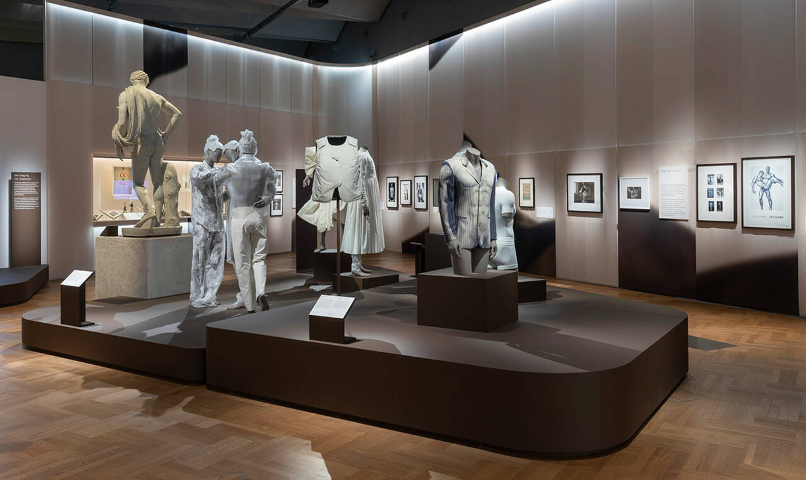
Fig 8. Undressed, Installation view of Fashioning Masculinities, V&A London
Source: https://www.vam.ac.uk/articles/inside-the-fashioning-masculinities-exhibition

A shift in aesthetics is immediately apparent in the next space the visitor encounters. Leaving the sombre monochromatic mood of Undressed, the visitor turns a corner and finds themselves in an entirely different space. Overdressed, the next section of the exhibition, is the polar opposite of the encounter just experienced by the visitor in Undressed. The aesthetic approach of the space is vivid and flamboyant with its choice of bold colours of green and blue with gold gilded frames and wallpaper patterns. Like the previous one, the subject matter in this section draws on masculinity. However, in Overdressed, flamboyance and wealth are the primary subjects for masculine presentation. The subject matter consists of gowns, coats and suits, all of which reflect the design setting they are displayed in. Again, the aesthetics of the space accentuated and reaffirmed the framework being posed on these subjects. (Bitgood 1994).
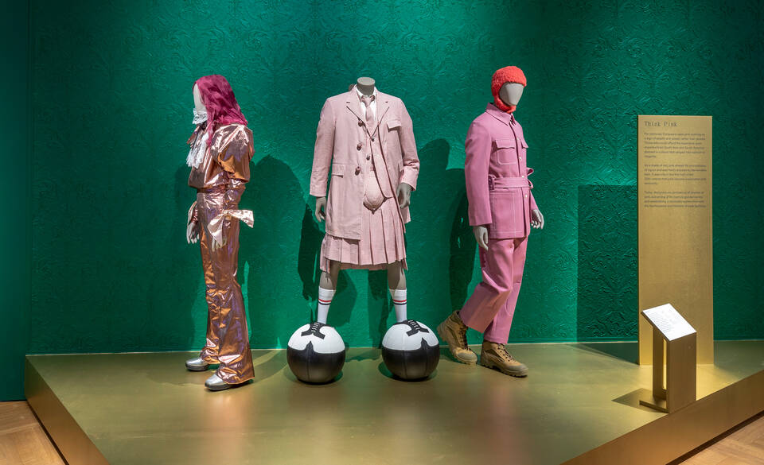
Fig 9. Overdressed, Installation view of Fashioning Masculinities, V&A London
Source: https://www.vam.ac.uk/articles/inside-the-fashioning-masculinities-exhibition

When looking at how the objects are displayed within this section, we see a variety of exhibits both behind glass in cases and presented to us in the open. Those behind glass are done to protect more fragile pieces and materials, but those in the open are raised on gold plinths and are more tangible for the visitor. Here, the importance is highlighted for the designer and curator to collaborate in presenting the objects as some need to be protected. Still, the objects also need to be seen and allow the audience to interact with them. By mixing case items and those in the open, the visitor is invited to be more engaged with certain pieces than others but can still appreciate those behind glass.
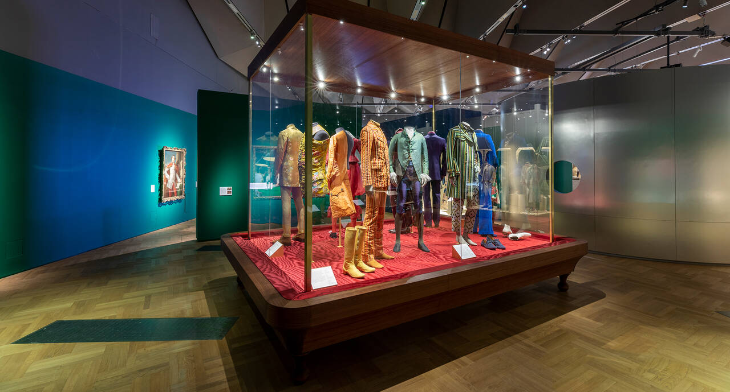
Fig 10. Overdressed, Installation view of Fashioning Masculinities, V&A London
Source: https://www.vam.ac.uk/articles/inside-the-fashioning-masculinities-exhibition

The final section of the exhibition is Redressed. Here we encounter a whole new environment once again. The visitor is presented with a shift towards modernity in the design style of the space. The grey ombre panels, offset by the glowing orange, which is reminiscent of the colour glass turns when blown, set a contemporary mood, paired with the pixelated font for parts of the contextual writings and titles with the less embellished and more streamlined finishes of the glass cases and display units. The design choices of this space are to evoke the industrialised era of menswear the visitor will interact with (Bitgood, 1994, 7). It is the first time in the exhibition that the classic menswear item, the black suit, is presented to us. This design choice was made for several reasons. Still, the key reason is that the black suit is the most ubiquitous object in menswear, meaning if it was placed amongst the frills and colour of Overdressed or the pared-back quality of Undressed, it would have been overlooked or jarring compared to its surroundings. The visitor can better understand its design's nuances by having several exhibits dedicated to the black suit in its many forms and representations of masculinity. Visitors can compare and ponder these differences as they are all presented at one point in the exhibition. This gives the significance and attention to detail the exhibit needs to succeed. This design choice provides a more complex Learning frame for the visitor as there is more content within the same field to engage with at once, meaning there is more detail explored here, providing a more profound learning opportunity for those who want to increase their knowledge on the subject (Roppola, 2013, 5 Framing Section).

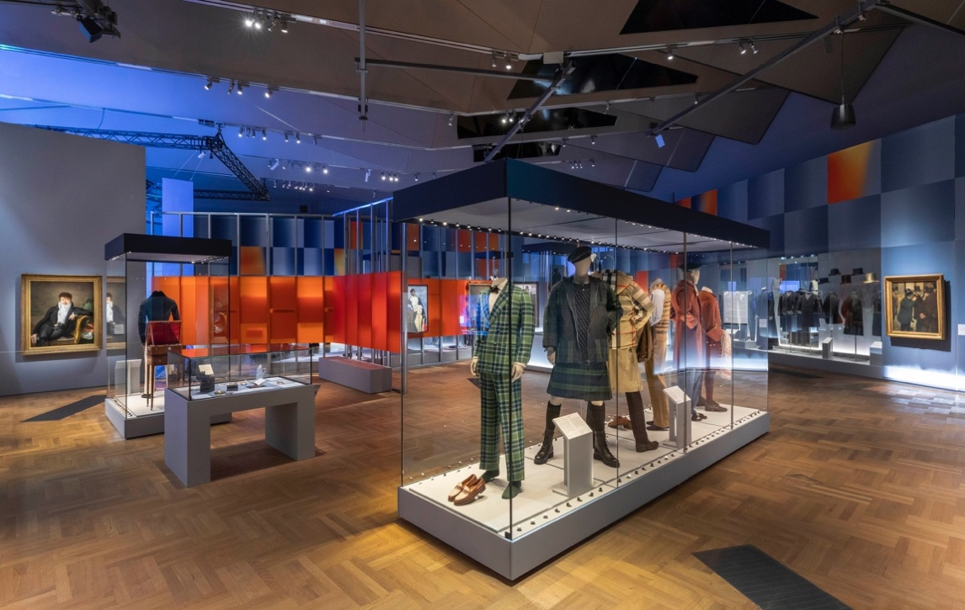
Fig 11. Redressed, Installation view of Fashioning Masculinities, V&A London
Source: https://www.vam.ac.uk/articles/inside-the-fashioning-masculinities-exhibition

Another design element present within these suit exhibits is that though they are, for the most part, placed behind glass, there are artfully placed mirrors on the back wall of the show to allow the visitor to get a complete idea of the whole suit and miss no detail no matter how small. This design consideration assists those with the frame regarding the Displayer-of Artefacts, as they can get the complete picture of the object and not feel frustrated by the design's limitations. Instead, the design and curatorial team acknowledged this issue and presented the exhibit so that this would not be an issue for the visitors engaging with the subject (Roppola, 2013, 5 Framing section and Bitgood, 1994, 4). Like in Overdressed, there is a blend of cased and open exhibits for the visitor to interact with. Some of the glass-enclosed shows are stood high above the visitor while others stand in the middle of the space allowing for the objects to be viewed in the round (fig 6). We also see a repeat of more animated mannequins similar to those first presented to the visitor in Undressed.
The exhibition's finale is theatrical and contemporary in its presentation and the subject matter exhibits of choice. The visitor exits Redressed and enters a more enclosed space than previously experienced in the exhibition and is immediately presented with a sizeable mirror-affected area with a film sequence featuring masculine bodies in various menswear. The film is in black and white, being played to upbeat music, and is dynamic and fast-paced in style. It makes for an all-consuming exit from the exhibition. In this space is one physical exhibit in the centre of the room, allowing it to be viewed in the round, featuring three gowns worn by Harry Styles, Billy Porter and Bimini Bon Boulash, as seen below in fig 7. It presents the ever-growing ever, visible gender non-conformity in the fashion world and the move towards designing gender-neutral clothing and its presence in our society. This immersive space offers the visitor a summation of all the ideas around masculinity and its representation in menswear. It allows them to look back and take in what the future of masculine representation looks like. Such an immersive experience encompassing a multitude of senses is an impactful ending to an exhibition. It leaves the visitor with solid imagery and ideas right to the very end to take away with them. The finale of this exhibition punctuates the materially distinct frame posed by Roppola. This frame's goal is to pose a series of objects in an exhibition in a way that many visitors may not have experienced before (Roppola, 2013, 5 Framing Section). It is the uniqueness of the experience that many visitors seek when they come to exhibitions like Fashioning Masculinities and even that of Dior. They are being given an experience that they cannot have anywhere else.

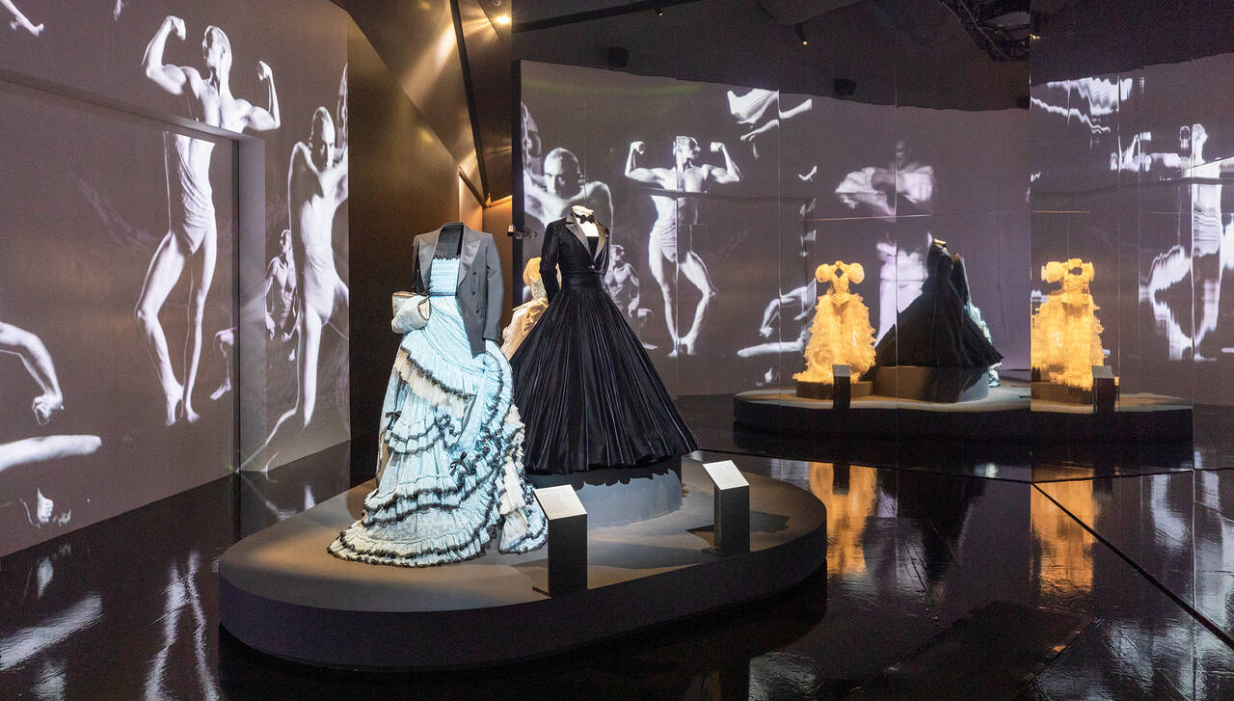

Fig 12. Exhibition Finale, V&A London
Source: https://www.vam.ac.uk/articles/inside-the-fashioning-masculinities-exhibition

This chapter has explored what it means to create a compelling and impactful exhibition experience through design for the visitors who encounter them. The importance of engaging with visitors before the conceptualising of exhibitions begins has become increasingly apparent whilst engaging with the sources of Bitgood and Roppola. To create these experiences, it is imperative as a designer to be aware of the demands and limits posed to you by the people you are creating for because if you are not making it for them, then for whom is it? The purpose of exhibitions and museums is to provide visitors with enjoyable and engaging learning experiences to broaden their perspectives and shape their opinions based on the subject matter they interact with. When designing these spaces, consideration for the visitor is pivotal to creating effective exhibition and museum spaces. Furthermore, the use of design to distinguish the narrative put in place by the museum reinforces the ethical responsibilities they hold and the importance of transparency for the visitors so to be aware of the lens being applied to the objects being presented.

CONCLUSION

From the various lines of enquiry followed in this thesis, the relevance of considered visitor-oriented exhibition design has been examined in a detailed and nuanced manner. While this thesis may not have garnered an exact solution to the issues surrounding how we integrate exhibition design within these cultural spaces, it sheds light on the need for understanding visitors' expectations and their perceptions of these spaces and the contents within, which may inform the manner of which these spaces are designed in future.
By exploring the social theories of Lefebvre and Bourdieu surrounding societal hierarchy and the representation of said hierarchies within the museum space, I was able to understand the importance of museum spaces and how they have the power to influence the beliefs and knowledge of members of society. Historically, museum spaces have been built and cultivated by the elite members of society, those with greater access to education and broader experiences, such as higher cultural capital (Lefebvre, 1991, Bourdieu, 1979). This gives them an inherent advantage over those with fewer opportunities and allows them to dictate both the selection and curation of objects within these spaces, thus making them a powerful tool in representing their values and beliefs, enforcing a cultural hegemony.

Furthermore, after examining the evolution of the museum from the curiosity cabinets of the 16th century to the encyclopaedic institutions during the Age of Enlightenment (Roppola, 2013, Exhibition Design as Mediation), their historical associations being environments of certainty gives contemporary museums an ethical obligation to be aware of their responsibilities to their audience. Ensuring their visitors are aware of the use of stagecraft within the museum space is crucial for their experience, as being transparent about the lens applied in the exhibition of objects informs the visitor that the mode in which they are being presented the information is but a single perspective to view from (Roppola, 2013, 2 Exhibition Design as Mediation). The exhibition case studies I created relating to Christian Dior: Designer of Dreams and Fashioning Masculinities: The Art of Menswear exhibit this use of stagecraft as the narratives within these spaces are presented through the object selection as well as the design of the space, portraying a specific interpretation of the objects to engage with. Fashioning masculinities is an exemplary example of stagecraft in an exhibition reflective of the society we live in; as discussed in chapter two of this thesis, the topic of masculinity and its depiction is a very current topic of discussion in society today, so by giving it space to be interrogated and represented within a museum space is reflective of the hegemonic influence on these spaces. Furthermore, due to the reputation and preconceived ideas about museums in society, hosting exhibitions that embody the cultural values of the society they are situated in further reinforces the message the exhibition conveys to its visitors. Briefly continuing the discussion of hegemonic power, this mode of stage crafting current affairs and historical events allows the objects and the environment to be a politically charged domain. This avenue of research, which I briefly touched on in chapters one and two, examines this area and breaks down how museums have become stages for political affairs in both contemporary and previous societies and could provide another interesting niche to explore at a later date when discussing the relationship between cultural Hegemony and the museum space. Distinguished university professor of political science in the College of Liberal Arts and Human Sciences, Timothy W Luke, discusses the representation of politics within the museum space in his book Museum Politics: Power Plays at the Exhibition, which could provide an excellent jumping-off point from this thesis to explore this area of related interest further.

After understanding how our societies not only shape these cultural spaces but also perceive them, I could examine how the design within these spaces communicates and engages with their audiences and understand the importance of the two entities' relationship with each other. The significance of visitor-oriented design was reinforced by examining the intensive visitor-oriented research of Roppola alongside the criteria assembled by Bitgood on the modes of effective exhibition design. As Roppola discusses, a large number of visitors within contemporary society come to museum spaces to be immersed in the world of the objects they are engaging with and can be left dissatisfied when presented with uncontextualised information as those who are not well versed in the area of information being presented, feel as though they lose out on the experience to learn something new or broaden their knowledge on an area of interest (3 'Experience in Museums, Visitor Experience as Multidimensional). Also, not everyone comes to museums for purely educational experiences; many come to experience something 'out-of-the-ordinary', to be excited by something new that they may not be able to see or experience elsewhere. This information is further supported by the research Bitgood carried out when creating his criteria, examining the various modes of exhibition design and breaking down what proved most and least effective, all of which were informed by interviews and visitor experiments conducted by scholars and specialists alike (1994, p 7-11). Applying Bitgood's criteria and Roppola's visitor-oriented research to my exhibition case studies, I gained a more critical understanding of each space and what design elements made them more effective as a visitor myself within the space. The use of various mediums to communicate the narrative of the space and the overall aesthetics throughout helped communicate the chosen lens effectively as I, a visitor, found the information accessible and well contextualised as I moved through the space. To add, both exhibitions, Dior mainly, were exceptionally well received by the public and press alike, as was seen through the numerous critical appraisals from the likes of Vogue magazine (2019) and Harper's Bazaar (2019), to the extent that the Dior exhibition was extended from the 14th July to the 1st September, running for a total of eight months, two months longer than previously planned. These findings all demonstrate the importance of visitor-oriented design within the museum and exhibition space, not only to assist the learning experience for visitors but also to create immersive experiences that can excite and broaden the horizons of those who visit them.
An area of further enquiry relating to the design and presentation of objects within exhibitions is the concept of ‘aura’ surrounding authentic artefacts and objects. Along this research journey, I encountered the work of Walter Benjamin, the renowned German Jewish philosopher, critic, historian, and beyond, and his book The Work of Art in the Age of Mechanical Reproduction discusses the loss of the ‘aura’ surrounding authentic artefacts due to the growth in the mass production of replicas. He claimed that with the coming age, items which previously held aura, like old masters' paintings and divine sculptures, were steadily losing it as the mechanical age of reproduction made these artefacts more and more accessible, in a sense, cheapening the experience (Benjamin, 1936 1-15). This area of study would have to be approached differently to contemporary times as the world we live in now is more accessible than ever, with all of this information in our back pockets. Examining the ‘aura’ of artefacts within exhibition spaces is an avenue of research that could be explored following this thesis. Benjamin's discussion of aura and its effect when being in the presence of an authentic item could correlate with the effect exhibition designers try to create through the presentation of objects. In chapter one of this thesis, when discussing Dior as an exquisite utopian-style design narrative, the focus is on presenting the objects within that space, which affirm said narrative. The definition of exquisite is an extreme or delicate beauty, a descriptor of either objects or emotions (Britannica, 2023). The exquisiteness of the exhibition space may be a contemporary mode for discussing Benjamin’s theories on the effect of aura, when visitors experience a fully immersed space where the authentic objects, as a collective under a design narrative, embody a sense of aura in their presentation.
Visitor-oriented design for the exhibition and museum space is integral to the exhibition design and planning process. Communicating with your audiences is crucial when creating immersive spaces for them to engage with and better understand the design requirements necessary for creating the said experience. Considered design can efficiently communicate a narrative and contextualise objects within spaces for the visitor to engage with as easily as ill-considered design can do the opposite. These cultural spaces must guide their visitors through the chasms of information and artefacts, presenting them with accessible mediums and contextualising them within the space, so they can get the most out of their experience and not be left indifferent by them. Museums have the power to influence, educate and inspire; including everyone in creating these spaces, from the designer to the consumer, is imperative when creating effective immersive experiences.

WORKS CONSULTED

Bibliography

Allen, D and Anderson, P. (1994) "Consumption and Social Stratification: Bourdieu's Distinction", in NA - Advances in Consumer Research Volume 21, eds. Chris T. Allen and Deborah Roedder John, Provo, UT : Association for Consumer Research, Pp 70-74. (Accessed: 12 November 2022)

Alexander, E. Porter and Alexander, M. (2008) Museums in Motion: An Introduction to the History and Functions of Museums. Rowan Altamira. (Accessed: 20 September 2022)

Benjamin, W (1936) The Work of Art in the Age of Mechanical Reproduction. Reprint edn. (2008), Penguin Books Limited. (Accessed: 8 February 2023)

Bitgood, S. (1994) “Designing Effective Exhibits: Criteria for Success, Exhibit Design Approaches, and Research Strategies”. (Accessed: 20th October 2022)

Bogle, E. (2013). Museum Exhibition Planning and Design. AltaMira Press. (Accessed: 12th February 2022)

Bourdieu, P. (1996) Distinction: A social critique of the judgement of taste. Cambridge, MA: Harvard University Press. (Accessed: November 10th 2022)

Brodskaya, N. (2010) Impressionism. 1st edn. Parkstone international. (Accessed: 15th February 2023)

Cardini, T. (2020). Dior’s Bar Jacket: A Brief History. VOGUE. Available from: https://www.vogue.com/article/christian-dior-bar-jacket-a-brief-history (Accessed: 17th September)

CMS College Kottayam. (2020) The Production of Space: Henri Lefebvre | Ani Merly Paul | Department of Sociology. YouTube. https://www.youtube.com/watch?v=BH-p9H43AiA). (Accessed: 15th November 2022)

Christian Dior. (2019) Christian Dior Designer of Dreams Exhibition at the V&A Museum. YouTube. Available from: https://www.youtube.com/watch?v=suIsMyZ2neA
(Accessed: 15th September 2022)

Donaldson, A. (2019) CELEBRATING AN ICON: CHRISTIAN DIOR GETS A BIG-DEAL DISPLAY AT V&A MUSEUM. Wanted. [online]. Available from: https://www.wantedonline.co.za/art-design/2019-03-05-celebrating-an-icon-christian-dior-gets-a-big-deal-display-at-va-museum/ (Accessed: 12th October 2022)

Encyclopaedia Britannica (1997). The New Encyclopaedia Britannica. Vol. 2 (15 ed.). ISBN 978-0-85229-633-2. (Accessed: 28th January 2023)

Harry Ransom Center. Norman Bel Geddes Database, Job 381, General Motors Building at the New York World's Fair, 1938-1952. Available from: https://norman.hrc.utexas.edu/nbgpublic/details.cfm?ID=307 (Accessed: 10th October 2022)

Hughes, P. (2015) Exhibition Design. 2nd edn. An Introduction. Laurence King Publishing. (Accessed: 2nd November 2022)

Impey, O and MacGregor, A. (2000) The Origins of Museums: The Cabinet of Curiosities in Sixteenth and Seventeenth Century Europe. 2nd edn. British Museum. (Accessed: 2nd January 2023)

Klerk, A. (2019) 'Christian Dior: Designer of Dreams' has become the most-visited exhibition in V&A history. Harpers Bazaar. Available from: https://www.harpersbazaar.com/uk/fashion/fashion-news/a28895674/christian-dior-designer-of-dreams-most-visited-exhibition-v-and-a/ (Accessed: 2nd September 2022)

Lefebvre, H. (1991) The Production of Space. Malden: Blackwell, pp. 1–85. (November 10th 2022)

Luke, T. (2002) Museum Politics: Power Plays at the Exhibition. 1st edn. University Of Minnesota Press. (Accessed: 28 December 2022)
Oddey, A and White, C. (2006). The Potentials of Space: The Theory and practice of Scenography and Performance. 1st edn. Intellect Books Ltd. (Accessed: 19th February 2022)

Manghani, S (2012) Image Studies: Theory and Practice. Taylor & Francis Group. (Accessed: 20th February 2022)

Marchand, R. (1992) The Designers Go to the Fair II: Norman Bel Geddes, The General Motors "Futurama," and the Visit to the Factory Transformed. Design Issues 8, no.2. Available from: https://www.jstor.org/stable/1511638 (Accessed: 10th October 2022)

McKenna-Cress, P and Kamien, J.(2013). Creating Exhibitions Collaboration in the Planning, Development, and Design of Innovative Experiences.1st edn. Wiley. (Accessed: 8th November 2022)

Mondello, B. (2008) A History of Museums, ‘The Memory of Mankind’. Museums in the 21st Century. Available from: https://www.npr.org/2008/11/24/97377145/a-history-of-museums-the-memory-of-mankind (Accessed: 20th September 2022)

Monks, A. (2009) The Actor in Costume. 1st edn. Bloomsbury Publishing. Available at: https://www.perlego.com/book/2997177/the-actor-in-costume-pdf (Accessed: 20 February 2022).

Peart, B. (1984). Impact of exhibit type on knowledge gain, attitudes, and behavior. Curator, 2, pp 220-237. (Accessed: 25th October 2022)

Roppola, T. (2013) Designing for the Museum Visitor Experience. 1st edn. Taylor and Francis. Available at: https://www.perlego.com/book/1676830/designing-for-the-museum-visitor-experience-pdf (Accessed: 15 February 2022).

Rothe, N. (2022) THIS IS A MAN'S WORLD | 'FASHIONING MASCULINITIES' REDEFINES MENSWEAR IN LONDON. FLAUNT. [online] Available from: https://archive.flaunt.com/content/fashioning-masculinities (Accessed: 15th October)

Sagmeister, S and Walsh, J (2018) Sagmeister & Walsh: Beauty. 1st edn. Phaidon Press (Accessed: 25th November 2021)

The Britannica Dictionary (2023),[online] Available from: https://www.britannica.com/dictionary/exquisite (Accessed: 24 January 2022)

Ulrich, H. (2014) Ways of Curating. 12th edn. (s.l) Allen Lane. Reprint. London: Penguin Books, 2015. (Accessed: 2nd February 2022)

Victoria and Albert Museum. (2019). Meet Jean Dawnay, Dior’s English Rose. [online] Available from: https://www.vam.ac.uk/articles/meet-jean-dawnay-diors-english-rose
(Accessed: 10th October 2022)

Victoria and Albert Museum. (2019). Inside the Christian Dior: Designer of Dreams [online]. Available from: https://www.vam.ac.uk/articles/inside-the-christian-dior-designer-of-dreams-exhibition [accessed 3 February 2022]

Victoria and Albert Museum. (2019).Q&A with Christian Dior: Designer of Dreams exhibition curator Oriole Cullen [online]. Available from:https://www.vam.ac.uk/blog/museum-life/qa-with-christian-dior-designer-of-dreams-exhibition-curator-oriole-cullen [accessed 15 September 2022]

Victoria and Albert Museum. (2022) Inside the Fashioning Masculinities exhibition [online]. Available from: https://www.vam.ac.uk/articles/inside-the-fashioning-masculinities-exhibition [accessed 15 October 2022]

Wood, E and Latham, K F. (2016) The Objects of Experience, Transforming Visitor-Object Encounters in Museums. 1st edn. Routledge (Accessed: 8th November 2022)

