

The Difference in students’ attention in online lectures versus in-person lectures.

Matthew Delaney

N00180329

Supervisor: Cliona Flood

Dissertation submitted as a requirement for the degree of BSc (Hons) in Applied Psychology, Dun Laoghaire Institute of Art, Design & Technology, 2022.

Declaration
I declare that this submission is my own work. Where I have read, consulted, and used the work of others I have acknowledged this in the text.

Signed: Matthew Delaney
Date: 31st March 2022
Word count: 4996 words

Acknowledgments
To begin, I would like to thank my research supervisor, Cliona Flood. She has offered me fantastic support and guidance throughout this entire process. Her enthusiasm and positivity has helped me to stay focused on my work.
I would like to thank Dr. Christine Horn for offering continuous support and answering any questions I had on any statistical problems. Many of the lecturers at IADT have also assisted me in completing this thesis.
Without the encouragement of my friends and family, I would have been very stressed. Thanks to them for all their encouragement and motivation. In particular my sister, Kate, who kept me motivated throughout the whole process of making this thesis. Lastly, a massive thank you to the participants that took part in this study.

Table of Contents

Abstract 1
1 Literature Review 2
1.1 Introduction 2
1.2 Divided Attention 2
1.3 Multi-Tasking and Divided Attention 3
1.4 Selective Attention 3
1.5 Attention During In-Person Learning 4
1.6 Attention During Online Learning 4
1.7 Online Learning 5
1.8 Gender Differences in Online Learning 5
1.9 Gender Differences in In-Person Learning 6
1.10 Present Study 6
1.10 Research Questions 7
1.11 Hypotheses 7
2 Methodology 8
2.1 Design 8
2.2 Participants 8
2.3 Materials 9
2.4 Pilot Study 10
2.5 Procedure 10
3 Results 11
3.1 Overview of Results 11
3.2 Descriptive Statistics 11
3.3 Assumptions of Two-Way Between Groups ANOVA 12
3.4 Inferential Statistics 12
3.5 Hypothesis 1 13
3.6 Hypothesis 2 13
3.7 Hypothesis 3 14
4 Discussion 16
4.1 Overview of Findings 16
4.2 Discussion of Findings 16
4.3 Strengths of The Present Study 17
4.4 Limitations of The Present Study 18
4.5 Implications and Future Research 19
4.6 Conclusion 19
5 References 21
6 Appendices 26
Appendix A: Ethics Form-Amber Route and Approval 26
Appendix B: Information Sheet 32
Appendix C: Consent Form 34
Appendix D: Debrief Sheet 35
Appendix E: Attention Control Scale 36
Appendix F: Cronbach’s Alpha Value For ATTC 40
Appendix G: Demographic Questions 41
Appendix H: SPSS Output 42
Appendix I: Test of Homogeneity of Variance 45
Appendix J: Tests of Normality 46

List of Tables

Table 1: How each variable was labelled and the number of participants in each group………………………………………………………………………………………….11
Table 2: Means and Std. Deviation for participants’ type of learning environment and gender………………………………………………………………………………………...11

List of Figures

Figure 1: Percentage of males and females in both groups…………………………………………………………………………...……………..9
Figure 2: Clustered boxplot of learning environment and gender based on students’ attention scores…………………………………………………………………………………………12
Figure 3: Simple bar chart of learning environment by means of students’ attentions scores…………………………………………………………………………………………13
Figure 4: Simple bar chart of gender by means of students’ attention scores........................................................................................................................................14
Figure 5: Estimated marginal means of students’ attention scores based on type of learning environment and gender………………………………………...……………………………15

Abstract

The sudden shift from in-person to online learning and the effects it may have had on student attention, is a surprisingly overlooked topic of investigation. The present study sought to explore this unexpected transition, as well as examine the potential differences between students’ attention during online and in-person lectures. A quantitative, survey design, using an online questionnaire was used to collect the data of 111 participants aged between 18 and 39 years (M=21.36, SD=2.71). Participants were randomly allocated an in-person lecture questionnaire (N=51) and an online lecture questionnaire (N=62). The results from a two-way ANOVA were used to interpret the data. The findings reported no significant difference between type of learning environments (online or in-person lectures) based on students’ attention scores. Likewise, there was no significant difference in gender (male/female) based on students’ attention scores. There was also no significant interaction between gender and the type of learning environment. Despite the insignificant conclusions, the present study offers both optimism for students’ adaption to online learning and support for student online streaming and support platforms. The strengths and limitations of the present study, as well as future research suggestions, were also considered .

1 Literature Review

1.1 Introduction
The COVID-19 pandemic has brought numerous unforeseen adjustments to a variety of sectors in people’s lives. Education is one such section. As many universities were suddenly forced to change to online learning in many cases, it was expected that the transition would carry problems that affected student learning. Notably, student attention was particularly disturbed as the learning environments of online lectures and in-person lectures present more perceptual information than can be efficiently managed. Chun et al. (2011) regards attention as a property of numerous, unique perceptual and cognitive functions. Through the addition of an overdrive in stimuli, it can lead to a failure to achieve an advancement of knowledge in these new and old educational settings (Chun et al., 2011). The process of attention has a finite capacity and as a consequence of this restricted capability, the practice involves the adaptable management of limited sources (Lindsay, 2020). As a result, the various types of attention illustrate distinctive ways of managing the information presented to students.
1.2 Divided Attention
Divided attention is a method used in the handling of information. Divided attention is an important part of education as it is often related to multi-tasking, a task many students attempt to accomplish when engaging in a learning environment. Divided attention occurs due to interference, created by competing stimuli (Cohen, 2014). While the amount of synchronized information sources increases, a parallel reduction arises in attentional performance. This decline is coupled with the task requirements proving exceedingly demanding (Cohen, 2014). Likewise, task performance depends on how automatic the duties are. Typing while listening to a lecture is an example of an automatised multi-task as it requires little cognitive pressure. Finley et al. (2014) investigated an individual’s underestimation of the cost of multi-tasking and divided attention. The results showed a lack of individual awareness of one’s vulnerability to the risks of divided attention. This literature is valuable to the existing literature as it could be applied to understand the source of lost attention/divided attention in an online or in-person lecture.

1.3 Multi-Tasking and Divided Attention
There have been numerous studies conducted on both the effects of multi-tasking and divided attention in learning environments. Middlebrooks et al. (2017) explored the way in which distractions and divided attention impact an individual’s capacity to selectively recall valuable information. In this study, participants were asked to examine a list of words while performing a digit-detection task, as well as listening with music or without it. The findings suggested that the participants compensated for divided attention by dedicating cognitive resources to the perceived most vital information available. The conclusions of Middlebrooks et al. (2017) demonstrate the role distractions and divided attention could have on students’ attention, as well as exhibiting the possibility of developing into a differential between students’ attention in an offline or in-person lecture. Although potentially valuable to the existing research, participants in this study were unable to regulate what was observed. This differs from the conditions that are present in the two learning environments of online and in-person lectures, where learners can determine when to engage with a distractor (e.g., turning on a mobile phone).
1.4 Selective Attention
Similarly to divided attention, selective attention is another process which interprets information presented by the general environment. Selective attention is a procedure concerned with permitting an individual to select and concentrate on specific input for additional processing, while simultaneously repressing irrelevant or disrupting information (Stevens & Bavelier, 2012). This capacity to filter for unwanted sources of knowledge is vital to students’ efforts to concentrate in both online and in-person lectures. Cohen (2014) regards selective attention as a system in which certain informational aspects are granted priority over others. An example presented by Cohen (2014) is listening to the radio for a specific song, while filtering out any irrelevant songs that play. Remarkably, Stevens and Bavelier (2012) reported that selective attention could have a significant role in shaping the neural paths critical for efficient reading. This role in the formation of neural circuits may be initiated by printed text and its demand for visuo-spatial attention, a technique that selective attention is synonymous with. Thus, a students’ ability to selectively pay attention to printed text may prove critical to a students’ efficiency in reading during an online or in-person lecture.

1.5 Attention During In-Person Learning
Prior to the COVID-19 pandemic, in-person learning was seen as the main approach to education for many universities. Although there were some institutes that facilitated online learning, such as the Open University in the United Kingdom which was mainly online prior to the pandemic, the shift to virtual learning has resulted in a new scheme for education. From an online learning perspective, Kumari et al. (2021) states that students find it more difficult to pay attention during online learning than in-person learning. From the perspective of in-person learning, Wilson and Korn (2007) reviewed the widespread claim that students’ attention deteriorates approximately 10 to 15 minutes into an in-person lecture. The researchers reviewed previous studies, including experiments that featured observations of pupils throughout lectures and self-reports of student attention. Wilson and Korn (2007) concluded that many of the studies revised experience issues involving methodological complications, reliance on subjective observations of students’ behaviour, and a failure to consider individual differences. This failure to recognise specific distinctions of participants is implemented in the current study, with the inclusion of gender. Furthermore, although student attention can occasionally fluctuate during in-person lectures, other studies fail to support the continuation of the 10 to 15 minute attention estimation. For example, Bradbury (2016) dismantles this notion by claiming that the existing literature disregards any well-established information on attention, in spite of the fact that previous studies continue to refer to the same original report as the basis of the 10 to 15 minute attention span claims.
1.6 Attention During Online Learning
As previously acknowledged, the COVID-19 pandemic resulted in an increased use of online lectures in educational settings. Maqableha and Alia (2021) evaluated the impact that the shift from in-person to online lectures had on undergraduate students. Assessment of students’ satisfaction as well the positive and negative qualities of online learning was achieved through two online surveys. One of the surveys consisted of 483 students that recently experienced the unexpected switch to online learning. The other survey involved 853 students that have previously participated in online learning for three academic semesters. The results revealed that the students who had freshly experienced the sudden change to online learning had numerous complications, such as technical issues, time management, and balance amongst life and learning. Maqableha and Alia (2021) also conducted a focus group to examine the circumstances behind the students' dissatisfaction. These findings could potentially be comparable to the future conclusions of the current study, as students reported decreased focus and a lack of face-to-face interaction with other students as some of the main reasons behind discomfort with online learning.
1.7 Online Learning
In conjunction with in-person lectures, online lectures likewise create unique factors that can influence student attention. Some of these aspects include lecture interactivity, student self-efficacy, and student learning satisfaction. Geri et al. (2017) explored the influence that merging interactivity with online lectures can have on students’ attention span. The study acquired data from Google Analytics and concluded that interactivity could improve the attention span of students. This progress was determined by the average online lecture viewing completion percentage. Despite the findings, the data used was paired with the reward of saving money on tuition fees, which indicates students had an extrinsic incentive to complete the online lectures. Furthermore, students' self-efficacy to complete an online programme could prove to be essential for student satisfaction with the online course (Shen et al., 2013). Self-efficacy is an individual's faith in one’s capability to perform actions required to produce certain performance achievements (Bandura, 1997). Moreover, Sachitra and Bandara (2017) reported that females exhibit greater academic self-efficacy than males. This finding could potentially imply female students display a greater desire to pay attention during online and in-person lectures. Finally on the topic of online learning, Lodge and Harrison (2019) reflect that by increasing the understanding of the previously mentioned fundamental processes that influence online education, this may then permit educators to assemble strategies for assisting students to effectively manage attention during online learning.
1.8 Gender Differences in Online Learning
Moving on from general student attention in online learning, the topic of gender differences and attention in online and in-person lectures is another topic that highlights a scarce amount of previous research. Ghazvini and Khajehpour (2011) argue that gender differences exist in the cognitive-motivational procedure of males and females in educational settings, with females implementing a more adaptable style to learning tasks. From the perspective of online lectures, Wu and Cheng (2019) researched college students’ perceived attention difficulties and attention self-regulatory tactics. These strategies are represented as active productive methods, whereby students agree on learning objectives and then seek to observe and regulate one’s attention in the online setting. From a sample size of 771 students, males demonstrated greater perceived attention problems than females. Females exhibited a more flexible approach to adjusting attention in the online environment. Similarly, Liu et al. (2021) studied gender differences in self-regulating learning environments in the context of an online setting. The findings revealed that females performed better than males in online self-regulated learning. Although potentially valuable, both of the studies conducted were carried out in Asia, resulting in a gap in sex difference literature concerning Western students’ online learning.
1.9 Gender Differences in In-Person Learning
The research conducted on the potential gender differences that could be present in in-person learning settings, is limited in comparison to the research achieved with online learning as the focus. Despite the partial literature offered, there are some studies that could possibly point to gender differences in an in-person learning environment. For instance, Seymour et al. (2021) declares that a students’ belief about one’s ability to pay attention, regardless of whether this perception is accurate or inaccurate, can influence one’s performance in these learning environments. This perception of attention differs amongst male and female students, with male students displaying a higher level of apparent ability of attention. Moreover, various studies suggest that the gender differences evident in some of the literature may have been affected by the disparities in cognitive abilities between males and females. An example of one of these studies is Feng et al. (2011), in which the cognitive ability of attention shifting was reviewed. The conclusions of this study imply that women have a greater capacity of shifting attention from one stimuli to another.
1.10 Present Study
Due to the ongoing COVID-19 pandemic, it is important that research is continued to be carried out on the consequences that the sudden shift to online learning is potentially having on students’ attention in educational environments. The present study looks to explore whether this shift has had an impact on students’ attention in these new and old environments. Almendingen et al. (2021) believes that this unexpected change to online education was difficult for students, but they have managed to adapt and react quickly to a relatively new and potentially problematic environment. The present study aims to investigate the differences between these learning environments, online lectures and in-person lectures, as well as inquiring into the potential gender differences in attention between male and female students in these educational settings. Following an extensive review of previous literature, it is evident that there is a gap in the modern literature regarding students’ attention in educational settings.
1.10 Research Questions
RQ1: How does student attention differ based on type of learning environments (online or in-person lectures)?
RQ2: How does gender (male/female) affect student attention?
1.11 Hypotheses
H1: There will be a difference in the type of learning environments (online or in-person lectures) based on students’ attention scores.
H2: There will be a difference in gender (male/female) based on students’ attention scores.
H3:There will be an interaction between gender and the type of learning environment based on students’ attention scores.

2 Methodology

2.1 Design
The current study employed a quantitative, between-groups, survey design using an online questionnaire. The independent variables of types of learning environments (online and in-person lectures) and gender (male and female) featured two levels, respectively. Students’ attention scores were recognised as the dependent variable.
2.2 Participants
Convenience sampling was used to recruit participants (N=111) aged between 18 and 39 years old (M=21.36, SD=2.71). Participants were recruited from the Institute of Art, Design and Technology (IADT), Dun Laoghaire. 51 participants (34 females, 16 males and one participant preferred not to indicate their gender) filled out the in-person lecture questionnaire version, while 62 participants (39 females, 22 males and one participant preferred not to indicate their gender) completed the online lecture questionnaire. Figure 1 displays the percentage of males and females in both groups. Ethical considerations were considered in compliance with the ethical standards of the Psychological Society of Ireland (PSI). An Amber Route Ethics Form was authorized by the Department of Technology and Psychology Ethics Committee (DTPEC) of IADT (Appendix A).

Figure 1:
Percentage of males and females in both groups.

2.3 Materials
The materials used in the study included an online information sheet (Appendix B), specifying the title, the purpose of the current study, what participation meant and details on participant data protection. A consent form (Appendix C) was used for participants to signify their informed consent to partake in the study. A debrief sheet (Appendix D) condensed the primary aim of the study and supplied various contact details for support services, as well as the contact details of the researcher and supervisor in the event of queries regarding the study.
The Attention Control Scale (ATTC; Derryberry & Reed, 2002) (Appendix E) was used with the intention of studying differences in students’ attention. The ATTC is a self-report scale that is intended to evaluate two major elements of attention (attention focusing and attention shifting). The ATTC involves 20 items that are assessed on a four-point Likert scale ranging from 1 (almost never) to 4 (always). An example of an item featured in the questionnaire is, ‘When concentrating, I can focus my attention so that I become unaware of what’s going on in the room around me.’ Total scale scores are estimated using the sum of each participants’ answer to each corresponding item. Reverse scoring is applied to 11 of the 20 items, while standard scoring is used to calculate the nine remaining items. Items one through nine measured attention focusing, while items 10 through 20 assessed attention shifting. Higher scores indicate a superior level of attention. Guo et al. (2021) reported that the internal consistency (coefficient alpha) for the scale was 0.81. The present study Cronbach’s alpha for the ATTC was .663 (Appendix F).
2.4 Pilot Study
A pilot study was conducted (N=10) to detect potential complications that may have impacted the study. Any problems highlighted throughout the pilot study were appropriately altered prior to the concluding period of data collection. As per participants' feedback, slight adjustments were made to the demographic questions. The pilot study permitted the researcher to become more familiar with the process of carrying out the research, as well as allowing for the calculation of the approximate time the questionnaire will take to complete.
2.5 Procedure
Participants were recruited during online lectures that were presented on the IADT Blackboard platform. Participants were given an online link to the website ‘Microsoft Forms’, in which they were then able to read the provided information sheet. Following this, participants who agreed to take part in the study completed the online consent form, by ticking each box, and created a unique identification code. This code was created by merging the participants’ initials with the last three digits of their mobile phone number. Participants were then asked various demographic questions such as their age as well as their gender (Appendix G). One group of participants were randomly designated to the online lecture questionnaire version, while the other group was randomly allocated to the in-person lecture questionnaire. Upon completion of the assigned questionnaire, participants were thanked for their participation in the study and were also provided with an online debrief sheet.

3 Results

3.1 Overview of Results
The independent variables for the current research were types of learning environments (online or in-person lectures) and gender (male/female). The dependent variable was student attention scores. Output from IBM SPSS Statistical Software (Version 26) was used to interpret the results (Appendix H). The alpha value was set to 0.05 for the analysis.
3.2 Descriptive Statistics
Table 1 illustrates how the summary data of the online and in-person lecture groups and gender were labelled, as well as the number of participants in each group.

Table 1:

How each variable was labelled and the number of participants in each group.
Table 2 illustrates the summary data of both the online and in-person groups and gender. The means and standard deviations demonstrate participants' scores on the attention control scale.
Table 2:

Means and Std. Deviation for participants’ type of learning environment and gender.
3.3 Assumptions of Two-Way Between Groups ANOVA
Preliminary tests were applied to confirm that Levene’s test of homogeneity of variances was violated (Appendix I). There were no outliers present in the dataset, which was judged by examination of a boxplot as displayed in Figure 1. A test of normality was conducted to assess the distribution of the scores of both independent variables. The assumption of normal distribution was violated for both the online group, Shapiro-Wilk (50) =.588, p=.000, and the in-person group Shapiro-Wilk (61) = .608, p=.000 (Appendix J). The assumption of normal distribution was violated for both males, Shapiro-Wilk (38) = .628, p=.000, and females Shapiro-Wilk (73) = .635, p= .000 (Appendix J).

Figure 2:
Clustered boxplot of learning environment and gender based on students’ attention scores.

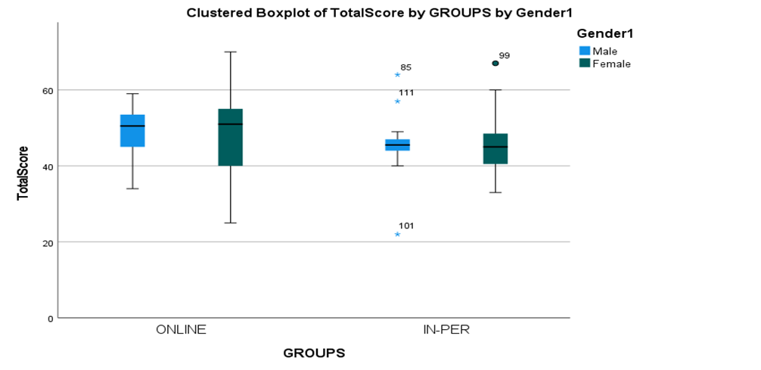
3.4 Inferential Statistics
A two-way between-groups ANOVA was performed in order to explore the difference in student attention scores based on type of learning environment (online or in-person lecture) and gender (male and female). The analysis also investigated if there was a significant interaction between learning environment and gender based on students’ attention scores.

3.5 Hypothesis 1
Hypothesis 1 stated that there will be a difference in the type of learning environment (online or in-person lectures) based on students’ attention scores. There was no significant difference in the type of learning environment based on student’s attention scores, F(1,107) = 3.815, p = .053, observed power =.490. Consequently, the hypothesis was rejected, and the null hypothesis was accepted. Figure 2 demonstrates the lack of any differences between type of learning environment and student attention scores.

Figure 3:

Simple bar chart of learning environment by means of students’ attentions scores.

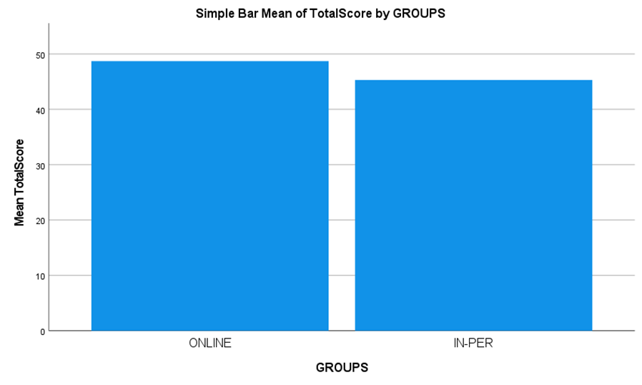

3.6 Hypothesis 2
Hypothesis 2 stated there will be a difference in gender (male/female) based on students’ attention scores. There was no significant difference in gender based on students’ attention scores, F(1, 107) = .028, p = .868, observed power= .053. Therefore, the hypothesis was rejected and the null hypothesis was accepted. Figure 3 further displays the lack of differences between gender and students’ total attention scores.

Figure 4:
Simple bar chart of gender by means of students’ attentions scores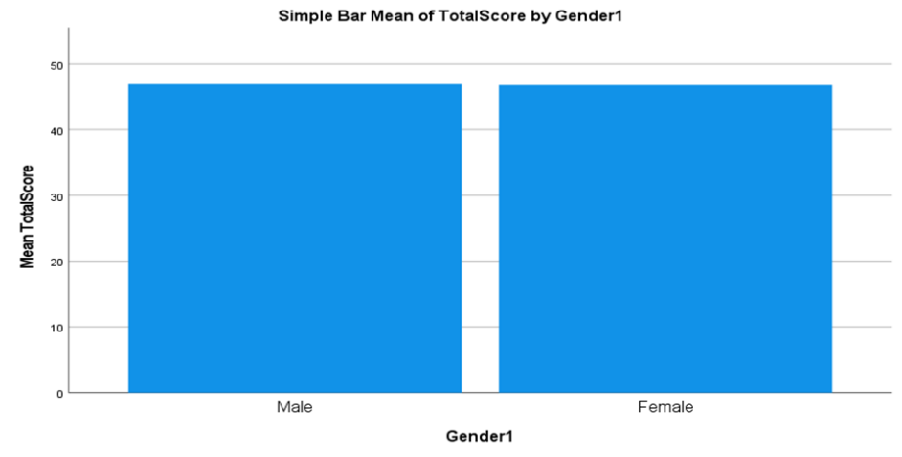3.7 Hypothesis 3
Hypothesis 3 indicated there will be an interaction between gender and the type of learning environment based on students’ attention scores. There was no significant interaction effect between gender and the type of learning environment based on students’ attention scores, F(1,107) = .008, p = .931, observed power= .051. Therefore, the hypothesis was rejected and the null hypothesis was accepted. Figure 4 exhibits the mean of students’ attention scores by gender and type of learning environment.

Figure 5:
Estimated marginal means of students’ attention scores based on type of learning environment and gender.
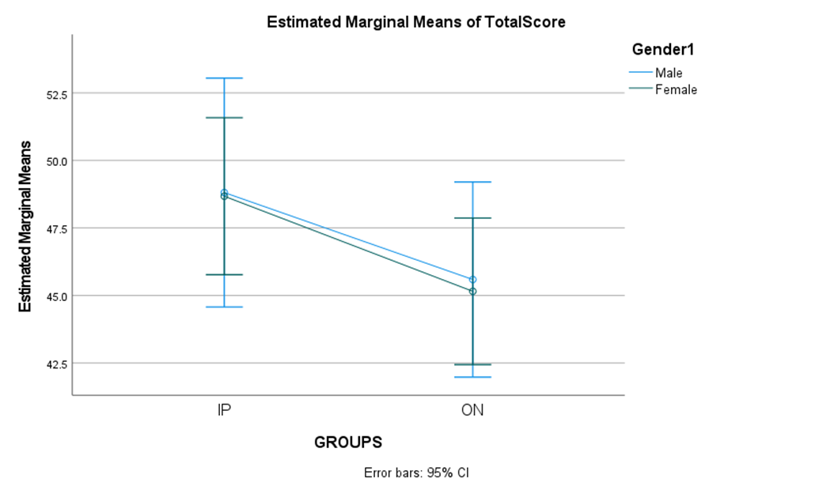

The results will be evaluated in the subsequent section.

4 Discussion

4.1 Overview of Findings
The present study intended to investigate if there was a difference in students’ attention in online lectures versus in-person lectures. Additionally, the interaction effect between gender and the type of learning environment, based on total student attention scores, was also explored. The current study is one of the first to examine the attention of college students during both online and in-person lectures. The existing research, which is centred around the shift from in-person learning to online learning and the potential impact it may have had on student attention, was previously discussed in the opening section. The conclusions of the current study are linked to prior literature, while the strengths and limitations of the current study will also be discussed. Moreover, theoretical implications and future research suggestions will be presented.
4.2 Discussion of Findings
Hypothesis 1 stated there would be a difference in the type of learning environment (online or in-person lectures) based on students’ attention scores. Hypothesis 1 was not supported as there was no significant difference between the online lecture group and in-person lecture group, based on each groups’ total attention scores. This conclusion does not contribute to the supporting of the findings of Maqableha and Alia (2021), who stated that the consequences of the shift to online learning affected student learning and attention. As previously mentioned, one of the main aims of the present study was to investigate the potential consequences that the shift to online learning had on student attention. The slight difference in student attention scores between online and in-person lectures, in favour of online lectures, further opposes previous research. This minor difference in students’ attention scores also fails to support Kumari et al. (2021) who declared that students find it significantly harder to pay attention during online learning. There may be a range of possible justifications as to why the current study reported that there was no difference between the two types of learning environments. These explanations take into consideration that the participants in the current study, who have experience with the shift to online learning, are better adapted to this type of learning than the students that featured in the existing studies. Furthermore, the participants in the current study are more likely to have adapted to the problems of online learning that were previously discussed in prior sections of the current study, such as distractions, mind wandering, and the increased use of laptops, as they have had more time to react to the change (Almendingen et al., 2021).
Hypothesis 2 stated there will be a difference in gender (male/female) based on students’ attention scores. As there was no significant difference between males and females based on both groups’ total attention scores, hypothesis 2 was not supported. The present study’s findings fail to support the existing research in which it is acknowledged that there is a difference in attention between males and females within the learning environments. For example, Ghazvini and Khajehpour (2011) concluded that gender differences do occur in educational settings, with females displaying a more flexible approach to learning material than that of males. Moreover, Liu et al. (2021) also uncovered gender differences in learning settings, as females achieved superior online self-regulated learning than males. In the current study, both the online and in-person groups featured uneven sample sizes. There was evidently a greater number of female participants than male participants. This may provide an explanation for the insignificant finding as the lack of male participants resulted in an imbalance of total attention scores, whereby there was a larger amount of female total scores.
Lastly, hypothesis 3 indicated that there would be an interaction between gender and the type of learning environment based on students’ attention scores. This hypothesis was rejected as there was no significant interaction between gender and the type of learning environment, based on students’ total attention scores. Previous research is lacking in this field of investigation. The prior studies conducted on student attention failed to investigate an interaction between the two variables. Despite this, the current study fails to support Sachitra and Bandara (2017) who predicted that, because female students have the capacity to demonstrate superior academic self-efficacy than that of male students, females would then display greater attention levels during both online and in-person lectures. This finding was not supported in the present study, as there was a lack of interaction between gender and the type of learning environment.
4.3 Strengths of The Present Study
The present study is one of the first to investigate the differences in student attention in an online and in-person lecture, especially in the context of Irish college students. Whereas most of the existing research is centred exclusively around attention in one mainstream learning environment, Wilson and Korn (2007), the present study discusses the differences in two types of learning settings. Furthermore, the current study was one of the first studies to explore the differences in gender in both online and in-person learning environments. Similarly, the focus on college students and the impact that the shift to online learning had on lecture attention is unique in comparison to the existing research that is currently accessible.
Another strength of the present study is that the participants had an extensive selection in ages, ranging from 18 to 39 years old. This age range differs from the usual undergraduate level in previous studies and allows for young and mature students’ data to be included in the findings. A further notable strength of the present study is the application of a reliable and valid test such as the ATTC scale, which exceeded the Cronbach’s alpha value criterion of above 0.6 (Pallant, 2016). The high Cronbach’s alpha value that is evident in the current study, (.663), indicates the scale that was used in the current study provided internal consistency and reliability.
4.4 Limitations of The Present Study
The major limitation of the present study is directed primarily towards the features of the sample. As previously mentioned, there is an uneven ratio of males (36%) and females (64%) in the online lecture group and in the in-person lecture group, males (32%) and females (68%). This causes a lack of representation of the male student sample in comparison to the female student sample. The present study also featured a small sample size, which means it cannot be generalised to a wider population of students. Although the researcher endeavoured to gain a sufficient sample size, the number of students that were present on the university campus was not at a typical level, due to COVID-19 restrictions at the time of data collection.
In terms of the scale used, a limitation was that the data of various participants were removed as a result of partially completed questionnaires. With the intention of continuing to adhere to ethical regulations, it was important to permit participants to exclude certain questions. This ethical necessity meant some total attention scores were at an inevitable disadvantage to other scores. Furthermore, the ATTC scale is 20 questions long and, although there is no method of documenting this information on Microsoft Forms, it is likely that potential participants failed to complete the questionnaire because of the lengthy range of the scale.
A further limitation of the current study was that the Levene’s test for homogeneity of variance was violated. This violation results in an unequal variance across groups. This could imply that there is a higher possibility of mistakenly rejecting the null hypothesis (Type 1 Error). Unequal variance can additionally diminish the statistical power of the test. In addition, convenience sampling was used to recruit participants and this method of sampling can enlarge the likelihood of selection bias (Acharya et al., 2013).
4.5 Implications and Future Research
Despite the limitations of the present study and the lack of significant differences between the variables, it may still generate numerous implications for the existing literature in the field of attention and student learning. For instance, the current study’s findings demonstrate to college administrators and executives that the infrastructures in place, such as online learning platforms and online support systems, are assisting college students in staying attentive during online lectures. Moreover, as per the results of the present study and that of Almendingen et al. (2021), students have effectively managed the transition from in-person to online learning and now may be more accustomed to it, compared with previous participants in the aforementioned studies. This finding may indicate that, if there was another sudden shift to online learning in the future, the impact on students’ attention may be less severe.
In terms of future research in the area of attention and student learning, there are some suggestions that could develop the field of research further. Some of these include the demand for a new scale to be developed that is specifically designed for the measuring of attention in any learning environment. Although the present study’s ATTC scale was reliable, a more attention focused scale could produce significant results. Additionally, as the present study exclusively concentrated on the learning settings of online and in-person lectures, future research could investigate the mix of these two with hybrid learning. As this type of learning could be active in education post COVID-19, it is important that the potential differences that might exist in these learning environments are explored.
4.6 Conclusion
As the existing literature on the subject area of the differences in student attention is not particularly plentiful, the present study is one of the first to investigate the gap in the literature, in the context of the COVID-19 pandemic. Although there were no significant differences between the variables, the study contributes to the understanding of student attention and students’ management of the shift from in-person to online learning. As well as this, the current study offers education administrators and board of directors knowledge that the online supports, such as online platforms like Blackboard, are assisting students and not having such a detrimental effect as sometimes suggested (Maqableha & Alia, 2021). The previously mentioned suggestions for future research can potentially expand the topic of student learning, which could positively develop student attention as well as the quality of online learning support practices in the long term.

5 References

Acharya, A. S., Prakash, A., Saxena, P., & Nigam, A. (2013). Sampling: Why and how of
it. Indian Journal of Medical Specialties, 4(2), 330-333.
https://doi.org/10.7713/ijms.2013.0032.

Almendingen, K., Morseth, M. S., Gjølstad, E., Brevik, A., & Tørris, C. (2021). Student's
experiences with online teaching following COVID-19 lockdown: A mixed methods
explorative study. PloS One, 16(8). https://doi.org/10.1371/journal.pone.0250378.

Bandura, A. (1977). Self-efficacy: Toward a unifying theory of behavioural change.
Psychological Review, 84(2),191-215.

Bradbury, N. A. (2016). Attention span during lectures: 8 seconds, 10 minutes, or more?
Advances in Physiology Education, 40(4), 509–513.
https://doi.org/10.1152/advan.00109.2016.

Chun, M. M., Golomb, J. D., & Turk-Browne, N. B. (2011). A taxonomy of external and
internal attention. Annual Review of Psychology, 62, 73–101.
https://doi.org/10.1146/annurev.psych.093008.100427.

Cohen, A. R. (2014). The Neuropsychology of Attention. Springer.

Derryberry, D., & Reed, M. (2002). Attention Control Scale (ATTC).
https://arc.psych.wisc.edu/self-report/attention-control-scale-attc/.

Feng, Q., Zheng, Y., Zhang, X., Song, Y., Luo, Y. J., Li, Y., & Talhelm, T. (2011). Gender
differences in visual reflexive attention shifting: evidence from an ERP study. Brain
Research, 1401, 59–65. https://doi.org/10.1016/j.brainres.2011.05.041.

Finley, J. R., Benjamin, A. S., & McCarley, J. S. (2014). Metacognition of multitasking: How
well do we predict the costs of divided attention? Journal of Experimental
Psychology: Applied, 20(2), 158–165. https://doi.org/10.1037/xap0000010.

Geri, N., Winer, A., & Zaks, B. (2017). A learning analytics approach for evaluating the
impact of interactivity in online video lectures on the attention span of students.
Interdisciplinary Journal of E-Learning and Learning Objects, 13(1), 215-228.
https://doi.org/10.28945/3875.

Ghazvini, S. D., & Khajehpour, M. (2011). Gender differences in factors affecting academic
performance of high school students. Procedia-Social and Behavioural Sciences, 15,
1040-1045. https://doi.org/10.1016/j.sbspro.2011.03.236.

Guo, Y., Yang, H., Elhai, J., & McKay, D. (2021). Anxiety regarding COVID-19 is related
to attentional control: The mediating role of anxiety sensitivity. Frontiers in
Psychiatry, 12, 713279. https://doi.org/10.3389/fpsyt.2021.713279.

Kumari, S., Gautam, H., Nityadarshini, N., Das, B. K., & Chaudhry, R. (2021). Online
classes versus traditional classes? Comparison during COVID-19. Journal of
Education and Health Promotion, 10, 457. https://doi.org/10.4103/jehp.jehp_317_21.

Lindsay, G. W. (2020). Attention in psychology, neuroscience, and machine learning.
Frontiers in Computational Neuroscience, 14, 29.
https://doi.org/10.3389/fncom.2020.00029.

Liu, X., He, W., Zhao, L., & Hong, J. C. (2021). Gender differences in self-regulated
online learning during the COVID-19 lockdown. Frontiers in Psychology, 12.
https://doi.org/10.3389/fpsyg.2021.752131.

Lodge, J. M., & Harrison, W. J. (2019). The role of attention in learning in the digital age.
The Yale Journal of Biology and Medicine, 92(1), 21–28.

Maqableh, M., & Alia, M. (2021). Evaluation online learning of undergraduate students
under lockdown amidst COVID-19 Pandemic: The online learning experience and
students’ satisfaction. Children and Youth Services Review, 128.
https://doi.org/10.1016/j.childyouth.2021.106160.

Middlebrooks, C. D., Kerr, T., & Castel, A. D. (2017). Selectively distracted: Divided
attention and memory for important information. Psychological Science, 28(8),
1103–1115. https://doi.org/10.1177/0956797617702502.

Pallant, J. (2016). Survival manual. A step by step guide to data analysis using SPSS (7th ed.).
Open University Publisher.

Sachitra, V., & Bandara, U. (2017). Measuring the academic self-efficacy of undergraduates:
The role of gender and academic year experience. World Academy of Science,
Engineering and Technology, 11(11), 2320-2325.
https://www.academia.edu/download/54672705/Final_Paper_.pdf.

Seymour, C. I., Erdynast, E. D., & Miller, M. D. (2021). Gender predicts beliefs and
knowledge about attention among college students. College Teaching, 69(4), 210-
217. https://doi.org/10.1080/87567555.2020.1853026.

Shen, D., Cho, M. H., Tsai, C. L., & Marra, R. (2013). Unpacking online learning
experiences: Online learning self-efficacy and learning satisfaction. The Internet and
Higher Education, 19, 10-17. https://doi.org/10.1016/j.iheduc.2013.04.001.

Stevens, C., & Bavelier, D. (2012). The role of selective attention on academic foundations:
A cognitive neuroscience perspective. Developmental Cognitive Neuroscience, 2, 30-
48. https://doi.org/10.1016/j.dcn.2011.11.001.

Wilson, K., & Korn, J. H. (2007). Attention during lectures: beyond ten minutes. Teaching
of Psychology, 34(2), 85–89. https://doi.org/10.1080/00986280701291291.

Wu, J., & Cheng, T. (2019). Who is better adapted in learning online within the personal
learning environment? Relating gender differences in cognitive attention networks to
digital distraction. Computer & Education, 128, 312-329.
https://doi.org/10.1016/j.compedu.2018.08.016.

6 Appendices

Appendix A: Ethics Form-Amber Route and Approval

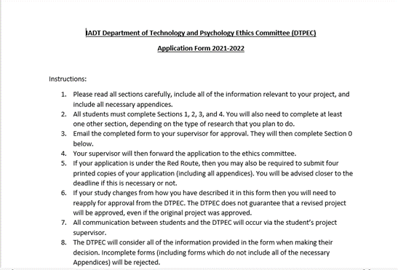
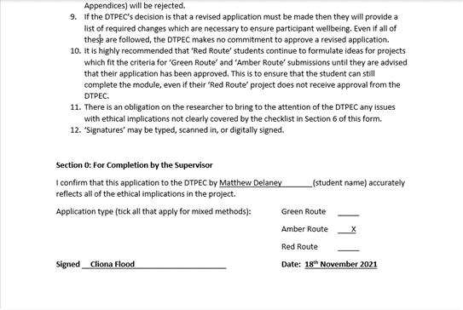
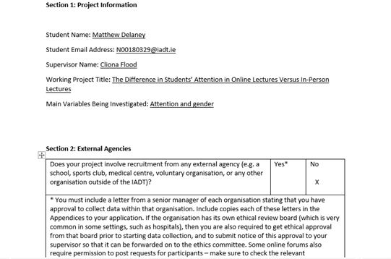
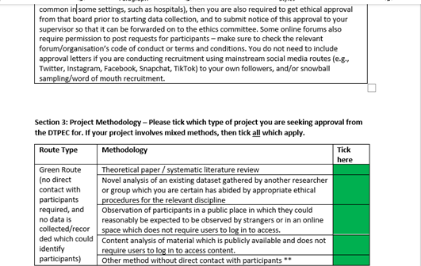
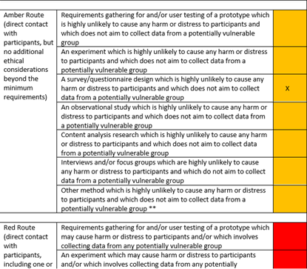
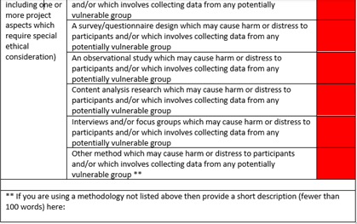
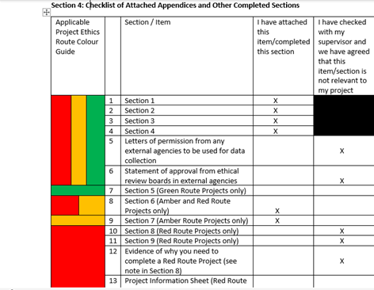
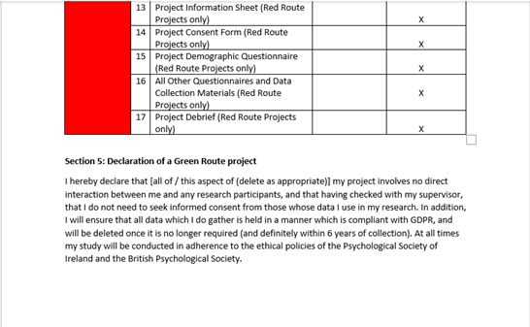
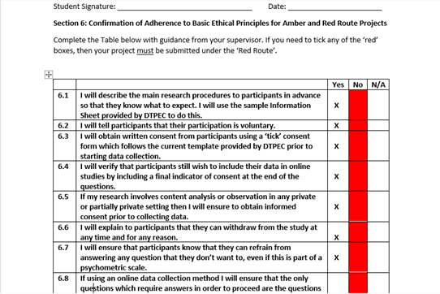
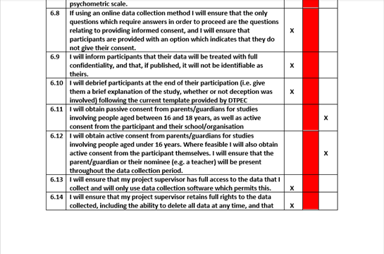
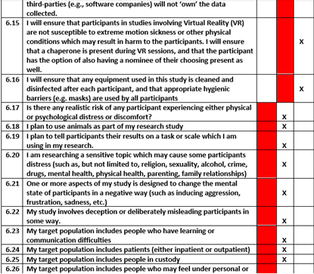
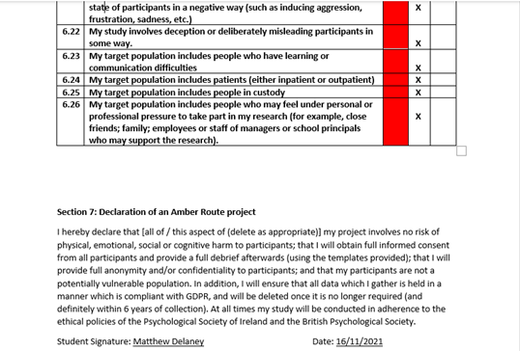

Document issued by ethics committee verifying ethical approval of application
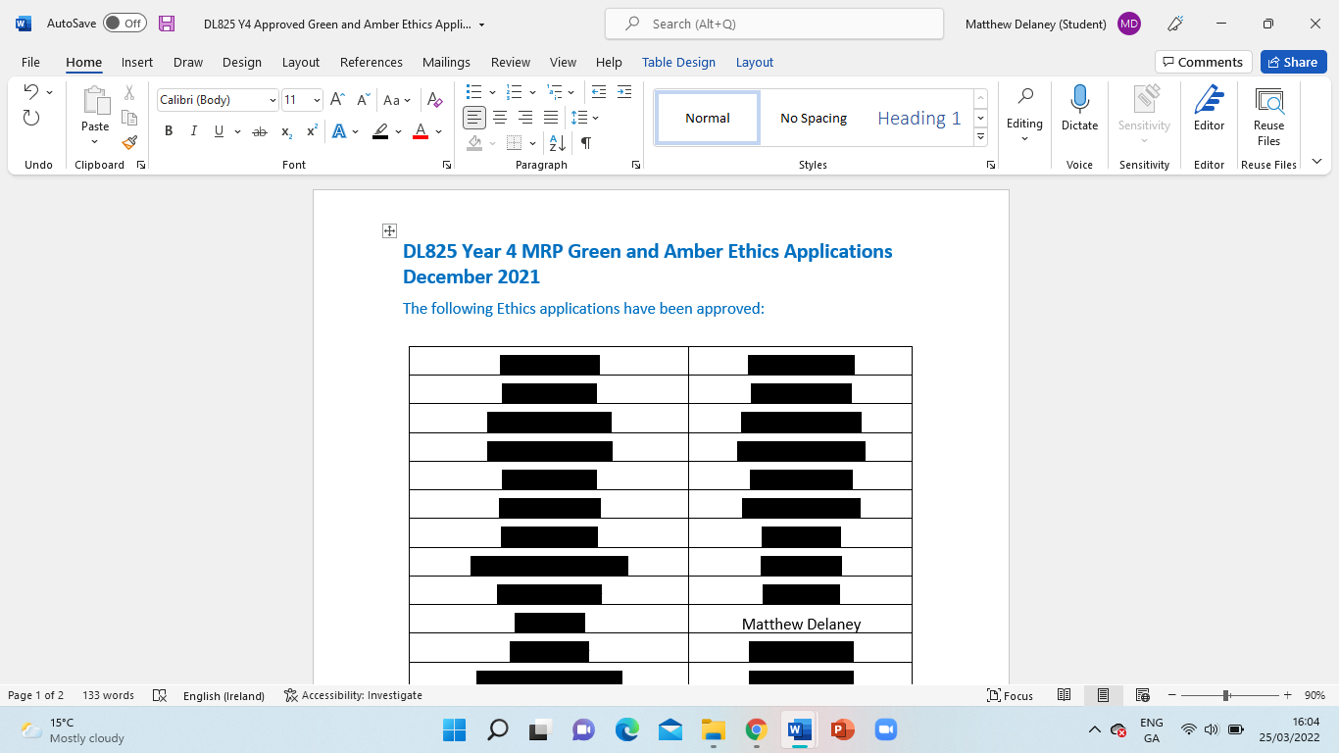

Appendix B: Information Sheet

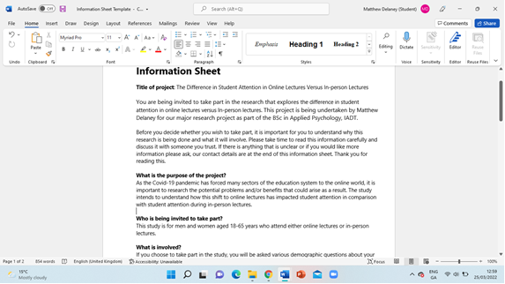
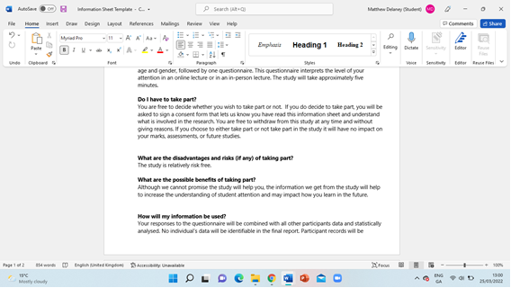
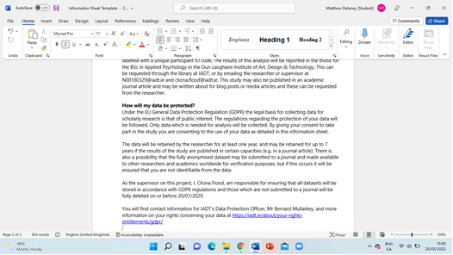
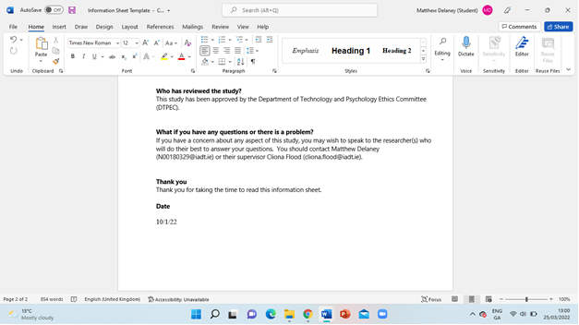

Appendix C: Consent Form

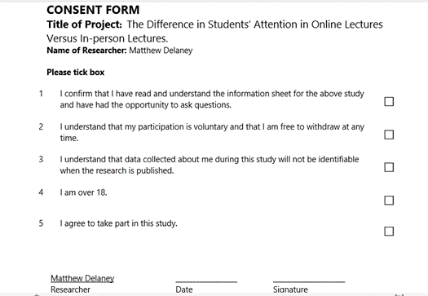

Appendix D: Debrief Sheet

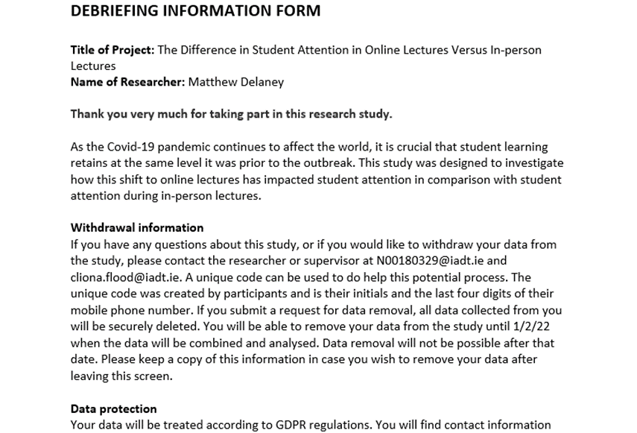

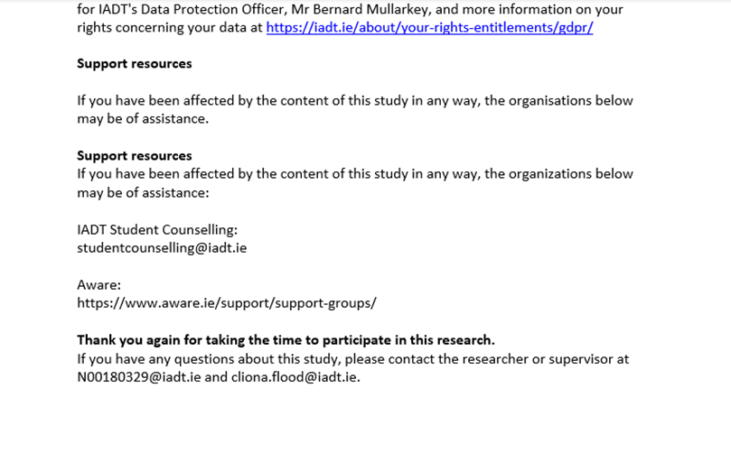

Appendix E: Attention Control Scale

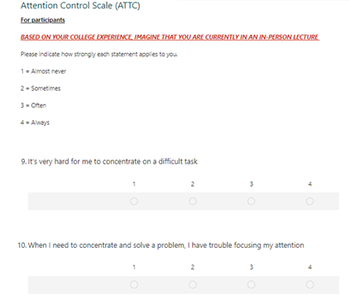
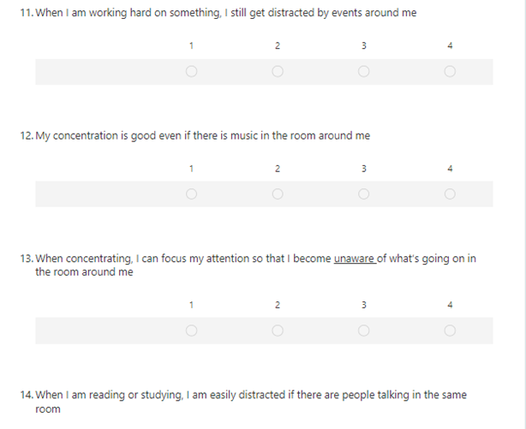
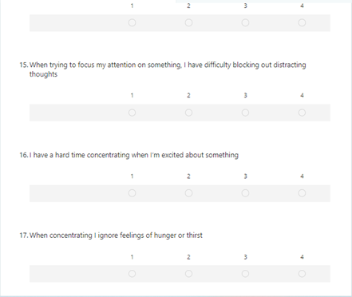
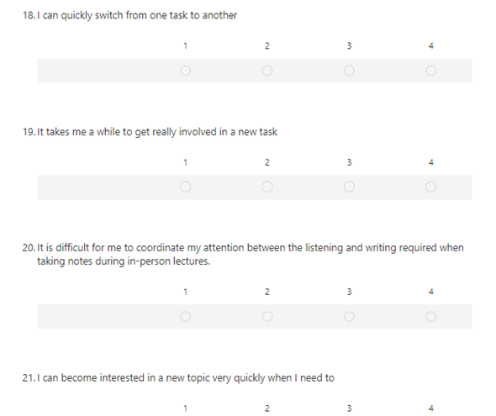
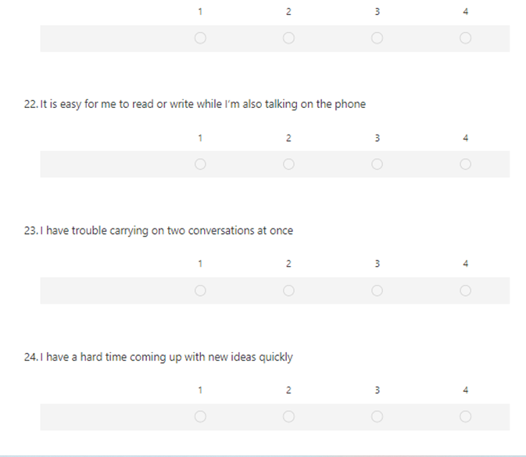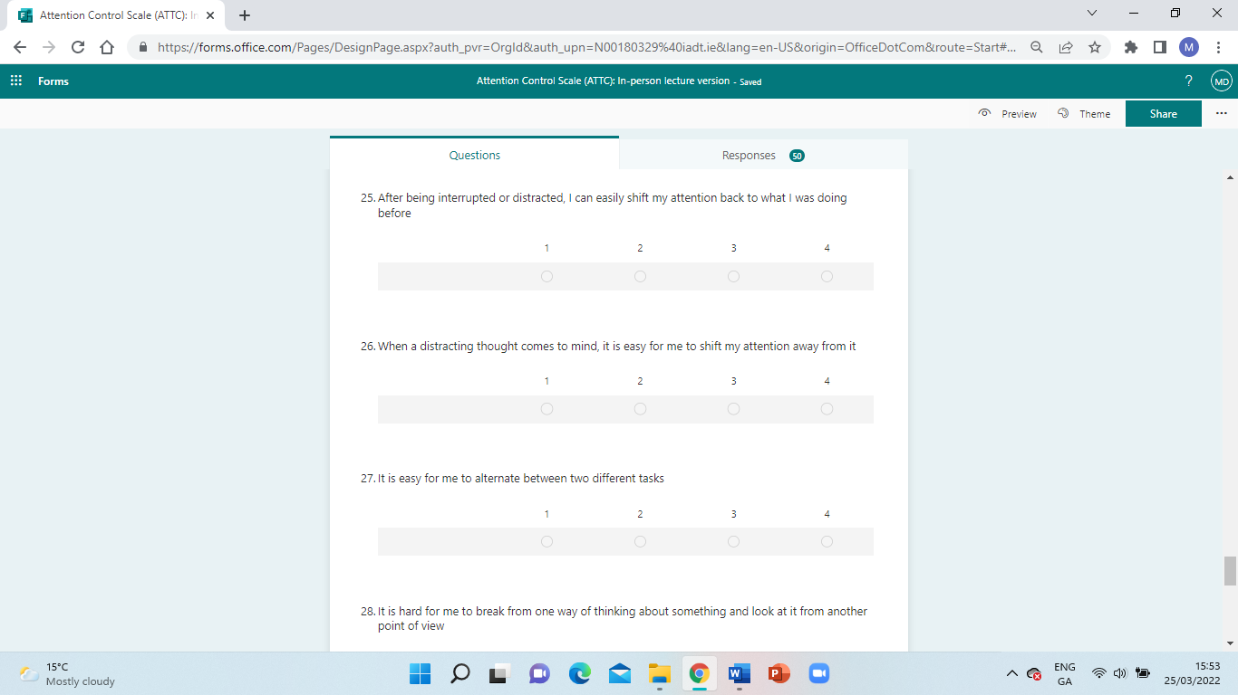
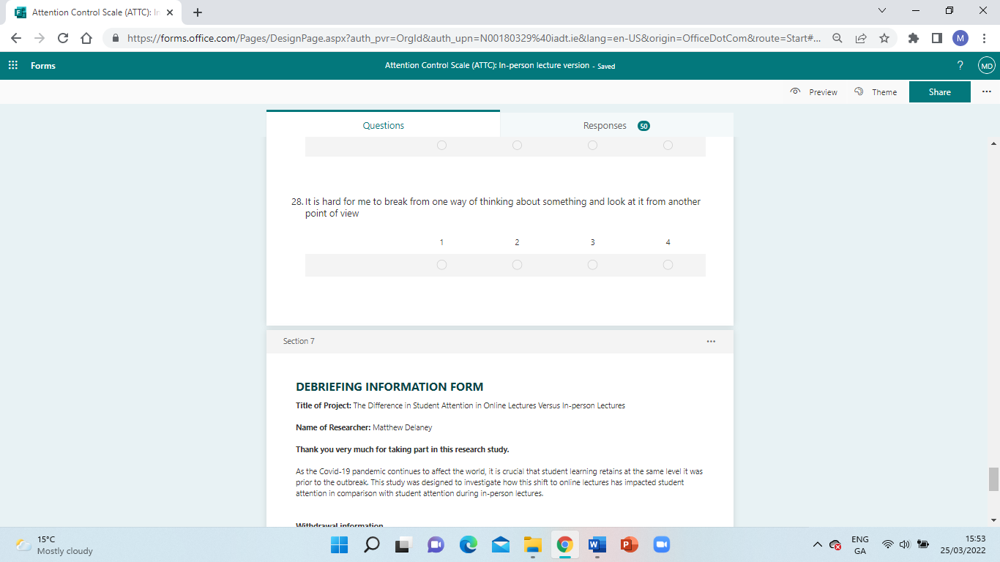
Appendix F: Cronbach’s Alpha Value For ATTC

Reliability Statistics
Cronbach's Alpha | Cronbach's Alpha Based on Standardized Items | N of Items
.663 | .669 | 20

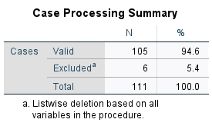

Appendix G: Demographic Questions

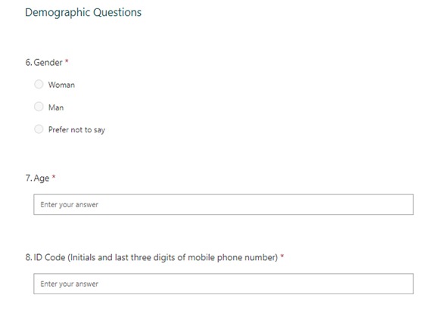

Appendix H: SPSS Output

Between-Subjects Factors
 |  | Value Label | N
GROUPS | 1.00 | IP | 50
GROUPS | 2.00 | ON | 61
Gender1 | 1 | Male | 38
Gender1 | 2 | Female | 73

Descriptive Statistics
Dependent Variable: TotalScore
GROUPS | Gender1 | Mean | Std. Deviation | N
IP | Male | 48.81 | 7.687 | 16
IP | Female | 48.68 | 10.775 | 34
IP | Total | 48.72 | 9.813 | 50
ON | Male | 45.59 | 7.301 | 22
ON | Female | 45.15 | 7.235 | 39
ON | Total | 45.31 | 7.201 | 61
Total | Male | 46.95 | 7.537 | 38
Total | Female | 46.79 | 9.164 | 73
Total | Total | 46.85 | 8.607 | 111

Levene's Test of Equality of Error Variances^{a,b}
 |  | Levene Statistic | df1 | df2 | Sig.
TotalScore | Based on Mean | 4.130 | 3 | 107 | .008
TotalScore | Based on Median | 2.882 | 3 | 107 | .039
TotalScore | Based on Median and with adjusted df | 2.882 | 3 | 97.221 | .040
TotalScore | Based on trimmed mean | 4.002 | 3 | 107 | .010
Tests the null hypothesis that the error variance of the dependent variable is equal across groups.
a. Dependent variable: TotalScore
b. Design: Intercept + GROUPS + Gender1 + GROUPS * Gender1

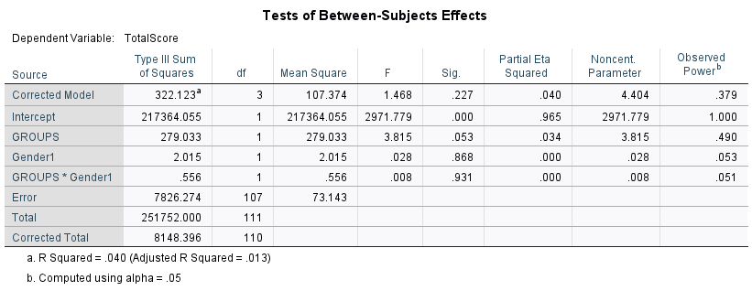

Estimates
Dependent Variable: TotalScore
GROUPS | Mean | Std. Error | 95% Confidence Interval
GROUPS | Mean | Std. Error | Lower Bound | Upper Bound
IP | 48.744 | 1.296 | 46.175 | 51.314
ON | 45.372 | 1.140 | 43.112 | 47.633

Pairwise Comparisons
Dependent Variable: TotalScore
(I) GROUPS | (J) GROUPS | Mean Difference (I-J) | Std. Error | Sig.ª | 95% Confidence Interval for Differenceª
 |  |  |  |  | Lower Bound | Upper Bound
IP | ON | 3.372 | 1.726 | .053 | -.050 | 6.795
ON | IP | -3.372 | 1.726 | .053 | -6.795 | .050
Based on estimated marginal means

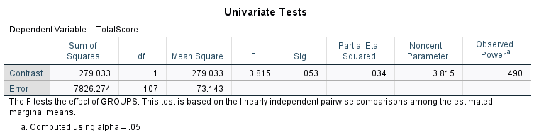

3. GROUPS * Gender1
Dependent Variable: TotalScore
GROUPS | Gender1 | Mean | Std. Error | 95% Confidence Interval
 |  |  |  | Lower Bound | Upper Bound
IP | Male | 48.813 | 2.138 | 44.574 | 53.051
IP | Female | 48.676 | 1.467 | 45.769 | 51.584
ON | Male | 45.591 | 1.823 | 41.976 | 49.206
ON | Female | 45.154 | 1.369 | 42.439 | 47.869

Appendix I: Test of Homogeneity of Variance

Levene's Test of Equality of Error Variances^{a,b}
 |  | Levene Statistic | df1 | df2 | Sig.
TotalScore | Based on Mean | 4.130 | 3 | 107 | .008
TotalScore | Based on Median | 2.882 | 3 | 107 | .039
TotalScore | Based on Median and with adjusted df | 2.882 | 3 | 97.221 | .040
TotalScore | Based on trimmed mean | 4.002 | 3 | 107 | .010
Tests the null hypothesis that the error variance of the dependent variable is equal across groups.
a. Dependent variable: TotalScore
b. Design: Intercept + GROUPS + Gender1 + GROUPS * Gender1

Appendix J: Tests of Normality

Tests of Normality
 | Gender1 | Kolmogorov-Smirnovª |  |  | Shapiro-Wilk
 | Gender1 | Statistic | df | Sig. | Statistic | Df | Sig.
GROUPS | Male | .379 | 38 | .000 | .628 | 38 | .000
GROUPS | Female | .357 | 73 | .000 | .635 | 73 | .000
a. Lilliefors Significance Correction

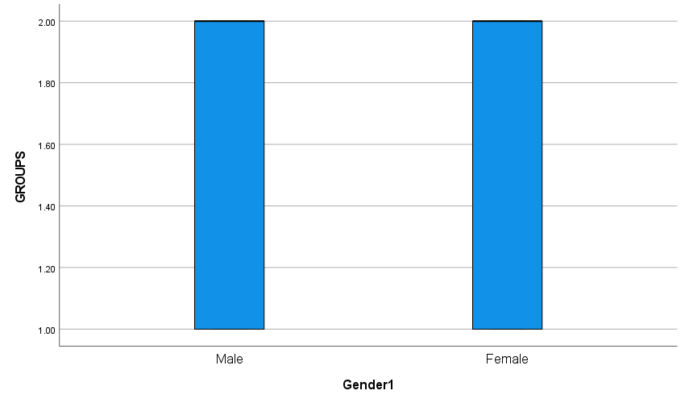

Tests of Normality
 | GROUPS | Kolmogorov-Smirnovª |  |  | Shapiro-Wilk
 | GROUPS | Statistic | df | Sig. | Statistic | Df | Sig.
Gender1 | ONLINE | .431 | 50 | .000 | .588 | 50 | .000
Gender1 | IN-PER | .411 | 61 | .000 | .608 | 61 | .000
a. Lilliefors Significance Correction
