Investigating Levels of Climate Change Action and Pro-Environmental Behaviour Post the Covid-19 Pandemic.
Megan Doherty,
N00180200

Supervisor: John Greaney

DISSERTATION SUBMITTED AS A REQUIREMENT FOR THE
DEGREE OF BSC (HONS) IN APPLIED PSYCHOLOGY, DUN
LAOGHAIRE INSTITUTE OF ART, DESIGN & TECHNOLOGY, 2022

Declaration

I declare that this submission is my own work. Where I have read, consulted and used the work of others I have acknowledged this in the text.

Word Count: 4,894 words
Signature:
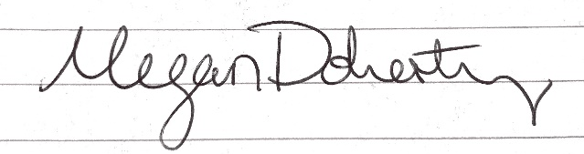

Date: 30/03/2022

Acknowledgments

I would like to thank the supervisor of this project John Greaney for his continued support and feedback throughout the duration of this project. Your patience and insight was invaluable during this year. I would also like to thank the members of the IADT psychology department for their support over the last four years throughout my studies. I would like to thank my family, partner, friends, and those who participated in this project for assisting and supporting me throughout my thesis.

Table of Contents
Table of Contents
Abstract 6
1.Literature Review 7
1.1 Introduction 7
1.2 Climate and Psychology 7
1.3 Climate change and COVID 19 8
1.4 Eco-anxiety 9
1.5 Climate change and gender 10
1.6 Current Research 12
1.7 Research Question 12
2. Method 13
2.1 Design 13
2.2 Participants 13
2.3 Materials 13
2.4 Pilot study 14
2.5 Procedure 14
3. Results 16
3.1 Overview of results 16
3.2 Descriptive Statistics 16
3.3 Pre-Post Pandemic 18
3.4 Pro-Environmental Behaviour 19
4.Discussion 20
4.1 Overview of findings 20
4.2 Strengths and Limitations of the current study 22
4.3 Recommendations for future research 22
4.4 Conclusion 23
References 24
Appendices 27
Appendix A: Ethical Approval 27
Appendix B: DTPEC Application Form 2021 27
Appendix C: Approval to use data (Cassoni, 2020) 33
Appendix D: Information Sheet, Consent, Debrief 34
Appendix E: Copy of Stevenson’s Pro-Environmental Behaviour Scale (2015) 36
Appendix F: Copy of The Dragons of Inaction Psychological Barrier Scale (Lacroix, Gifford, & Chen, 2019) 36
Appendix G: SPSS Output 37

Abstract

This study investigated the relationship between gender and time on pro-environmental behaviour and climate change inaction. The independent variables were gender (male/female) and time (pre-pandemic (2020) and post pandemic (2022)) and the dependent variables were pro-environmental behaviour and barriers to climate change action. A survey was conducted on participants (N=77) based on The Dragons of Inaction Psychological Barrier Scale (Lacroix, Gifford, & Chen, 2019) and Stevenson’s Scale for Pro-Environmental Behaviour (2015). Inferential statistics were analysed to investigate the relationship between these variables. A significant difference was found between climate change inaction and gender and climate change inaction and time. No significant relationship was found between both gender and time and climate change inaction. A significant difference was found between gender and pro-environmental behaviour with females scoring on average higher than males. There appears to be an increase in climate change inaction post the COVID -19 Pandemic in both males and females. Suggestion for future research would be to investigate the effect of time on pro-environmental behaviour and to employ a more gender balanced sample.
Keywords: climate action, gender, pro-environmental behaviour, Covid-19

1.Literature Review

1.1 Introduction

With the climate crisis increasing, anxiety disorders related to climate are also increasing. Extreme weather events caused by climate change will increase the spread of infectious diseases such as Covid-19 as these diseases often thrive in warmer conditions. 56% of Americans say that the climate crisis is currently our biggest societal problem (APA, 2020). In this paper it is investigated whether there has been a rise in pro-environmental behaviour or climate inaction among adults during the COVID 19 pandemic. The findings of this paper will hopefully lead to an understanding of the inevitable strain these two crises will have on the mental health system and how we can combat these issues in the future.
On a social level, people had to be adaptive when adjusting to the COVID 19 pandemic. With social distancing regulations and travel limitations, interpersonal relationships were under extreme strain. While many adapted by bringing their relationships into an online setting with video calls and catch ups over the internet, many felt a loss of human connection. The uncertainty in these times inevitably brought a rise in anxiety with it (Kelly, 2021).

1.2 Climate and Psychology
Whomsley (2021) outlines the roles of psychologists in relation to climate change and responses to the COVID 19 pandemic as the need for mental health services and clinical intervention is on the rise. The five roles are: Changing human behaviours that are causing climate change, advising and assisting on leadership, increasing human connection with nature, providing support and psychological interventions and preparing for bad outcomes. Increased stressors in everyday life caused by the pandemic and the climate crisis will place a strain on mental health worldwide. Psychologists will need to assist in changing human behaviours that are causing climate change. Scientists from other disciplines will develop the technology to aid the fight against climate change, psychologists play the role of persuading people to change their climate damaging behaviours and adapting to new technology. They will play a pivotal role that compliments the approaches of other scientific disciplines. Psychology has been suggested as a way of changing consumer behaviour, as overconsumption has placed a significant strain on the planet and its resources. However, changing people's attitudes may not be enough to change their behaviour. Many do not see it as their responsibility to adjust their behaviour (Cuomo,2011). Psychologists can address the psychological barriers standing between people and this change. In the case of the COVID 19 pandemic, it was reported that a sense of shared collectivism was important for communities to adhere to new regulations and restrictions. This may also apply to the climate crisis. At an individual level there is displacement of responsibility but collectively communities can make big changes. Increasing human connection with nature is another role for psychologists in fighting climate change. A sense of being part of an ecosystem may be beneficial for human well-being but also for the healing of the planet. The COVID pandemic gave us a stark insight into how ecosystems connect and how human behaviour has consequences (Whomsley, 2021).

1.3 Climate change and COVID 19

The two phenomena of climate change and COVID 19 are interrelated, contrary to what many individuals believe. Rising sea levels and desertification will cause a strain on resources as forced migration rises. Extreme weather events such as hurricanes, floods, heatwaves etc. may be traumatic and dangerous which can increase anxiety in individuals affected or at risk. Heatwaves in particular are associated with higher levels of interpersonal violence which can be a significant stressor. Shelters during extreme weather events are often overcrowded, contributing to the spread of diseases, for example COVID 19. New disorders related to the pandemic are currently being researched such as COVID stress syndrome, but these are not yet recognised by the DSM 5 and further research into these disorders is required. It is hypothesised that climate related disorders might also be rising and are currently being studied. Individuals with pre-existing mental health disorders are significantly more vulnerable to pandemic and climate related anxiety. After a significant period of uncertainty during the pandemic and also during the climate crisis, intolerance of uncertainty is a contributing factor for anxiety (Taylor 2020).
Gong and Sun(2020) conducted a longitudinal study in China investigating the relationship between perceived risk of the pandemic and climate change. The study reports that public attention to climate change was not impaired by increased concern towards the COVID 19 Pandemic. A correlation appeared to be present between having a higher perceived risk of the pandemic and concern about climate change. One silver lining reported due to the pandemic is the reduction of greenhouse gas emissions due to reduced level of travel worldwide including both local and international travel and a change in levels of consumption due to being confined to local areas. However, these positive changes may be negligible if life returns to the same patterns prior to the pandemic. In fact, the pandemic may influence a deterioration in climate change progress as sustainable developments require economic growth. A rise in homelessness caused by forced migration due to climate change will cause overcrowding in shelters and reduce the possibility for social distancing among these communities. There is a direct correlation between climate change and the increase of infectious diseases, similar situations to the COVID pandemic are likely to arise in the future, so it is recommended that tackling the climate crisis remains at the forefront of people’s minds to prevent further pandemics. In previous surveys however, only 48% of people felt governments should treat climate change with the same urgency as the current pandemic (Opinium, 2020).

1.4 Eco-anxiety

Eco-anxiety is a relatively new phenomenon and while it is connected to fear and worry it has also been strongly linked to existential anxiety. While most eco-anxiety is not considered a clinical case, an increased number of people are reported to have “pathological” and debilitating eco-anxiety. It appears also to manifest as a “practical” anxiety, often resulting in proactive behaviour, reassessment of lifestyle and high levels of research in the individual suffering (Panu, 2020). Psychologists have also observed the rise in climate anxiety particularly in young people. In a survey on children in the UK, 73% worried about the current state of the world and 58% worried about how climate change could affect the future. It is still uncertain whether the climate crisis can be averted. Psychologists will play a vital role in helping people to adapt if the crisis continues to grow (Whomsley, 2021).
Similarly, in a predictive cross- sectional study a link between climate anxiety and mental health was observed. The study was conducted on 433 Filipinos aged 18 to 26. Results show a significant relationship between climate anxiety and mental health with climate anxiety predicting 13.5% of the overall mental Health Index Variance (Reyes, Carmen, Luminarias, Mangaluabnan & Ogunbode, 2021).
While emphasis on the climate crisis and building climate change concerns are vital for preventing apathy towards it, there are downfalls to this when anxiety is increased to a pathological level. Inaction and denial often affect individuals who feel despair towards the climate crisis. This is particularly evident in younger generations who feel the situation is out of their control and the damage has already been done by the generations before them. Fear based messaging can often backfire in individuals who have perceived a low level of control over the situation. Promoting hope and concern rather than despair is important to encourage productive responses. It is reported that hope may be an independent predecessor to behavioural change in relation to climate change (Stevenson & Peterson, 2015).
Examinations of behaviour patterns pre-pandemic have relied on overly simplistic models. Human connection to place appears to have increased during the pandemic as individuals were confined to their local areas and appears to have promoted desirable behaviours. This may have beneficial impacts on the planet as pro-social and pro-environmental behaviours were implemented during the pandemic restrictions. These changes could become habitual and have long lasting benefits to the planet. Engaging individuals in low-level pro-environmental behaviours may have benefits for physical and mental well-being as well as environmental benefits (Ramkissoon, 2020).

1.5 Climate change and gender
There has been an observed gender gap in household pro-environmental behaviours with women engaging significantly more than men. However, it has been reported that levels of pro-environmental behaviour in women correlates to their socioeconomic level (Kennedy & Kmec, 2018). Blok, Wesselink, Studynka, and Kemp (2015) reported a 10% effect level on pro-environmental behaviour with women engaging more frequently than men. Gender is a blind spot in environmental politics and policies. The overarching theme in the limited amount of gender research and climate change is that it is not gender neutral and there are differentiations in behaviour towards the crisis. It is reported that climate change will affect women more severely than men. There is a strong correlation between gender inequalities and women’s survival rates in natural disasters which is significantly lower than men’s. It is hypothesised that women are largely absent from environmental politics due to the stereotypically masculinist discourses in the area of climate in media and society at large that tend to alienate women. Here lies a paradox in the area of climate change where women are largely absent or alienated from discourse and yet more affected by the damaging affects of the crisis (MacGregor, 2010).
McRight (2010) reported that women express a slightly greater concern for climate change than men do. Women also convey greater assessed level of climate change knowledge than men do which contrasts with expectations from prior scientific research. Theoretical research on gender in relation to climate change is limited as gender is often only used as a statistical control in multivariate models. However, while women convey greater assed level of knowledge in relation to climate change they have less confidence in their knowledge than men do.
Women constitute most of the worlds poor and, as those in poverty suffer more from the effects of climate change, women will be more vulnerable in the climate crisis. In developing countries where the population depends more on natural resources, women are relied on to provide food, water and fuel for their children and will face greater challenges when these resources are limited due to climate change. People in poverty will be disproportionately affected by the decline in biodiversity due to climate change. In poorer communities in the developing world women and children are in charge of collecting natural fuels such as firewood. With excessive deforestation these resources are highly limited. With increased spread of diseases due to contamination of water sources, increasing temperatures and scarcity of resources this will likely aggravate women’s care-giving role (UN, 2009).
It has also been reported that men in the northern hemisphere contribute more to pollution than women regardless of their socioeconomic status. In regard to environmentally damaging behaviours, men contribute more, with significantly higher levels of meat consumption, driving more and taking public transport less than women. However, generalizations in the discourse about women’s vulnerability and virtuousness towards the climate may lead to greater levels of responsibility without the corresponding rewards (Arora-Jonsson, 2011).
Cassoni (2020) reported that the amount of climate change content viewed on social media could predict the number of barriers to climate change action in viewers. This data used in Cassoni’s study (with permission) will be used in the present study to compare finding of barriers to climate change action prior to the Covid-19 Pandemic. Data gathered from the present study will be used for the Post Pandemic level in relation to the independent variable of time.
Interventions for these new anxiety disorders are being investigated. Promoting resilience has been claimed to prevent previous anxiety disorders so may be applied to climate and pandemic anxiety. Psychological supports have been put under great strain during the pandemic and need to be improved upon and developed on a larger scale as these new anxiety disorders continue to increase in individuals.

1.6 Current Research
As outlined so far the climate crisis and pandemic will inevitably put a strain on the mental health services in Ireland, reviewing the link between new climate and pandemic related anxiety disorders will be vital for preventing a mental health crisis. Whether individuals are more apathetic and less likely to act on climate change due to the pandemic has yet to be conclusively established. Previous research states that there appears to be a gender gap in pro-environmental behaviours with females engaging significantly more than men. This is a relatively new area of study investigating the links between climate anxiety, the pandemic, climate change action and pro-environmental behaviour. A gap in knowledge appears to be present when measuring pro-environmental behaviour and climate change action before and after the pandemic. The research in this paper hopes to contribute to a better understanding of the levels of pro-environmental behaviour and climate change inaction in adults based on gender post the COVID 19 Pandemic.

1.7 Research Question
The research question for this paper asks whether there is an increase in pro-environmental behaviour and barriers to climate change action in adults based on gender post the COVID 19 pandemic.
H1: There will be an increase in barriers to climate change action in adults post the COVID 19 Pandemic.
H2: There will be a difference in pro-environmental behaviour based on gender (males and females) post the COVID-19 Pandemic.

2. Method

2.1 Design

This study employed a quantitative, independent measures 2 x 2 between groups design. The Independent variables (IV) were gender (male and female) and time (pre-pandemic and post-pandemic) and the Dependent variables (DV) were barriers to climate change action and pro- environmental behaviour. Inferential statistics were conducted to determine whether there was a difference among participants in barriers to climate change action based on gender (male and female) and time (pre and post-pandemic). In order to compare pre-post pandemic data from 99 participants (62 females and 36 males) collected during 2020 were included in the analysis (Cassoni, 2020) (Appendix C).

2.2 Participants

Convenience sampling was carried out online through social media and on the IADT campus. A total of 100 participants took part in the survey. Seventy-six of these participants contributed usable data. Age ranged from 18-55 (M=24 , SD=5.656). Fifty-three participants were female and 23 participants were male. All participants were debriefed prior to completion of the study in which they were informed that they were allowed to withdraw at any stage and no personal information would be shared. This study was carried out within the ethical guidelines of IADT and approved by the Department of Technology and Psychology Ethics Committee (DTPEC) (Appendix A and B).

2.3 Materials

A brief, debrief form and information sheet, a consent form, a copy of the pro-environmental behaviour survey were used in this study contained in a Microsoft form (Appendix D). The pro-environmental section of the survey was scored on a five-point Likert scale and the barriers to environmental change section of the survey were scored on a seven-point Likert scale. A combination of The Dragons of Inaction Psychological Barrier Scale (Lacroix, Gifford, & Chen, 2019) and Stevenson’s Scale for Pro-Environmental Behaviour (Stevenson & Peterson, 2015) was used in this study. A copy of the Scale for Pro-Environmental Behaviour and The Dragons of Inaction Psychological Barrier Scale are attached in the appendices (Appendix E and F).
Stevenson’s Scale for Pro-Environmental Behaviour has a five-point Likert Scale ranging from 1= never to 5= always. Higher numbers indicate higher levels of pro-environmental behaviour. All questions from this scale were included but two were combined into one question when asking participants if they walked or cycled. The pro-environmental scale has a Cronbach’s Alpha reliability score of .74 (Stevenson & Peterson, 2015).
The Dragons of Inaction Psychological Barrier Scale (Lacroix, Gifford, & Chen, 2019) measures barriers to climate change action. It is a 7-point Likert scale from 1= strongly disagree to 7= strongly agree. Higher numbers indicate higher levels of barriers to climate change action. The reliability of the scale was tested and obtained a Cronbach’s Alpha between .77 and .85. Reversed item questions were removed from the scale by the researcher in the current study.

2.4 Pilot study

Before beginning data collection, a small pilot study of five participants was carried out to test the survey. The estimated time the survey would take participants was recorded and any necessary alterations were made to the survey before it was issued to more participants. This included shortening the survey, to reduce the time it would take participants, as initial feedback reported that it was too long. This was achieved by removing the reversed item questions from the Dragons of Inaction Psychological Barrier Scale (Lacroix, Gifford, & Chen, 2019).

2.5 Procedure

Each participant was given a link to a google form and a Microsoft survey or a printed version if conducted in person. Before beginning the survey, they read an information sheet and signed a consent form virtually on Microsoft forms. They were informed that they could withdraw from the study at any point and that no personal information would be stored or shared. Participants were asked to submit their identified gender at the start of the survey and to ensure that they were over the age of 18. Each participant then completed the survey on barriers to climate action and pro-environmental behaviour. Participants then submitted their answers. A debrief was then carried out on each participant, with further information relevant to the study and contact details for the researcher at the end of the Microsoft form. The participants were thanked for their participation in the study. Inferential statistics were analysed by the researcher.

3. Results

3.1 Overview of results

SPSS version 27 was used to conduct this statistical analysis. Full SPSS output is included in the appendices (Appendix G). Dependent Variables were Barriers to climate change action and pro-environmental behavior and the Independent variables were time (Time 1 and Time 2) and gender (Males and Females).

3.2 Descriptive Statistics

The participants section (section 2.2) contains a more detailed overview of gender, age and recruitment method of participants. Figures 1 and figure 2 contain a visual representation of the gender and age range of participants. The mean score for female participants in The Dragons of Inaction Psychological Barrier Scale for Time One was M=50.4921 (N=63) and for Time Two was M=58.5283 (N=53). The mean score for male participants in The Dragons of Inaction Psychological Barrier Scale for Time One was M=55.4054 (N=37) and for Time Two was M=67.5652 (N=23). These scores are displayed in Table 1 below. The mean score among participants (N=76) for Stevenson’s Pro-Environmental Behaviour Scale was M=24.6579.
Table 1. Descriptive statistics for barriers to climate change action in relation to gender and time. The table displays the mean DOIS scores of time one and time two increased overall, with males scoring significantly higher than females. There was an imbalance in participants genders with 116 females and 60 males.

Descriptive Statistics
Dependent Variable: DOIS
Gender | Time | Mean | Std. Deviation | N
Female | TIME 1 | 50.4921 | 11.51559 | 63
Female | TIME 2 | 58.5283 | 13.30790 | 53
Female | Total | 54.1638 | 12.95138 | 116
Male | TIME 1 | 55.4054 | 19.49424 | 37
Male | TIME 2 | 67.5652 | 15.19816 | 23
Male | Total | 60.0667 | 18.80305 | 60
Total | TIME 1 | 52.3100 | 15.06397 | 100
Total | TIME 2 | 61.2632 | 14.42255 | 76
Total | Total | 56.1761 | 15.40455 | 176

Table 2. Descriptive statistics for pro-environmental behavior in relation to gender. The table displays the mean scores for the Pro-environmental behavior scale with females scoring significantly higher than males.

Descriptives
PEBS
 | N | Mean | Std. Deviation | Std. Error | 95% Confidence Interval for Mean |  | Minimum | Maximum
 |  |  |  |  | Lower Bound | Upper Bound | Minimum | Maximum
Female | 53 | 25.7170 | 4.25792 | .58487 | 24.5434 | 26.8906 | 10.00 | 33.00
Male | 23 | 22.2174 | 4.49198 | .93664 | 20.2749 | 24.1599 | 9.00 | 30.00
Total | 76 | 24.6579 | 4.59435 | .52701 | 23.6080 | 25.7077 | 9.00 | 33.00

Figure 1: Participant Gender 2022 (Female 69.74%, Male 30.26%)

Figure 2: Participants age range 2022

3.3 Pre-Post Pandemic

A two way Anova was conducted to examine the effect of gender and time on climate change action. Data collected using the Dragons of Inaction Psychological Barriers Scale in 2020 from 99 participants (62 females and 36 males) was included in addition to data collected by the current researcher to compare pre-pandemic data with post-pandemic data (Cassoni, 2020)(Appendix C). This data combined with data gathered in 2022 gave a total of 176 participants (116 females and 60 males) in this analysis. There appears to be a significant effect of time and gender in relation to climate change inaction. There appears to be a significant main effect for gender, F(1,172)= 8.787, p= .003, ETA= .049 such that males appeared on average to score higher than females. There appears to be a significant main effect for time, F(1,172)= 18.417, p= <.001, ETA= .097. There is no significant interaction effect between gender and time, F(1,172)= .768, p= .382, ETA= .004. Post Hoc test was not carried out as the independent variable has only two levels. Levenes test of equal variance showed that the population variances were not equal, F(3,172)= 4.518, P=0.04.

3.4 Pro-Environmental Behaviour

A one way between groups Anova was conducted to examine the effect of gender on pro-environmental behavior. A total of 76 participants (53 females and 23 males) were included in this analysis. There appears to be a significant difference in relation to gender and pro-environmental behavior, F(1,74)= 10.483, p= .002, such that females scored on average higher than males.
The correlation appears to be a significant negative such that lower score in The Dragons of Inaction Psychological Barriers Scale is associated with a higher score in Stevensons Pro-Environmental Behaviour Scale, -0.278.

4.Discussion

4.1 Overview of findings

After interpreting the results of the analysis, it appears that when comparing pre-pandemic data (2020) and post-pandemic data (2022) that there is a significant increase in climate change inaction in both males and females. There also appears to be a higher level of barriers to climate change action among males than among females. However, there was also a significant relationship apparent between gender and pro-environmental behaviour with females scoring on average higher than males.
Hypothesis 1: There will be an increase in barriers to climate change action in adults post the COVID 19 Pandemic was supported. Data gathered in 2022 was compared to data gathered in 2020, there was a significant increase in climate change inaction in both genders in 2022.
Hypothesis 2: There will be a difference in pro-environmental behaviour based on gender (males and females) post the COVID-19 Pandemic was not supported. There appeared to be a difference in pro-environmental behaviour between males and females.
This result is in line with previous research discussed in the literature review, that males engage in less environmentally friendly behaviours than females (Blok, Wesselink, Studynka, & Kemp, 2015). A significant relationship was found between gender and pro-environmental behaviour in the current study. If this research was to be repeated a larger population would be recommended. There was a significantly higher level of barriers to climate change action in males than females which may correlate to environmental behaviour in a larger population. The current analysis on pro-environmental behaviour had 53 female participants and only 23 male participants (N=76). However, the researcher found there to be a greater level of hesitancy amongst males to participate in the study than females, who appeared more engaged in the topic, which may account for the gender imbalance. A larger number of male participants also submitted the current survey incompletely than female participants which resulted in their data being unusable in the current study. Had these surveys been submitted correctly the sample would have had a more equal gender balance.
Cuomo (2011) reported that many people don’t feel it is their responsibility to adjust their damaging behaviours. The increased level of agreement among participants with statements in the Dragons of Inaction Psychological Barrier Scale (2019) such as “I can’t change because I’m too invested in my current lifestyle” and “These issues are important to me but it’s too hard to change my habits” support this research. The consensus appears to be that someone else will solve this problem and that it is the governments responsibility, that anything regular people can do will not help. This is corroborated by agreement to statements such as “Humans are powerless when it comes to saving the earth, so there is no need to change” and “ It’s the governments responsibility to regulate this change”. This is also in line with research that reports that women engage in more environmentally friendly behaviours on a household level than men (Kennedy & Kmec, 2018). As men scored higher in the current survey, it would imply that in general men do not feel that engaging personally in pro-environmental behaviour will make any change in the crisis. The results indicate that marketing towards environmental change and improvements may need to be targeted according to gender in order for both males and females to engage equally.
Gong and Sun (2020) reported in a longitudinal study that public attention to climate change was not impaired by increased concern towards the COVID 19 pandemic. However, the current research does not support this finding as barriers to climate action appear to have increased post pandemic. Opinium (2020) reported that only 48% of people felt governments should treat climate change with the same urgency as the current pandemic.
Inaction, apathy and denial may often affect individuals who feel despair in relation to the climate crisis. Hope may be an independent predecessor to behavioural change in relation to climate change (Stevenson & Peterson, 2015). This may explain the apparent increase in climate change inaction as individuals have been under increased anxiety and stress throughout the duration of the pandemic. Levels of despair may have increased during the COVID crisis, therefore supporting the report that apathy can subsequently increase. Intolerance of uncertainty has been linked to anxiety and levels of uncertainty surrounding the climate and the pandemic is high (Taylor, 2020). Individuals partaking in this survey may be experiencing apathy in relation to the climate crisis due to the increased level of stress and uncertainty over the last two years. Fostering hope in humans towards the climate crisis may prevent inaction and apathy towards adjusting their climate damaging behaviour. This should be implemented in media for the wider society and on an educational level as young people appear to be greatly affected by climate anxiety and stress (Stevenson & Peterson, 2015).

4.2 Strengths and Limitations of the current study

The strengths of the current study include research into a relatively new area of study. Climate inaction relating to time is a limited area of study and there is no conclusive agreement among researchers on the subject of gender and pro-environmental behaviour. Addressing how the COVID 19 pandemic may have altered mindsets towards the climate crisis is also a new area of research. Having access to and permission to use previous data in a similar area of research was also a strength of this study as it allowed for a comparison of data gathered pre-pandemic (Cassoni,2020).
The current study was limited by the use of self-report measures which can result in biases on behalf of participants. A relatively small number of participants participated in this study, with a gender imbalance of significantly more females participating than males which may also be another limitation. The conducting of this study exclusively online may also be a limitation. Hirao, Koizumi, Ikeda and Ohira (2021) reported that in order for online surveys to be as reliable as laboratory studies, researchers would need to have an average of 1.3-2.6 times more participants than they would have in a laboratory study. The researchers also reported that the lack of a controlled environment could affect the reliability of the data collected. The current study faced limitations due to Covid-19 restrictions, repeating this study in the future without pandemic restrictions would be recommended as it enables the researcher to interact more with participants.

4.3 Recommendations for future research

For future research, it is recommended that a more equal gender balance among participants is achieved in order to measure gender differences in pro-environmental behaviour. It is also recommended that a larger sample size is gathered in order to validate the findings. The current study had 53 female participants and only 23 male participants (N=76). As previous research states that women engage in more environmentally friendly behaviour than men, in order to corroborate these findings and obtain a statistically significant result, a larger and more gender balanced population sample is highly recommended. A controlled environment, such as a lab, may be helpful in gathering reliable unbiased data with participants carrying out the survey in the presence of the researcher.

4.4 Conclusion

The overall findings of this study report a significant increase of barriers to climate change action post the COVID 19 pandemic among both males and females with a significantly higher level in men than women. The finding helps fill a gap in current psychological literature surrounding climate change inaction, gender and pro-environmental behaviour. This research will hopefully aid in a better understanding of how society can tackle the climate crisis from a psychological perspective and the impact of the Covid 19 Pandemic on climate action. Obtaining a statistically significant result in relation to gender and pro-environmental behaviour with a more balanced and larger sample could be an important area of future research. The current study reports valuable findings in the area of climate inaction and pro-environmental behaviour after the Covid crisis.

References

Arora-Jonsson, S. (2011). Virtue and vulnerability: Discourses on women, gender and climate change. Global Environmental Change, 21(2), 744–751. https://doi.org/10.1016/j.gloenvcha.2011.01.005
Blok, V., Wesselink, R., Studynka, O., & Kemp, R. (2015). Encouraging sustainability in the workplace: a survey on the pro-environmental behaviour of university employees. Journal of Cleaner Production, 106, 55–67. https://doi.org/10.1016/j.jclepro.2014.07.063
Cassoni (2020) The Social Influence: Investigating the relationship between online behaviour and climate action. [Bachelors Thesis: Dun Laoghaire Institute of Art, Design and Technology]. Sourced: Georgina Cassoni Thesis Final Version (1) (1).pdf.
Cuomo, C. J. (2011). Climate Change, Vulnerability, and Responsibility. Hypatia, 26(4), 690–714. http://www.jstor.org/stable/41328876
Gong, Y., & Sun, Y. (2020). Higher perceived risk of COVID-19 pandemic, higher concern for climate change: evidence from a longitudinal study in China. Research Square. Published. https://doi.org/10.21203/rs.3.rs-90452/v1
Kelly, B. (2021). The Science of Happiness: The six principles of a happy life and the seven strategies for achieving it. Gill Books.
Kennedy, E. H., & Kmec, J. (2018). Reinterpreting the gender gap in household pro-environmental behaviour. Environmental Sociology, 4(3), 299–310. https://doi.org/10.1080/23251042.2018.1436891
Lacroix, K., Gifford, R., & Chen, A. (2019). Developing and validating the dragons of Inaction Psychological Barriers (DIPB) scale. Journal of Environmental Psychology. doi:10.1016/j.jenvp.2019.03.001
MacGregor, S. (2010). ‘Gender and climate change’: from impacts to discourses. Journal of the Indian Ocean Region, 6(2), 223–238. https://doi.org/10.1080/19480881.2010.536669
Opinium (2020) Expanding a Charity’s International Understanding. https://www.opinium.com/eu/case-study/expanding-a-charitys-international-understanding/
Panu, P. (2020). Anxiety and the Ecological Crisis: An Analysis of Eco-Anxiety and Climate Anxiety. Sustainability, 12(19), 7836. https://doi.org/10.3390/su12197836
Ramkissoon, H. (2020). COVID-19 Place Confinement, Pro-Social, Pro-environmental Behaviors, and Residents’ Wellbeing: A New Conceptual Framework. Frontiers in Psychology, 11. https://doi.org/10.3389/fpsyg.2020.02248
Reyes, M. E. S., Carmen, B. P. B., Luminarias, M. E. P., Mangulabnan, S. A. N. B., & Ogunbode, C. A. (2021). An investigation into the relationship between climate change anxiety and mental health among Gen Z Filipinos. Current Psychology. Published. https://doi.org/10.1007/s12144-021-02099-3
Stevenson, K., & Peterson, N. (2015). Motivating Action through Fostering Climate Change Hope and Concern and Avoiding Despair among Adolescents. Sustainability, 8(1), 6. https://doi.org/10.3390/su8010006
Taylor, S. (2020). Anxiety disorders, climate change, and the challenges ahead: Introduction to the special issue. Journal of Anxiety Disorders, 76, 102313. https://doi.org/10.1016/j.janxdis.2020.102313
United Nations (2009) The UN Internet Gateway on Gender Equality and Empowerment of Women. Sourced: www.un.org/womenwatch
Whomsley, S. R. C. (2021). Five Roles for Psychologists in Addressing Climate Change, and How They Are Informed by Responses to the COVID-19 Outbreak. European Psychologist, 26(3), 241–248. https://doi.org/10.1027/1016-9040/a000435

Appendices

Appendix A: Ethical Approval

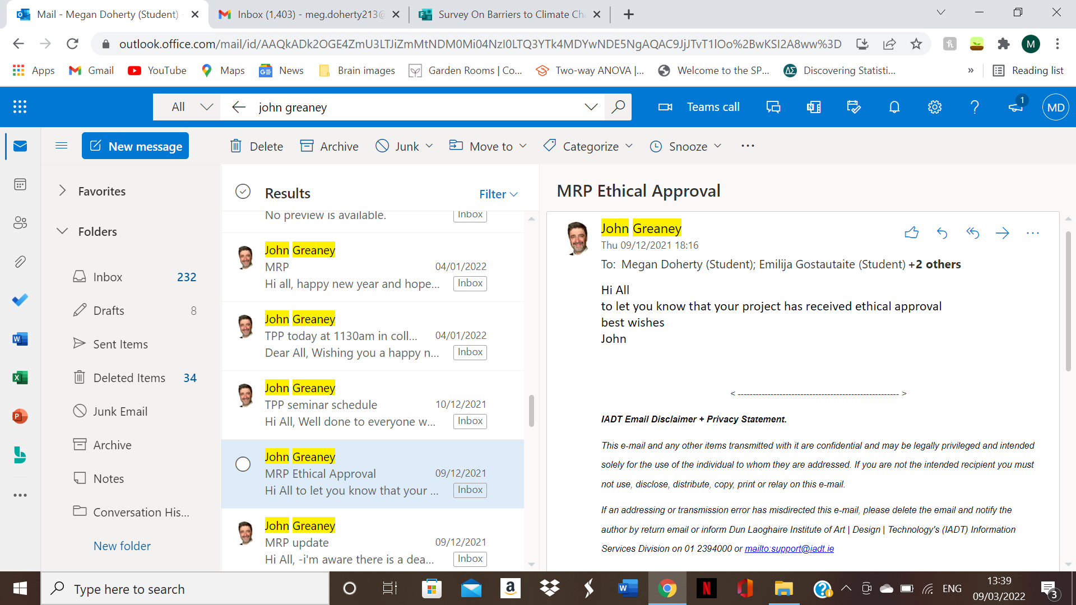

Appendix B: DTPEC Application Form 2021

Section 1: Project Information

Student Name: Megan Doherty
Student Email Address: N00180200@iadt.ie
Supervisor Name: John Greaney
Working Project Title: Has Pro-Environmental Behaviour Increased in Irish College Students Post the COVID-19 Pandemic?
Main Variables Being Investigated: Pro-environmental behaviour,

Section 2: External Agencies
Does your project involve recruitment from any external agency (e.g. a school, sports club, medical centre, voluntary organisation, or any other organisation outside of the IADT)? | Yes* | No  X
* You must include a letter from a senior manager of each organisation stating that you have approval to collect data within that organisation. Include copies each of these letters in the Appendices to your application. If the organisation has its own ethical review board (which is very common in some settings, such as hospitals), then you are also required to get ethical approval from that board prior to starting data collection, and to submit notice of this approval to your supervisor so that it can be forwarded on to the ethics committee. Some online forums also require permission to post requests for participants – make sure to check the relevant forum/organisation’s code of conduct or terms and conditions. You do not need to include approval letters if you are conducting recruitment using mainstream social media routes (e.g., Twitter, Instagram, Facebook, Snapchat, TikTok) to your own followers, and/or snowball sampling/word of mouth recruitment.

Section 3: Project Methodology – Please tick which type of project you are seeking approval from the DTPEC for. If your project involves mixed methods, then tick all which apply.
Route Type | Methodology | Tick here
Green Route (no direct contact with participants required, and no data is collected/recorded which could identify participants) | Theoretical paper / systematic literature review
 | Novel analysis of an existing dataset gathered by another researcher or group which you are certain has abided by appropriate ethical procedures for the relevant discipline
 | Observation of participants in a public place in which they could reasonably be expected to be observed by strangers or in an online space which does not require users to log in to access.
 | Content analysis of material which is publicly available and does not require users to log in to access content.
 | Other method without direct contact with participants **
Amber Route (direct contact with participants, but no additional ethical considerations beyond the minimum requirements) | Requirements gathering for and/or user testing of a prototype which is highly unlikely to cause any harm or distress to participants and which does not aim to collect data from a potentially vulnerable group
 | An experiment which is highly unlikely to cause any harm or distress to participants and which does not aim to collect data from a potentially vulnerable group
 | A survey/questionnaire design which is highly unlikely to cause any harm or distress to participants and which does not aim to collect data from a potentially vulnerable group | X
 | An observational study which is highly unlikely to cause any harm or distress to participants and which does not aim to collect data from a potentially vulnerable group
 | Content analysis research which is highly unlikely to cause any harm or distress to participants and which does not aim to collect data from a potentially vulnerable group | X
 | Interviews and/or focus groups which are highly unlikely to cause any harm or distress to participants and which do not aim to collect data from a potentially vulnerable group
 | Other method which is highly unlikely to cause any harm or distress to participants and which does not aim to collect data from a potentially vulnerable group **
Red Route (direct contact with participants, including one or more project aspects which require special ethical consideration) | Requirements gathering for and/or user testing of a prototype which may cause harm or distress to participants and/or which involves collecting data from any potentially vulnerable group
 | An experiment which may cause harm or distress to participants and/or which involves collecting data from any potentially vulnerable group
 | A survey/questionnaire design which may cause harm or distress to participants and/or which involves collecting data from any potentially vulnerable group
 | An observational study which may cause harm or distress to participants and/or which involves collecting data from any potentially vulnerable group
 | Content analysis research which may cause harm or distress to participants and/or which involves collecting data from any potentially vulnerable group
 | Interviews and/or focus groups which may cause harm or distress to participants and/or which involves collecting data from any potentially vulnerable group
 | Other method which may cause harm or distress to participants and/or which involves collecting data from any potentially vulnerable group **
** If you are using a methodology not listed above then provide a short description (fewer than 100 words) here:

Section 4: Checklist of Attached Appendices and Other Completed Sections
Applicable Project Ethics Route Colour Guide |  |  |  |  | Section / Item | I have attached this item/completed this section | I have checked with my supervisor and we have agreed that this item/section is not relevant to my project
 |  |  |  | 1 | Section 1 | X
 |  |  |  | 2 | Section 2 | X
 |  |  |  | 3 | Section 3 | X
 |  |  |  | 4 | Section 4 | X
 |  |  |  | 5 | Letters of permission from any external agencies to be used for data collection |  | X
 |  |  |  | 6 | Statement of approval from ethical review boards in external agencies |  | X
 |  |  |  | 7 | Section 5 (Green Route Projects only)
 |  |  |  | 8 | Section 6 (Amber and Red Route Projects only) | X
 |  |  |  | 9 | Section 7 (Amber Route Projects only) | X
 |  |  |  | 10 | Section 8 (Red Route Projects only)
 |  |  |  | 11 | Section 9 (Red Route Projects only)
 |  |  |  | 12 | Evidence of why you need to complete a Red Route Project (see note in Section 8)
 |  |  |  | 13 | Project Information Sheet (Red Route Projects only)
 |  |  |  | 14 | Project Consent Form (Red Route Projects only)
 |  |  |  | 15 | Project Demographic Questionnaire (Red Route Projects only)
 |  |  |  | 16 | All Other Questionnaires and Data Collection Materials (Red Route Projects only)
 |  |  |  | 17 | Project Debrief (Red Route Projects only)

Section 5: Declaration of a Green Route project
I hereby declare that [all of / this aspect of (delete as appropriate)] my project involves no direct interaction between me and any research participants, and that having checked with my supervisor, that I do not need to seek informed consent from those whose data I use in my research. In addition, I will ensure that all data which I do gather is held in a manner which is compliant with GDPR, and will be deleted once it is no longer required (and definitely within 6 years of collection). At all times my study will be conducted in adherence to the ethical policies of the Psychological Society of Ireland and the British Psychological Society.
Student Signature: _________________________________ Date: _______________________
Section 6: Confirmation of Adherence to Basic Ethical Principles for Amber and Red Route Projects
Complete the Table below with guidance from your supervisor. If you need to tick any of the ‘red’ boxes, then your project must be submitted under the ‘Red Route’.

 |  | Yes | No | N/A
6.1 | I will describe the main research procedures to participants in advance so that they know what to expect. I will use the sample Information Sheet provided by DTPEC to do this. | X
6.2 | I will tell participants that their participation is voluntary. | X
6.3 | I will obtain written consent from participants using a ‘tick’ consent form which follows the current template provided by DTPEC prior to starting data collection. | X
6.4 | I will verify that participants still wish to include their data in online studies by including a final indicator of consent at the end of the questions. | X
6.5 | If my research involves content analysis or observation in any private or partially private setting then I will ensure to obtain informed consent prior to collecting data. | X
6.6 | I will explain to participants that they can withdraw from the study at any time and for any reason. | X
6.7 | I will ensure that participants know that they can refrain from answering any question that they don’t want to, even if this is part of a psychometric scale. | X
6.8 | If using an online data collection method I will ensure that the only questions which require answers in order to proceed are the questions relating to providing informed consent, and I will ensure that participants are provided with an option which indicates that they do not give their consent. | X
6.9 | I will inform participants that their data will be treated with full confidentiality, and that, if published, it will not be identifiable as theirs. | X
6.10 | I will debrief participants at the end of their participation (i.e. give them a brief explanation of the study, whether or not deception was involved) following the current template provided by DTPEC | X
6.11 | I will obtain passive consent from parents/guardians for studies involving people aged between 16 and 18 years, as well as active consent from the participant and their school/organisation | X
6.12 | I will obtain active consent from parents/guardians for studies involving people aged under 16 years. Where feasible I will also obtain active consent from the participant themselves. I will ensure that the parent/guardian or their nominee (e.g. a teacher) will be present throughout the data collection period. | X
6.13 | I will ensure that my project supervisor has full access to the data that I collect and will only use data collection software which permits this. | X
6.14 | I will ensure that my project supervisor retains full rights to the data collected, including the ability to delete all data at any time, and that third-parties (e.g., software companies) will not ‘own’ the data collected. | X
6.15 | I will ensure that participants in studies involving Virtual Reality (VR) are not susceptible to extreme motion sickness or other physical conditions which may result in harm to the participants. I will ensure that a chaperone is present during VR sessions, and that the participant has the option of also having a nominee of their choosing present as well. | X
6.16 | I will ensure that any equipment used in this study is cleaned and disinfected after each participant, and that appropriate hygienic barriers (e.g. masks) are used by all participants | X
6.17 | Is there any realistic risk of any participant experiencing either physical or psychological distress or discomfort? |  | X
6.18 | I plan to use animals as part of my research study |  | X
6.19 | I plan to tell participants their results on a task or scale which I am using in my research. |  | X
6.20 | I am researching a sensitive topic which may cause some participants distress (such as, but not limited to, religion, sexuality, alcohol, crime, drugs, mental health, physical health, parenting, family relationships) |  | X
6.21 | One or more aspects of my study is designed to change the mental state of participants in a negative way (such as inducing aggression, frustration, sadness, etc.) |  | X
6.22 | My study involves deception or deliberately misleading participants in some way. |  | X
6.23 | My target population includes people who have learning or communication difficulties |  | X
6.24 | My target population includes patients (either inpatient or outpatient) |  | X
6.25 | My target population includes people in custody |  | X
6.26 | My target population includes people who may feel under personal or professional pressure to take part in my research (for example, close friends; family; employees or staff of managers or school principals who may support the research). |  | X

Section 7: Declaration of an Amber Route project
I hereby declare that [all of / this aspect of (delete as appropriate)] my project involves no risk of physical, emotional, social or cognitive harm to participants; that I will obtain full informed consent from all participants and provide a full debrief afterwards (using the templates provided); that I will provide full anonymity and/or confidentiality to participants; and that my participants are not a potentially vulnerable population. In addition, I will ensure that all data which I gather is held in a manner which is compliant with GDPR, and will be deleted once it is no longer required (and definitely within 6 years of collection). At all times my study will be conducted in adherence to the ethical policies of the Psychological Society of Ireland and the British Psychological Society.
Student Signature: Megan Doherty Date: 16/11/2021

Appendix C: Approval to use data (Cassoni, 2020)

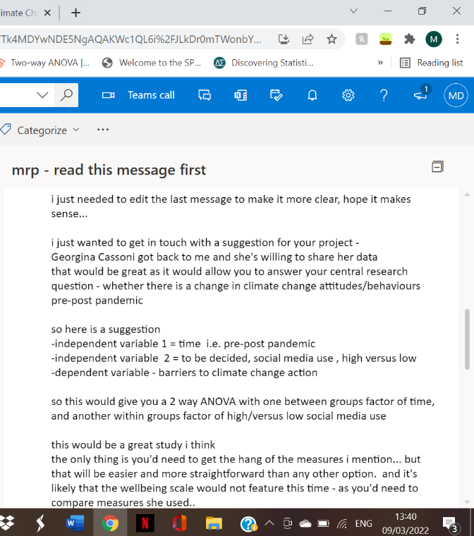

Appendix D: Information Sheet, Consent, Debrief

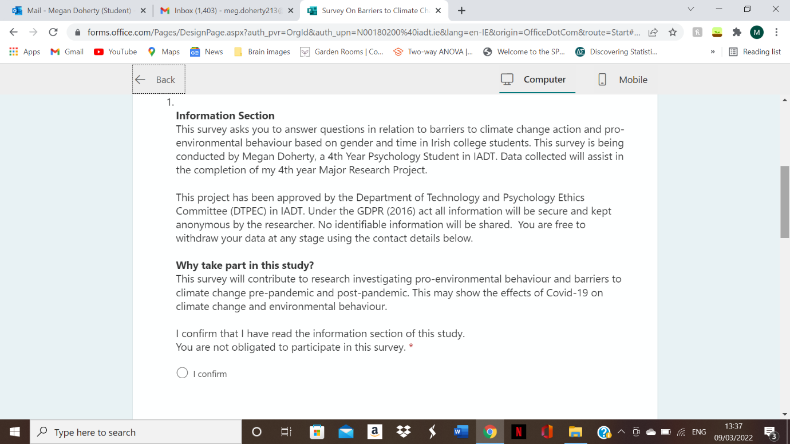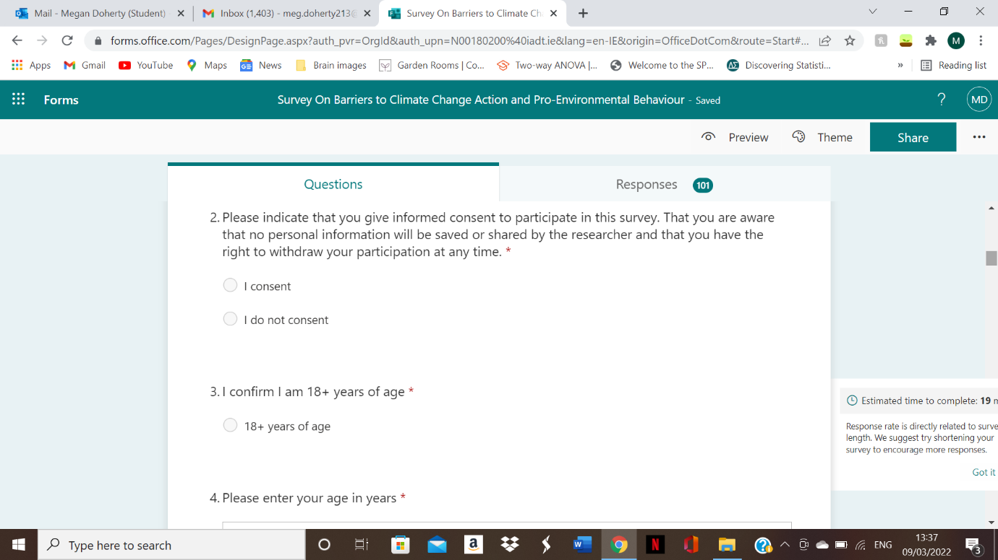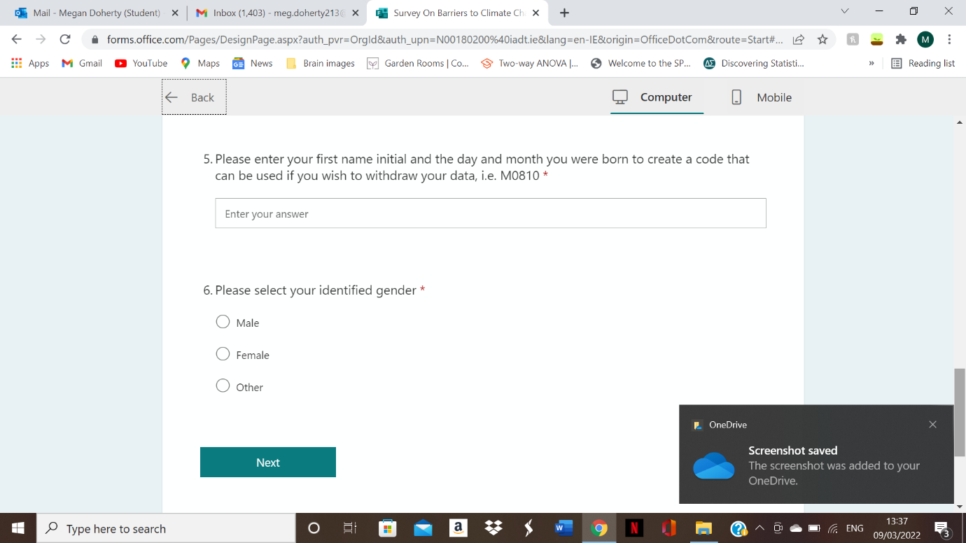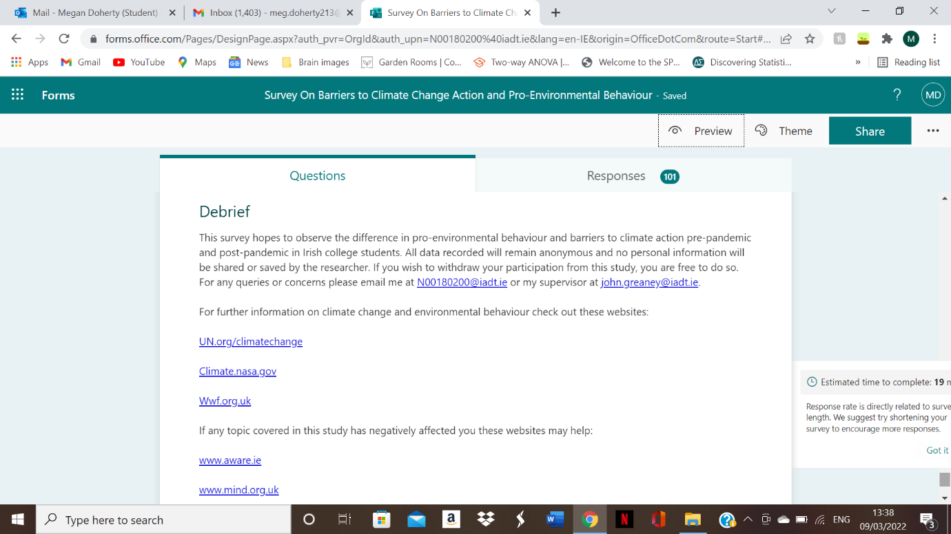

Appendix E: Copy of Stevenson’s Pro-Environmental Behaviour Scale (2015) Questions nine and ten were combined in the current survey.

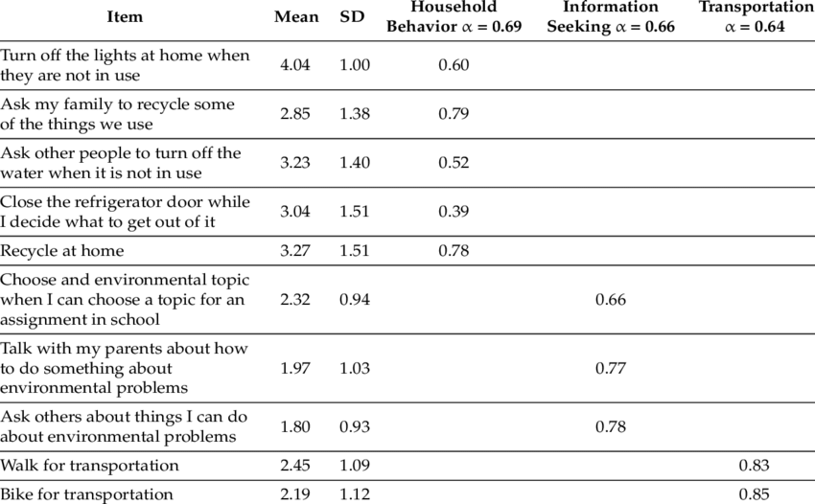

Appendix F: Copy of The Dragons of Inaction Psychological Barrier Scale (Lacroix, Gifford, & Chen, 2019) Reversed item questions were removed from the current survey.
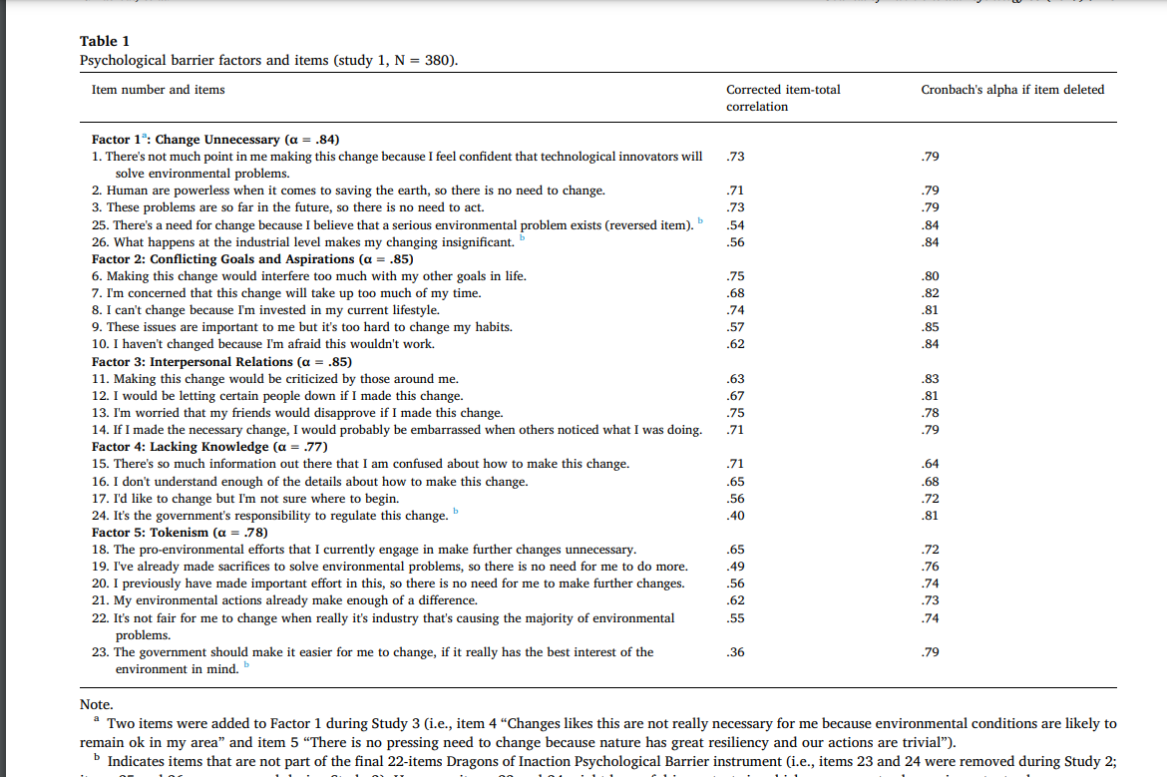

Appendix G: SPSS Output

Explore

Notes
Output Created |  | 07-MAR-2022 18:22:05
Comments
Input | Active Dataset | DataSet2
Input | Filter | <none>
Input | Weight | <none>
Input | Split File | <none>
Input | N of Rows in Working Data File | 178
Missing Value Handling | Definition of Missing | User-defined missing values for dependent variables are treated as missing.
Missing Value Handling | Cases Used | Statistics are based on cases with no missing values for any dependent variable or factor used.
Syntax |  | EXAMINE VARIABLES=DOIS BY Gender Time  /PLOT BOXPLOT STEMLEAF  /COMPARE GROUPS  /STATISTICS DESCRIPTIVES  /CINTERVAL 95  /MISSING LISTWISE  /NOTOTAL.
Resources | Processor Time | 00:00:00.39
Resources | Elapsed Time | 00:00:00.40

Gender

Case Processing Summary
 | Gender | Cases
 | Gender | Valid |  | Missing |  | Total
 | Gender | N | Percent | N | Percent | N | Percent
DOIS | Female | 116 | 100.0% | 0 | 0.0% | 116 | 100.0%
DOIS | Male | 60 | 100.0% | 0 | 0.0% | 60 | 100.0%

Descriptives
 | Gender |  |  | Statistic | Std. Error
DOIS | Female | Mean |  | 54.1638 | 1.20251
DOIS | Female | 95% Confidence Interval for Mean | Lower Bound | 51.7819
DOIS | Female | 95% Confidence Interval for Mean | Upper Bound | 56.5457
DOIS | Female | 5% Trimmed Mean |  | 53.7989
DOIS | Female | Median |  | 54.0000
DOIS | Female | Variance |  | 167.738
DOIS | Female | Std. Deviation |  | 12.95138
DOIS | Female | Minimum |  | 27.00
DOIS | Female | Maximum |  | 89.00
DOIS | Female | Range |  | 62.00
DOIS | Female | Interquartile Range |  | 17.00
DOIS | Female | Skewness |  | .333 | .225
DOIS | Female | Kurtosis |  | -.140 | .446
DOIS | Male | Mean |  | 60.0667 | 2.42746
DOIS | Male | 95% Confidence Interval for Mean | Lower Bound | 55.2093
DOIS | Male | 95% Confidence Interval for Mean | Upper Bound | 64.9240
DOIS | Male | 5% Trimmed Mean |  | 59.9074
DOIS | Male | Median |  | 60.5000
DOIS | Male | Variance |  | 353.555
DOIS | Male | Std. Deviation |  | 18.80305
DOIS | Male | Minimum |  | 22.00
DOIS | Male | Maximum |  | 117.00
DOIS | Male | Range |  | 95.00
DOIS | Male | Interquartile Range |  | 26.75
DOIS | Male | Skewness |  | .193 | .309
DOIS | Male | Kurtosis |  | .288 | .608

DOIS

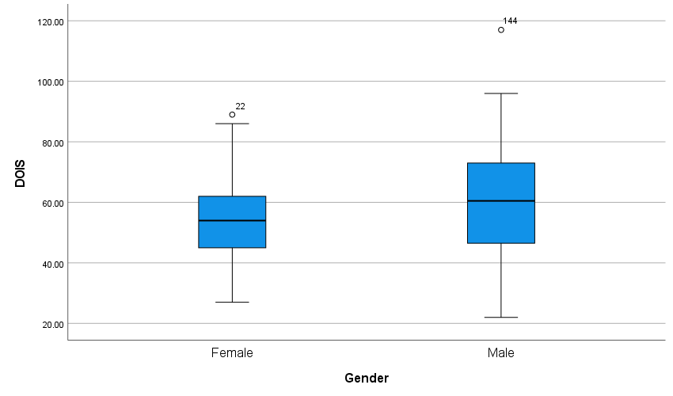

Time

Case Processing Summary
 | Time | Cases
 | Time | Valid |  | Missing |  | Total
 | Time | N | Percent | N | Percent | N | Percent
DOIS | TIME 1 | 100 | 100.0% | 0 | 0.0% | 100 | 100.0%
DOIS | TIME 2 | 76 | 100.0% | 0 | 0.0% | 76 | 100.0%

Descriptives
 | Time |  |  | Statistic | Std. Error
DOIS | TIME 1 | Mean |  | 52.3100 | 1.50640
DOIS | TIME 1 | 95% Confidence Interval for Mean | Lower Bound | 49.3210
DOIS | TIME 1 | 95% Confidence Interval for Mean | Upper Bound | 55.2990
DOIS | TIME 1 | 5% Trimmed Mean |  | 51.8889
DOIS | TIME 1 | Median |  | 52.5000
DOIS | TIME 1 | Variance |  | 226.923
DOIS | TIME 1 | Std. Deviation |  | 15.06397
DOIS | TIME 1 | Minimum |  | 22.00
DOIS | TIME 1 | Maximum |  | 117.00
DOIS | TIME 1 | Range |  | 95.00
DOIS | TIME 1 | Interquartile Range |  | 20.75
DOIS | TIME 1 | Skewness |  | .750 | .241
DOIS | TIME 1 | Kurtosis |  | 2.245 | .478
DOIS | TIME 2 | Mean |  | 61.2632 | 1.65438
DOIS | TIME 2 | 95% Confidence Interval for Mean | Lower Bound | 57.9675
DOIS | TIME 2 | 95% Confidence Interval for Mean | Upper Bound | 64.5589
DOIS | TIME 2 | 5% Trimmed Mean |  | 61.1374
DOIS | TIME 2 | Median |  | 59.0000
DOIS | TIME 2 | Variance |  | 208.010
DOIS | TIME 2 | Std. Deviation |  | 14.42255
DOIS | TIME 2 | Minimum |  | 34.00
DOIS | TIME 2 | Maximum |  | 96.00
DOIS | TIME 2 | Range |  | 62.00
DOIS | TIME 2 | Interquartile Range |  | 21.75
DOIS | TIME 2 | Skewness |  | .246 | .276
DOIS | TIME 2 | Kurtosis |  | -.626 | .545

DOIS

Boxplots

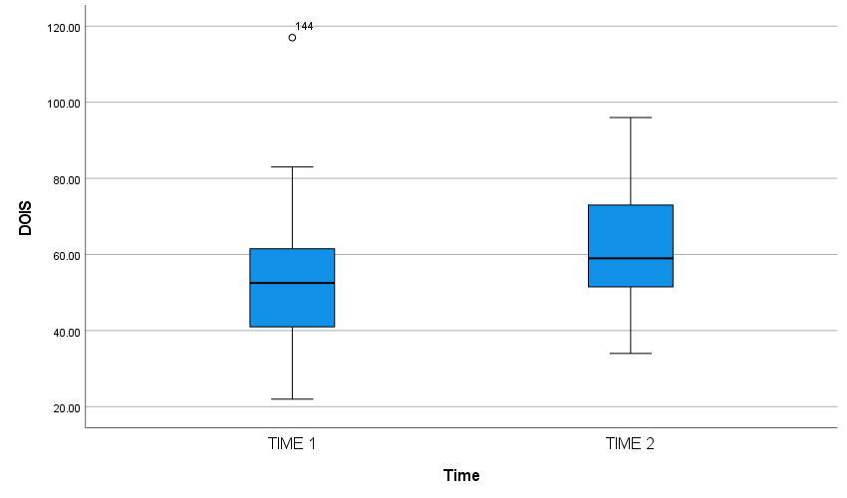

Univariate Analysis of Variance

Notes
Output Created |  | 07-MAR-2022 18:29:05
Comments
Input | Active Dataset | DataSet2
Input | Filter | <none>
Input | Weight | <none>
Input | Split File | <none>
Input | N of Rows in Working Data File | 178
Missing Value Handling | Definition of Missing | User-defined missing values are treated as missing.
Missing Value Handling | Cases Used | Statistics are based on all cases with valid data for all variables in the model.
Syntax |  | UNIANOVA DOIS BY Gender Time  /METHOD=SSTYPE(3)  /INTERCEPT=INCLUDE  /POSTHOC=Gender Time(TUKEY SCHEFFE)  /PLOT=PROFILE(Gender*Time) TYPE=LINE ERRORBAR=NO MEANREFERENCE=NO YAXIS=AUTO  /PRINT ETASQ DESCRIPTIVE HOMOGENEITY OPOWER  /CRITERIA=ALPHA(.05)  /DESIGN=Gender Time Gender*Time.
Resources | Processor Time | 00:00:00.23
Resources | Elapsed Time | 00:00:00.20

Between-Subjects Factors
 |  | Value Label | N
Gender | 1.00 | Female | 116
Gender | 2.00 | Male | 60
Time | 2020.00 | TIME 1 | 100
Time | 2022.00 | TIME 2 | 76

Descriptive Statistics
Dependent Variable: DOIS
Gender | Time | Mean | Std. Deviation | N
Female | TIME 1 | 50.4921 | 11.51559 | 63
Female | TIME 2 | 58.5283 | 13.30790 | 53
Female | Total | 54.1638 | 12.95138 | 116
Male | TIME 1 | 55.4054 | 19.49424 | 37
Male | TIME 2 | 67.5652 | 15.19816 | 23
Male | Total | 60.0667 | 18.80305 | 60
Total | TIME 1 | 52.3100 | 15.06397 | 100
Total | TIME 2 | 61.2632 | 14.42255 | 76
Total | Total | 56.1761 | 15.40455 | 176

Levene's Test of Equality of Error Variances^{a,b}
 |  | Levene Statistic | df1 | df2 | Sig.
DOIS | Based on Mean | 4.526 | 3 | 172 | .004
DOIS | Based on Median | 4.232 | 3 | 172 | .006
DOIS | Based on Median and with adjusted df | 4.232 | 3 | 140.420 | .007
DOIS | Based on trimmed mean | 4.518 | 3 | 172 | .004
Tests the null hypothesis that the error variance of the dependent variable is equal across groups.
a. Dependent variable: DOIS
b. Design: Intercept + Gender + Time + Gender * Time

Tests of Between-Subjects Effects
Dependent Variable: DOIS
Source | Type III Sum of Squares | df | Mean Square | F | Sig. | Partial Eta Squared | Noncent. Parameter | Observed Power^{b}
Corrected Model | 5334.015ª | 3 | 1778.005 | 8.449 | .000 | .128 | 25.348 | .993
Intercept | 511370.521 | 1 | 511370.521 | 2430.151 | .000 | .934 | 2430.151 | 1.000
Gender | 1849.089 | 1 | 1849.089 | 8.787 | .003 | .049 | 8.787 | .838
Time | 3875.488 | 1 | 3875.488 | 18.417 | .000 | .097 | 18.417 | .989
Gender * Time | 161.563 | 1 | 161.563 | .768 | .382 | .004 | .768 | .140
Error | 36193.525 | 172 | 210.427
Total | 596941.000 | 176
Corrected Total | 41527.540 | 175
a. R Squared = .128 (Adjusted R Squared = .113)
b. Computed using alpha = .05

Profile Plots

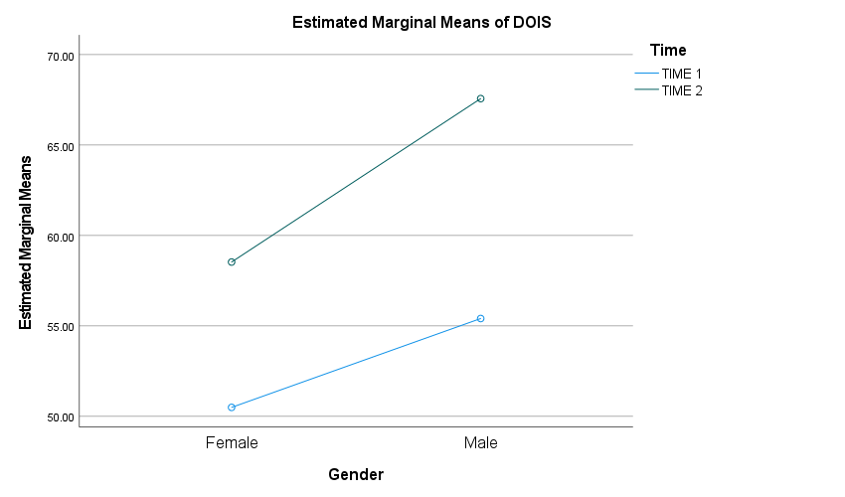

Oneway

Notes
Output Created |  | 07-MAR-2022 18:34:09
Comments
Input | Active Dataset | DataSet2
Input | Filter | <none>
Input | Weight | <none>
Input | Split File | <none>
Input | N of Rows in Working Data File | 178
Missing Value Handling | Definition of Missing | User-defined missing values are treated as missing.
Missing Value Handling | Cases Used | Statistics for each analysis are based on cases with no missing data for any variable in the analysis.
Syntax |  | ONEWAY PEBS BY Gender  /STATISTICS DESCRIPTIVES HOMOGENEITY  /PLOT MEANS  /MISSING ANALYSIS  /CRITERIA=CILEVEL(0.95).
Resources | Processor Time | 00:00:00.22
Resources | Elapsed Time | 00:00:00.15

Descriptives
PEBS
 | N | Mean | Std. Deviation | Std. Error | 95% Confidence Interval for Mean |  | Minimum | Maximum
 |  |  |  |  | Lower Bound | Upper Bound | Minimum | Maximum
Female | 53 | 25.7170 | 4.25792 | .58487 | 24.5434 | 26.8906 | 10.00 | 33.00
Male | 23 | 22.2174 | 4.49198 | .93664 | 20.2749 | 24.1599 | 9.00 | 30.00
Total | 76 | 24.6579 | 4.59435 | .52701 | 23.6080 | 25.7077 | 9.00 | 33.00

Tests of Homogeneity of Variances
 |  | Levene Statistic | df1 | df2 | Sig.
PEBS | Based on Mean | .039 | 1 | 74 | .844
PEBS | Based on Median | .057 | 1 | 74 | .813
PEBS | Based on Median and with adjusted df | .057 | 1 | 73.740 | .813
PEBS | Based on trimmed mean | .067 | 1 | 74 | .796

ANOVA
PEBS
 | Sum of Squares | df | Mean Square | F | Sig.
Between Groups | 196.438 | 1 | 196.438 | 10.483 | .002
Within Groups | 1386.668 | 74 | 18.739
Total | 1583.105 | 75

Means Plots

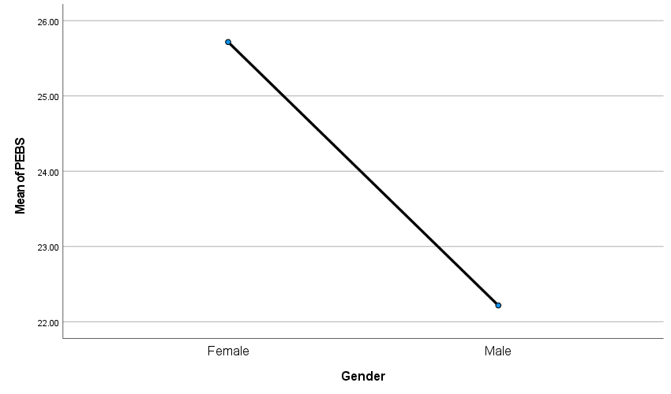

Correlations

Notes
Output Created |  | 07-MAR-2022 18:35:00
Comments
Input | Active Dataset | DataSet2
Input | Filter | <none>
Input | Weight | <none>
Input | Split File | <none>
Input | N of Rows in Working Data File | 178
Missing Value Handling | Definition of Missing | User-defined missing values are treated as missing.
Missing Value Handling | Cases Used | Statistics for each pair of variables are based on all the cases with valid data for that pair.
Syntax |  | CORRELATIONS  /VARIABLES=PEBS DOIS  /PRINT=TWOTAIL NOSIG FULL  /STATISTICS DESCRIPTIVES  /MISSING=PAIRWISE.
Resources | Processor Time | 00:00:00.02
Resources | Elapsed Time | 00:00:00.02

Descriptive Statistics
 | Mean | Std. Deviation | N
PEBS | 24.6579 | 4.59435 | 76
DOIS | 56.1761 | 15.40455 | 176

Correlations
 |  | PEBS | DOIS
PEBS | Pearson Correlation | 1 | -.278*
PEBS | Sig. (2-tailed) |  | .015
PEBS | N | 76 | 76
DOIS | Pearson Correlation | -.278* | 1
DOIS | Sig. (2-tailed) | .015
DOIS | N | 76 | 176
*. Correlation is significant at the 0.05 level (2-tailed).

