

DL835 BSc (Hons) in Creative Media Technologies – 2021/2022

Year 4 Project module

Title of project: Struggle +Alarm (Safety device)

Your name: Joseph Ajayi
Your student number: N00181918
Supervisor: supervisor’s name:
Paul Comiskey

Declaration

DECLARATION:
I am aware of the Institute’s policy on plagiarism and certify that this thesis is my own work.
Student: Joseph Ajayi
Signed

Acknowledgements
I want to take this opportunity to say thank you to my supervisor Paul Comiskey, he was very helpful in getting this project up and running.
Abstract
The aim of this project was to create a safety device which helps an individual feel safe in a public or private environment.
The device will be able to send a message asking for help to their friend or family and transmit their location.
The purpose of the application is to enable people a sense of safety wherever they are.
The steps involved in the construction of the system were research, design, and testing were carried out throughout and after implementation. Results from the testing show that the system can send a message using more than one micro bit, one as a transmitter and one as a receiver.
Further work that could be carried out include adding a GPS module that would be able to get the exact location.

Table of Contents
1 Introduction 1
2 Research 2
2.1 Introduction 2
2.2 Technology 2
2.3 ESP 8266 IC 2
2.4 LED Operation 3
2.5 Applications 3
2.6 Background to Requirements 3
2.7 Similar Systems 3
2.8 Interviews 3
2.9 List of requirements 3
2.10 Conclusion 3
3 Design 4
3.1 Introduction 4
3.2 Diagrams and Schematics 4
3.2.1 Block Diagram 4
3.2.2 High level schematic 5
3.2.3 Lower level schematic 1 5
3.2.4 Lower level schematic 2 5
3.3 Components 6
3.4 Software Design 6
3.5 Conclusion 6
4 Implementation 7
4.1 Introduction 7
4.2 Safety 7
4.2.1 Electrocution/Electric shock 7
4.2.2 Fire 7
4.2.3 Cutting injuries 7
4.2.4 Drilling injuries 7
4.2.5 Heavy equipment 7
4.2.6 Burn injury 7
4.2.7 Fumes 7
4.2.8 Covid-19 7
4.3 Prototype 1 8
4.3.1 Process 8
4.3.2 Features 8
4.3.3 Issues 8
4.3.4 Resolution of Issues 8
4.4 Prototype 2 8
4.4.1 Process 8
4.4.2 Features 9
4.4.3 Issues 9
4.4.4 Resolution of Issues 9
4.5 Prototype 3 9
4.5.1 Process 9
4.5.2 Features 9
4.5.3 Issues 9
4.5.4 Resolution of Issues 9
4.6 Conclusion 9
5 Testing & Results 10
5.1 Introduction 10
5.2 Test set up 10
5.3 Hardware testing 10
5.4 Software testing 10
5.4.1 Unit testing 10
5.4.2 Integration testing 10
5.4.3 Systems testing 11
5.5 Conclusion 11
6 Conclusion 12
References 13
Appendix 1 14

Introduction
The struggle alarm is a safety device that works using micro: bits microcontroller. The purpose of this device is to ensure safety especially for individuals who cannot defend themselves in a situation where they don’t feel safe.
A single click of the button on this device triggers an alarm with a volume of up to 80 dB and above which can draw the attention of people in the area and hopefully scare off the attacker in time of danger. It also comprises GPS tracker that transmits the location of the device and sends a message to a designated phone number asking for help.
The device should be able to fit into hidden places such as clothing, strap of a bag, or hooked to a belt. The idea behind the project is based on recent news in Ireland of ladies being injected in the streets and their fear of not feeling safe. The device is not a massive guarantee for help but a little struggle device might save a life depending on the situation.

The project will use the following technologies, two micro bits, one as a transmitter and one as a receiver.

The Introduction is followed by the Research chapter which describes in depth the technologies that is used for the project. It explains the purpose of having two micro bits and what it is supposed to achieve.

There is then the Design chapter which explains the process of using the project from a user’s perspective.

The Implementation chapter details the instruction of the hardware (Micro bit) and the development of the software (Microbits.org). as well as stages passed through to achieve final results.

The Testing and Results chapter shows the actuation of micro: bits
Finally, the Conclusion gives an overview of the entire project, from the research chapter to the design and implementation chapter and then the testing and results. It also discusses future possibilities of the project.

Research

Introduction
Safety is in most cases a personal responsibility, as humans we should be aware of our surroundings and the situations we put ourselves in so as not to be a victim of crime. However, we can sometimes find ourselves in situations where we don’t feel very safe and we want to call for help, this device is built for situations like this. This research chapter summarises the importance of safety and the proposal of a modern and high-level technology to make people feel safe in a public or private environment. The objective is to implement a small safety device where a single click of the button on this device triggers an alarm with a volume of up to 80 dB and above which can draw the attention of people in the area and hopefully scare off the attacker in time of danger.

Technology
Area of research
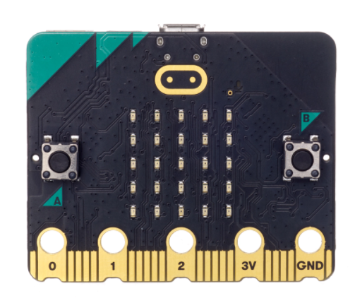

Fig1. Micro: bit

Figure 1. Micro: bit

BBC micro: bit is an open-source electronics board that's founded on easy to use software and hardware. The micro: bit runs on an ARM Cortex-M0 processor, it reads inputs and can translate them into outputs. They can be manipulated by a user sending instructions to the microcontroller on the board by writing python code on the python editor for micro:bit and uploading it to the board. The micro: bit has two programmable buttons, A and B to help provide user input. It also has a reset button, a touch logo, and it has a display of 25 programmable LEDs. It can be connected to a computer using a USB connector. The new micro:bit has built-in speaker, which makes it really easy to add sound and that is vital to this project because we need an alarm.
The micro bit has a radio antenna that can be used to transmit messages over a distance using radio waves to communicate wirelessly between two microbits. For this project two micro:bits are being used and they have been programmed to use this feature. One of them transmits a message asking for help and the other one receives the message, it will work with the push of button A which will also trigger the alarm. Button B will be used to clear the screen.

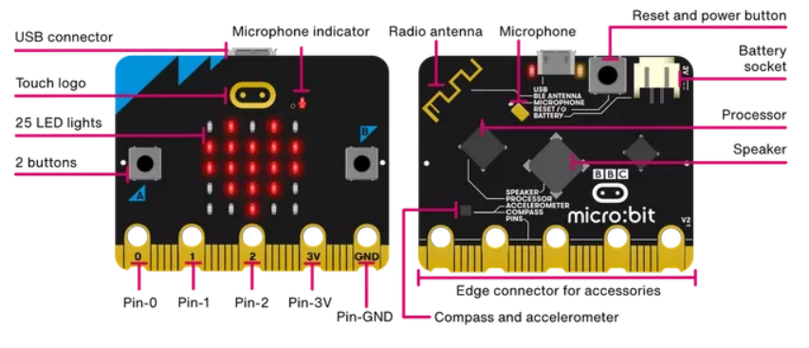
Fig2. Micro:bit v2

Figure 2 above shows the front and back of the half sized credit card micro:bit and labels of its features.

LED Operation
The LED is an important feature for this project as it is programmed to display the message being transmitted between the micro:bits. The microbit board has 25 LED lights arranged in a 5x5 grid, sufficient to display messages.

Applications

BBC MicroBit was initially designed to promote learning computer science in the UK and it was distributed for free in schools to encourage students learn about computer programming. Now it can be purchased by Programming Enthusiasts throughout the World.
It is mainly used by students and programming enthusiasts to create projects and enhance their programming skills. Common projects made with micro:bits include: Motorbike simulator, combination lock, temperature reading, step counter.

2.5 Background to Requirements
The struggle alarm is required to provide a sense of safety to individuals who don’t feel safe in an environment or can’t defend themselves.
The user pushes a button and it transmit a message to user with another device in the same group as well as triggering an alarm to scare off an attacker.

2.6 Similar Systems

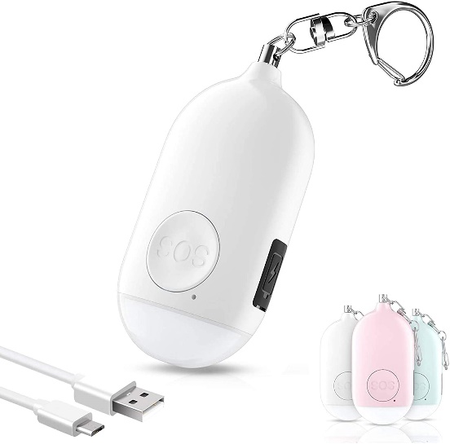
Fig3. Kimfly’s Invensdc-02-01 Self-Defense Keychain Alarm Siren.
In fig3. Kimfly’s Invensdc-02-01 Self-Defense Keychain Alarm Siren is a device that provides people with protection by the activation of an ear-piercing alarm.
Users can pull the contact pin or press the switch twice. Once a method’s chosen, it unleashes a 130db sound to let everyone know what’s happening.
It has a rechargeable lithium battery with 30-minute charge time and a USB cable.

It also functions as a usable LED flashlight. It has a portable and lightweight design for easy attachment to many objects.

2.7 List of requirements
For this project, a prototype for the struggle alarm is required. The device is meant to trigger an alarm with the click of a button and send a message to a receiver asking for help. It should be able to get the exact location of the user. To build this prototype, certain components are needed.
- 2 Microbits
- USB Connectors

• One Prototyping Bread Board
• One Arduino nano/Uno(ATMEGA328P)
• Soldering iron and solder
• Wires, jumper cables
• GPS module
• GSM module
• One 3V Power supply and Piezo buzzer

2.8 `1 Conclusion
This research chapter summarises the importance of safety and the proposal of a modern and high-level technology (safety device) to make users feel safe from crime. The research explains the various technical aspects of the microcontroller being used and components needed for the struggle alarm project. The research chapter discusses the project's aim, the requirements, and its application, the micro: bit and its application, and the similar systems presently available.

Design

Introduction
The purpose of the project is to give people a sense of safety no matter where they find themselves. It is mostly to offer protection for those who cannot defend themselves in tough situations.

Diagrams and Schematics

Block Diagram

Figure 4. Block diagram for user

As seen in figure 4. A shake feature as also been included in the project as well a touch logo feature for easy use. So when a user shakes the device it can trigger the alarm and send a message as well.

High level schematic

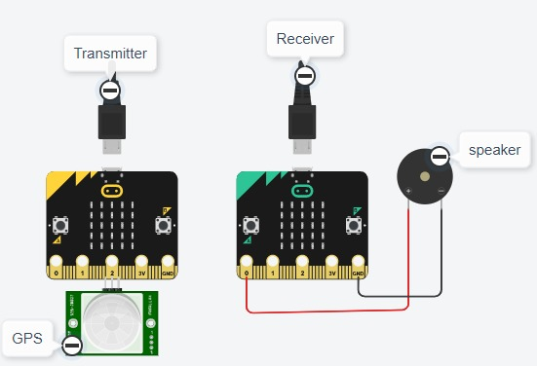

Figure 5. High level schematic

Lower level schematic 1

Figure 6. Block diagram for the process

As shown in Fig 6 above, the Lower level schematic 2, there are two micro:bits connected in the same group using the radio feature of the micro:bit, one as a transmitter and another as a receiver. Once it connected any message sent through the transmitter appears on the receiver and the alarm is triggered on both micro:bits. Button B on the receiver can be clicked to turn off the alarm and clear the screen.

Components

COMPONENTS | QUANTITIES
Micro:bit V2 (Transmitter) | One
Micro:bit V2 (Receiver) | One
USB Connector | Two

Software Design

The code below shows the actuation of the two micro: bits connected to the same group (2) using radio so as to ensure communication between the microcontrollers. The codes show what has been uploaded to the first micro: bit used for transmitting and the second used for receiving. Connect both microbits to a computer and press button A to display the message on the receiver and also trigger the alarm. Button B resets the device and clears screen.

CODES

Transmitter
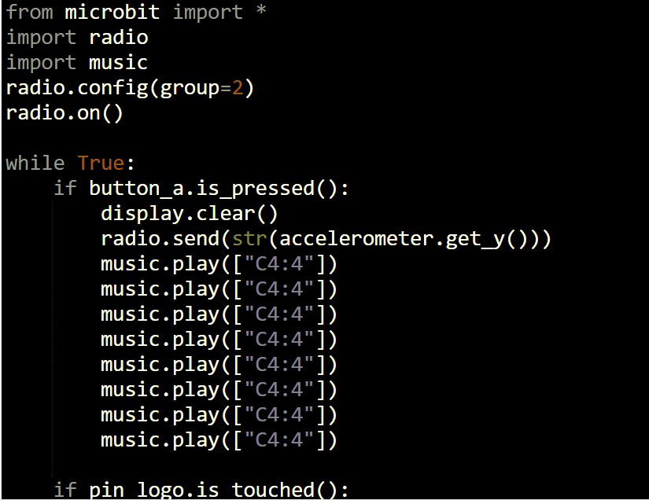
Fig 7. Transmitter code

Receiver

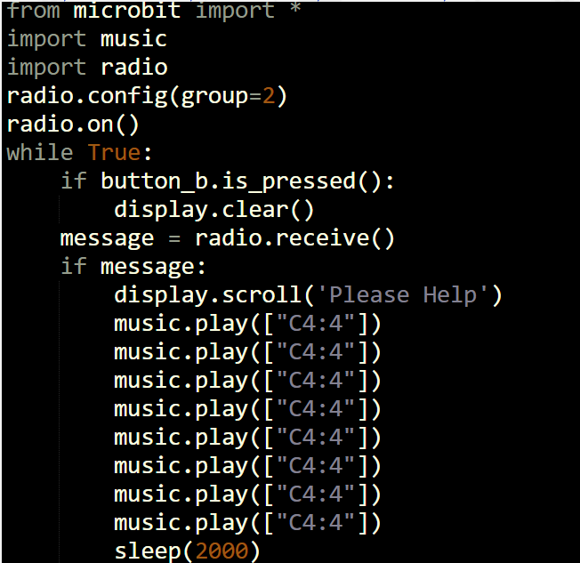

Fig 8. Receiver code.

Conclusion
The design chapter shows how the project works technically and from the users’ point of view. It shows the block diagram for the user, block diagram of the process, a schematic and a photo of what the project looks like. It explains how the project works, the user pushes a button and a message as well as an alarm is received on the receiving micro: bit.

Implementation

Introduction
This chapter describes the three prototypes and their development. This project was initially supposed to work with a Piezo buzzer, a GPS module and a GSM module. It was supposed to work such that when a button is pressed, it will be able to track the location of the user and send a message asking for help to a designated phone number. Unfortunately, the GPS and GSM module used were quite fiddly and burnt out. Given the lack of time, the micro:bits were opted for, but I would like explain the process passed through to achieve the final result of this project.

Safety

Electrocution/Electric shock
Using standard power supplies, one has to be careful when handling electricity. This project Is powered by a 3V Power supply across the components so the risk of electrocution is very low.

Fire
Using soldering iron, the risk of fire is very high if it is not carefully used and tended to. A soldering iron will be used to solder components to the prototyping board. After soldering the iron needs to be turned off and placed in its holder so it does not come in contact with any other material that could start a fire. Fire can be fatal and the injuries very severe.

Cutting injuries
All cutting carried out by a laser cuter. The risk of a cutting injury is very low.

Drilling injuries
When drilling, certain procedures have to be adhered to. There is a high risk of injury when drilling if it is not properly used by a professional or someone with experience using a drill. The injuries from a drilling accident can be very severe. For this project drilling is not required so the risk of an injury is zero.

Heavy equipment
Not applicable…

Burn injury
Using soldering irons can cause severe burns if there is an accident. The risk of burn injury is very high because the iron is open and extremely hot. Care has to be taken so It doesn’t come in contact with skin. Ensure that the iron is turned off as soon as it is done being used.

Fumes
Using soldering irons, you need solder as well, and when soldering with lead or other metals used in soldering, the fumes produced are hazardous. If inhaled it can result in occupational asthma as well as cause eye and upper respiratory tract infection. A safety goggle should be worn and the room it is being used in should be properly ventilated.

Covid-19
Control measures to reduce the likelihood of contracting Covid-19 during the course of developing the project was to order most of the components online and work on the project from home.

Prototype 1

Process
The first prototype is the actuation of the piezo buzzer and the button. The button is connected to digital pin 7 on the Arduino, also connected to a 4.7kohm resistor which goes to gnd. The button is connected to negative side of the buzzer and the LED which also goes to ground on the breadboard rail and the Arduino. The positive side of the buzzer is connected to pin 3 on the Arduino and the LED is connected to digital pin 6. 5V and GND is connected from the Arduino to the breadboard rails.

CODES

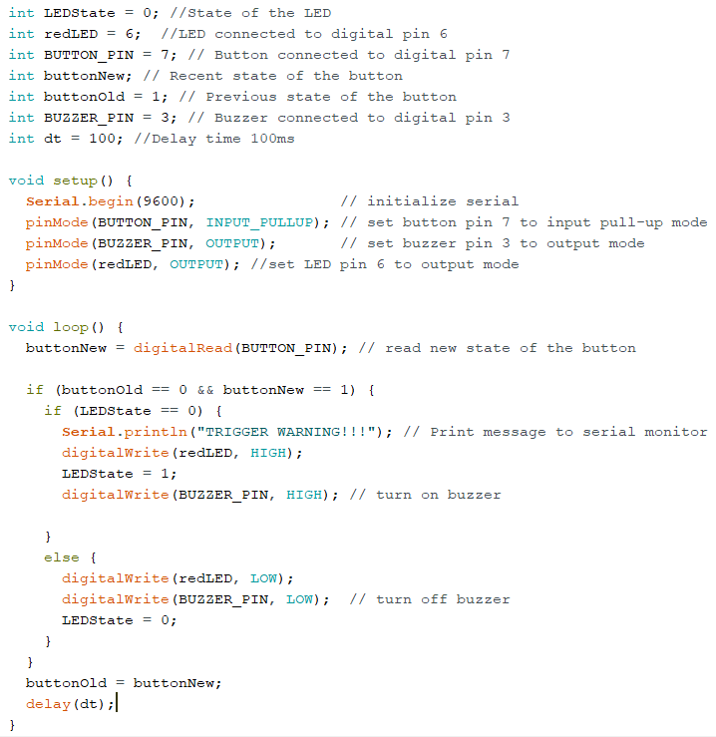
Fig 9. Piezo buzzer code

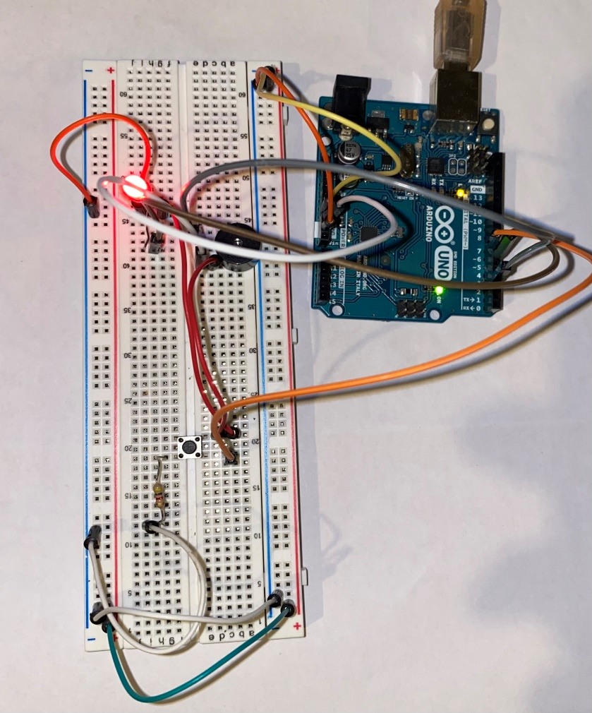
Fig 10. Piezo buzzer circuit

Features
- Piezo Buzzer
Button
LED
Jump cables

Issues
There was not a lot of issues with the buzzer. The only issue I encountered was late delivery of the ordered buzzer.

Resolution of Issues
Started research and did the work when the buzzer arrived.

Prototype 2

Process
The second prototype is the actuation of the GPS Module. To test this module, pin 4 of the Arduino was connected to TX on the GPS module (Neo6m), pin 3 was connected to the RX of the module and ground connected to ground(gnd). VCC pin on the GPS module was connected to 3.3V on the Arduino.

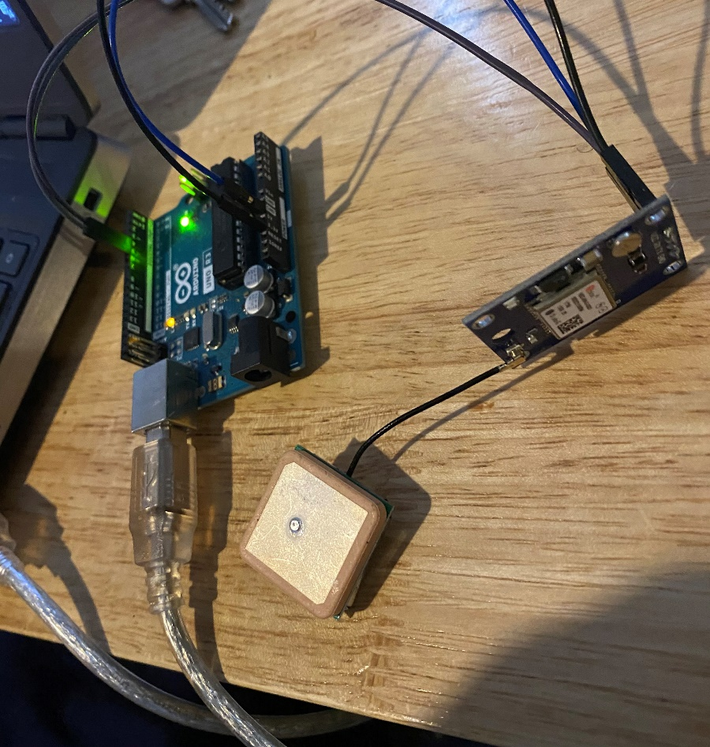
Fig 11. GPS module connected to the Arduino.

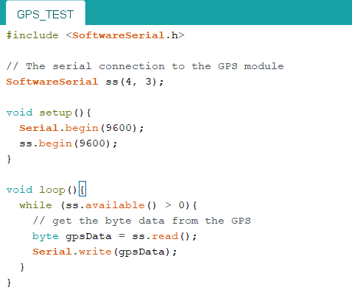
Fig 12. GPS testing code.

Features
- GPS module (NEO-6M)
- Antenna
- Arduino Uno
- 4 Jump cable

Issues
The connected was successful, the code compiled and uploaded successfully but it does not display and GPS data. After troubleshooting, it was concluded that the module might be burnt out.

Resolution of Issues
To resolve this, another module was purchased and tried and the same problem occurred, which resulted into opting for Micro: bits due to lack of time to complete the project.

Prototype 3

Process
The third prototype has to do with the GSM module (SIM 800L). Using a Arduino Uno, Pin 3 is connected to Tx on the GSM module, and pin 2 is connected to Rx on the module. Ground is connected to ground and vcc is connected to 3 volts power supply. In other not to burn out the GSM module I have connected it to a adjustable buck module regulator and given it 3V, tested using a multimeter.

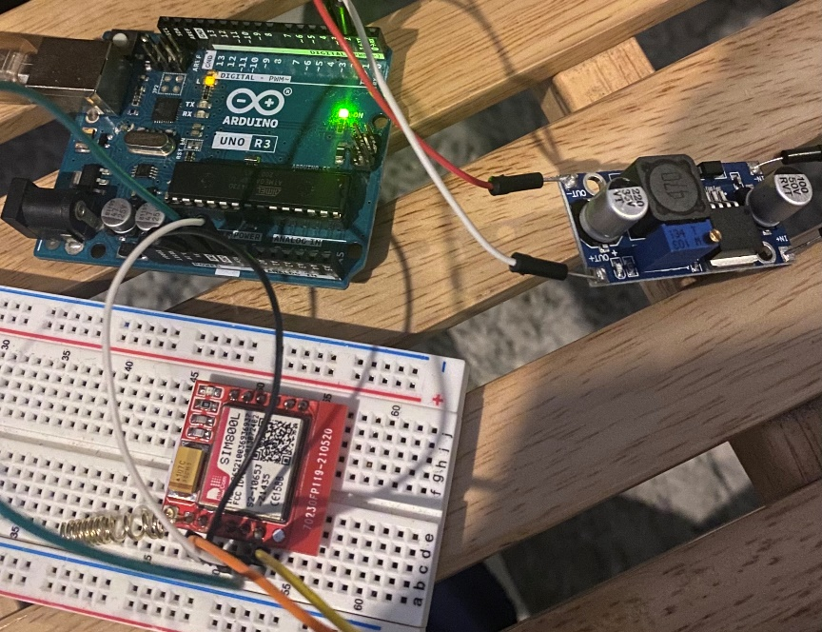

Fig 13. GSM module connected to the Arduino

CODES

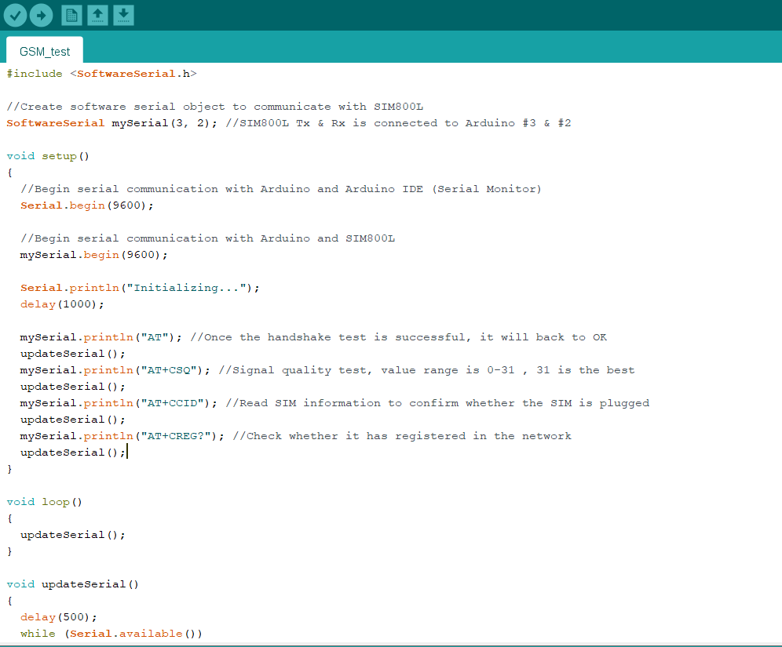
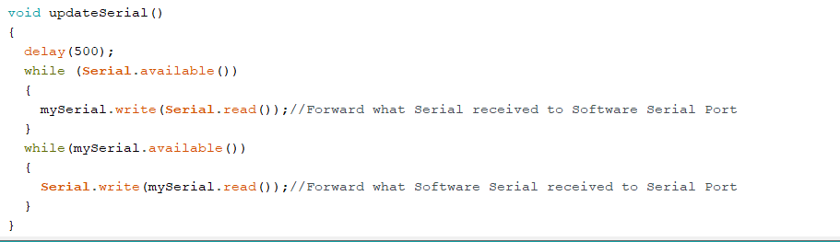

Fig 14. Codes for GSM module

Features
- SIM 800L GSM module

Issues
First problem I ran into was late delivery of the module. After the module was delivered, it was soldered and I began testing. The module just stopped working even though I had connected the buck converter to reduce the voltage to avoid burning out.

Resolution of Issues
To resolve the issue, the Microbits were opted for due to lack of time to complete the project.

Conclusion

This chapter describes step by step the progress of the project by explaining the prototypes involved, and the problems faced along the way. It details the reason for using Micro:bits for the final project.

Testing & Results

Introduction
After testing the Microbit, it worked as intended. Clicking button A on the transmitter sends a message to the receiver and triggers the alarm.

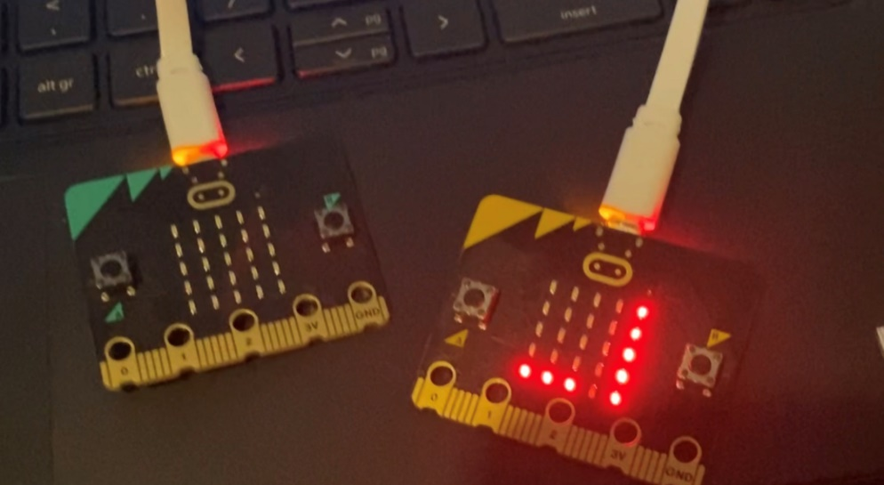Fig 14. Microbit test

Test set up

Fig 15. Test set up

Conclusion

This chapter describes how the system was tested. It shows how the message is being transmitted from one microbit to the other using the radio feature. When the micro:bits are programmed under the same group it allows for easy communication between them, hence how we were able to transmit a message from one microbit to the other.

Conclusion

This report has described the development of a safety device which is capable of giving individuals who cannot defend themselves a sense of safety.
The system was developed using the 2 micro:bits grouped together.
The steps involved in the project had been outlined in the report. The Research chapter described the technologies that is used for the project. It explains the microprocessor (BBC Micro:bit) It shows schematics of the Micro: bits and block diagrams that are self-explanatory so the project is easy for a user to use.
The implementation chapter describes how the project was put together. The connection of both Micro:bits and the stages it took to come to a final result for the project. It also shows and explains the python code used for the project.
The project was tested and the results displayed on an LED screen of the Micro:bit. Screenshots of the tests are seen above in the testing and result chapter.
During the course of this project a lot was learnt, from time management, to project management skills, communication skills, presentation skills and working under pressure away from the lab. The project had to be communicated to the supervisor and also presented in class and a lot of problem solving was required because at certain times the project was not working so that had to be addressed and solved.
Research about the Micro:bit was done when the first and second trial of actuating the GPS and GSM module did not go well.
In conclusion, the project was successful and it achieved what it was set out to do. Although it can be improved a lot more by adding an external GPS module to the Micro:bit that way we can get the users location.

References

Arduino - Introduction. (2020). Retrieved 22 November 2020, from https://www.arduino.cc/en/guide/introduction

https://www.microbit.org/projects/make-it-code-it/guitar-3-octaves/?editor=python

Performance of GPS/GPRS tracking devices improves with increased fix interval and is not affected by animal deployment
Acácio et al.
https://journals.plos.org/plosone/article?id=10.1371%2Fjournal.pone.0265541

Neo 6m GPS module not fixing GPS co-ordinates - portal.u-blox.com
https://portal.u-blox.com/s/question/0D52p0000AIpWFgCQN/neo-6m-gps-module-not-fixing...

Interface NEO-6M GPS Module with Arduino
https://microcontrollerslab.com/neo-6m-gps-module-arduino-tutorial

Development of a Sim800l Based Reprogrammable Household Smart Security ...
https://www.researchgate.net/profile/Blessed-Oyebola/publication/329775868_Development...

Accelerometer¶
https://microbit-challenges.readthedocs.io/en/latest/tutorials/accelerometer.html

Appendix 1

